Safeguarding Adults
Tell us your concern (formerly referred to as alerting)

You can report concerns by completing this form: Send by secure email to: spor@health.gov.je

You can speak to us via the single point of referral (Mon to Fri - office hours) 01534 444440

If a crime has occurred & police help is needed please call 01534 612612, (or 999 in an emergency)

Please complete all information in the sections below. Failure to do so may result in the form not being able to be processed and being returned to you for completion.

Date Safeguarding Concern Raised:

1. Who is the person at risk?

Title:  Mr/Mrs/Ms/Other | First Name(s): |  | Surname: | Date of Birth:  Age:
Address:  Post Code:  Tel: |  |  | URN: (if known)
 |  |  | Gender:
 |  |  | Language spoken:
 |  |  | Communication needs:
 |  |  | Ethnicity:
 |  |  | Religion:
 |  |  | Other:
Primary Support Reason:
Physical support needs.  (exc. sensory support needs) |  |  | Support with memory / cognition.  (including dementia)
Mental health support needs.  (excluding dementia) |  |  | Support for learning disability.
Sensory support needs. |  |  | Support for substance misuse.
The individual being referred is an informal carer. |  |  | Other (please specify below.

2. What existing professional/care/support services is the person receiving (if any)?

3. Details of the safeguarding concern
(A) Describe what has happened, when and where. (B) What are the person at risk’s views about this incident (C) Describe the risks or any injuries or harm experienced by the person at risk
Please tick here if a Body Map has been completed

Type(s) of abuse: Please tick more than one if required
Physical abuse |  | Sexual abuse
Domestic abuse |  | Emotional / Psychological abuse
Financial / Material abuse |  | Discriminatory abuse
Neglect & acts of omission (excluding pressure ulcers). |  | Self-Neglect.
Pressure Ulcer Concern – Please attach decision guide |  | Organisational / institutional abuse
Modern Slavery |  | Hate & Mate Crime
Female Genital Mutilation (FGM)

4. What does the person at risk want to happen now?
What are the desired outcomes of the person at risk? (That is, what do they wish to achieve from the support they might receive, such as feeling safe at home or having no contact with certain individuals)
Has the person at risk given consent for these concerns to be raised? | Yes No
Did the person have capacity to give consent? | Yes No
Can you justify why consent was not ascertained | Complete in part 7

5. Actions already taken in relation to the safeguarding concerns?
Details of action taken:

Have the police been informed? | Yes No | Crime Ref. Number:
Has medical intervention been sought? | Yes No | From where/whom?

6. Details of the person or organisation alleged to be responsible for the abuse or neglect
Name: |  | Date of Birth:
Address:  Post Code: |  | Gender:
Does the person/organisation know that a safeguarding concern has been raised?

Yes No Not Sure
What is their relationship to person at risk?  Are they known to the person at risk? Yes No |  | Is this person also an adult at risk? Yes No
Additional information, such as previous concerns:

7. Any other relevant information
Include any safety or confidentiality issues that may impact on how the concern is acted upon and why consent needs to be overridden

8. Details of the person completing this form
Name: |  | Job Title:

Address:

Post Code:
Tel: |  | Date:

Please send by secure email to Single Point of Referral (SPOR) – spor@health.gov.je

Appendix 1
Body Map
Where appropriate use this form to provide further information to support a safeguarding concern.
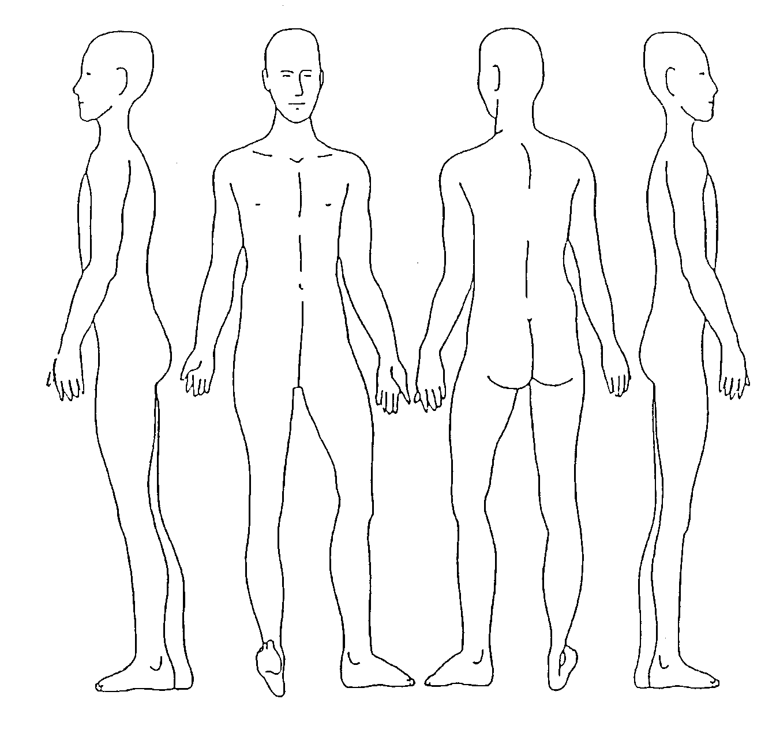
Date when the injury happened (if known) |  | Date injury below was first observed (if this is different) to the original date
Record the area/site of any injury, marks, bruising, etc. Please also indicate the rough size in centimetres or use a comparison, for example, the same size as a 10p coin. Record details such as the colour of bruising, etc.
A – Pressure trauma B – skin excoriation/grazing/reddening C – burns D – bruising E – wounds

