Delegate Workbook

Adult Safeguarding: Making Enquiries Outcome Focussed

About this course
These materials are part of a learning package that includes self-directed learning via this workbook and an in-person seminar. Please ensure that you have set aside at least 3 hours to complete the work before attending the in-person seminar. The seminar will build on your knowledge and understanding and will ask you to reflect on the content of the materials.
You should set up an account with Research in Practice (RIP) if you don’t have one already (see below for instructions on how to set up your account). RIP is a free resource provided by the Safeguarding Partnership Board and contains a wealth of information including videos, briefings, webinars etc which will help you in your work.
All you need is a quiet place to work through the content and/or watch any videos, either alone or in a group. It might be useful, as you read or listen, to jot down thoughts that occur to you about the work you do and any questions or new ideas that come to mind.
Important!
You will need to bring your workbook to the seminar as we will be referring to it on the day.

Setting up your account with Research in Practice
Research in Practice (RIP) supports evidence-informed practice with children and families, young people and adults. RIP brings together academic research, practice expertise and the experiences of people accessing services to develop a range of resources and learning opportunities.
As a partner of the Safeguarding Partnership Board, your organisation is able to access RIP’s resources free of charge. To do this, you will need to set up a RIP account:
Go to www.researchinpractice.org.uk and select ‘create account’ at the top.
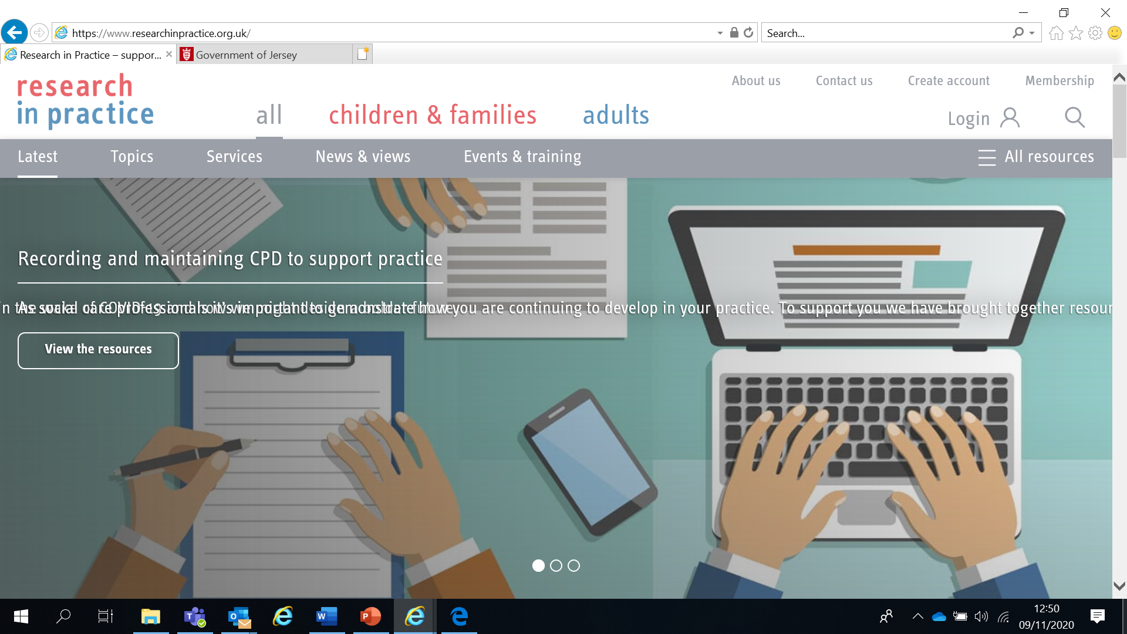

Use your work email and select ‘States of Jersey’ as your organisation from the drop-down list
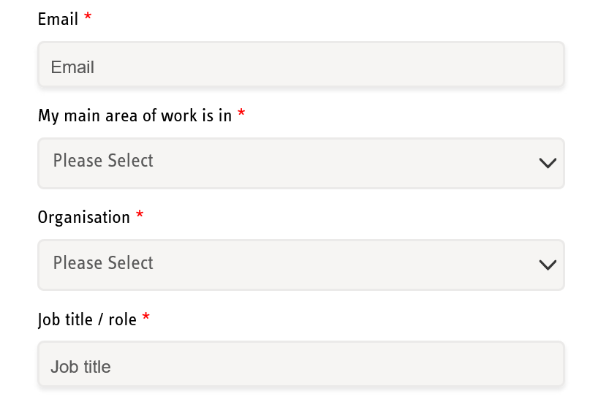

NOTE: You cannot set up an account with RIP if your work email uses Gmail, Hotmail or other generic accounts. Please contact us if this applies to you.

Once you have logged in with your new account, the resources are free to download:
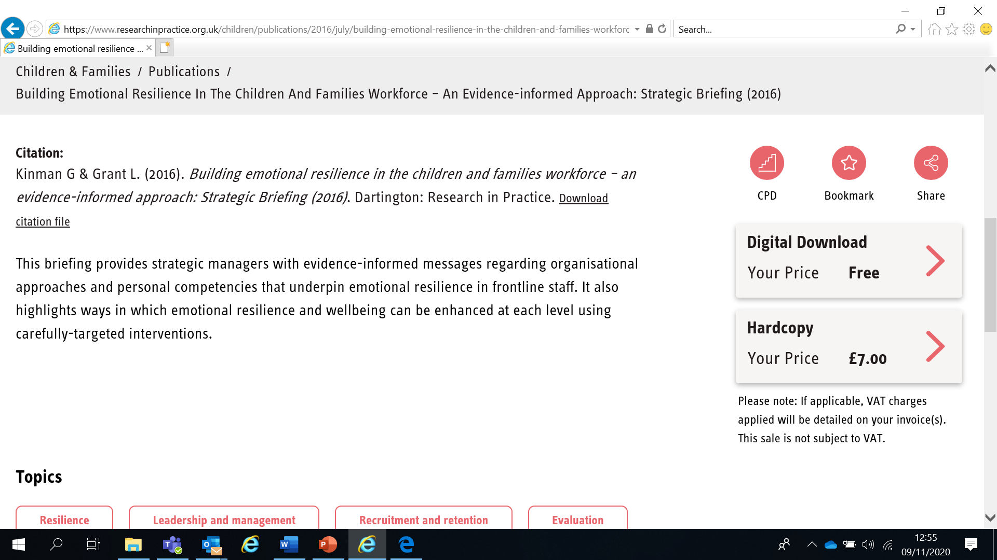

If you have any problems setting up an account, please contact safeguardingtraining@gov.je

Learning Objectives
In this module you will:
- Ensure responses to safeguarding situations are delivered in accordance with the principles of Making Safeguarding Personal
- Explain why professional curiosity is fundamental to keeping people safe
- Understand the types, purpose and models of enquiry
- Use an outcomes-focused approach in your practice
- Debunk the myths around adult safeguarding enquiries
- Identify the policy used to resolve professional differences in relation to the safeguarding needs of adults
Links to Professional Practice
SPB: Adult Procedures Manual, Adult Workforce Competency Framework
PQS KSS: Person-centred practice; Safeguarding; Effective assessment and outcome based support planning; Direct work with individuals and families
CQC: Safe
PCF: Knowledge; Intervention and skills; Critical reflection and analysis
RCOT: Understanding relationship; Service users; Demonstrate quality; Communication; Support development

Top Tips
Do the readings – we've selected reading material that we know will enhance your knowledge and skills
Do the exercises – the more you put into this course, the more you will get out of it. The exercises will give you the opportunity to reflect on what you've read. You'll get a chance to discuss ideas and ask questions in the seminar.

Emotional Alert!
We acknowledge that this is a sensitive subject – look after yourself and others.
This content:
- can trigger memories of experiences which were in some way abusive
- can highlight areas of difficulty for individual people who are aware of others or their own personal experiences
- can have an emotional impact on those working to protect children, families and adults
- seek support from your manager if you are upset by any of the materials

What is Making Safeguarding Personal (MSP)?
MSP promotes responses to safeguarding situations in a way that enhances a person’s involvement, choice and control as well as improving quality of life, well-being and safety. Adults will define what ‘safe’ means for them, have choice and control about what they want as an outcome of any safeguarding intervention and be empowered to make their own decisions.
MSP means that safeguarding is person-led and outcome-focused

Six Principles of Adult Safeguarding
These principles apply to all sectors and should inform the ways in which professionals and other staff work with adults (Care Act, 2014).

Empowerment - Presumption of person-led decisions and informed consent
“I am asked what I want as the outcomes from the safeguarding process and this directly inform what happens.”

Prevention - It is better to take action before harm occurs
“I receive clear and simple information about what abuse is. I know how to recognise the signs, and I know what I can do to seek help.”

Proportionality - Proportionate and least intrusive response appropriate to the risk presented
“I am sure that the professionals will work in my interest and they will only get involved as much as is necessary.”

Protection - Support and representation for those in greatest need
“I get help and support to report abuse and neglect. I get help so that I am able to take part in the safeguarding process to the extent to which I want.”

Partnership - Local solutions through services working with their communities
“I know that staff treat any personal and sensitive information in confidence, only sharing what is helpful and necessary. I am confident that professionals will work together and with me to get the best result for me.”

Accountability - Accountability and transparency in delivering safeguarding
“I understand the role of everyone involved in my life and so do they.”
Read Sections 1 to 3 of the SPB’s Practice Guidance on MSP in the Adult Procedures (you will get a chance to read the rest later)
www.proceduresonline.com/jersey/adults/p_pract_guid_making_sg_pers_guid.html

Professional Curiosity
Nurturing professional curiosity is a fundamental aspect of working together to keep people safe.
Professional curiosity is the capacity and skill to explore and understand what is happening rather than making assumptions or accepting things at face value – sometimes described as ‘respectful uncertainty’.
Questions to ask yourself to enhance professional curiosity:
- Would I live here and if not, why not?
- Would I be happy with this standard of care of a member of my family?
- What am I contributing to this challenge / problem / difficulty? How can I be of service?
- Whose voice needs to be in the conversation? Extend your invitation to everyone.
- How well do I know this person and their family? What other ‘stories’ are there about this person and their family that I am not privilege to?
- Do I need to change my mind? Are there gaps in my understanding?
- What is the purpose of my intervention and what is my desired impact?
- Am I curious about the exceptions to the problems?
- Change the frame of the conversation, change the response.
- How can I use relationships to create change?

We all have resources within us, tap into your expertise.
The SPB’s Resolving Professional Differences/Escalation Policy should be used to escalate unresolved disputes where professional curiosity or challenge has not resolved any professional conflict
Engaging Resistant, Challenging and Complex People
Working with adults and their families where there are safeguarding concerns can be difficult – but it is made especially demanding when people are resistant, challenging and complex. In such cases, it is important to look at the reasons why people may not engage with services because we know that successful early intervention underpinned by positive engagement is key to improving outcomes.

Many people in need of support have experienced discrimination, oppression & disadvantage which shape their interactions with professionals. Intervention by agencies can reinforce their experiences & is often viewed as further oppression which leads to further resistance & fear. Such fears may also inhibit people from discussing concerns with professionals & accessing support. Use professional curiosity and a trauma-informed approach to reflect on why people may be resistant. The past affects the present – understand the story. A range of initiatives and approaches are required with flexibility of approach rather than strict adherence to any particular practice model.

Problems with service design and delivery can make services inaccessible or unattractive to engage with. Professionals’ behaviour is also a key factor, so a strengths and relationship-based approach is important.

Good supervision is key when working with resistant and complex people.
Disguised Compliance
Read the SPB’s 7 Minute Briefings on:
- Professional Curiosity
- Engaging Resistant, Challenging and Complex Families

7 Minute Briefings are in the Resources section of the website. They are a useful resource that can be shared within your organisations and teams as a helpful way to support learning in your organisation.
Disguised compliance involves people appearing to cooperate with professionals in order to allay concerns and stop professional engagement. Published case reviews both locally and nationally highlight the importance of practitioners being able to recognise disguised compliance, establishing the facts and gathering evidence about what is actually happening in people’s lives.
Key issues:
- People’s behaviour towards professionals (minimising, denying, diverting attention, manipulation, saying the right things and engaging ‘just enough’)
- Engagement with professionals (missing or cancelling appointments, promising to reschedule but not attending)
- Optimism (practitioner over-optimism about progress/ability to change/promises to engage, rationalizing behaviour as ‘choice’ rather than non-compliance, acceptance of information without professional curiosity/further investigation)
- Lack of action (in some case reviews, disguised compliance was suspected or discussed but no actions were put in place to tackle it)
Practitioners need to remain open to the possibility of disguised compliance:
- Display professional curiosity when working with people and not accept information at face value without investigating further
- Establish the facts and gather evidence about what is actually happening or has been achieved
- Focus on the person’s lived experience and hear their voice
- Make unannounced visits as well as pre-arranged ones

Our approach to enquiries
Enquiries can range from non-complex single agency interventions to multi-agency complex enquiries. The key questions in choosing the right type of enquiry, is dependent on:
- What outcome does the adult want?
- How can enquiries be assessed as successful in achieving outcomes?
- What prevention measures need to be in place?
- How can risk be reduced?
The specific objectives of an enquiry into abuse or neglect are to:
- Establish facts
- Ascertain the adult's views, wishes and desired outcomes
- Protect the adult from abuse or neglect, in accordance with their wishes
- Assess the needs of the adult for protection, support and redress, and how these might be met
- Make decisions as to what action should be taken with regard to the person or organisation thought to be the cause of risk
- Enable the adult to achieve resolution and recovery
- Add measures that protect others from abuse or neglect.
Identifying the primary source of risk may assist in deciding what the most appropriate and proportionate response to the individual enquiry might be. There are no hard and fast rules and judgement will need to be made about what type of enquiry and actions are right for each particular situation.
Enquiries may involve:
- Holding single or multiple conversations with the person at risk
- Identifying and revisiting the person's desired outcomes
- Assessing and reviewing capacity throughout
- Medical examinations (with consent)
- Reviewing documents such as incident reports, logs, accounts, medical information, statements etc
- Interviewing witnesses, the person at risk, or the person alleged to have caused harm, etc
- Carrying out observations and assessing risk
- Assessing needs and levels of support – including carers' needs
- Receiving and reviewing information from other partners and agencies
- Investigations carried out by others, e.g. employers -(SI's) Serious Incidents, (RCA's) Root Cause Analysis
- Police-led investigations carried out alongside other supportive functions i.e. social services
- Specialist input e.g. IDVA (Independent Domestic Violence Advisor)
- Regulatory input and decisions.
(N.B. this is not an exhaustive list)
Read more about our approach to enquires at www.proceduresonline.com/jersey/adults/p_sg_proc_four_stage_two.html#6.-our-approach-to-enquiries
Professional differences
Multi-agency working to safeguard children and adults at risk is often complex and means that, from time to time, staff from different professional backgrounds may hold a different professional opinion. It is important that this is fully understood as a different perspective has the potential to cause conflict.
Partnership working depends on resolving conflict as soon as possible. Professional differences of opinion can block effective partnership working and can lead to poorer outcomes for children and adults at risk. Effective partnership working depends on understanding differences of opinion and working towards resolving professional disagreements as soon as possible.
The SPB’s Resolving Professional Differences/Escalation Policy should be used to escalate unresolved disputes where professional curiosity or challenge has not resolved any professional conflict
The Four Stage Approach to Adult Safeguarding
“No decision about me, without me” – conversations should involve the person at all stages and give the person choice and control. Conversations should improve the person’s quality of life, wellbeing and safety. If there is a risk to others, the safety of everyone will need to be considered. This approach is about listening and working alongside people at their pace.
“Nothing about me, without me”

The process is responsive to the needs of the person being safeguarded at all times.

Stage 1 – Raising a Concern
At this initial stage, the adult at risk should be involved in defining what safeguarding means for them, have choice and control about what they want as an outcome of any intervention and be empowered to make their own decisions. In accordance with the principles of MSP, it is important to talk to the person about their wishes, the risks, their involvement and how agencies can work together towards achieving the person’s desired outcomes wherever possible. Where people have unrealistic expectations, it is important to discuss this from the beginning. Early discussions enable the person to consider if there are other options in relation to their concern.
Not every concern will need a referral to the Safeguarding Adults Team (SAT). You may have concerns which are not related to harm & abuse – eg if you are worried about an adult’s ability to cook for themselves, a conversation with the person to ascertain their views & wishes may find they have a relative who can cook for them or they would prefer to access Meals on Wheels. Or they might share other worries and would like a Social Care assessment to see what other help can be provided.
If you have a concern which is not a safeguarding concern, you can contact Adult Social Services during office hours for advice, information and, if appropriate, to arrange an assessment of a person’s needs.
For further information, see www.gov.je/Health/SocialServices/Pages/Adult.aspx
Read the section on ‘Prevention’ in the SPB’s Adult Safeguarding Policy and Procedures Manual - https://www.proceduresonline.com/jersey/adults/p_sg_pol_prevention.html#

Other concerns may indicate low level harm or abuse which can be dealt with by other responses, eg if there is an isolated incident where an adult is spoken to in an inappropriate way and respect is undermined but no distress is caused.
Non-reportable incidents do not require reporting to the SAT but you should keep a written internal record of what happened and what action was taken. Actions may include advice, information, risk management and staff training / supervision.

Read the SPB’s Adult Thresholds guidance for examples of concerns which do not need to be reported, concerns that require consultation with your Safeguarding Lead and/or the Safeguarding Adults Team and those incidents which are reportable.
www.proceduresonline.com/jersey/adults/files/pract_guid_threshold_grid.pdf

Note: The thresholds tool is for guidance only and does not replace professional judgement or professional curiosity. If in doubt, speak to the SAT

The Safeguarding Adults Team
A referral should be made to the SAT if all three points are met below:
- The person has care and support needs
- They may be experiencing or at risk of experiencing abuse and neglect
- They are unable to protect themselves from that abuse and neglect because of those care and support needs
The concern form is available on the Resources page (Forms section) at Forms | Jersey Safeguarding Partnership Board and an example is at the end of this workbook.
The SAT are responsible for deciding whether to undertake an enquiry and what the enquiry will entail. If an enquiry is required, an Enquiry Officer will be appointed and a planning discussion/meeting will be held to agree the next steps. All enquiries need to be planned and coordinated. Support will be provided throughout by the SAT. No agency should undertake enquiries prior to a planning discussion or meeting unless necessary for the immediate protection of the adult or others.

Stage 2 – Safeguarding Enquiry
A Safeguarding Enquiry is not just another word for ‘investigation’ - it may take many forms:
- Conversations with people
- Changes in care and support
- Changes in systems or processes
- Repairing or maintaining key relationships
- Accessing social justice and recovery
- Different types of investigations: criminal, regulatory, HR

All enquiries will be planned. This may take the form of a series of phone calls and/or meetings or more formalised planning in more complex/serious cases. The SAT will decide on the most appropriate and proportionate response and will be the lead agency for the enquiry.

The involvement of the adult at risk is vital so consideration must be given as to how to optimise their inclusion and empowerment throughout the enquiry process. Enquiries will be tailored to the individual needs and circumstances of the adult. It should be proportionate to the level of risk involved.
The approach to risk should be to steer away from ‘protecting’ to promoting human rights. Organisations need to take into account the impact that any restrictive, safety-led responses have on the emotional well-being of the person they support.
The Research in Practice ‘Risk enablement’ frontline briefing and chart has more information on working with risk
www.researchinpractice.org.uk/adults/publications/2016/february/risk-enablement-frontline-briefing-2016/
www.researchinpractice.org.uk/media/3624/ripfa_frontline_chart_risk_enablement_feb2016.pdf

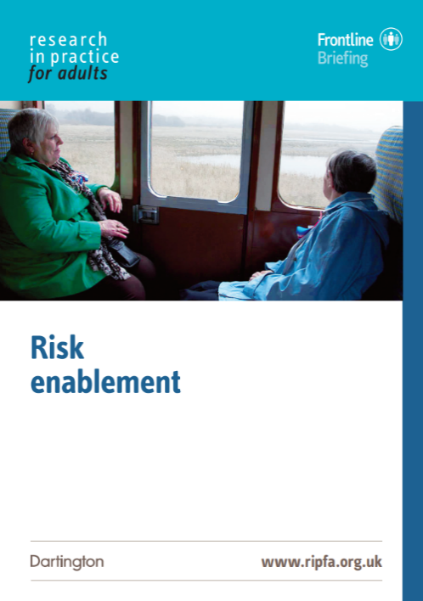
“Risk enablement is a key skill for practitioners in promoting wellbeing and achieving outcomes”
(Research in Practice, 2016)

“The fact is that all life involves risk, and the young, the elderly and the vulnerable, are exposed to additional risks and to risks they are less well equipped than others to cope with. But just as wise parents resist the temptation to keep their children metaphorically wrapped up in cotton wool, so too we must avoid the temptation always to put the physical health and safety of the elderly and the vulnerable before everything else. Often it will be appropriate to do so, but not always. Physical health and safety can sometimes be bought at too high a price in happiness and emotional welfare.
The emphasis must be on sensible risk appraisal, not striving to avoid all risk, whatever the price, but instead seeking a proper balance and being willing to tolerate manageable or acceptable risks as the price appropriately to be paid in order to achieve some other good – in particular to achieve the vital good of the elderly or vulnerable person's happiness.
What good is it making someone safer if it merely makes them miserable?”
Mr Justice Munby - Local Authority X v MM & Anor (no 1) (2007)

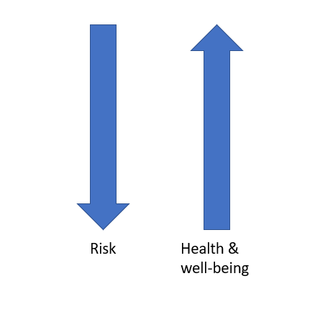
Assessing Risk
Risk assessment and risk management are an integral part of safeguarding adults work. Risk is dynamic – it is constantly changing in response to altered circumstances. Risk can never be eliminated, but it can be assessed and minimised. Anything you do should have the aim of increasing health and wellbeing and decreasing risk.
Read the section on ‘Wellbeing’ in the SPB’s Adult Safeguarding Policy and Procedures Manual https://www.proceduresonline.com/jersey/adults/p_sg_pol_wellbeing.html#
The involvement of the adult at risk is vital so consideration must be given as to how to optimise their inclusion and empowerment.
Once the SAT have confirmed that a safeguarding response is required, an Enquiry Officer will be assigned. The person carrying out the enquiry will need to be appropriately skilled and have the sufficient resources to manage the required work objectively. Some enquiries may require a range of staff to play their part. The SAT remain the lead agency with responsibility for coordinating adult safeguarding arrangements.
Read the SPB’s Standard Safeguarding Pathway Flowchart at www.proceduresonline.com/jersey/adults/f_stand_sg_pathway.html

Stage 3 – Safeguarding Plan and Review
Not every safeguarding enquiry will need a safeguarding plan.
Safeguarding plans:
- Formalise actions needed to safeguard against (current and future) abuse and neglect
- Offer resolution and recover to the experience of abuse and neglect
- Must be agreed and co-created with the person (or their representative) and should be in an appropriate format for the person, eg easy read
- Should not be confused with care and support plans BUT actions that may safeguard, protect or help monitor situations can form part of an ongoing care plan

The involvement of the adult is vital so consideration must be given as to how to optimise their inclusion and empowerment

Stage 4 – Closing the Enquiry
Enquiries can be closed at any stage. The person will be advised how any ongoing concerns will be managed with their consent. Their views will be recorded. A review of care and support should take place soon after closure. Other processes may continue, eg disciplinary or professional body investigation.
Agreements for cases to remain open or closed should be reached between all relevant partners – including the adult at risk whose involvement is vital throughout.
All closures (no matter what stage) are subject to evaluation of outcomes.

A Word About Consent
An enquiry is not dependent on the consent of the adult, once it has been established that they are at risk of abuse. There is a duty of care to undertake an assessment of the adult’s care and support needs despite their refusal in cases (a) where they lack capacity to refuse the assessment and it would be in their best interests, or (b) where the adult is experiencing, or at risk of abuse or neglect.

In cases where the adult does not wish to co-operate with an enquiry or rejects any proposed safeguarding measures, genuine attempts will be made to negotiate and try and find areas of possible agreement. (Recording these discussions is important).

For cases where there remains a high level of significant complexity the SAT can apply for (case specific) legal advice from the Law Officers Department.

Capacity and Self-Determination (Jersey) Law 2016
The Capacity and Self-Determination (Jersey) Law 2016 (CSDL) affects everyone aged 16 or over and supports people’s decision making, including future decisions. It provides a legal framework for assessing capacity and making decisions for those who lack capacity. It is wider than just safeguarding.
CSDL contains provisions for:
- Lasting Powers of Attorney (LPA)
- Advance Decisions to Refuse Treatment (ADRT)
- Restrictions on Liberty
- Independent Capacity Advocates
- Wilful neglect and ill-treatment

All interventions must take into account the capacity of the adult to make informed choices and specifically the adult’s ability to understand the implications of their situation and to take action themselves (or with support) to prevent abuse, and to participate to the fullest extent possible in decision-making about safeguarding interventions.
Making Safeguarding Personal does not mean ‘walking away’ if a person declines safeguarding support. That is not the end of the matter. Empowerment must be balanced with a duty of care and the principles of the Human Rights (Jersey) Law 2000 and the CSDL. People must not simply be abandoned in situations where, for example, there is significant risk and support is declined and/or coercion is a factor.
A capacitated refusal for a safeguarding intervention is not to be seen as the end of the concern, as this may require ongoing risk management, monitoring or changes to care and support. Further multi-disciplinary discussions and interventions may need to continue.
Training is available on CSDL. Contact safeguardingtraining@gov.je for more information

Read the section on Capacity and Consent in the SPB’s procedures
https://www.proceduresonline.com/jersey/adults/p_sg_pol_capacity_consent.html

What do we mean by outcomes?
Outcomes are the impact support or services have on a person’s life. They are not interventions.
When we say that MSP means that safeguarding is outcome-focused, it means that outcomes are personalised and relate to the priorities and aspirations of an individual person. An outcomes-focused approach must place the person at the centre of discussions from the outset, finding ways to engage and empower them so that they are able to explain their needs, concerns, problems and circumstances. Only then can the whole person, their current situation and history be understood so they can discuss and negotiate with those supporting them what their desired outcomes are and how they might be achieved.
Outcomes-focused services therefore aim to achieve the aspirations, goals and priorities identified by people. They are by definition individualised, as they depend on the priorities and aspirations of individual people.
Sometimes there is confusion between outcomes, outputs and needs.
Outcome: The impact or end results the person wishes to achieve
Output: The action or process of producing something
Need: The reason the person needs support or the thing they need support with

Are the following statements outcomes, outputs or needs?
Statement | Outcome, Output or Need?
I can’t open tins, jars or packets or do up buttons and zips without help because my fingers are so bad with arthritis
I want to be able to stay in my home and be able to keep looking after it like I’ve always done
Provision of information on local art and craft clubs and activities
I’m lonely. I really miss visits from Carlos. I hardly see anyone now and it’s getting me down
I want to understand what is happening now that I have been told I have dementia
Access a seated exercise class
I keep being hassled by my neighbour for money and it upsets me
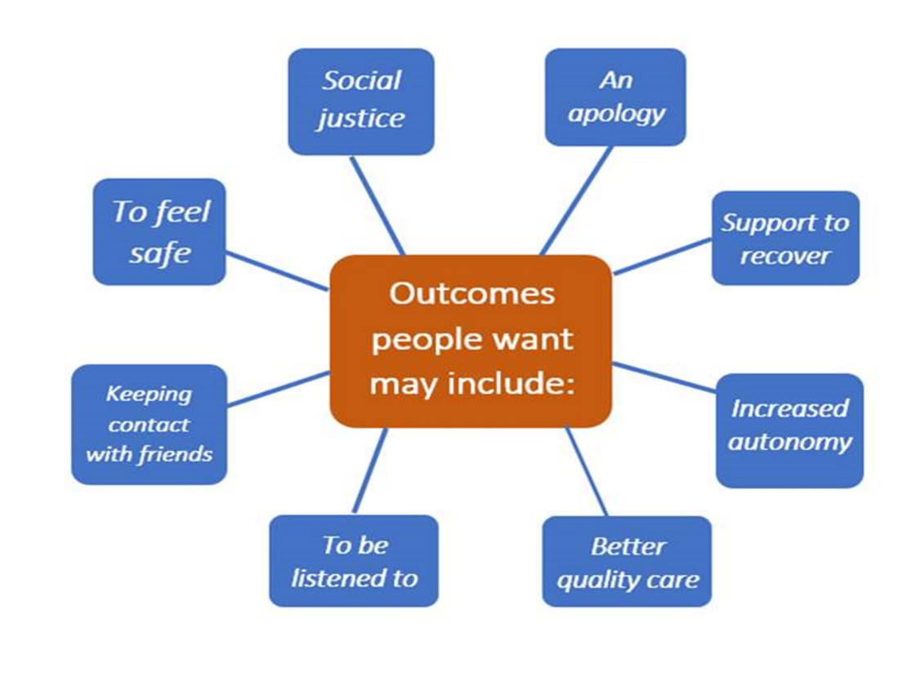

What outcomes might you expect the people in the scenarios below to express?

Need | Impact on wellbeing | Outcomes (person’s words)
I can’t go to the library, shopping or pop for a coffee anymore without asking for help and waiting until someone can come – I get really upset and angry | I’ve got no control over what I can do and when. My family and friends don’t understand how frustrated and useless that makes me feel and I get cross with them. I don’t like asking for help so go out less and less.
I have COPD and so get tired easily when doing anything – being clean, having a shave and cleaning my teeth is really important to me but it takes a long time for me to do this and I get exhausted so can’t use my shower safely. My daughter showers me but that is embarrassing for a dad. | I don’t like my personal care being done by my daughter, it is really embarrassing and neither of us feel comfortable. She doesn’t have time before work to support me and it ends up rushed and I’m exhausted afterwards. I’m only washing once a week or twice at the most, but this means often I don’t feel clean I look scruffy. I’ve never looked scruffy in my whole life. I’m feeling really low and have started getting sore with skin problems and infections

Need | Impact on wellbeing | Outcomes (person’s words)
I sometimes forget things and I can get mixed up. I’ve missed some appointments with the doctor and lost some tablets. Jem says I’m not looking after myself because I have lots of out of date food and am not eating enough but I don’t agree. He says I’m not safe on my own. | Edith’s memory lapses and need for prompts mean that she is not getting enough to eat and drink. This may be compounding her memory problems and putting her at risk. She is finding it difficult to get out and about or to have a routine for my daily life. It is affecting her decision making and safety.
I’ve been in residential care since I fell back in July. They said to come here for a while as my home wasn’t safe because of the steps and stairs. I don’t like it here so stay in my room most of the time – my friends don’t visit as it is too far out for them. I want to go home I miss my own things and routine. I think I can manage fine with some help. | Being in the residential home has made Maura withdrawn and isolated – my opinion would be that she may be depressed. She does not engage much with the carers and as a result most of the areas of her life are affected negatively.

Identifying outcomes
Research in Practice have developed an Outcomes Triangle to support outcomes-focused conversations. This encourages a broader whole-person approach to what may be important to an individual and what strengths and assets are already in place.
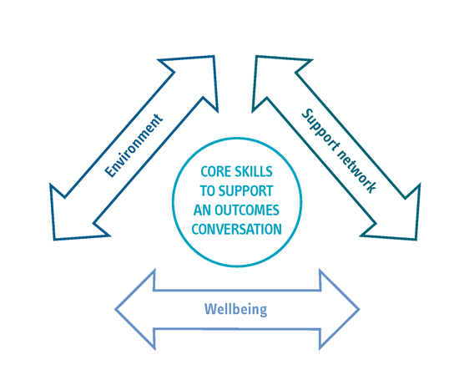

Environment: the physical environment surrounding the person. This might be their home, workplace if they have one, recreation facilities they access or the local area and the community in which they live. Understanding the different environments people need to access and what they need or want to do in them ensures that you can focus on their strengths and assets.
Support network: informal support such as family, friends, people or facilities in the local area or community and work colleagues. It also includes formal paid support which the person already accesses or may be able to access such as domiciliary care, accessing day opportunities or education, employing a personal assistant etc. Understanding people’s support networks ensures that you can focus on their strengths and assets.
Wellbeing: defined broadly in terms of:
- personal dignity
- physical and mental health and emotional wellbeing
- protection from abuse and neglect
- control by the individual over day to day life
- participation in work, education, recreation etc
- social and economic wellbeing
- domestic, family and personal relationships
- suitability of living accommodation
- contribution to society
Core Skills to support outcomes-focused conversations include non-verbal communication, a conversational style, powerful questions, active listening, asset and strength-based conversations, analysis and critical thinking and universal questions.
Examples of universal questions you could use are:
Identifying need | What are things like for you now? How does this affect you? How does this affect others around you?
Identifying impact | What, if anything, has changed and when? How has this affected you? How has this affected others around you?
Identifying outcomes | What is most important to you and why? What is good that you do not want to change? What, if anything, do you want to change? What are your desired outcomes? On a scale of 1 to 5 where are you at the moment?
Identifying actions | How will you achieve these outcomes? What would help achieve these? Who could help you achieve these? Where can you best achieve these?
If you would like more information on outcomes-focused practice, visit the RIP site https://outcomes.ripfa.org.uk/
Or download the Practice Tool at www.researchinpractice.org.uk/adults/publications/2014/january/working-with-outcomes-practice-tool-2014/

Read Section 4 of the SPB’s Practice Guidance on MSP in the Adult Procedures www.proceduresonline.com/jersey/adults/p_pract_guid_making_sg_pers_guid.html
Challenges and dilemmas
Safeguarding adults is complex because people’s lives are complicated, and everyone’s situation is different. Working in partnership with the person raising the concern, other agencies and the individual themselves, is critical to safeguarding adults. Safeguarding adults is about prevention and early intervention as well as intervention when things have gone wrong. We have to become better at engaging with people so that we can anticipate things that could be addressed to minimise any likelihood of harm and to spot early when things aren’t quite right and take early steps to offer support.
Read the ‘Myths and Realities about Making Safeguarding Personal at www.local.gov.uk/sites/default/files/documents/25.144%20MSP%20Myths_04%20WEB.pdf

Some of the challenges and dilemmas in safeguarding adults are:
- Managing risk – can the risk be reduced without compromising other things that are important to the person? Defensible decisions rather than defensive actions
- A shift in focus from risk to wellbeing. Professionals should not take a paternalistic or risk averse approach
- Refusals – there must be attempts to negotiate and seek to identify areas of possible agreement. It does not mean ‘walking away’
- Undertaking an Enquiry is not dependent on the consent of the adult once it has been established that they are at risk of abuse
- Empowerment must be balanced with a duty of care to undertake an assessment of the adult’s care and support needs despite their refusal in cases:
  - Where they lack capacity to refuse the assessment and it would be in their best interests
  - Where the adult is experiencing, or is at risk of, abuse and neglect

Have you encountered any of these challenges or dilemmas in your practice? How did you resolve them? Would you do anything different if faced with these challenges again?

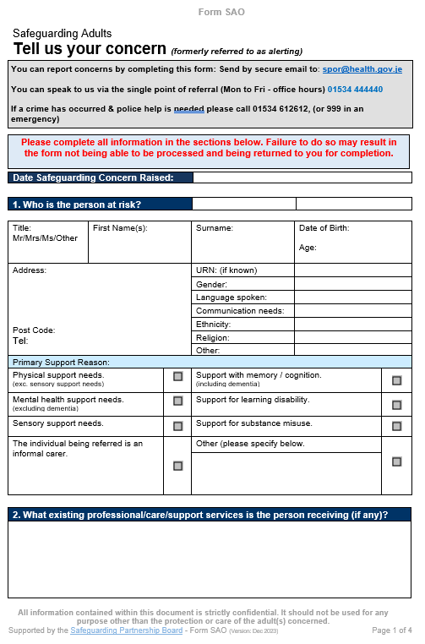
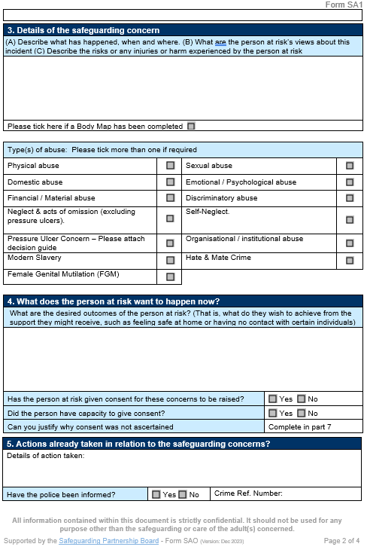

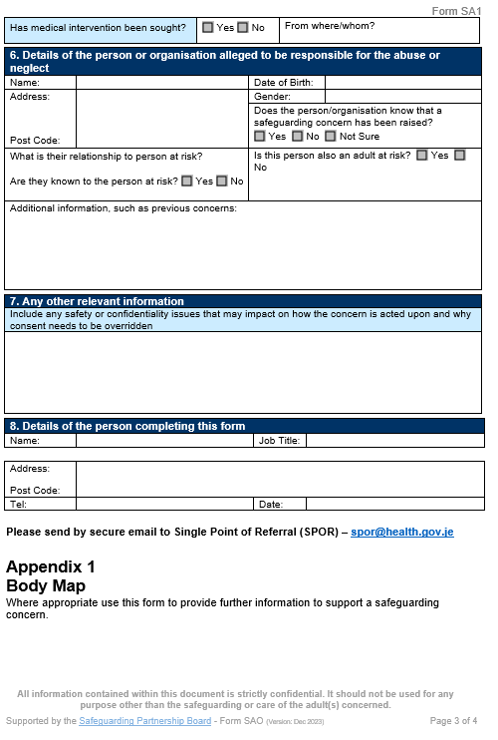

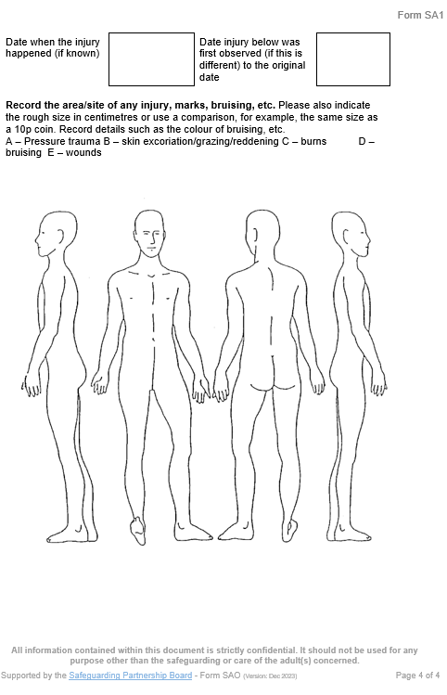
Raising-a-Concern-Form-January-2024-1.pdf (safeguarding.je)
Next Steps
You have now finished the independent learning ahead of the in-person seminar.
In the seminar, we will reflect on your learning from this module and in particular we will:
- Consider the part that risk plays in many decisions
- Look at safeguarding scenarios and case studies

Important!
Please bring this workbook to the seminar with you. We will be referring to it throughout the session.

Further Learning
The SPB website has a series of 7 Minute Briefings on a range of topics which you can use with your teams to prompt discussion and reflection on practice and systems. You can find 7 Minute Briefings under the Resources page on the website – including an explanation of what they are.
The SPB has a range of courses which will help you to further your knowledge. Please check our website for further details.
The Research in Practice website is an excellent source of further material. In particular, the ‘Safety Matters: Practitioners’ Handbook’ is useful for all those working in safeguarding adults. It can be downloaded at ripfahandbook_safetymatters_revised_third_edition_apr2019-update_web-1.pdf (researchinpractice.org.uk)
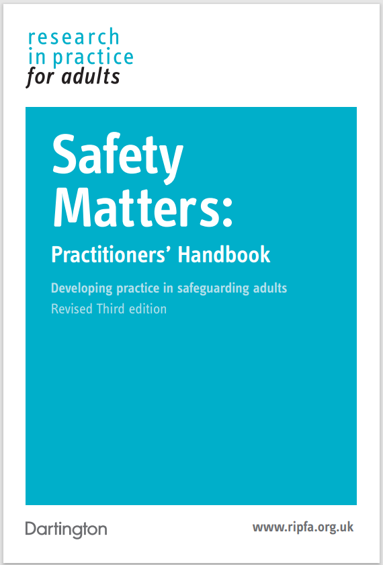
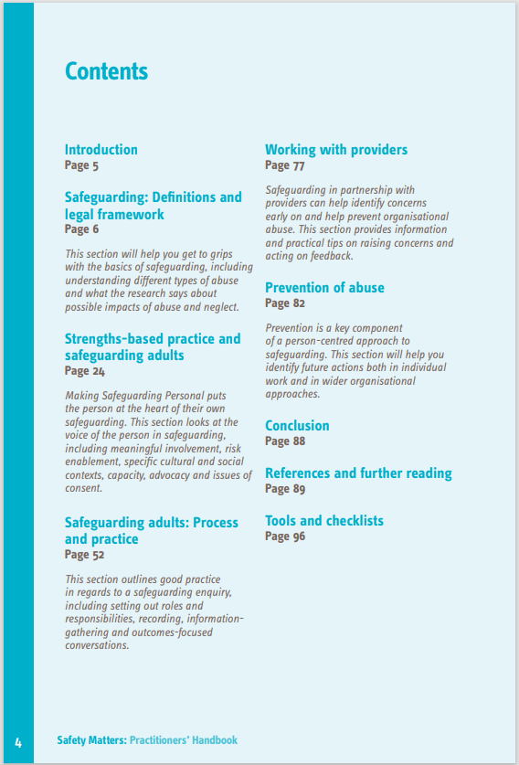

Acronyms
ABE | Achieving Best Evidence
ADRT | Advance Decisions to Refuse Treatment
APVA | Adolescent to Parent Violence and Abuse
ASCIT | Autism and Social Communication Inclusion Team
AWDO | Adult Workforce Designated Officer
CAMHS | Child and Adolescent Mental Health Service
CCE | Child Criminal Exploitation
CDC | Child Development and Therapy Centre
CEOP | Child Exploitation and Online Protection Agency
CEYS | Childcare and Early Years Service
ChiSVA | Children and Young People’s Sexual Violence Advisor
CIN | Child In Need
CLA | Children who are Looked After (formerly known as LAC Looked After Children)
CMHT | Community Mental Health Team
CP | Child Protection
CPC | Child Protection Conference
CQC | Care Quality Commission
CSDL | Capacity and Self-Determination Law
CSE | Child Sexual Exploitation
CYPES | Children Young People Education and Skills
DA(DV) | Domestic Abuse (Domestic Violence)
DBS | Disclosure and Barring Service
DSL | Designated Safeguarding Lead
ECHR | European Convention on Human Rights
EP | Educational Psychologist
EWO | Education Welfare Officer
EYAT | Early Years Advisory Team
EYFS | Early Years Foundation Stage
EYIT | Early Years Inclusion Team
FGM | Female Genital Mutilation
FII | Fabricated or Induced Illness
FLO | Family Liaison Officer
FNHC | Family Nursing and Home Care
GDPR | General Data Protection Regulation
GSF | Gold Standards Framework
HBV | Honour Based Violence
HSB | Harmful Sexual Behaviour
ICA | Independent Capacity Advocate
ICPC | Independent Child Protection Conference
IDVA | Independent Domestic Violence Advisor
IPVA | Inter Personal Violence and Abuse in Young People’s Relationships
ISS | Independent Safeguarding and Standards
ISVA | Independent Sexual Violence Advisor
JCAF | Jersey Common Assessment Framework
JCCT | Jersey Child Care Trust
JCF | Jersey’s Children First
JDO | Jersey Designated Officer
JFCAS | Jersey Family Court Advisory Service
JPACS | Jersey Probation and After-Care Service
JMAPPA | Jersey Multi Agency Public Protection Arrangements
LADO | Local Area Designed Officer (see JDO)
LPA | Lasting Power of Attorney
MAF | Managing Allegations Framework
MARAC | Multi Agency Risk Assessment Conference
MARRAM | Multi Agency Risk Review Action Meeting
MASH | Multi Agency Safeguarding Hub
MSP | Making Safeguarding Personal
NAI | Non Accidental Injury
PBS | Positive Behaviour Support
PPU | Public Protection Unit
PR | Parental Responsibility
RCPC | Review Child Protection Conference
RRRT | Rapid Response and Reablement Team
SALT | Speech and Language Therapy/Therapist
SARC | Sexual Assault Referral Centre
SCR | Serious Case Review
SEMHIT | Social, Emotional and Mental Health Inclusion Team
SEN | Special Educational Needs
SENCO | Special Educational Needs Coordinator
SEND | Special Education Needs and Disability
SNRM | Self-Neglect Risk Management Meeting
SOJP | States of Jersey Police
SOLO | Sexual Offences Liaison Officer
SPB | Safeguarding Partnership Board
SPOC | Single Point of Contact
SPOR | Single Point of Referral
SRoL | Significant Restriction on Liberty
SUDI | Sudden Unexplained Death in Infancy
SUI | Serious or Untoward Incident
TAC | Team Around the Child
TAF | Team Around the Family
YES | Youth Enquiry Service

For information on services in Jersey, please see:
Jersey Online Directory www.jod.je

NOTES

