Delegate Workbook

Child Protection Conferences

About this course
These materials are part of a learning package that includes self-directed learning via this workbook and an in-person seminar. Please ensure that you have set aside at least 2 hours to complete the work before attending the in-person seminar. The seminar will build on your knowledge and understanding and will ask you to reflect on the content of the materials.
You should set up an account with Research in Practice (RIP) if you don’t have one already (see below for instructions on how to set up your account). RIP is a free resource provided by the Safeguarding Partnership Board and contains a wealth of information including videos, briefings, webinars etc which will help you in your work.
All you need is a quiet place to work through the content and/or watch any videos, either alone or in a group. It might be useful, as you read or listen, to jot down thoughts that occur to you about the work you do and any questions or new ideas that come to mind.
Important!
You will need to bring your workbook to the seminar as we will be referring to it on the day.

Setting up your account with Research in Practice
Research in Practice (RIP) supports evidence-informed practice with children and families, young people and adults. RIP brings together academic research, practice expertise and the experiences of people accessing services to develop a range of resources and learning opportunities.
As a partner of the Safeguarding Partnership Board, your organisation is able to access RIP’s resources free of charge. To do this, you will need to set up a RIP account:
Go to www.researchinpractice.org.uk and select ‘create account’ at the top.
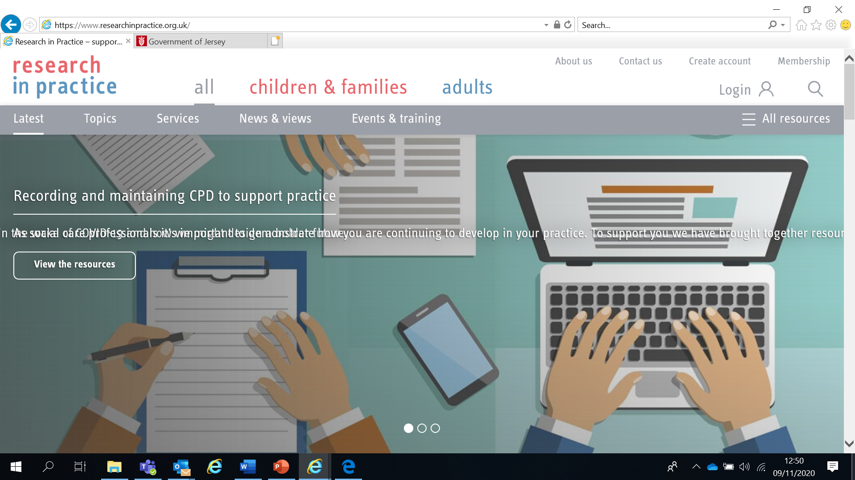

Use your work email and select ‘States of Jersey’ as your organisation from the drop-down list
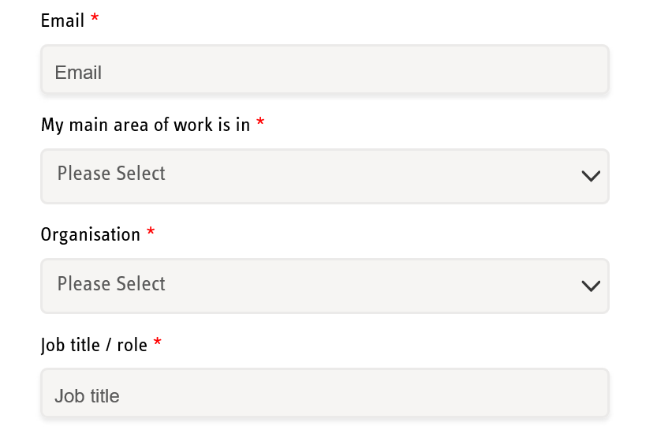

NOTE: You cannot set up an account with RIP if your work email uses Gmail, Hotmail or other generic accounts. Please contact us if this applies to you.

Once you have logged in with your new account, the resources are free to download:
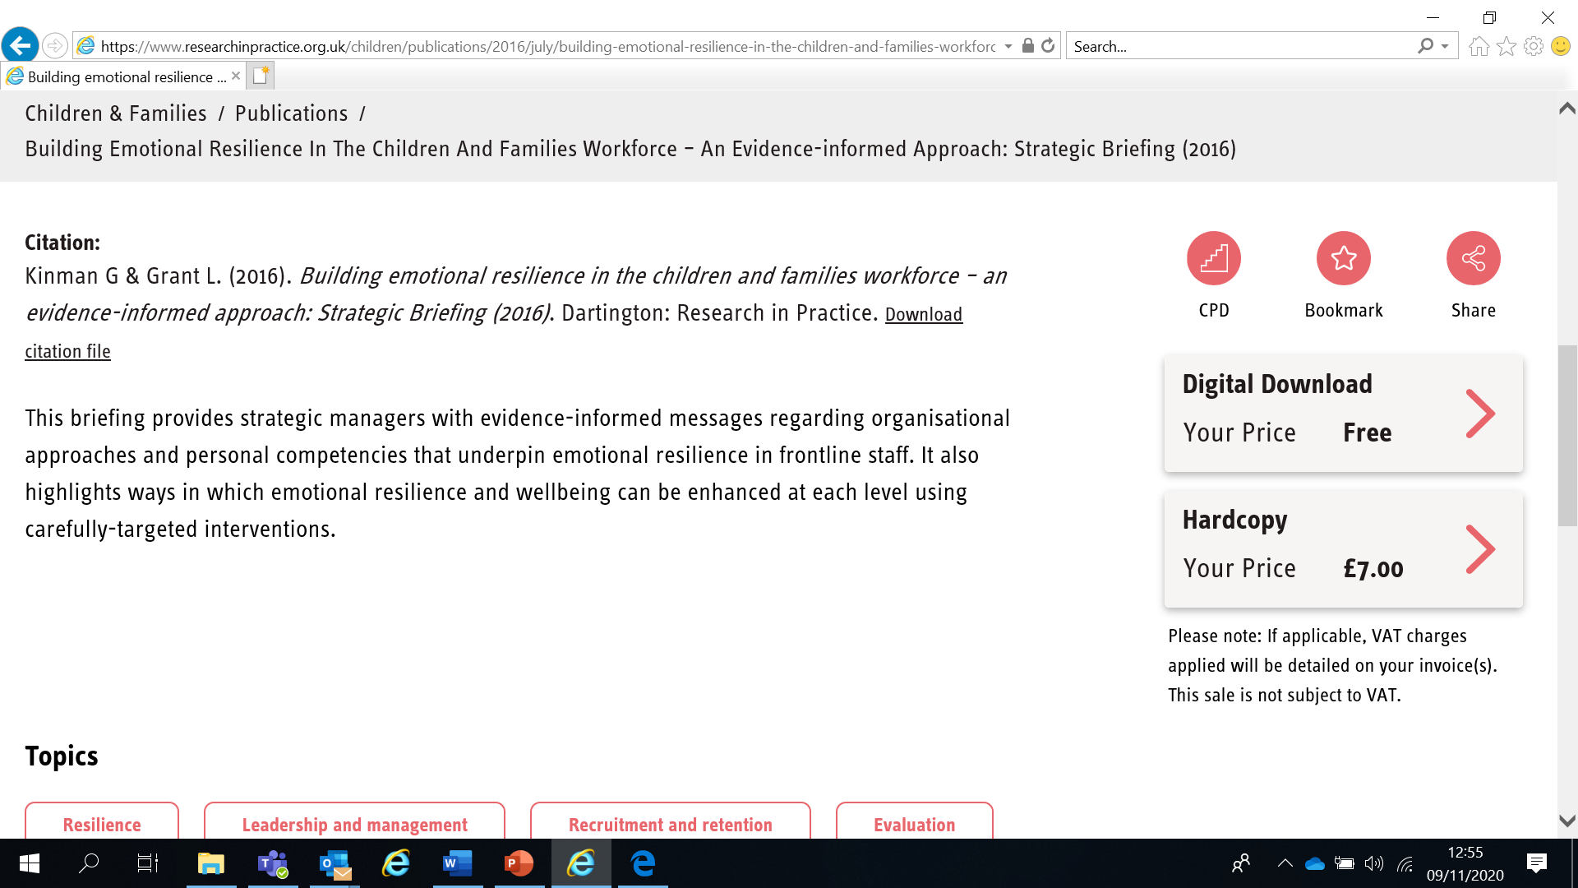

If you have any problems setting up an account, please contact safeguardingtraining@gov.je

Learning Objectives
In this module you will:
- Outline the structure and function of a strategy meeting, core group and a child protection conference
- Be able to confidently and competently prepare for and participate in child protection conferences
- Maintain focus on the child throughout in order to promote their safety
- Work openly and honestly in order to work effectively in partnership with families and children
- Explore issues surrounding parental and child attendance and participation at conferences to help them understand concerns for the child’s safety, and how this can be improved
- Identify the issues of power and inequity between professionals and families in order to be aware of the potential for oppressive practice

Links to Professional Practice
SPB: Child Procedures Manual, Continuum of Needs, Resolving Professional Differences/Escalation Policy, Child Workforce Competency Framework

Intercollegiate Competency Framework: Level 3 and above

Top Tips
Do the readings – we've selected reading material that we know will enhance your knowledge and skills
Do the exercises – the more you put into this course, the more you will get out of it. The exercises will give you the opportunity to reflect on what you've read. You'll get a chance to discuss ideas and ask questions in the seminar

Emotional Alert!
We acknowledge that this is a sensitive subject – look after yourself and others.
This content:
- can trigger memories of experiences which were in some way abusive
- can highlight areas of difficulty for individual people who are aware of others or their own personal experiences
- can have an emotional impact on those working to protect children, families and adults
- seek support from your manager if you are upset by any of the materials

What is Child Protection?
Whilst local authorities play a lead role, safeguarding children and protecting them from harm is everyone’s responsibility. Everyone who comes into contact with children and families has a role to play.
Safeguarding and promoting the welfare of children is defined as:
- Protecting children from maltreatment
- Preventing impairment of children’s health or development
- Ensuring that children grow up in circumstances consistent with the provision of safe and effective care
- Taking action to enable all children to have the best outcomes
(Working Together to Safeguard Children 2018)

The Legal Framework
- Article 2 of the Children (Jersey) Law 2002 (Children (Jersey) Law 2002 (jerseylaw.je)) states that:
“The child’s welfare shall be the court’s paramount consideration”
- The 1989 UN Convention on the Rights of the Child (Convention on the Rights of the Child | OHCHR) states that every child has a right to a childhood, to be protected from harm, a right to education, to be treated fairly and for their views to be heard

- The Jersey SPB Multi-Agency Child Protection Procedures (Welcome (proceduresonline.com)) state that all agencies must have safeguarding procedures in place for professionals to meet their responsibility to identify and report risks and concerns of children to the Children and Families Hub (www.gov.je/ChildrenAndFamiliesHub)
Strategy Meetings
The Police, Children’s Services and other agencies as appropriate will hold a strategy meeting when information gathered during a referral or on assessment indicates reasonable cause to suspect that a child is suffering or likely to suffer significant harm.
At least three organisations have to be present at a Strategy Meeting.
Read the section on Strategy Meetings on the SPB Child Procedures at https://jerseyscb.proceduresonline.com/chapters/p_ch_protection_enq.html

Strategy Meetings are chaired by a Children’s Service Manager or Senior Practitioner. Agencies share information relevant to determining whether a child has suffered or is likely to suffer significant harm. We will look at the definition of significant harm later.
The meeting also:
- determines whether a child protection enquiry (sometimes called an ‘Article 42’ as this is the part of the law it relates to) is needed and if so, how this will be coordinated
- decides what information will be shared with the family and by whom
- considers the needs of any other children
The Continuum of Need
All agencies have a responsibility to address the needs of children and young people in Jersey. Effective joint working ensures children’s needs can be met across the continuum.
The Continuum of Need guidance describes potential indicators of concern for children and their families and can be used to enhance and support collective understanding of risk. This will help inform professional conversations between services and practitioners, improving the quality and consistency of assessments.
Problems should be identified as early as possible so that the child and family receive help and support in a timely way to prevent the problem becoming worse or entrenched. The Continuum of Need is a useful tool to help with this. It enables everyone to have a shared understanding and language and supports consistency of practice.
Download and read the SPB’s Continuum of Need (Continuum of Need) on the Polices section of the website
Policies | Jersey Safeguarding Partnership Board

*** NOTE: The Continuum of Need document is not intended to replace the professional judgement of practitioners. If in doubt, advice should always be sought from a manager, Designated Safeguarding Lead or the Children and Families Hub ***
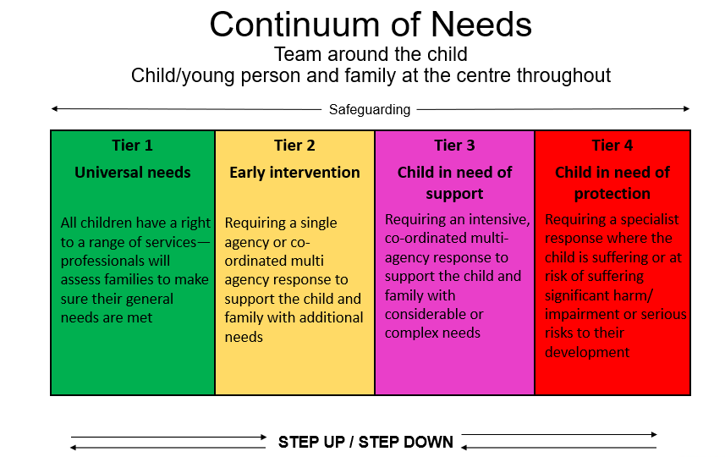
REMEMBER – Never do nothing
The SPB’s Resolving Professional Differences/Escalation Policy should be used to escalate unresolved disputes where professional curiosity or challenge has not resolved any professional conflict

Scenario Activity – Jayden
Read the information about Jayden below and then complete the table on Page 9. You should use the SPB’s Continuum of Need to help you identify the level of risk for Jayden.

Health Visitor Information
You have known Mum and Jayden since Jayden was born. You feel you have got to know Mum well and have developed a good relationship with her. Jayden is four years old.

Since you’ve known Mum you are aware that she speaks of feeling isolated so you have given her information on local community resources and groups she can attend. You have also made referrals for her to attend at parenting support groups. When you asked Mum how she was finding these support groups she said that she didn’t feel she needed them and as such hasn’t attended.

Jayden’s immunisations are up to date. There was delay in getting his immunisations done but mum always had a good reason why she had missed an appointment. She always had a good reason when she was not able to be at home for visits you arranged with her and if she missed a home visit, she would bring Jayden to the clinic. Looking at your records it is now apparent that you’ve not had a successful visit to the home since Jayden was quite a young baby. But mum has brought him to clinic, so you’ve not really viewed the lack of home visiting as an issue of concern.

Since you’ve known them, you’ve seen Jayden with a few bruises. Mum has always had an explanation which you felt was plausible. It’s only by putting your report together for conference that you’ve seen from looking at your own chronology that for a 4-year-old, Jayden seems to have had more injuries than most. And a lot of these injuries seem to be facial.

You’ve also accessed A & E records which show Jayden has attended the hospital on 3 occasions when Mum has reported he has fallen over and hurt himself. These injuries are in addition to the ones you have observed. Jayden doesn’t have any health conditions, but he has been referred to speech and language therapy as his speech appears delayed.

Designated Teacher Information
Jayden only started at your school this term, so you don’t feel that you know him well. Since he’s been with you, there have been no concerns regarding his attendance or punctuality. There have been a couple of lates but Mum has always apologised and had a reasonable explanation.

But it has been noted that Jayden never returns to school with his homework. When you ask him about this, he seems confused. You raised this with Mum but were concerned with her reaction as she appeared to get angry with Jayden, saying to him that she always does his homework with him and he has it when he comes into school so she doesn’t know what he is doing with it after she leaves him in the playground. You were a bit concerned about Jayden’s reaction to Mum when she appeared angry as although he didn’t say anything he seemed to ‘freeze’ and become quite watchful of mum’s actions. This occurred at the end of a school day and you observed mum to take Jayden quite roughly by his hand. You then saw mum walk off at quite a quick pace so that Jayden had difficulties keeping up with her and he had to keep running. Mum didn’t seem aware that she was walking too fast for Jayden to walk with her in comfort. This incident occurred a few days before Jayden came into school with the bruising on him.

Since Jayden has been cared for full time by Dad, he has been bringing his homework into school. Jayden has also appeared more talkative since being in Dad’s care and he says he likes having Dad around more.

Housing
You’ve known the family since shortly after they came to Jersey. There have been repeated complaints made by neighbours re fighting and shouting at mum’s accommodation. Some of the complaints have referred to hearing a child crying. Mum has been spoken to and has made counter allegations against her neighbours. She says that they are picking on her because she has come from the UK. The weekend before Jayden made his disclosure at school about Mum hurting him, another neighbour complaint had been received regarding hearing shouting followed by what sounded like a child crying.

You haven’t been inside the property for almost a year. When you last visited you were concerned that there was damage to doors where it looked like they had been hit – possibly by a fist? On the last occasion when you visited, you noted that whilst Mum’s bedroom appeared comfortable and warm, Jayden’s room was poorly furnished. There was no sheet on his bed and the bed was a mattress on the floor. His duvet appeared dirty and there was an unpleasant background smell. There was a lock toward the top of Jayden’s door on the outside. Mum said she had put it there to keep Jayden out of his room during the day as he has been smearing in there (hence the smell) and she had been advised to do this by the health visitor.

GP
The GP has known Jayden’s dad since he was a child and knows the rest of the family well. He has seen Jayden’s dad for anxiety and depression prior to him leaving Jersey some years ago but has not seen him since he returned to the island.

Jayden is registered with the same GP and he has seen him on twelve occasions in the last two years. Jayden appears to be a clumsy child who falls often as he presents with bruises and bumps, often to his head. He has on a few occasions warranted an attendance at A&E.
The GP has had concerns that when presenting, Jayden can look pale and grubby and is often silent in his mother’s presence. A very quiet child.

Now answer the following questions about Jayden below:

What does your information tell you about Jayden’s life experience?

What risks or concerns can you identify for Jayden?

What things are working well for Jayden?

What would you do with this information?

Who else may have relevant information to share about Jayden to help give a more holistic view of his life experiences to help decide what should happen next?

Where do you think the level of risk of harm currently is for Jayden?

What about future risk of harm to Jayden?

DEFINITIONS OF ABUSE

PHYSICAL ABUSE
Physical abuse may involve hitting, shaking, throwing, scalding, drowning, suffocating or otherwise causing physical harm to a child. Physical harm may also be caused when a parent or carer fabricates the symptoms or deliberately induces, illness in a child.
EMOTIONAL ABUSE
Emotional abuse is the persistent emotional ill treatment of a child such as to cause severe and persistent adverse effects on the child’s emotional development. It may involve conveying to a child that they are worthless and unloved, inadequate, or valued only insofar as they meet the needs of another person. It may feature age or developmentally inappropriate expectations being impose on children. These may include interactions that are beyond the child’s developmental capability, as well as overprotection and limitation of exploration and learning, or preventing the child from participating in normal social interaction. It may involve seeing or hearing the ill-treatment of another, including domestic violence or serious bullying causing children frequently to feel frightened or in danger, or the exploitation or corruption of children. Some level of emotional abuse in involved in all types of maltreatment of a child, though it may occur alone.
SEXUAL ABUSE
Sexual abuse involves forcing or enticing a child or young person to take part in sexual activities, including prostitution whether or not the child is aware of what is happening. The activities may involve physical contact, include penetrative (e.g. rape) or non-penetrative acts. They may include non-contact activities such as involving children in looking at, or in the production of sexual online images, watching sexual activities, or encouraging children to behave in sexually inappropriate ways.
NEGLECT
Neglect is the persistent failure to meet a child’s basic physical and/or psychological needs, likely to result in the serious impairment of the child’s health or development. Neglect may occur during pregnancy as a result of maternal substance misuse. It may also include neglect of, or unresponsiveness to, a child’s basic emotional needs.
- Once a child is born, neglect may involve a parent or carer failing to;
- Provide adequate food, clothing and shelter (including exclusion from home or abandonment)
- Protection a child prom physical harm or danger
- Ensure adequate supervision (including the use of inadequate care-givers)
- Ensure access to appropriate medical care or treatment

What is ‘Significant Harm’?
Significant Harm is defined in the Children (Jersey) Law 2002, Article 24:
Harm means ill treatment or the impairment of health or development. It is judged to be significant or not in relation to the health and development of a similar child.

Children witnessing domestic abuse is recognised as ‘harm’ after the UK Adoption and Children Act 2002 amended the definition in the Children Act 1989 to include 'impairment suffered from seeing or hearing the ill-treatment of another’. We follow this definition in Jersey.
A child’s name can be placed on the register based on the likelihood of significant harm based on information known.

Child Protection Conferences

The Standards and Quality Team (SQT) are the organisation that provides independent oversight to child protection plans and reviews the care arrangements for children who are looked after by the Government of Jersey. They also investigate allegations of professional abuse.
An Initial Child Protection Case Conference (ICPC) will be held:
- where child protection enquiries show that a child has suffered or is likely to suffer significant harm (ICPC)
- where there are concerns regarding an unborn child (unborn ICPC)
- where a child subject to a Child Protection Plan in another authority moves to Jersey (transfer in ICPC)
The Conference should take place within 15 working days of a Strategy Discussion or from being notified that a child on a CP plan has moved to Jersey.

Involving Parents

When CP Conferences were established in the UK in 1974 following the Maria Colwell inquiry, they were professional only forums. In 1988, following the Cleveland inquiry, parents/carers were invited to attend but were only passive observers.
Nowadays, parents/carers are active participants in child protection case conferences and are encouraged to contribute usually by attending unless it is likely to prejudice the welfare of the child.
Read the section on ‘Involving Children and Family Members’ on the SPB Child Procedures (https://jerseyscb.proceduresonline.com/chapters/p_ch_protection_conf.html#invol_ch_fam)

Involving Children

“Children and young people are a key source of information about their lives and the impact any problems are having on them in the specific culture and values of their family. It is therefore puzzling that the evidence shows that children are not being adequately included in child protection work.”
(Munroe Review 2011 Section 2.5)

Advocacy Services
The main function of advocacy is to assist the child / young person to contribute effectively and make their views known. They may assist the child / young person to give their views. An advocacy worker can have a positive role to play as a child’s independent supporter and can help them prepare for a conference.
Advocacy Services in Jersey are provided by:
- Jersey Cares (for looked after children)
- Barnardo’s (for child protection conferences)

Your Professional Responsibilities
You have specific responsibilities as a professional to:
- report concerns for the safety and welfare of a child to the Children and Families Hub (519000) or to police if urgent
- evidence concerns or risks for a child and not present assumptions as factual information
- work openly and honestly with children and their families and communicate in clearly understood ways
- participate in strategy meetings, child protection enquiries, child protection conferences and core group meetings when requested and required
- complete updated reports for meetings and send well-briefed professionals if you are unable to attend

Professional Reports
Your reports should:
- contain any information deemed relevant to assessing the risks to and welfare of a child
- be child focused – what does this mean for the child’s experience? The child’s voice should be included in your report
- be written clearly and jargon free so parents and professionals alike can understand. Be mindful of other languages spoken, cognitive abilities and cultural context. Have your report translated if necessary
- be evidenced based – avoid assumptions or note areas that require further information or clarity. Professional opinion is welcome, but it must be made clear
- be shared in advance with parents/carers unless doing so would increase the risk to a child
The Child Protection Report Template is available to download from the Forms section of the SPB website at Forms | Jersey Safeguarding Partnership Board
Using the information on pages 9-10 of your delegate workbook, choose one of the four professionals and complete the Report on p16 of your workbook using the information you hold (you may need to keep some sections blank). An exemplar of a completed case conference report is provided on p19.
Be sure your report:
- is evidence based
- is as accurate as possible given the information you have
- is balanced in identifying both concerns and strengths
- has an analysis about what your information means for Jayden’s actual or likely experience

We will discuss this further in the seminar.

“The big problem for society (and consequently for professionals) is establishing a realistic expectation of professionals ability to predict the future and manage risk of harm to children and young people….. It may be judged highly unlikely that the child will be re-abused but low probability events happen. This does not in itself indicate flaws in the professional reasoning. The ideal would be if risk management could eradicate risk, but this is not possible; it can only try to reduce the probability of harm.”

Munroe Review, May 2011

Case Conference Report
DETAILS OF CONFERENCE
Family Name:
Date of Conference:
DETAILS OF REPORT
Name of Service/School/ Agency:
Name and job title of report writer:
Date report completed: |  | Date report submitted:
Has the report been shared in advance and by whom:
Conference Attendance: | Yes/No
Name of Person Attending:

DETAILS OF FAMILY
HOME ADDRESS OF FAMILY:
Subject Child/ren:
Full Name: |  | DOB:
Full Name: |  | DOB:
Full Name: |  | DOB:
Full Name: |  | DOB:

REPORT - COMPLETE ONLY THE SECTIONS THAT ARE RELEVANT TO YOU
Details of your involvement:
Information and knowledge about the child’s health and development.
Information and knowledge on the capacity of the parents/carers to safeguard and promote the child’s welfare. Including previous family history that may influence risk to the child/children
The child’s view of the situation and what needs to change:
The parent/carers view of the situation and what needs to change:
Analysis of implications for the child’s future safety, health and development including risk factors and strengths:
Recommendations

Signature Block
Print Name of Author:
Designation:
Agency:
Email:
Contact phone number
Signature of author |  | Date

NB You can download the form at Forms | Jersey Safeguarding Partnership Board

Case Conference Report - ** EXEMPLAR **
DETAILS OF CONFERENCE
Family Name: | Smith
Date of Conference: | 22.01.2021
DETAILS OF REPORT
Name of Service/ School/ Agency: | Health Visitor
Name and job title of report writer: | Wilma Flintstone
Date report completed: | 18.01.2021 | Date report submitted: | 15.01.2021
Has the report been shared in advance and by whom: | Yes, I shared the report with Jayden’s Mum , Beyonce on 15.01.2021
Conference Attendance: | Yes
Name of Person Attending: | Wilma Flintstone

DETAILS OF FAMILY
HOME ADDRESS OF FAMILY:
Subject Child/ren:
Full Name: | Jayden Knowles | DOB: | 01.08.2016
Full Name: |  | DOB:
Full Name: |  | DOB:
Full Name: |  | DOB:

REPORT - COMPLETE ONLY THE SECTIONS THAT ARE RELEVANT TO YOU
Details of your involvement:
I have been Jayden’s Health Visitor since he was born. Most of our appointments have been in clinic and I last saw Jayden in his home for his six month developmental check on the 01.02.2017. There has been 4 missed home visits.
I have been able to look at Jayden’s hospital records, which include visits to the Emergency department and the Paediatrician earlier in January of this year.
I referred Jayden to the Speech Therapist on the 01.12.2020, when I saw Jayden in clinic.
I have attached my department Chronology.

Information and knowledge about the child’s health and development.
Jayden’s had all his immunisations now. There was some delay with completing these, as Beyoncé had missed three appointments.
On, 01.01.2020, Beyoncé was unwell, and could not attend. She rang us on the 10.01.2020 to rearrange the appointment after she had received a letter from me.
On 01.04.2020, Beyoncé was unwell, and could not attend. She rang us on the 10.04.2020 to re arrange the appointment, after she had received a letter from me.
On 01.08.2020, Jayden was unwell. Beyoncé rang us on the 20.08.2020 to rearrange the appointment, after she had received a letter from me.
On 01.12.2020, Jayden received his immunisations.

I referred Jayden to the Speech Therapist on the 01.12.2020, after I noticed some slight delay in his speech development.

Jayden has been seen on a number of occasions with bruising.
On the 11.01.2020, Jayden had a yellowing bruise on his forehead. Beyoncé explained he had fallen on play equipment at the park.
On the 13.04.2020, Jayden had a yellowing bruise on his left cheek and a fresh bruise on his ear. Beyoncé explained Jayden had been playing roughly with a friend’s child and that he had got carried away and hit Jayden. He was said to have banged his ear on a table that morning.
On the 22.08.2020, Jayden had a bruise on his nose and two black eyes. Beyoncé explained that Jayden had been “having a tantrum” and was kicking his legs, causing his shoe to come off and hit him in his face.

In addition to these injuries, Jayden’s Hospital records show he has been to the Emergency Department on three occasions between September 2020 and January 2021, when Beyoncé reported Jayden had fallen over and hurt himself. I completed Jayden’s last developmental check in 2019, there were no concerns about his physical development, or gross motor skills.
No concerns about Jayden’s physical development were noted by the Emergency department.
In preparing this report, I have seen the number of occasions that Jayden has been seen by professionals with bruising or injury, and I assess this is a higher number than average when compared to other children of his age and stage of development. It is noted that most of Jayden’s injuries are on his face.

Jayden had a Child Protection Paediatric assessment on the 31.12.2020, due to the referral for bruising received by Childrens services. The Social Worker has received a copy of the report, and has shared its findings with the professionals. In summary, Dr Bruno Mars, Paediatrician, concluded that the bruising to Jayden’s arm was conclusive with having been grabbed and held onto as fingertip bruising was evident. Dr Mars said that the bruising to the buttocks is from smacking with an open hand print bruise evident.
The paediatrician also said that Jayden’s weight has dropped from the 50th to the 25th centile in the last six months. with the information about the financial situation for this family, I would be concerned that there is difficulty for Beyoncé in providing adequate food for Jayden.

Jayden has no additional health conditions.
Information and knowledge on the capacity of the parents/carers to safeguard and promote the child’s welfare. Including previous family history that may influence risk to the child/children
Reflecting on Jayden’s history from writing this report and reviewing my involvement in his chronology, I have concerns that:
Jayden has had a number of injuries, mainly to his face over the last year. The frequency of these is higher than would be expected for a child of a similar age and developmental history. I am concerned that this may show he is not being supervised as closely as he should be when he is playing, or that he has injuries caused by overly rough handling by an adult, or someone older than him.
Beyoncé has missed a number of appointments for Jayden and had only realised when she was prompted to do when receiving a letter from the department. In my professional opinion, I am concerned that Jayden’s needs are not always given priority.
Dr Mars, when he saw Jayden at his appointment in December, noted that Jayden’s clothes were dirty, and he had dirty fingernails and hands.
When I saw Jayden on the 01.12.2020, he was wearing dirty clothing and had dirty fingernails and hands. He had chocolate on his face. Beyoncé explained that he had been playing in the dirt at the bus stop and she had noticed how dirty he was until she got the clinic. She had given him chocolate on the way, because he had promised to be a brave boy when he had his injection.

Beyoncé has often told me that she feels isolated. I have given her information on local community resources and groups she can attend. I have also made referrals for her to attend parenting support groups. I am aware that Beyoncé has chosen not to attend these groups to date.
Beyoncé has said she is on a low income and doesn’t have support from her own family so since Jayden’s birth, we have accessed financial support from charities to help with the cost of buying furniture and toys for Jayden.
The child’s view of the situation and what needs to change:
Jayden is very quiet when I have seen him in clinic. I have already said in this report, that his speech is delayed.
In recent meetings, situations have been described where Jayden has been handled roughly by Beyoncé, and this combined with the bruising that has been seen leads me to assess that Jayden would like to be cared for in a much more gentle way, without the use of smacking.
In my professional opinion, Jayden would like to be clean and wear clean clothing that fits and is appropriate for the weather.

The parent/carers view of the situation and what needs to change:
Beyoncé has said to me that she disagrees with my report and that Jayden is just a very clumsy boy, and that she is doing the best she can. She said she does not know why he has lost weight.
Beyoncé has said she doesn’t need any extra help with parenting Jayden. She would like Jayden’s father, Jason Z, to help out more. I have not been able to speak to Jason before this meeting.

Analysis of implications for the child’s future safety, health and development including risk factors and strengths:
If the situation were to continue for Jayden with no additional support, then I believe the following risks may increase:
-Additional bruising and or physical injury, which could have long lasting impact;
-Jayden’s emotional and physical needs are unmet;
-Unmet health needs through missed health appointments;
-Further weight loss leading to illness;
-Homelessness may be a factor should the housing concerns continue to escalate;
- Financial difficulties may increase, with Jayden’s physical needs being umet.

Having worked with this family, I believe that the following strengths are evident;
Beyoncé has asked for help when she needed financial support;
Beyoncé is planning on attending the child protection conference;
Beyoncé did take Jayden to the Hospital when he was hurt.

Recommendations
It is my assessment, on hearing from other professionals at a meeting last week, that there is a risk of significant harm to Jayden. He is at risk of physical harm, either through lack of supervision, or through rough disciplining.
He is at further risk of harm due to Beyoncé and Jason’s financial situation and their ability to provide for Jayden’s physical needs.
I am happy to continue to support Jayden through the plan, and we will discuss at the conference what support is necessary to reduce risks for Jayden.

Signature Block
Print Name of Author: | WILMA FLINTSTONE
Designation: | HEALTH VISITOR
Agency: | FAMILY HEALTH
Email: | w.flintstone@health.gov.je
Contact phone number | 01534 666666
Signature of author |  | Date | 18.01.2021

Conference Process
- Chair reads multi-agency reports to prepare for meeting. Initial reports should be submitted to SQT at least 2 working days before the conference. Review reports should be submitted at least 5 working days before
- Chair, in conjunction with other professionals, considers if exclusion periods or safety issues need to be considered and preparations made
- Chair, in conjunction with the social worker and the family, considers if the child / young person is or should be invited and how they can participate effectively and appropriately
- Chair meets with the family before to explain the process
- Chair opens the meeting with introductions, ground rules, process, and issues around confidentiality
- Chair asks professionals to share their information and what the likely impact is on the child being discussed
- Chair seeks clarity and views from the parents, carers and child / young person on the information shared
- Chair may exclude individuals from part or all of the meeting due to safety considerations or the sensitivity or confidentiality of the information being shared
- Chair summarises the information shared
- Professionals make a recommendation to the Chair to inform his/her decision on whether a child should be subject of a child protection plan
- An outline plan for the child is devised aimed at reducing the risks of harm to the child and providing support

Tips for Professionals
- Share information about concerns in the conference, not afterwards. If you need advice on whether to share something, ask the chair prior to the conference
- Share your reports and their contents with the parents or service user and submit them before deadline. Seek consent to share info where necessary under the Data Protection (Jersey) Law 2018
- Actively participate in the decision-making process and development of the child’s plan
- Do not get into heated exchanges with parents/family
- Do not present assumptions as factual statements
- If you cannot attend, send a well-informed colleague
- Avoid reading reports verbatim. Summarise salient facts
- Be mindful if an interpreter is present. Take frequent pauses when sharing information
- Be mindful of language barriers, cultural differences and interpretations, and cognitive delays or issues. Consider this when writing reports and discussing concerns with parents and their children
- Our goal is to improve outcomes for children and reduce the risk of significant harm

Decisions of an Initial Child Protection Conference
- Whether a child has and is likely to suffer significant harm from abuse or neglect and thus placed on the Child Protection Register. If not, whether a child in need plan should be established to promote the child’s welfare
- Deciding on the most suitable category for registration
- Developing an outline plan to safeguard and promote the child’s welfare
- Identifying the core group members responsible for implementing the child’s protection plan
- Setting timescales for the completion of necessary work, referrals and assessments
Core Group Meetings
- Consists of relevant family members, child/young person (as appropriate), and professionals involved with the children or have actions within the child protection plan
- Will meet within 10 working days of an initial conference and at least every 4 weeks thereafter
- Must review the progress of the child protection plan and relevant updates on the children’s safety and welfare
- Helps to inform relevant assessments
- Should take place at a location that is considered safe for those attending and maximises the attendance of all
- Will be chaired by a social worker or their manager
- Review conference

Next Steps
You have now finished the independent learning ahead of the in-person seminar.
In the seminar, we will reflect on your learning from this module and in particular we will:
- Discuss the Jayden scenario and your answers to the questions on page 10-11
- Discuss the case conference report you have completed
- Convene a mock child protection conference where you will be given a specific role and scenario to present at the mock conference. You will be asked to decide the level of risk, based on the Continuum of Need and the information you will hear during the mock conference.
Important!
Please bring this workbook to the seminar with you. We will be referring to it throughout the session.

Further Learning
The SPB website has a series of 7 Minute Briefings on a range of topics which you can use with your teams to prompt discussion and reflection on practice and systems. You can find 7 Minute Briefings under the Resources page on the website – including an explanation of what they are.
The Research in Practice website is an excellent source of further material.
The SPB has a range of courses which will help you to further your knowledge. Please check our website for further details.

Acronyms
ABE | Achieving Best Evidence
APVA | Adolescent to Parent Violence and Abuse
ASCIT | Autism and Social Communication Inclusion Team
CAMHS | Child and Adolescent Mental Health Service
CCE | Child Criminal Exploitation
CDC | Child Development and Therapy Centre
CEOP | Child Exploitation and Online Protection agency
CEYS | Childcare and Early Years Service
ChiSVA | Children and Young People’s Sexual Violence Advisor
CIN | Child In Need
CLA | Children who are Looked After (formerly known as LAC Looked After Children)
CP | Child Protection
CPC | Child Protection Conference
CQC | Care Quality Commission
CSDL | Capacity and Self-Determination Law
CSE | Child Sexual Exploitation
CYPES | Children Young People Education and Skills
DA(DV) | Domestic Abuse (Domestic Violence)
DBS | Disclosure and Barring Service
DSL | Designated Safeguarding Lead
ECHR | European Convention on Human Rights
EP | Educational Psychologist
EWO | Education Welfare Officer
EYAT | Early Years Advisory Team
EYFS | Early Years Foundation Stage
EYIT | Early Years Inclusion Team
FGM | Female Genital Mutilation
FII | Fabricated or Induced Illness
FLO | Family Liaison Officer
FNHC | Family Nursing and Home Care
GDPR | General Data Protection Regulation
HBV | Honour Based Violence
HSB | Harmful Sexual Behaviour
ICPC | Independent Child Protection Conference
IDVA | Independent Domestic Violence Advisor
IPVA | Inter Personal Violence and Abuse in Young People’s Relationships
ISVA | Independent Sexual Violence Advisor
JCAF | Jersey Common Assessment Framework
JCCT | Jersey Child Care Trust
JCF | Jersey’s Children First
JDO | Jersey Designated Officer
JFCAS | Jersey Family Court Advisory Service
JPACS | Jersey Probation and After-Care Service
JMAPPA | Jersey Multi Agency Public Protection Arrangements
LAC | Looked After Children
LADO | Local Area Designed Officer (see JDO)
MAF | Managing Allegations Framework
MASH | Multi Agency Safeguarding Hub
MARAC | Multi Agency Risk Assessment Conference
MARRAM | Multi Agency Risk Review Action Meeting
NAI | Non Accidental Injury
NFA | No Further Action
PBS | Positive Behaviour Support
PPU | Public Protection Unit
PR | Parental Responsibility
QST | Quality and Standards Team (formerly ISS – Independent Safeguarding Standards)
RCPC | Review Child Protection Conference
SALT | Speech and Language Therapy/Therapist
SARC | Sexual Assault Referral Centre
SCR | Serious Case Review
SEMHIT | Social, Emotional and Mental Health Inclusion Team
SEN | Special Educational Needs
SENCO | Special Educational Needs Coordinator
SEND | Special Education Needs and Disability
SNRM | Self-Neglect Risk Management Meeting
SOJP | States of Jersey Police
SPB | Safeguarding Partnership Board
TAC | Team Around the Child
TAF | Team Around the Family
YES | Youth Enquiry Service

Notes

