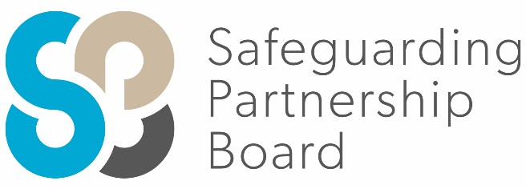

Delegate Workbook

Continuum of Need

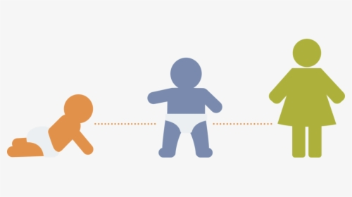

About this course
These materials are part of a learning package that includes self-directed learning via this workbook and an in-person seminar. Please ensure that you have set aside at least 2 hours to complete the work before attending the in-person seminar. The seminar will build on your knowledge and understanding and will ask you to reflect on the content of the materials.
You should set up an account with Research in Practice (RIP) if you don’t have one already (see below for instructions on how to set up your account). RIP is a free resource provided by the Safeguarding Partnership Board and contains a wealth of information including videos, briefings, webinars etc which will help you in your work.
All you need is a quiet place to work through the content and/or watch any videos, either alone or in a group. It might be useful, as you read or listen, to jot down thoughts that occur to you about the work you do and any questions or new ideas that come to mind.
Important!
You will need to bring your workbook to the seminar as we will be referring to it on the day.

Setting up your account with Research in Practice
Research in Practice (RIP) supports evidence-informed practice with children and families, young people and adults. RIP brings together academic research, practice expertise and the experiences of people accessing services to develop a range of resources and learning opportunities.
As a partner of the Safeguarding Partnership Board, your organisation is able to access RIP’s resources free of charge. To do this, you will need to set up a RIP account:
Go to www.researchinpractice.org.uk and select ‘create account’ at the top.
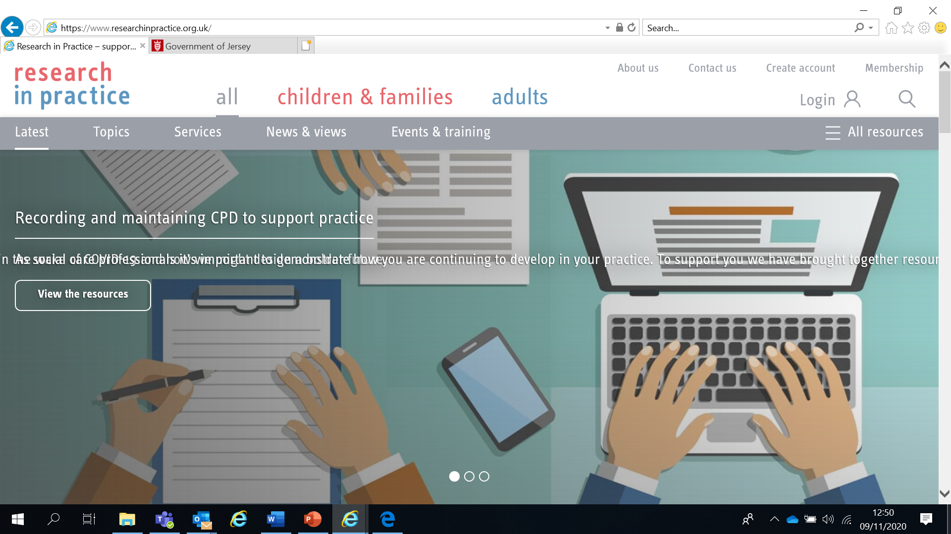

Use your work email and select ‘States of Jersey’ as your organisation from the drop-down list
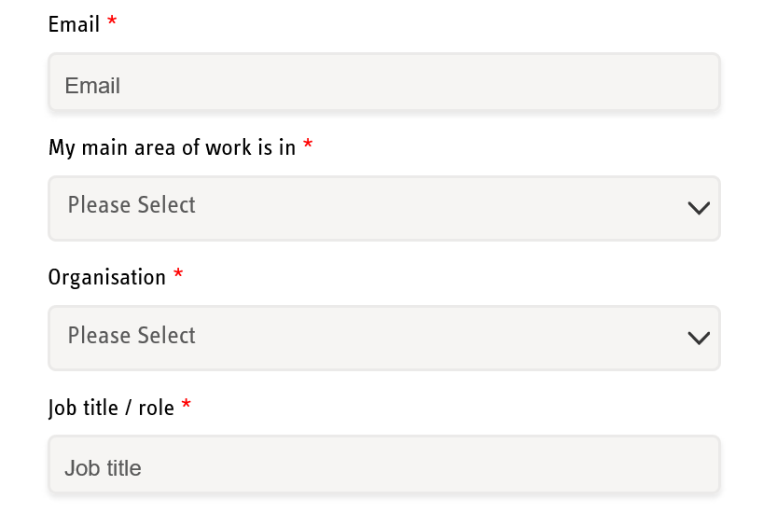

NOTE: You cannot set up an account with RIP if your work email uses Gmail, Hotmail or other generic accounts. Please contact us if this applies to you.

Once you have logged in with your new account, the resources are free to download:
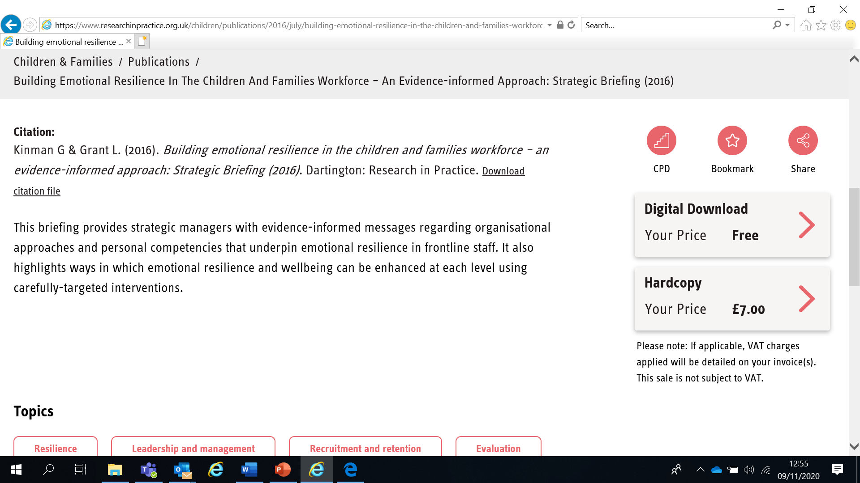

If you have any problems setting up an account, please contact safeguardingtraining@gov.je

Learning Objectives
In this module you will:
- Be able to state the ages at which key developmental milestones and stages typically occur to help identify changes in behaviour or progress which may indicate abuse
- Explain what thresholds are, why we have them and their purpose in safeguarding/protecting children
- Outline the importance of early intervention in order to safeguard children and young people and name the model used locally to support children who do not meet the threshold for Children’s Social Care
- Be able to identify the appropriate level of response and different levels of intervention required in order to safeguard children and young people using the SPB Multi Agency Continuum of Need guidance
- Be able to name the policy which supports the escalation and resolution of professional differences

Links to Professional Practice
SPB: Child Procedures Manual, Continuum of Needs, Resolving Professional Differences/Escalation Policy, Child Workforce Competency Framework

Intercollegiate Competency Framework: Level 1 and above

PQS: KSS - Developing excellent practitioners | Child development | Child and family assessment

PCF – Diversity and equality | Knowledge | Intervention and skills
Top Tips
Do the readings – we've selected reading material that we know will enhance your knowledge and skills
Do the exercises – the more you put into this course, the more you will get out of it. The exercises will give you the opportunity to reflect on what you've read. You'll get a chance to discuss ideas and ask questions in the seminar

Emotional Alert!
We acknowledge that this is a sensitive subject – look after yourself and others.
This content:
- can trigger memories of experiences which were in some way abusive
- can highlight areas of difficulty for individual people who are aware of others or their own personal experiences
- can have an emotional impact on those working to protect children, families and adults
- seek support from your manager if you are upset by any of the materials

Child Development
All practitioners working with children should have a sound knowledge of child development. Knowing what is ‘normal’ supports effective assessment of need or risk, whilst a strong understanding of what can help support growth and development will ensure interventions are appropriate. It is important to interpret each stage of child development in relation to the specific circumstances of each individual child. In work with disabled children, milestones need to be used inclusively to identify strengths and abilities, as well as needs, in order to facilitate access to services that will promote each individual’s full potential.
Neither nature nor nurture alone determines how children develop. Each child’s progress is the result of a unique mix of that child’s individual genetics, their temperament and life experiences. Assessing whether a child is in need and determining the right response requires a systematic approach to identifying and analysing the different factors that impact on children and families.
There is increasing evidence that the greatest threat to healthy development lies in an accumulation of adversities (ACEs – Adverse Childhood Experiences) rather than any single, isolated event.
Download and read the Research in Practice Child development Frontline Briefing (www.researchinpractice.org.uk/media/2860/child_development_frontline_briefing_2010.pdf)

Additional RIP resources and charts are available:
- Child development chart: 0-11 years
- Attachment in children and young people
- Attachment: Understanding and supporting parent/carer bonding before birth and in infancy

“…to develop normally, a child requires progressively more complex joint activity with one or more adults who have an irrational emotional relationship with the child. Somebody’s got to be crazy about the kid. That’s number one. First, last and always.”
Urie Bronfenbrenner (National Scientific Council on the Developing Child, 2004)

Child development and trauma
Children need stable, sensitive, loving and stimulating relationships and environments in order to reach their potential. They are particularly vulnerable to witnessing and experiencing violence, abuse and neglectful circumstances. As well as having sound knowledge of child development, it is important for professionals to understand the typical indicators of trauma at different ages and stages so that support can be offered as soon as possible.
Download and read the ‘Child development and trauma guide’ at www.wa.gov.au/government/publications/child-development-and-trauma-guide
Please note that specific characteristics and behaviours in the document are indicative only. Many specific developmental characteristics should be seen as ‘flags’ of a child’s behaviour which may need to be looked at more closely.

Thresholds
Thresholds provide ‘uniformity’ and fairness of response. Clear thresholds and a common understanding of them across local partners should facilitate appropriate referrals being made and received across agencies so that children and young people receive the proper services at the right time to safeguard their welfare and promote their wellbeing.
They help to identify children who require additional support and aid professional judgement about the likelihood of a child or young person’s risk of suffering significant harm.
‘Thresholds are not static, but rather shift and flex to fit local conditions’ (Broadhurst et al 2010: 358). Developing local threshold criteria is one of the Jersey Safeguarding Partnership Board’s core functions
Answer the questions below. We will discuss your answers further in the seminar.
- What are the benefits of having thresholds in place?

- What are the challenges to having thresholds in place?

- List any agencies that you work with that have their own thresholds:

The Continuum of Need
All agencies have a responsibility to address the needs of children and young people in Jersey. Effective joint working ensures children’s needs can be met across the continuum.
The Continuum of Need guidance describes potential indicators of concern for children and their families and can be used to enhance and support collective understanding of risk. This will help inform professional conversations between services and practitioners, improving the quality and consistency of assessments.
Problems should be identified as early as possible so that the child and family receive help and support in a timely way to prevent the problem becoming worse or entrenched. The Continuum of Need is a useful tool to help with this. It enables everyone to have a shared understanding and language and supports consistency of practice.
Download and read the SPB’s Continuum of Need (Continuum of Need) on the Policies page of the SPB website
Policies | Jersey Safeguarding Partnership Board

*** NOTE: The Continuum of Need document is not intended to replace the professional judgement of practitioners. If in doubt, advice should always be sought from a manager, Designated Safeguarding Lead or the Children and Families Hub ***
REMEMBER – Never do nothing
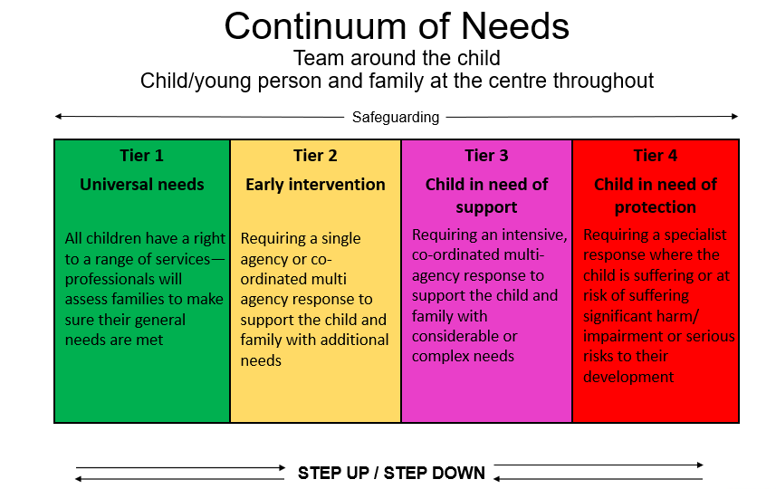

Using the Continuum of Needs, can you find the answers to the following questions?
- How many different domains are listed under ‘Development Needs of Child/Young Person’?

- How many different domains are listed under ‘Parent/Carer Factors’?

- How many different domains are listed under ‘Family and Environmental Factors’?

- Under the ‘Parent/Carer Factors’ and ‘Ensuring Safety’ domain, where does ‘inappropriate, frequent visits to A&E/GP’ sit?

- Under the ‘Development Needs of Child/Young Person’ and ‘Education and Learning’ domain, where does ‘persistently tired/lack of motivation/concentration’ sit?

- Under the ‘Family and Environmental Factors’ and ‘Family History and Functioning’ domain, where does ‘family has serious physical/mental ill-health difficulties which impact on the child/ren’ sit?

- Under the ‘Development Needs of Child/Young Person’ and ‘Health’ domain, where does ‘dental decay due to neglect’ sit?

- Under the ‘Parent/Carer Factors’ and ‘Basic Care’ domain, where does ‘domestic abuse in pregnancy’ sit?
Levels of Need in the Continuum
Tier 1 – Universal Needs/Universal Services
Children who require no additional support beyond that which is universally available and are making at least satisfactory progress in relation to their expected development.

Tier 2 – Early Intervention/Help
If children’s needs cannot be met by universal services and/or they have emerging needs, then early intervention by providing help and support in a timely way can prevent the problem becoming worse or entrenched. The Children and Families Hub provides information, advice and support to families, young people and professionals

Tier 3 - Child in Need
Children with considerable or complex needs are unlikely to reach their desired outcomes without the support of coordinated, multi-agency services. These children would benefit from a social work assessment to ascertain the child’s needs and the level of vulnerability. A Child In Need plan can be formulated with relevant consent to coordinate services already involved and identify specialist services.

Tier 4 - Child in need of protection
Children with acute and/or significant needs that are so great that statutory and/or specialist timely intervention is required to keep them safe.
Complete the table below with examples of services that you might find at each level of the Continuum of Need. We will explore this further in the seminar.

Level | Services
Tier 1 – Universal Needs

Tier 2 – Early Intervention/Help

Tier 3 - Child in Need

Tier 4 - Child in need of protection

Jersey’s Children First
Jersey’s Children First is a standard practice framework adopted across agencies, services and settings in the public, community and voluntary sectors in Jersey.
It is designed for all those working with children from pre-birth to 25 with emerging or known additional or complex needs/disabilities, including children in care and those in need of protection. The approach has additional responsibilities for young people who have been in the care of the Government of Jersey and young people in transition to adult services.
It is the vehicle for delivering the four outcomes of the Children and Young People’s Plan:
  - Grow up Safely
  - Learn and Achieve
  - Live Healthy Lives
  - Are Valued and Involved

At the heart of Jersey’s Children First is a commitment to providing the right help at the right time for children, young people and families. Evidence shows this is more effective than later, statutory intervention. The term ‘Right Help, Right Time’ describes Jersey’s approach to providing support to children, young people and families as soon as problems start to emerge. This may be at any point during childhood or adolescence.
Right Help, Right Time is offered via a single agency or, if a child or young person’s needs and circumstances make them more vulnerable, as a co-ordinated multi-agency approach.
You can access more information, including training, on Jersey’s Children First via the Government of Jersey website at www.gov.je/caring/jerseyschildrenfirst/Pages/index.aspx
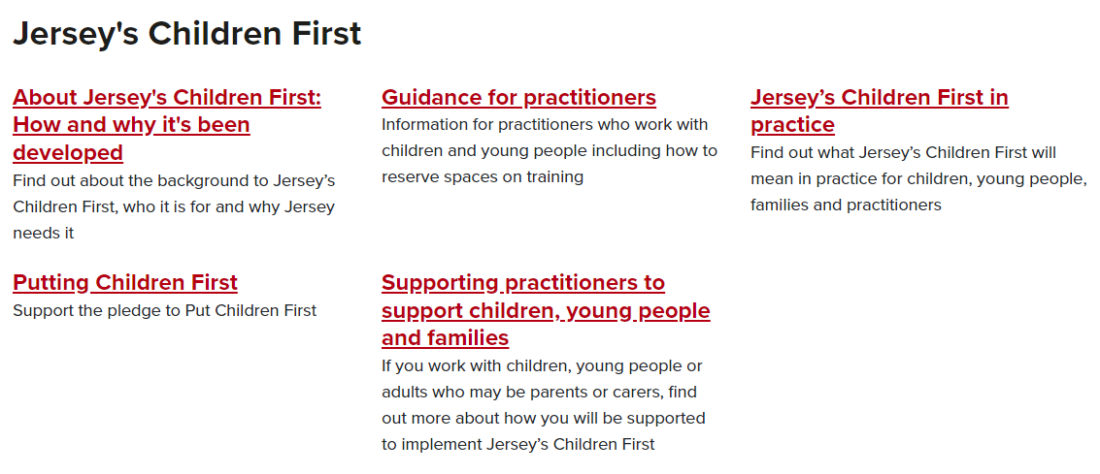
Escalation and Resolution
Professional challenge and curiosity are a fundamental aspect of working together to keep children and young people safe – it is a professional responsibility. Where professional curiosity or challenge has not resolved professional differences, then the issue can be escalated using the Resolving Professional Differences/Escalation Policy unless the situation is so serious that it requires urgent action (eg via the Police).
Any escalation of concern should be carried out in the spirit of achieving better outcomes for children, young people and their families. Possible resolutions before escalation are to take the case to supervision or calling a multi-disciplinary meeting.
The Resolving Professional Differences/Escalation Policy is on the SPB website at Policies | Jersey Safeguarding Partnership Board

Next Steps
You have now finished the independent learning ahead of the in-person seminar.
In the seminar, we will reflect on your learning from this module and in particular we will:
- Discuss thresholds and reflect on their benefits and challenges
- Consider a case study
- Identify a range of services available in Jersey to support children and families
Important!
Please bring this workbook to the seminar with you. We will be referring to it throughout the session.

Further Learning
The SPB website has a series of 7 Minute Briefings on a range of topics which you can use with your teams to prompt discussion and reflection on practice and systems. You can find 7 Minute Briefings under the Resources page on the website – including an explanation of what they are.
The Research in Practice website is an excellent source of further material.
The SPB has a range of courses which will help you to further your knowledge. Please check our website for further details.

Additional Resources
Categories of abuse
PHYSICAL ABUSE
Physical abuse may involve hitting, shaking, throwing, scalding, drowning, suffocating or otherwise causing physical harm to a child. Physical harm may also be caused when a parent or carer fabricates the symptoms or deliberately induces, illness in a child.
EMOTIONAL ABUSE
Emotional abuse is the persistent emotional ill treatment of a child such as to cause severe and persistent adverse effects on the child’s emotional development. It may involve conveying to a child that they are worthless and unloved, inadequate, or valued only insofar as they meet the needs of another person. It may feature age or developmentally inappropriate expectations being impose on children. These may include interactions that are beyond the child’s developmental capability, as well as overprotection and limitation of exploration and learning, or preventing the child from participating in normal social interaction. It may involve seeing or hearing the ill-treatment of another, including domestic violence or serious bullying causing children frequently to feel frightened or in danger, or the exploitation or corruption of children. Some level of emotional abuse in involved in all types of maltreatment of a child, though it may occur alone.
SEXUAL ABUSE
Sexual abuse involves forcing or enticing a child or young person to take part in sexual activities, including prostitution whether or not the child is aware of what is happening. The activities may involve physical contact, include penetrative (e.g. rape, buggery or oral sex) or non-penetrative acts. They may include non-contact activities such as involving children in looking at, or in the production of sexual online images, watching sexual activities, or encouraging children to behave in sexually inappropriate ways.
NEGLECT
Neglect is the persistent failure to meet a child’s basic physical and/or psychological needs, likely to result in the serious impairment of the child’s health or development. Neglect may occur during pregnancy as a result of maternal substance misuse. It may also include neglect of, or unresponsiveness to, a child’s basic emotional needs.
- Once a child is born, neglect may involve a parent or carer failing to;
- Provide adequate food, clothing and shelter (including exclusion from home or abandonment)
- Protection a child prom physical harm or danger
- Ensure adequate supervision (including the use of inadequate caregivers)
- Ensure access to appropriate medical care or treatment

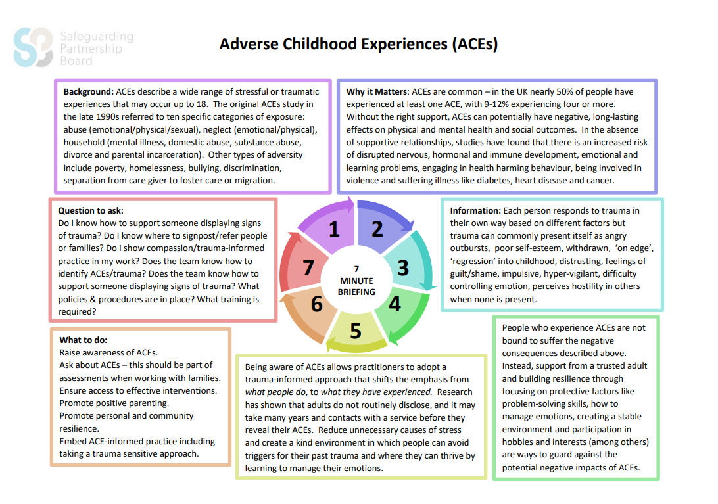
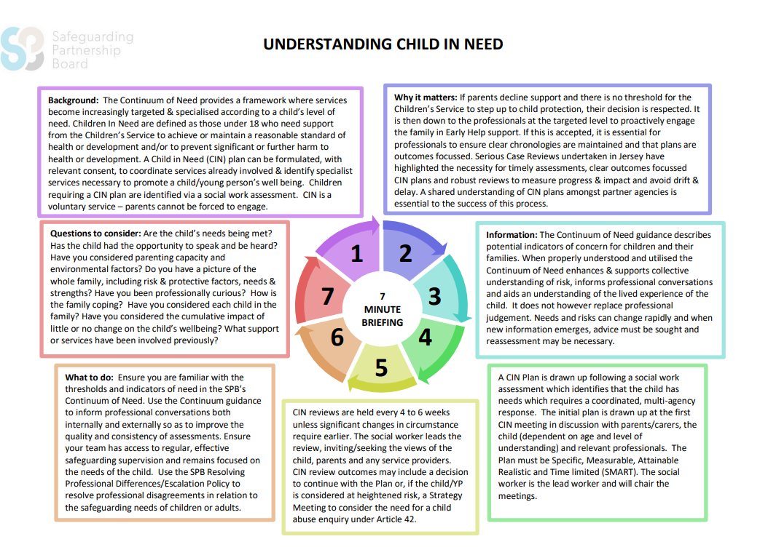
Acronyms
ABE | Achieving Best Evidence
ADRT | Advance Decisions to Refuse Treatment
APVA | Adolescent to Parent Violence and Abuse
ASCIT | Autism and Social Communication Inclusion Team
AWDO | Adult Workforce Designated Officer
CAMHS | Child and Adolescent Mental Health Service
CCE | Child Criminal Exploitation
CDC | Child Development and Therapy Centre
CEOP | Child Exploitation and Online Protection Agency
CEYS | Childcare and Early Years Service
ChiSVA | Children and Young People’s Sexual Violence Advisor
CIN | Child In Need
CLA | Children who are Looked After (formerly known as LAC Looked After Children)
CMHT | Community Mental Health Team
CP | Child Protection
CPC | Child Protection Conference
CQC | Care Quality Commission
CSDL | Capacity and Self-Determination Law
CSE | Child Sexual Exploitation
CYPES | Children Young People Education and Skills
DA(DV) | Domestic Abuse (Domestic Violence)
DBS | Disclosure and Barring Service
DSL | Designated Safeguarding Lead
ECHR | European Convention on Human Rights
EP | Educational Psychologist
EWO | Education Welfare Officer
EYAT | Early Years Advisory Team
EYFS | Early Years Foundation Stage
EYIT | Early Years Inclusion Team
FGM | Female Genital Mutilation
FII | Fabricated or Induced Illness
FLO | Family Liaison Officer
FNHC | Family Nursing and Home Care
GDPR | General Data Protection Regulation
GSF | Gold Standards Framework
HBV | Honour Based Violence
HSB | Harmful Sexual Behaviour
ICA | Independent Capacity Advocate
ICPC | Independent Child Protection Conference
IDVA | Independent Domestic Violence Advisor
IPVA | Inter Personal Violence and Abuse in Young People’s Relationships
ISS | Independent Safeguarding and Standards
ISVA | Independent Sexual Violence Advisor
JCAF | Jersey Common Assessment Framework
JCCT | Jersey Child Care Trust
JCF | Jersey’s Children First
JDO | Jersey Designated Officer
JFCAS | Jersey Family Court Advisory Service
JPACS | Jersey Probation and After-Care Service
JMAPPA | Jersey Multi Agency Public Protection Arrangements
LADO | Local Area Designed Officer (see JDO)
LPA | Lasting Power of Attorney
MAF | Managing Allegations Framework
MARAC | Multi Agency Risk Assessment Conference
MARRAM | Multi Agency Risk Review Action Meeting
MASH | Multi Agency Safeguarding Hub
MSP | Making Safeguarding Personal
NAI | Non Accidental Injury
PBS | Positive Behaviour Support
PPU | Public Protection Unit
PR | Parental Responsibility
RCPC | Review Child Protection Conference
RRRT | Rapid Response and Reablement Team
SALT | Speech and Language Therapy/Therapist
SARC | Sexual Assault Referral Centre
SCR | Serious Case Review
SEMHIT | Social, Emotional and Mental Health Inclusion Team
SEN | Special Educational Needs
SENCO | Special Educational Needs Coordinator
SEND | Special Education Needs and Disability
SNRM | Self-Neglect Risk Management Meeting
SOJP | States of Jersey Police
SOLO | Sexual Offences Liaison Officer
SPB | Safeguarding Partnership Board
SPOC | Single Point of Contact
SPOR | Single Point of Referral
SRoL | Significant Restriction on Liberty
SUDI | Sudden Unexplained Death in Infancy
SUI | Serious or Untoward Incident
TAC | Team Around the Child
TAF | Team Around the Family
YES | Youth Enquiry Service

For information on services in Jersey, please see:
Children & Families Hub www.gov.je/caring/childrenandfamilieshub/Pages/ChildrenAndFamiliesHubHomepage.aspx
Jersey Online Directory www.jod.je
Children with Disabilities Directory www.gov.je/Health/Children/ChildDevelopment/Pages/Centre.aspx
Special Educational Needs pages on gov.je www.gov.je/Education/Schools/Sen/Pages/WhatSupportAvailable.aspx

Services available in Jersey
ASCIT | Autism and Social Communication Inclusion Team. Supports schools in their understanding and management of pupils presenting with Autism Spectrum Condition (ASC) or related social communication difficulties.
Autism Jersey | Support, social events for children including a sibling support group, holiday play scheme, adult social club
Baby Steps | Support new parents with emotional transition to parenthood and building strong relationships with their babies
Barnardo’s Plan B | Support, drop-in sessions at Thomas House, mentoring service, decider skills programme in secondary schools
Brighter Futures | Supports parents, carers, children and young people with a range of personal development & educational programmes, advice and help
Brook | Provides free and confidential sexual health advice to young people under 25
CAMHS | Child and Adolescent Mental Health Service – mental health assessment and therapeutic service for children and young people up to 18
Child Development Centre | Offers assessment, treatment, diagnostic & family support service to U18s with complex developmental and/or health needs
Early Bird Programme | Programme for parents/carers of pre-school children who have or have been referred for diagnosis of an autism spectrum disorder
Eden House | Government of Jersey short break home for U18s on the autism spectrum and / or who have associated developmental complex needs
Educational Psychology | Work with schools, young people & others to reduce barriers to inclusion and improve understanding of special needs
Education Welfare Service | Works with children, families, schools and a range of other services to address concerns about attendance, punctuality and welfare
EYAT | Early Years Advisory Team – provide support for early years settings
EYIT | Early Years Inclusion Team – provide support for pre-school settings
Family First | Supports families of children with illnesses who require off-island treatment
Farm School | After school and holiday sessions on the farm. Also offers a smaller group session for children aged 6+ with additional needs
FNHC | Family Nursing and Home Care. Provides nursing and home care in the community from pre-birth to end of life
Frame Football | Football for children and young people with mobility and additional learning needs
Inclusion Project | Part of Jersey Youth Service. Youth clubs for young people aged 11-25 with various special needs and disabilities
Jersey Child Care Trust | Provides information and services to families, policy makers, childcare providers and other professionals
Jersey’s Children First | Standard practice model enabling agencies to work together to ensure children and families access the right help at the right time
Jersey Sport | Offer a range of after-school and holiday sessions for children of all abilities. ‘Sportability’ sessions for those with additional needs
JSAD | Jersey Sports Association for the Disabled – sport for those of all ages with a disability
Mavericks Performing Arts | Performing arts group for children and adults with disabilities, special needs and / or any additional needs
MECSH | Maternal Early Childhood Sustained Home-Visiting. Programme supporting child development and parent education
Mind Jersey | Mental health charity. Offers a range of services for adults, children and young people

Services available in Jersey
Motion Studio | Term time and holiday courses on animation and digital art. Staff are SPELL (autism) trained
My Time for Young Carers | Activity and support sessions for U18s – including holiday programmes
NSPCC Letting the Future In | Therapeutic service for children age 4-17 who have made a disclosure of sexual abuse
Oakwell | Government of Jersey short break home for U18s with a range of additional needs including life limiting conditions
Parentscope | Free, regular drop—in session where parents and carers of children aged 3-16 can access a range of qualified professionals
Portage | Home-based educational support for pre-school children with special educational needs
Positive Behaviour Support | Supports professionals, carers and families to understand and respond effectively to behaviour that challenges
Riding for the Disabled | Weekly riding sessions for disabled children and adults
SALT | Speech and Language Therapy.
SEMHIT | Social Emotional & Mental Health Inclusion Team. Works with schools to provide advice and support on managing challenging behaviour
Short Breaks | For children and young people with disabilities.
Silkworms | Support programme for children aged 7-12 affected by a loved one’s chemical dependency
The Bridge | Multi agency community facilities offering an accessible one-stop shop for families and young people
Triple P/Stepping Stones | Positive Parenting Programme for parents and carers of U18s. Stepping Stones is for parents and carers of children with special needs
Youth Arts | Offer gig and performance opportunities plus a range of courses, events and weekly workshops on music, dance, drama and visual arts
Youth Service | Provide a range of personal and social development opportunities for young people aged 12-18

The above list is not exhaustive. For more information on the above services, or other services in Jersey, please see the Children & Families Hub (www.gov.je/caring/childrenandfamilieshub/Pages/ChildrenAndFamiliesHubHomepage.aspx), Jersey Online Directory (www.jod.je), Children with Disabilities Directory (www.gov.je/Health/Children/ChildDevelopment/Pages/Centre.aspx) or Special Educational Needs pages on gov.je (www.gov.je/Education/Schools/Sen/Pages/WhatSupportAvailable.aspx)

NOTES

