Delegate Workbook
Designated Safeguarding Lead
DSL: Your Role as Safeguarding Lead
About this course
These materials are part of a learning package that includes self-directed learning via this workbook and an in-person seminar. Please ensure that you have set aside at least 4 hours to complete the work before attending the in-person seminar. The seminar will build on your knowledge and understanding and will ask you to reflect on the content of the materials.
You should set up an account with Research in Practice (RIP) if you don’t have one already (see below for instructions on how to set up your account). RIP is a free resource provided by the Safeguarding Partnership Board and contains a wealth of information including videos, briefings, webinars etc which will help you in your work.
All you need is a quiet place to work through the content and/or watch any videos, either alone or in a group. It might be useful, as you read or listen, to jot down thoughts that occur to you about the work you do and any questions or new ideas that come to mind.
Important!
You will need to bring your workbook to the seminar as we will be referring to it on the day.

Setting up your account with Research in Practice
Research in Practice (RIP) supports evidence-informed practice with children and families, young people and adults. RIP brings together academic research, practice expertise and the experiences of people accessing services to develop a range of resources and learning opportunities.
As a partner of the Safeguarding Partnership Board, your organisation is able to access RIP’s resources free of charge. To do this, you will need to set up a RIP account:
Go to www.researchinpractice.org.uk and select ‘create account’ at the top.
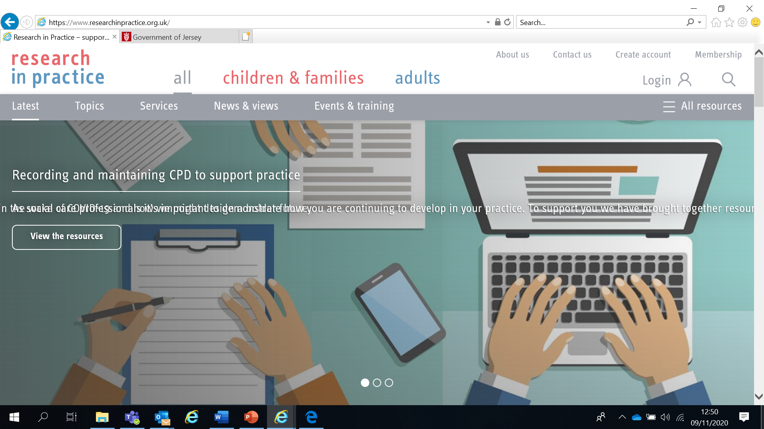

Use your work email and select ‘States of Jersey’ as your organisation from the drop-down list
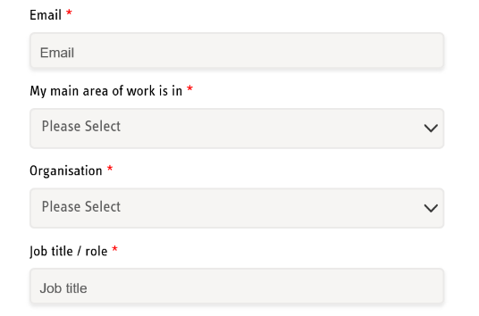
NOTE: You cannot set up an account with RIP if your work email uses Gmail, Hotmail or other generic accounts. Please contact us if this applies to you.
Once you have logged in with your new account, the resources are free to download:
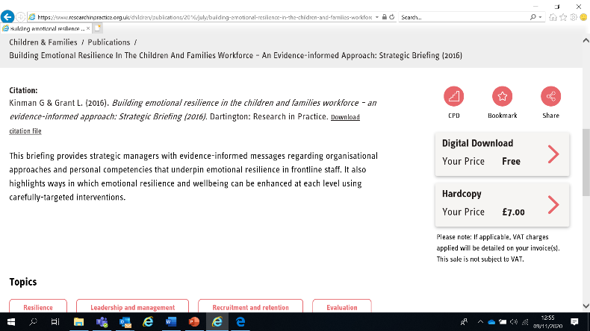

If you have any problems setting up an account, please contact safeguardingtraining@gov.je

Learning Objectives
In this module you will:
- Describe the attributes of a safer organisation
- Describe the role and responsibilities of the Designated Safeguarding Lead within an organisation
- Identify safer recruitment practices
- Identify why empowering children, young people and adults at risk is an essential part of safeguarding
- Explain the importance of staff supervision and how it supports professional curiosity and challenge
- Define a variety of practice techniques which can be used in organisations to enhance supervision
- Use a supervision tool to reflect on a child, family or adult at risk that you are currently working with

Links to Professional Practice
SPB: Child Procedures Manual, Adult Procedures Manual, Child Workforce Competency Framework, Managing Allegations Framework for Adults, Children’s Safeguarding Training Framework, Adult Safeguarding Training Framework, Resolving Professional Differences/Escalation Policy, Safeguarding Supervision Principles Statement

Intercollegiate Competency Framework: Level 1 and above

PQS:KSS - Relationships and effective direct work | The role of supervision | Organisational context | Promote and govern excellent practice | Developing excellent practitioners | Emotionally intelligent practice supervision | Shaping and influencing the practice system | Lead and govern excellent practice | Developing excellent practitioners | Support effective decision-making | Creating a context for excellent practice | The role of social workers | Direct work with individuals and families | Supervision, critical analysis and reflection | Professional ethics and leadership | Organisational context | Values and ethics | Effective use of power and authority as a practice supervisor

CQC - Well led | Safe

PCF - Professionalism | Critical reflection and analysis | Professional leadership

RCOT - Understanding relationship | Qualified | Collaborative

Top Tips
Do the readings – we've selected reading material for you that we know will enhance your knowledge and skills
Do the exercises – the more you put into this course, the more you will get out of it. The exercises will give you the opportunity to reflect on what you've read. You'll get a chance to discuss ideas and ask questions in the seminar

Emotional Alert!
We acknowledge that this is a sensitive subject – look after yourself and others.
This content:
- can trigger memories of experiences which were in some way abusive
- can highlight areas of difficulty for individual people who are aware of others or their own personal experiences
- can have an emotional impact on those working to protect children, families and adults
- seek support from your manager if you are upset by any of the materials

What makes a ‘safer organisation’?
One of the cornerstones of excellent safeguarding practice is for an organisation to be ‘safer’ by enabling staff to work in a safe environment and supporting them in their safeguarding work. This can be demonstrated in the policies, procedures and structures that the organisation has.
Think about the attributes of a ‘safer organisation’ and write them below.
Be ready to discuss this further in the seminar.

Safer organisations
Safeguarding policies and procedures are the foundation to helping keep children and adults at risk safe. They set out an organisation’s commitment to safeguarding, how it will put the commitment into action and what it will do if there is a concern.
The Safeguarding Partnership Board conducts audits of member organisations aimed at driving improvements to safeguarding. But all organisations should aim to be ‘safe’ to ensure that children and adults at risk are protected from harm.

Safer organisations:
- Champion wellbeing and safeguarding throughout the organisation, including senior leadership/ board level
- Know that safeguarding is everyone’s business - not just the responsibility of the Designated Safeguarding Lead - and act appropriately on any concerns
- Foster a culture of professionalism, transparency and honesty where staff and volunteers are encouraged to share concerns and learn from past experiences
- Are inclusive, equipping children and adults at risk with the knowledge and language to raise concerns, listening to them and taking their views into account
- Embed safeguarding in all aspects of their work including employment, data sharing, record keeping, collaboration, team-working and relationships with partner agencies including the SPB
- Support learning opportunities for staff and volunteers within and outside of the organisation
- Monitor and evaluate their performance through audits etc

Responsibilities of the Designated Safeguarding Lead
Whether you work with children or adults at risk, we need to ‘Think Family’ in all our work. ‘Think Family’ means thinking about the child, the parent and the family together, with professionals taking into account family circumstances and responsibilities. For this reason, we recommend that you read BOTH sections below so that you have an understanding of multi-agency procedures for both children AND adults.
Read the following:
- Read the SPB’s Multi-Agency Procedures for Adults - Roles and Responsibilities section (https://www.proceduresonline.com/jersey/adults/contents.html#)

- Read the SPB’s Multi-Agency Procedures for Children section on ‘Roles & Responsibilities of Agencies & Associated Groups’ (https://jerseyscb.proceduresonline.com/chapters/p_agency_role.html)

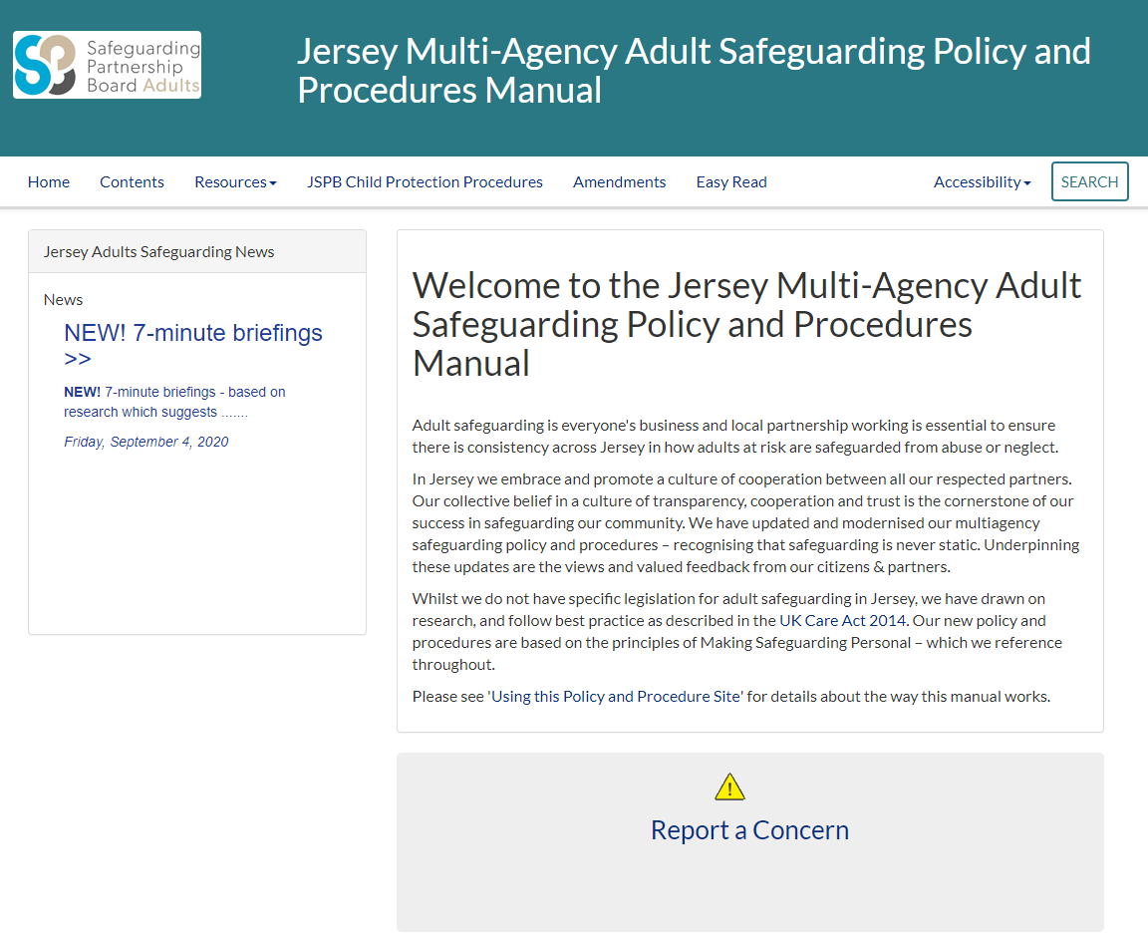
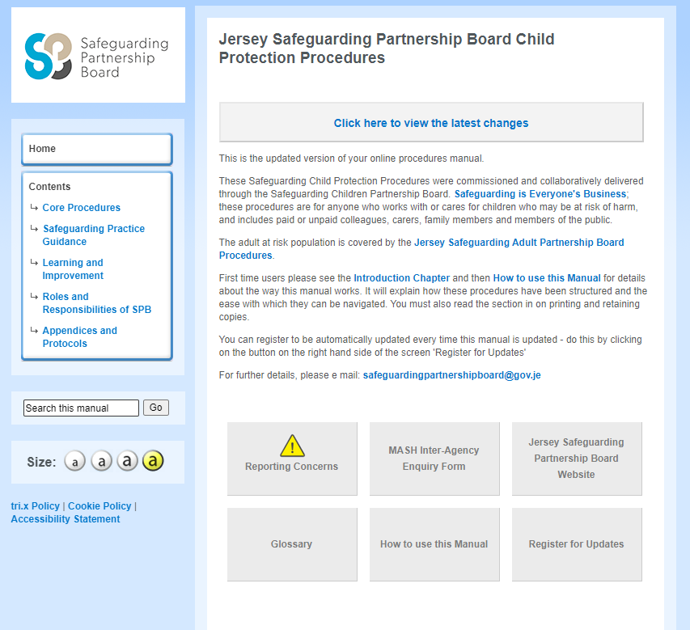
Think about whether your responsibilities as the safeguarding lead within your organisation are similar to those outlined by the SPB procedures. We will discuss this further in the seminar.

An example of DSL responsibilities is below:
- Raise the profile of safeguarding and lead the development of safeguarding policy and procedures
- Role model child-centred/person-centred practice in accordance with the rights of the child and adults and the principles of Making Safeguarding Personal (MSP)
- Act as a source of support, advice and expertise within the establishment when deciding whether to make a referral by liaising with relevant agencies
- Ensure all staff have induction training covering child safeguarding and safeguarding adults at risk (as appropriate) and are able to recognise and report any concerns immediately as they arise
- Ensure each member of staff has access to and understands the establishment’s child protection policy and safeguarding adults at risk policy (as appropriate) especially new or part time staff
- Ensure parents have access to the child protection policy and safeguarding adults at risk policy
- Ensure that detailed accurate written records of all cases, referrals and concerns are made and kept securely. Undertake audits, where necessary
- Ensure that when a child or adult at risk leaves the establishment, their safeguarding file is stored securely, and information shared/deleted according to data protection law guiding principles
- Ensure the establishment’s child protection policy and safeguarding adults at risk policy is updated and reviewed annually and work with the governing body or proprietor regarding this task
- Have a working knowledge of how the SPB, Standards and Quality Team and Adult Safeguarding Team operates, the conduct of a child protection conference and adult safeguarding planning meeting and be able to attend and contribute to these effectively when required to do so
- Understand how multi-agency working keeps children and adults at risk safe and be clear about own and other colleagues’ roles and responsibilities and professional boundaries
- Have access to resources and maintain professional CPD in accordance with the SPB’s Multi-Agency training frameworks and any organisation-specific requirements
- Liaise with the Senior Manager to inform him or her of any issues and ongoing investigations and ensure there is always cover for this role
- Recognise signs of abuse and respond appropriately to suspected abuse
- Know what to do in the case of an allegation against a member of staff being made or a low-level concern about a member of staff being raised
- Manage conflict and disagreement between practitioners within and across services/agencies in accordance with the SPB’s Professional Differences and Escalation Policy

The importance of the organisational culture in preventing abuse
“When a group of people work or live together, a culture evolves: it is something greater than the sum of the behaviour, attitudes and aspirations of the individuals”
(Department of Health, 1988)
There is no single factor that prevents the possibility of children or adults at risk being abused or maltreated by those working with them, but repeated inquiries have noted that the organisational context is an important factor. Public inquiries into high profile offending in organisations (eg by Jimmy Savile) have found themes where organisational functioning and culture were a contributory factor (Protecting Children and Adults From Abuse After Savile, Marcus Erooga 2018). These themes can also be found in many serious case reviews.
The six themes are:
- Unclear expectations of staff behaviour
- Absence of procedure
- Ineffective response to inappropriate behaviour
- Absent management and ineffective structures
- Closed culture
- Silo management and consequent disconnected senior management
Read the case study below. We will be discussing themes of organisational functioning and culture in the seminar.

From the Independent investigation into governance arrangements in the paediatric haematology and oncology service at Cambridge University Hospitals NHS Foundation Trust following the Myles Bradbury case, Cambridge, Cambridge University Hospitals NHS Foundation Trust (UK). Scott-Moncrieff, L. and Morris, B. (2015)
Dr Myles Bradbury was employed as a paediatric haematologist in the oncology team at Cambridge University Hospitals NHS Foundation Trust (the trust). In November 2013, the family of a patient raised a concern about possible inappropriate behaviour by Dr Bradbury. Senior staff were alerted at once. He was excluded from clinical duties the following day, and did not return to the trust. In September 2014, Dr Bradbury pleaded guilty to 25 sexual offences against 18 children who had been his patients, as well as to charges of voyeurism and possession of indecent images. He was sentenced to a total of 22 years’ imprisonment, with the judge emphasising the seriousness of the breach of trust that these offences displayed. Subsequently, on appeal, his sentence was restructured to 16 years’ imprisonment and six years on licence.
Dr Bradbury’s known victims were patients of the paediatric haematology and oncology service, and the offences took place at the paediatric day unit (PDU) at Addenbrooke’s Hospital – a teaching hospital where consultants had an obligation to assist in the training of junior doctors, including students.
His victims were adolescent boys and the sexual offences took place under the guise of necessary medical treatment: genital examination is routine for some cancers, and Dr Bradbury committed his offences by carrying out unnecessary genital examinations.
None of those interviewed for the independent investigation, who included the families of victims as well as trust staff, had raised any concern about Dr Bradbury’s behaviour with the trust or with anyone else, nor were they aware of anyone else raising a concern. Detective Sergeant Fasey, the police liaison officer in the case, was not aware that any of the families interviewed by the police had said that they had raised a concern.
After Dr Bradbury’s arrest, the trust set up a helpline for patients’ families to contact. None of those who contacted the helpline said that they had raised concerns, although one mother felt uncomfortable that Dr Bradbury spoke to her son rather than herself, another mother was suspicious of Dr Bradbury’s attempts to see her son without her being present, and one father thought that Dr Bradbury was suspiciously over-friendly and “too nice”. Most family callers to the helpline were full of praise for Dr Bradbury.
The Paediatric Day Unit (PDU) is open on weekdays and has clinics every morning and some afternoons. Quite often the morning clinic list goes over into the afternoon. Routine appointments are booked into clinics, and all clinic appointments are discussed at pre- and post-clinic meetings.
Sometimes routine appointments are fixed for non-clinic times: for example, if a child is coming from a distance to see another specialist, the appointment at the PDU will be arranged so that the patient does not have to make two journeys. Out-of-clinic appointments might also be made so that children did not have to miss something important at school. In addition, emergency appointments are accommodated throughout the working day.
Routine appointments were made by the clinic clerks, but emergency appointments could be made directly with a named consultant or duty doctor. Some staff noticed that Dr Bradbury was more likely than his colleagues to see patients out of normal clinic hours, although still during the normal opening hours of the PDU. His explanation was that he was accommodating the needs of his patients, and this explanation was accepted and generally regarded as praiseworthy.
A consultant at the hospital said:
“The clinic clerk told me a couple of times that he [Dr Bradbury] was seeing patients in the afternoons, which I have to say infuriated me because this was the man who said he was too busy to do anything else – do any laboratory reporting – but he had enough time to be seeing families, supposedly because it was more convenient for the family to be seen after school. And so this was more of a time management issue and we had robust discussions about that… and usually it ended up saying he would agree and said he would stop seeing them in the afternoons and I used to check up. At the time [the ward clerk] had a written diary and so anyone could book in someone at any time for any clinic and then [the ward clerk] would transfer that name into the electronic HISS appointments system. So I would look – occasionally pick up the diary and just look through the next few weeks and just see if there was anybody he booked in for an afternoon clinic…He had his own system. Patients would text him or phone him on his private mobile and he would make an appointment then”.
It was no-one’s job to monitor practices or policies for unusual behaviour or non-compliance. Patients and families were not given information on the policies or practices.
An adult was expected to accompany a child to every appointment with a doctor, except that when a child turned 14, he or she could request a private discussion with the doctor with no adult present, as part of the transition to adult services at the age of 16. The hospital’s chaperone policy required either a family member or another professional to chaperone any intimate examination. Intimate examinations take place with the patient on the couch in the consulting room, behind a curtain, so that no one glancing into the room or opening the door unexpectedly will see them.
Dr Bradbury saw children on their own when they were under 14 and carried out intimate examinations during some appointments. He carried out criminal intimate examinations on patients behind the curtain with their family member in the room but on the other side of the curtain.
One consultant said:
“It became clear that families had been introduced to what they considered to be standard practice that is just unrecognisable. So for example, families had been (at an early stage) introduced to the idea that it was essential for him to see their child alone. And the reasons given, that the families gave me, were that their child would be under medical care for the rest of their life and it was very important for them to have a trust of doctors and that was why he needed to see them alone. This was just totally unrecognisable as any sort of policy. Families have said that he was very insistent to this to the point almost of pushing them to say that this was essential – that they must agree to it, even when they felt a bit uncomfortable about it. And clearly he managed to introduced this way of working with families to the extent that they were willing - no, not willing – they were coerced into going along with it. Several of them have said ‘I felt uncomfortable at the time. It didn’t seem quite right but...’
And all of them talked about how well he got on with their children and so they respected his professional status and at the same time they recognised the importance of him for the treatment of their child and so if it was the price they had to pay to make it all work for their child then…”
Another consultant said:
“What Myles seemed to have been able to do was to take his personal involvement with families in terms of gaining their trust, to a whole different level. So that the children trusted him. He had a wall in his office and – this is not with hindsight – I remember looking at his wall and his wall was covered with letters from children and – you know – best doctor in the world – Myles is my best friend – just covered in them. So I remember thinking ‘My goodness, I’ve got none of those on my wall. What is this guy doing that is so fantastic for these families? By implication what is it that I’m not doing?’”
The PDU is a busy unit, with people coming and going the whole time, and with children playing with toys or with their friends, or visiting the toilet, and not necessarily with their parents. There is also a room with games in it for teenage patients to pass the time. It would therefore be unsurprising to see adults without their older children at any given moment. In addition, all staff have their own tasks, and it was no one's job to monitor the policy. At interview some staff told us that they thought the policy was more for the protection of the professionals than the patients.
The design of the consulting room doors made it difficult to see who was in there without getting very close and peering, and in any event, if a doctor and patient were behind the curtain it would not be possible to determine whether another adult was there or not.
Dr Bradbury was very friendly with patients, and this was noticed not only by his patients and their families but also by some of his colleagues. One of his colleagues thought that perhaps this was a sign of neediness: Dr Bradbury had told him that he was rather lonely, as he had split up with his girlfriend in Birmingham and was having to start afresh in a new district. However, none of his colleagues saw anything sinister in his behaviour. Although, as mentioned before, one father was suspicious of this friendliness, he expressed no concern about it at the time.
Staff did not notice that Dr Bradbury was seeing some patients unnecessarily, and much more frequently than their stage of treatment required. They did not notice this because he made appointments directly with the families, and made appointments out of clinic times, or for different clinics. This meant that staff at routine clinics were not aware of how often these patients were attending, and some of these appointments did not lead to pre- and post-clinic discussions with the whole team.
Dr Bradbury’s consultant colleagues noticed that he was reluctant to have medical students with him when he saw patients on the PDU. His excuse was that he was very busy, and that he did not like students to be present when he was having difficult conversations with families. These reasons were accepted as legitimate.
It was noted that Dr Bradbury could be abrupt and critical of junior colleagues, and there were occasions when consultant colleagues had to have a quiet word with him about this. However, there was never any behaviour that would have justified a complaint, and the traditional hierarchy was such that most of those treated in this way simply put up with it and/or tried to ignore it, on the basis that it was not unusual consultant behaviour.
All staff undergo safeguarding training in accordance with NHS guidelines. Dr Bradbury fulfilled his training obligations. There is a high take-up of safeguarding training, and its effectiveness was evident in the trust’s immediate and robust response to a concern being raised about Dr Bradbury’s conduct. The online training does not include content in relation to identifying someone who may specifically target jobs where they have easy access to vulnerable groups, but we were told by the chief nurse that face-to face training for more senior staff does include this.
The family of a patient raised a query about Dr Bradbury’s conduct on 27 November 2013. The concern was immediately escalated to the medical director. Dr Bradbury was sent home and the local authority was contacted in accordance with the safeguarding policy. The local authority contacted the police.
Dr Bradbury had an interview at the trust on 28 November at which he was informed that he was restricted with immediate effect from having any patient contact, from undertaking clinical work or attending any clinical area while the concerns raised were dealt with. He never returned to the hospital except for formal interviews or to hand over case notes, on which occasions he was escorted.

Safeguarding Policy and Procedures
Often the Designated Lead is tasked with creating and/or reviewing the organisation’s safeguarding policy and procedures. Use the checklist below to review your organisation’s safeguarding policy and procedures and note if any areas need updating.

Where do the procedures................... | Page No?
Tell staff what to do if they are worried about a child or adult at risk’s behaviour but they haven’t actually disclosed any abuse?
Tell staff how to records their concerns?

Tell staff where records will be kept and for how long?

Mentions the JDO (Jersey Designated Officer) or AWDO (Adult Workforce Designated Officer)?

Include the definitions of abuse?

Inform children or adults at risk about safeguarding procedures, and what to expect, in appropriate language and format?
Tell staff how to respond to a disclosure?

State when the procedures will be reviewed and by who?

Make it clear that children and adults at risk may be abused by their peers?

Say who the Designated Safeguarding Lead (DSL) is and how to contact them?

Say who to contact in the absence of the DSL and how to contact them?

Say what to do if someone has concerns about the behaviours of the DSL?

Say what to do if staff want to escalate concerns? eg if staff are not happy with the decision of the DSL or another agency?
Tell staff how to recognise the possible signs or indicators of abuse?

Provide guidance on confidentiality and when information should be shared with others?

Give the contact details for Children and Families Hub (including out of hours) and SPOR?

Make it clear what to do where there is a serious and immediate threat to a child or adult at risk?

Remind staff to always take action when they are worried about someone - never do nothing

Policy: clear, simple statements of how your organisation intends to conduct its services, actions or business.

Procedures: describe how each policy will be put into action in your organisation. Each procedure should outline:
- Who will do what
- What steps they need to take
- Which forms or documents to use
Ten Pitfalls and How to Avoid Them (NSPCC 1998)
- Pressures from high status referrers or the press, with fears that a child may die, lead to over-precipitate action. Ask yourself: Would I see this as a child protection matter if it came from another source?

- Professionals think that when they have explained something as clearly as they can, the other person will have understood it. Ask yourself: Have I double-checked with the family and the child that they understand what will happen next?

- Assumptions and pre-judgements about families lead to observations being ignored or misinterpreted. Ask yourself: What are my assumptions about this family? What, if any, is the hard evidence which supports them? What, if any is the hard evidence that refutes them?

- Parents’ behaviour, whether co-operative or uncooperative, is often misinterpreted. Ask yourself: What is the reason for the parents’ behaviour? Are there other possibilities besides the most obvious? Could their behaviour be a reaction to something I did or said rather than to do with the child?

- Not enough weight is given to information from family, friends and neighbours. Ask yourself: Would I react differently if these reports had come from a different source? How can I check whether they have substance? Even if they are not accurate, could they be a sign that the family are in need of some help or support?

- Not enough attention is paid to what children say, how they look and how they behave. Ask yourself: Have I been given appropriate access to all the children in the family? If I have not been able to see any child, is there a good reason, and have I made arrangements to see them as soon as possible, or made sure that another relevant professional sees them? How should I follow up any uneasiness about the child’s health or wellbeing? If the child is old enough and has the communication skills, what is the child’s account of events? If the child uses a language other than English, or alternative non-verbal communication, have I made every effort to enlist help in understanding them? What is the evidence to support or refute the child’s account?

- Attention is focused on the most visible or pressing problems and other warning signs are not appreciated. Ask yourself: What is the most striking thing about this situation? If this feature were to be removed or changed, would I still have concerns?

- When the initial enquiry shows that the child is not at risk of significant harm, families are seldom referred to other services which they need to prevent longer term problems. Ask yourself: Is this family’s situation satisfactory for meeting the child’s needs? Whether or not there is a child protection concern, does the family need support or practical help? How can I make sure they are aware of services they are entitled to, and can access them if they wish?

- When faced with an aggressive or frightening family, professionals are reluctant to discuss fears for their own safety and ask for help. Ask yourself: Did I feel safe in this household? If not, why not? If I, or another professional, should go back to ensure the child’s safety, what support should I ask for? If necessary, put your concerns and requests in writing to your manager.

- Information taken at the first enquiry is not adequately recorded, facts are not checked and reasons for decisions are not noted. Ask yourself: Am I sure the information I have noted is 100% accurate? If I didn’t check my notes with the family during the interview, what steps should I take to verify them? Do my notes clearly show the difference between the information the family gave me, my own direct observations, and my interpretation or assessment of the situation? Do my notes record what action I have taken/will take? Do my notes show what action all other relevant people have taken/will take?
Audit Example
A Designed Lead may also undertake audits to provide assurance of the organisation’s safeguarding processes. An audit may be completed as part of a planned programme or it may take place at any time, for example when an issue has been identified. Below is an example of a pitfall audit sheet, together with examples of common pitfalls that you may encounter:
 | Pitfall | Area | Assessment | Comment
1 | Records not made at the time of incident | - Are the records contemporaneous and chronological?
2 | The voice of the child or adult at risk is missing from the record | - Is the impact of events on the child/adult at risk or the child/adult at risk’s situation clearly recorded?  - Are the child/adult at risk’s views recorded in their own words?
3 | Facts and professional judgements are not distinguished in the records | - Are the facts and professional judgements clearly differentiated?  - Would someone else reading the file understand the reasons/evidence underpinning professional judgements?  - Is the family aware of professional judgements recorded in the file?
4 | There is no record of any assessment in the records | - Is there any assessment on file?
5 | The record written is not written in a style for sharing | - Is the record written in plain language?  - Would it make sense to professionals from other sectors? And the child/parent/family/adult at risk?
6 | The record is disrespectful to the service user | - Is the record written in non-discriminatory style?

Safer Recruitment
Safer recruitment is one of the foundations of safer organisations. Although a Designated Lead is not usually responsible for recruitment, they are usually involved in the induction, training and support of new staff in all matters connected to safeguarding
Safer recruitment is the name given to the administrative steps and extra care we take to examine and verify a candidate’s application and pre-employment checks in order to help deter, reject or identify those who are unsuitable to work with children or adults at risk. This includes all staff – paid, voluntary and students on placement – and whether part-time or full-time.
Safer recruitment is only one part of a range of measures to prevent unsuitable people from gaining access to children, young people or adults at risk.
“The harsh reality is that if a sufficiently devious person is determined to seek out opportunities to work their evil, no one can guarantee that they will be stopped. Our task is to make it as difficult as possible for them to succeed.”
Bichard, M (2004) The Bichard Enquiry
What does safer recruitment mean to you and what are the benefits of safer recruitment? Does your organisation have a safer recruitment policy?

Benefits of safer recruitment
- Staff and volunteers have clearly defined roles and responsibilities
- Parents, carers and families are assured that measures are taken to recruit only suitable people to work with children and adults at risk
- Organisations reduce the risk to their reputation
- Safer recruitment can help to reduce allegations against staff (see ‘Managing Allegations’ Module)

Safeguarding ‘strapline’
We have already seen how safer organisations champion safeguarding at every opportunity. Having a visible safeguarding ‘strapline’ on your organisation’s website, on job adverts and job descriptions etc demonstrates an organisation’s attentiveness and vigilance in relation to safeguarding and can help to deter unsuitable individuals.

Example safeguarding strapline:

“Our organisation is committed to safeguarding and promoting the welfare of children and young people and requires all staff and volunteers to share this commitment.”

Key Steps to Safer Recruitment
Read the SPB’s Multi-Agency Procedures for Children section on ‘Guidance for Safe Recruitment, Selection and Retention for Staff and Volunteers’ at https://jerseyscb.proceduresonline.com/chapters/g_safe_rec.html
The SPB guidance applies to both the children and adults workforce.

Below is a brief outline of what is required. For detailed advice, see the SPB Procedures, speak to your recruiting manager, human resources department or other advisory body.

- Preparation
- Job/role description
    - Full range of tasks, duties and responsibilities
    - Helps everyone understand the extent and nature of the role
- Person specification
    - Type of skills, experience and attributes required for the role, eg specific experience, qualifications, other requirements such as effective communication with children/adults at risk
- Job/role advert
    - Advertising to promote widest response and demonstrate open recruitment process
    - Indicates if the post involves working with children/adults at risk and that a DBS will be undertaken (if required)
- Application form
- Use a standard form
- Do not accept a CV alone
- Identify any gaps in employment/volunteering history
- Note discrepancies
- When references come in, compare information – do dates, reasons for leaving etc match up?
- Interview
- People who work with children/adults at risk should always include a face-to-face interview even if there is only one candidate
- Two people from the organisation should conduct the interview
- Prepare the questions in advance
- Check out gaps in the application form
- Ask about attitudes to children/adults at risk and safeguarding and motives for working in your organisation
- Pre-employment checks
- Identity – request photographic ID
- Qualifications – see originals
- Experience
- References – at least two written, ideally before interview. Follow up with direct contact, eg phone call
- DBS check – see originals. A DBS number does not mean the individual has ‘passed’
- Probationary/trial period and induction
- Set a probationary/trial period
- New recruit should go through induction process as soon as possible to include all organisation’s policies, in particular safeguarding
- Arrange safeguarding training
- Review the post holder’s performance against the job description after the trial period
Consider the questions below

Does your organisation have a safeguarding strapline on the home page of its website?

Who deals with recruitment in your organisation? Have they had safeguarding and recruitment training?

Does your organisation have a safer recruitment policy? Where is it?

Do all staff (including volunteers and students on placement) go through a safer recruitment process?

Do all staff (including volunteers and students on placement) have a job description, outlining what they are expected to do?

Do all staff (including volunteers and students on placement) undergo an induction/trial period? Do they get increased supervision and support in their induction period?

Does your organisation have a code of conduct for all staff (including volunteers and students on placements)? Have all staff signed up to the code of conduct?

DBS checks (Disclosure and Barring Service)
- The DBS aims to ensure that unsuitable people do not work with children or adults at risk, whether in paid employment or on a voluntary basis
- An organisation must not knowingly allow a barred person to work in ‘Regulated Activity’
- An organisation must inform DBS if an individual is removed from ‘Regulated Activity’ because they have harmed or because they pose a risk of harm to vulnerable groups
- For information on ‘Regulated Activity’ see the guidance from DBS at www.gov.uk/government/organisations/disclosure-and-barring-service/about or speak to your organisation’s recruiting manager, HR department or advisory body

Safer recruitment is just one factor that helps organisations to be safer and, in turn, keeps children and adults at risk safe from harm.
The Safeguarding Lead is a key role but it is everyone’s responsibility
Training
Training helps staff acquire new knowledge and skills but a safer organisation is committed to supporting staff to use and develop those skills through its culture, structure and resources
“If poor performance results from a lack of staff knowledge or skill, training can be provided. If it results from other factors, eg organisational, social, resource, managerial or attitudinal, these must be addressed accordingly.”
(McKenzie et al 2002)

The Safeguarding Partnership Board has developed training frameworks to support individuals and organisations to undertake their safeguarding roles and responsibilities in a confident and competent manner and establish more efficient and consistent safeguarding practice across Jersey.
There is an expectation that organisations (statutory, private or third sector) will ensure that all staff providing a service know how to respond to all concerns in line with Government of Jersey requirements. Some individuals will work in settings which provide both universal and specialist services for adults and children. It is the responsibility of the organisation to determine the knowledge and learning that is required.
The training frameworks are for use by everyone who works or volunteers with children or adults at risk and provide the minimum standards expected by the SPB.
You can find the frameworks on the Resources page (Guidance section) of the SPB website – Guidance | Jersey Safeguarding Partnership Board

Voice of children and adults at risk
Read the SPB’s Multi-Agency Procedures for Children section on ‘Good Practice Supporting the Voice of the Child’ (https://jerseyscb.proceduresonline.com/chapters/p_voice_of_ch.html)
and
Read the SPB’s Multi-Agency Procedures for Adults on ‘Principles of Safeguarding’ Personal’ (www.proceduresonline.com/jersey/adults/p_sg_pol_principles_sg.html) and ‘Making Safeguarding Personal’ (www.proceduresonline.com/jersey/adults/p_sg_pol_mak_sg_personal.html)

Empowerment
Children’s Ladder of Participation Ladder of Participation
Children’s Participation: From Tokenism to (Arnstein, 1969)
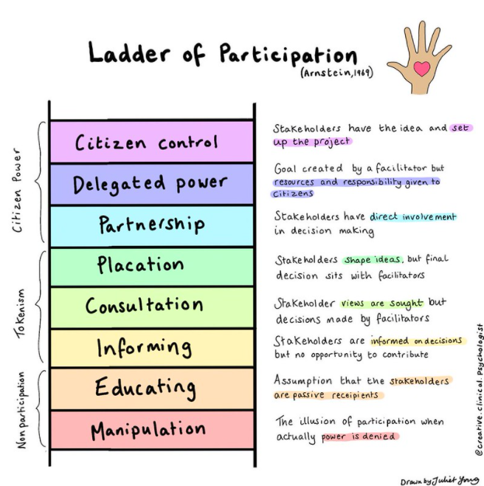
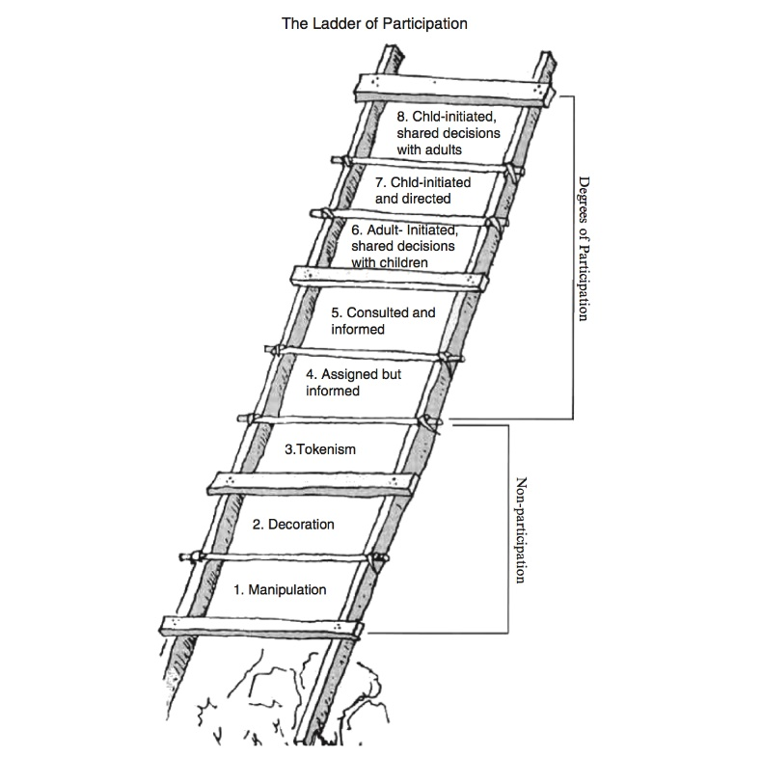
Citizenship (Hart, 1992)

Children’s Ladder of Participation

Examples of the eight rungs of Hart’s Ladder of Children’s Participation are below (with quotes from Hart):

- Manipulation
When children and young people do not understand the issues motivating a participatory process or their role in that process. Eg “children carrying political placards concerning the impact of social policies on children when those children do not understand the issues or their role in the political process”
- Decoration
When children and young people are put on public display during an event, performance, or other activity organized for a specific purpose, but they do not understand the meaning or intent of their involvement. Eg “when children perform at an event but have little idea of what it is all about and no say in the organizing of the occasion”

- Tokenism
When children are apparently given a voice, but in fact have little or no choice about the subject or the style of communicating it, and little or no opportunity to formulate their own opinions. Eg “how children are sometimes used on conference panels. Articulate, charming children are selected by adults to sit on a panel with little or no substantive preparation on the subject and no consultation with their peers who, it is implied, they represent”

- Assigned but Informed
When the children and young people understand the intentions of the project, know who made the decisions concerning their involvement and why, have a meaningful role, and volunteer for the project after the project was made clear to them. Eg “a World Summit for Children held at the UN Headquarters - an extremely large event with great logistical complexity and it would have been difficult to involve young people genuinely in the planning of such an event. However, a child was assigned to each of the 71 world leaders. As ‘pages,’ these children became experts on the UN building and the event, and were able to play the important role of ushering the Presidents and Prime Ministers to the right places at the right times”

- Consulted and Informed
When children act as consultants for adults in a manner which has great integrity. The project is designed and run by adults, but children understand the process and their opinions are treated seriously. Eg “an adult-led survey of youth perceptions in which the youth are informed about the purpose of the survey, consulted about appropriate questions before it’s developed, and given an opportunity to provide feedback on the final survey before it is administered”

- Adult-Initiated, Shared Decisions with Children
When adults initiate participatory projects, but they share decision-making authority or management with children. Eg “a youth newspaper may be an adult-initiated project, but children can manage every aspect of the operation—from reporting, writing, and editing to advertising, printing, and distribution—with only guidance and technical assistance from adults”

- Child-Initiated and Directed
When children and young people conceptualize and carry out complex projects by working cooperatively in small or large groups. While adults may observe and assist the children, they do not interfere with the process or play a directive or managerial role. “It’s difficult to find examples of child-initiated community projects. A primary reason for this is that adults are usually not good at responding to young people’s own initiatives. Even in those instances where adults leave children alone to design and paint a wall mural or their own recreation room, it seems hard for them not to play a directing role.”

- Child-Initiated, Shared Decisions with Adults
When children and young people share decision-making authority, management, or power with adult partners and allies. Eg “students partnering with adults to raise funding, develop and run a school program, or lead a community campaign. A major advantage of this form of youth participation is that it can empower young people to have a significant impact on policies, decisions, or outcomes that were traditionally under the exclusive control and direction of adults, such as legislative or political processes”
Everyone working with children, young people and adults at risk must seek out their voice and reflect and respond to it in all aspects of work. Abuse silences children, young people and adults at risk and so it is important that they are empowered to speak out about all matters that affect them. In the case of children and young people, this is enshrined in Article 12 of the UN Convention on the Rights of the Child. For adults at risk, this is the approach of ‘Making Safeguarding Personal’.
Reflect on these questions:

Where do you think some of your organisation’s work with children, young people and risk would sit on the ladder of participation? Can you give examples?

Wherever your organisation sits, can you improve their position? Can you think of examples of how you could achieve this?

What is safeguarding supervision?
Supervision means lots of things to different people. It is often seen as an activity in which a manager oversees the activities and responsibilities of employees they manage, which may include managing poor attendance or rewarding an employee for a job well done
Safeguarding supervision aims to ensure reflective space for practitioners with the intention of promoting safe, ethical best practice for the service user, their family, the worker, the organisation and the wider community. It is a core element in any learning organisation
Read the Multi Agency Safeguarding Supervision Principles Statement at Policies | Jersey Safeguarding Partnership Board
Why is safeguarding supervision important?
Serious Case Reviews in Jersey and significant SCRs and Inquiries (such as the Victoria Climbié report) show that good supervision and support are critical to ensure effective protection of children and adults with care and support needs. Safeguarding supervision helps professional curiosity and challenge
Organisations have a duty of care to their workforce and good-quality supervision can support well-being, job satisfaction and can support workforce retention
Practitioners and services that have a lead role in safeguarding and promoting the welfare of children and adults at risk are expected and required to demonstrate effective use of supervision

Supervision essentials
Does your organisation have a supervision policy? If not, we have given you some questions to ask below.
* The SPB’s Resolving Professional Differences/ Escalation Policy gives further guidance on escalating concerns. This is considered in more detail in the second part of the DSL course ‘Professional Differences and Managing Allegations’
How does supervision support a learning culture within your organisation?
If you don’t have supervision, consider how it could best meet the needs of your service users, organisation and staff.
Questions to ask when formulating a Supervision Policy

- What definition do you want for your policy?
- What is the purpose of your policy?
- Do you want to use a specific model of supervision to support people to work consistently?
- How often should supervision take place and for how long?
- What environment do you want for supervision?
- How are you going to record the supervision?
- How are you going evaluate supervision?

Examples:

- Definition: ‘A process by which one worker is given responsibility by the organisation to work with another to meet certain organisational, professional and personal objectives which together promote the best outcomes for service users.’ (Morrison 2005)

- What is the purpose of your supervision policy?

1) Support staff to practice well, learn and develop, and be supported
2) Enable good practice, safe practice and positive outcomes for children, adults, and families
3) Help the organisation to learn and improve

- How often should supervision take place and for how long?

All staff will have supervision a minimum of every four to six weeks. Frequency should depend on:

- The experience of the worker
- The length of time in the job
- The complexity of their work
- The individual’s support needs

- What environment do you want for supervision?

Effective support is enabled

- A safe, confidential, quiet space
- Respectful, self-aware, empathetic supervisors
- Active listening
- A supportive relationship
- Recognition of anxiety
- Supervision should occur in a place where confidentiality can be maintained and that is free from interruptions

Models of Supervision
1:1 Supervision – this can be planned as part of a regular programme or responsive supervision (requested when concerns arise about a child, family or adult with care and support needs)
Group supervision – using a group to implement part or all of the responsibilities of supervision (Brown and Bourne, 1996). Group supervision can complement 1:1 supervision or be used on its own. It be used within a multi-agency team or a group of peers
Your organisation’s model of supervision should be the one that best suits the needs of everyone involved
Supervision in Schools
Supervision has been less widely developed in schools. Pastoral care teams and specialist staff working with pupil behaviour may have established methods of providing staff with supervision, but the idea of supervision may be unfamiliar for some teachers and school staff. The Anna Freud National Centre (www.annafreud.org) for Children and Families has a booklet ‘Supporting staff wellbeing in schools’ which on page 10 has a section on what supervision can look like in schools. You can download the booklet at Supporting staff wellbeing in schools | Anna Freud
Supervision Tools
The Appendices in the SPB supervision policy statement provide tools for use in organisations. These are suggestions only and it is up to your organisation to decide which method or tool best meets its needs.
Download the Research in Practice ‘Reflective supervision: Resource pack’ for further examples of tools you can use in your organisation https://www.researchinpractice.org.uk/children/publications/2017/april/reflective-supervision-resource-pack-2017/
Reflection Activity
Think of a child or adult at risk that you are currently working with and use BOTH Example 1 and Example 2 on the next few pages in your delegate workbook to consider the issues involved
Take time to reflect, explore possibilities and look for meaning. Record your thoughts using each tool you have chosen.
Did the tools help to clarify your thoughts? Which tool did you find most useful?

EXAMPLE 1
Framing the dilemma (Research in Practice Tool 6)

Many tools that help support decision-making and critical thinking require the supervisee to identify and clearly articulate a key issue. By refining your thinking prior to a reflective supervision session, you will gain more clarity and rigour from the process of exploring the issue.
Aims
To support the supervisee to:
- Define the key issue faced by the child/adult at risk, instead of bringing an overwhelming and complex problem to supervision, and
- Gain clarity in supervision as to whether this is the crucial issue and whether the supervisee can gain any traction on it to produce change in the child/adult at risk’s lived life

Application
Supervisees can use this tool on their own, with the supervisor or with their peers ahead of, and then in, supervision.

Instructions
Follow steps 1-4 ahead of supervision. You’ll need Post-it notes and a piece of paper to produce a mind map/spider diagram. Complete steps 5 and 6 in supervision.

Step 1: Map the story
With the child/adult at risk at the centre of the piece of paper, use the Post-it notes to begin a mind map or spider diagram of all the issues that are surrounding the child/adult at risk.

Step 2: Sort the issues into themes
Take all of the threads of the story that feel similar and place them together under the following headings (it’s likely they will have clusters of similar sub-themes):
- Child/adult at risk’s own experience/action
- Parents/family’s experience/action
- Environmental and wider family impactors
- Other issues.

Step 3: Ask yourself the following questions
1. Which one of these themes worries me the most? (Choose only one)
2. Which one of these things harms the child/adult at risk the most? (Choose only one)
3. Which one of these things is the lever for change for the child/adult at risk? (If we could do something here, the child/adult at risk’s safety and lived experience would be improved.) (Choose only one)

Step 4: Frame the dilemma
Take the theme that has the most impact on the child/adult at risk and write (in one sentence) what the issue is from the child/adult at risk’s point of view. For example:
Where should Jamie live?
Is Kerry’s mother able to protect her from violence?
Can Paul’s mum manage her drug addiction well enough to give Paul the care he needs?
Does Sarah’s father understand her disability and how best to help her?
This is the dilemma that you should bring to your supervision session.

Step 5: Present the dilemma in supervision
Present your statement first before any other information is offered.
You can then build on the original statement in a number of ways:
- You can offer a two-minute case description of what is working well and what you are worried about, and then let your supervisor/the group examine this
- You can provide a genogram and a chronology of significant events to look for patterns
- You can answer the question (‘I think that Kerry’s mother can protect her’) and then ask your supervisor/the group to test it out for you by looking for exceptions, bias and errors in thinking or any outlying factors not considered

Step 6: Return to your themes
Once you have worked on the dilemma for 15 minutes, go back to your themes.
Is this still the one that stands out?
Ask the questions again.
If you get the same answers, then it’s likely you have framed the dilemma that will have a helpful impact on the child/adult at risk if you can work out a way forward.

EXAMPLE 2
Wonnacott’s Discrepancy Matrix (Research in Practice Tool 13)

This tool encourages practitioners to reflect on what is known about a case and what is unknown or not yet known – a vital aspect of working with uncertainty. It supports the practitioner to tease out the information they hold into four types: evidence, ambiguous, assumption, and missing.

Aim
To help the practitioner think critically about the information upon which they’re basing their decision-making.

Application
Can be used as a standalone activity or in combination with other tools.

Instructions
Follow the steps below and record key evidence of reflection and the outcomes of the discussion either in the matrix itself or by using one of the recording templates in this Resource Pack.

Step One: Telling the story
The case-holding practitioner tells their story briefly. The supervisor or group members then begin to support the practitioner to sort the information they have been told into each of the boxes. Questions such as:

- How do you know that…?
- What other evidence do you have that this is true?
- How often have you felt like that even though you have no evidence it is true?
- When do you feel that most strongly? Why?
- If you had this piece of information what might it make you do differently?

Step Two: Sorting information
The information is sorted into the four areas as the practitioner answers the questions.
1. What do I know? For something to go into the ‘evidence’ category, it needs to be proven and verified (in other words, come from more than one source as a fact). Evidence also includes knowledge about legal frameworks and roles and responsibilities, as well as research. This category provides the strongest factual evidence for analysis and decision-making.
2. What is ambiguous? This relates to information that is not properly understood, is only hearsay or has more than one meaning dependant on context, or is hinted at by others but not clarified or owned.
3. What I think I know This allows the practitioner to explore their own practice wisdom and also their own prejudices to see how this is informing the case. Emotion and values can also be explored in this area and the self-aware practitioner can explore how they are responding and reacting to risk.
4. What is missing? These are the requests for information coming from the people listening to the story (supervisors, peers, other agency staff) that prompt the practitioner to acknowledge there are gaps in the information. The gaps then have to be examined to see if the lack of information might have a bearing on the decision-making in the case; if so, it needs to be explored.

Step Three: Reflections
Once the exercise is complete the practitioner is then asked:
1. What has changed about what you know?
2. What do you still need to know?
3. What does this mean for the child/family/adult at risk?
4. What do you want to do next?

Discrepancy matrix
Strong evidence
Unclear or no view
Strongly held view
What do I know (evidence)? | What is ambiguous?
What I think I know (assumption) | What is missing (what action is needed)?
Weak or no evidence

The following tool can be used to reflect on a supervision session:
Supervisees Reflective Record (SPB Appendix 3)

This form can be used as part of a personal development plan if appropriate. Each supervisee is responsible for removing any identifying factors of patient or other staff identifiable information must not be included in this form. It can then be placed in their professional portfolios as part of their reflective practice record

To be retained by the practitioner:
Safeguarding Supervision, supervisees record (to be retained by the practitioner):
Name of Supervisor: Date:
What was the issue?

Action taken?

What have I learned?

What will I do differently?

What are my training needs?

Other thoughts

The following tool can be used to prepare for a supervision session:
Preparation Tool (Research in Practice Tool 5)

NAME ____________________________________________
DATE _______________________

Supervision is a two-way process. Both supervisor and supervisee must prepare for it, helping to ensure that learning is maximised and best use made of the time available.
Aims
To support the supervisee to:
- reflect on the positive and negative aspects of the child/adult at risk’s lived experience and the next steps
AND/OR
- define the issue they would like support with

Application
This tool can be photocopied or shared electronically with staff for them to keep and complete as needed. A completed form can be uploaded to the child/adult at risk’s file as a case note.

Instructions (to the supervisee)
Take some time to think about and respond to statements 1-3 ahead of supervision. Be prepared to discuss your responses. If you can’t respond to statement 3, try to respond to number 4.
If you are considering whether or not you require ad hoc supervision and you have managed to respond to questions 1-3, consider whether you now feel you can hold onto the case until your next scheduled supervision.

- This is what is worrying me and others | - This is what is working well for you (the child) | - This is what I have decided to do

4. This is the issue I am asking for support with today
____________________________________________________________________________________
____________________________________________________________________________________
____________________________________________________________________________________
A Word about Wellbeing
We often talk about resilience in our work with children, families and adults at risk. It is the ability to cope and recover from difficulties. Professionals work to identify and promote resilience in those they support. Developing resilience means counterbalancing protective experiences and coping skills on one side with significant adversity on the other. Resilience is evident when positive outcomes outweigh negative ones.
But what about your own resilience? We know that working with children, young people and families can be stressful as well as emotionally rewarding. Protecting the wellbeing of staff allows them to provide high quality support to their clients. Emotional resilience is ‘the ability to maintain personal and professional wellbeing in the face of ongoing work stress and adversity’
(McCann et al, 2013)

How does your organisation support staff well-being?
How can you support as a DSL support?
Who supports you?

The NHS Every Mind Matters website is a useful source of information for supporting yourself and others (www.nhs.uk/every-mind-matters/).
Mental Health At Work has toolkits tailored to specific sectors, eg emergency services, healthcare, voluntary sector (www.mentalhealthatwork.org.uk)
Research in Practice’s practice guide ‘Supporting practitioner wellbeing’ aims to support practitioners to repair, maintain, grow and sustain your own mental health and wellbeing (www.researchinpractice.org.uk/all/publications/2022/october/supporting-practitioner-wellbeing-practice-guide-2022/)

Next Steps
You have now finished the independent learning ahead of the in-person seminar.
In the seminar, we will reflect on your learning from this module and in particular we will:
- discuss the case study and the importance of organisational culture in preventing abuse
- ask you to think about your role as a DSL and how you contribute to your organisation being ‘safe’
- use supervision tools to consider a case study

Important!
Please bring this workbook to the seminar with you. We will be referring to it throughout the session.

Further Learning
The SPB website has a series of 7 Minute Briefings on a range of topics which you can use with your teams to prompt discussion and reflection on practice and systems. You can find 7 Minute Briefings under the Resources page on the website – including an explanation of what they are.
The Research in Practice website is an excellent source of further material.
The SPB has a range of courses which will help you to further your knowledge. Please check our website for further details.

Acronyms
ABE | Achieving Best Evidence
ADRT | Advance Decisions to Refuse Treatment
APVA | Adolescent to Parent Violence and Abuse
ASCIT | Autism and Social Communication Inclusion Team
AWDO | Adult Workforce Designated Officer
CAMHS | Child and Adolescent Mental Health Service
CCE | Child Criminal Exploitation
CDC | Child Development and Therapy Centre
CEOP | Child Exploitation and Online Protection agency
CEYS | Childcare and Early Years Service
ChiSVA | Children and Young People’s Sexual Violence Advisor
CIN | Child In Need
CLA | Children who are Looked After (formerly known as LAC Looked After Child)
CMHT | Community Mental Health Team
CP | Child Protection
CPC | Child Protection Conference
CQC | Care Quality Commission
CSDL | Capacity and Self-Determination Law
CSE | Child Sexual Exploitation
CYPES | Children Young People Education and Skills
DA(DV) | Domestic Abuse (Domestic Violence)
DBS | Disclosure and Barring Service
DSL | Designated Safeguarding Lead
ECHR | European Convention on Human Rights
EP | Educational Psychologist
EWO | Education Welfare Officer
EYAT | Early Years Advisory Team
EYFS | Early Years Foundation Stage
EYIT | Early Years Inclusion Team
FGM | Female Genital Mutilation
FII | Fabricated or Induced Illness
FLO | Family Liaison Officer
FNHC | Family Nursing and Home Care
GDPR | General Data Protection Regulation
GSF | Gold Standards Framework
HBV | Honour Based Violence
HSB | Harmful Sexual Behaviour
ICA | Independent Capacity Advocate
ICPC | Independent Child Protection Conference
IDVA | Independent Domestic Violence Advisor
IPVA | Inter Personal Violence and Abuse in Young People’s Relationships
ISS | Independent Safeguarding and Standards
ISVA | Independent Sexual Violence Advisor
JCAF | Jersey Common Assessment Framework
JCCT | Jersey Child Care Trust
JCF | Jersey’s Children First
JDO | Jersey Designated Officer
JFCAS | Jersey Family Court Advisory Service
JPACS | Jersey Probation and After-Care Service
JMAPPA | Jersey Multi Agency Public Protection Arrangements
LADO | Local Area Designed Officer (see JDO)
LPA | Lasting Power of Attorney
MAF | Managing Allegations Framework
MARAC | Multi Agency Risk Assessment Conference
MARRAM | Multi Agency Risk Review Action Meeting
MASH | Multi Agency Safeguarding Hub
MSP | Making Safeguarding Personal
NAI | Non Accidental Injury
PBS | Positive Behaviour Support
PPU | Public Protection Unit
PR | Parental Responsibility
RCPC | Review Child Protection Conference
RRRT | Rapid Response and Reablement Team
SALT | Speech and Language Therapy/Therapist
SARC | Sexual Assault Referral Centre
SCR | Serious Case Review
SEMHIT | Social, Emotional and Mental Health Inclusion Team
SEN | Special Educational Needs
SEND | Special Education Needs and Disability
SENCO | Special Educational Needs Coordinator
SNRM | Self-Neglect Risk Management Meeting
SOJP | States of Jersey Police
SOLO | Sexual Offences Liaison Officer
SPB | Safeguarding Partnership Board
SPOC | Single Point of Contact
SPOR | Single Point of Referral
SRoL | Significant Restriction on Liberty
SUDI | Sudden Unexplained Death in Infancy
SUI | Serious or Untoward Incident
TAC | Team Around the Child
TAF | Team Around the Family
YES | Youth Enquiry Service

For information on services in Jersey, please see:
Children & Families Hub www.gov.je/caring/childrenandfamilieshub/Pages/ChildrenAndFamiliesHubHomepage.aspx
Jersey Online Directory www.jod.je
Children with Disabilities Directory www.gov.je/Health/Children/ChildDevelopment/Pages/Centre.aspx
Special Educational Needs pages on gov.je www.gov.je/Education/Schools/Sen/Pages/WhatSupportAvailable.aspx

NOTES

