Delegate Workbook

Effective Recording:
An Essential Part of Safeguarding

About this course
These materials are part of a learning package that includes self-directed learning via this workbook and an in-person seminar. Please ensure that you have set aside at least 3 hours to complete the work before attending the in-person seminar. The seminar will build on your knowledge and understanding and will ask you to reflect on the content of the materials.
You should set up an account with Research in Practice (RIP) if you don’t have one already (see below for instructions on how to set up your account). RIP is a free resource provided by the Safeguarding Partnership Board and contains a wealth of information including videos, briefings, webinars etc which will help you in your work.
All you need is a quiet place to work through the content and/or watch any videos, either alone or in a group. It might be useful, as you read or listen, to jot down thoughts that occur to you about the work you do and any questions or new ideas that come to mind.
Important!
You will need to bring your workbook to the seminar as we will be referring to it on the day.

Setting up your account with Research in Practice
Research in Practice (RIP) supports evidence-informed practice with children and families, young people and adults. RIP brings together academic research, practice expertise and the experiences of people accessing services to develop a range of resources and learning opportunities.
As a partner of the Safeguarding Partnership Board, your organisation is able to access RIP’s resources free of charge. To do this, you will need to set up a RIP account:
Go to www.researchinpractice.org.uk and select ‘create account’ at the top.
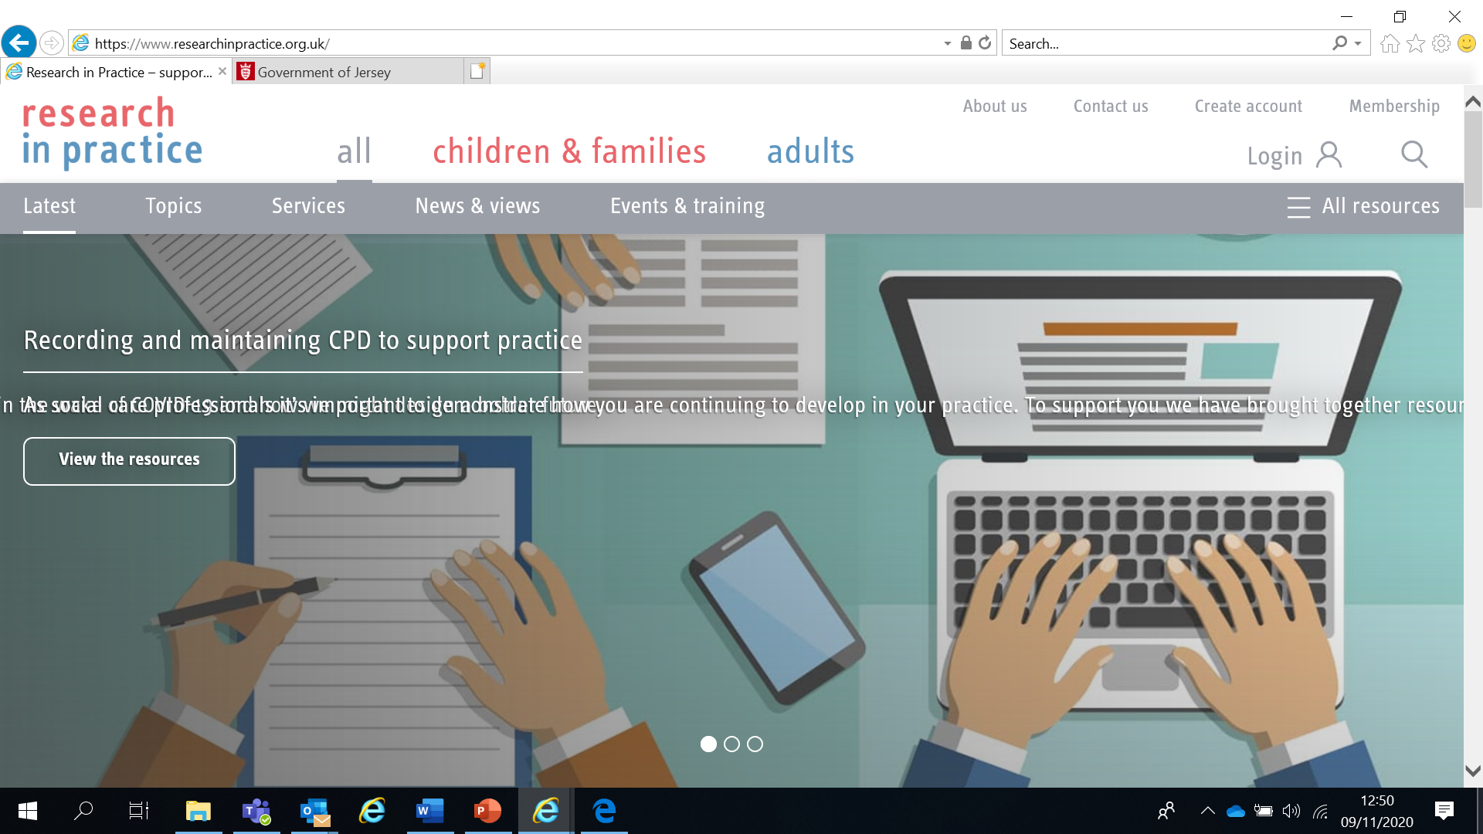

Use your work email and select ‘States of Jersey’ as your organisation from the drop-down list
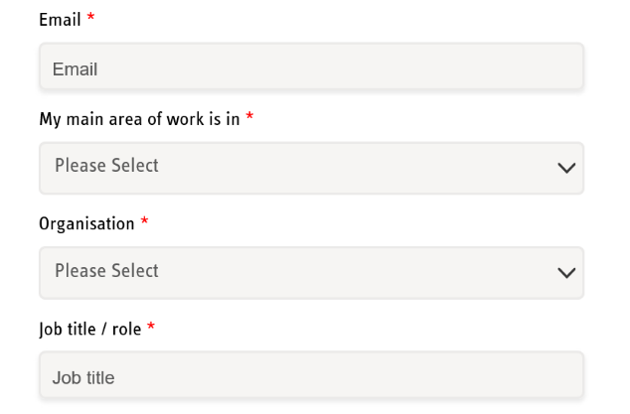
NOTE: You cannot set up an account with RIP if your work email uses Gmail, Hotmail or other generic accounts. Please contact us if this applies to you.

Once you have logged in with your new account, the resources are free to download:
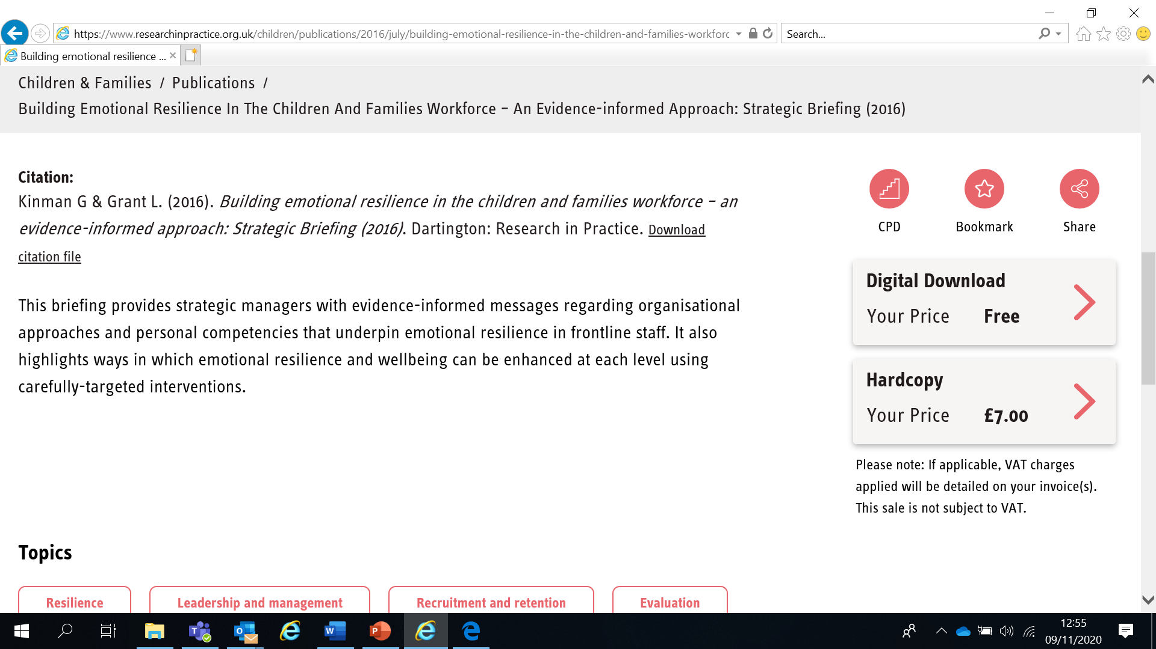

If you have any problems setting up an account, please contact safeguardingtraining@gov.je

Learning Objectives
In this module you will:
- Explain why effective recording is an essential part of the service provided to children, families and adults at risk
- Explain why using a strengths-based approach is important to effective recording
- Be able to put the voice of the child or adult at risk first
- Know how to use organisational recording documentation, present safeguarding concerns and store documents
- Explain the difference between fact, opinion and assumption
- Know how to share information appropriately

Links to Professional Practice
SPB: Child Procedures Manual, Adult Procedures Manual, Child Workforce Competency Framework, Adult Competency Framework

Intercollegiate Competency Framework: Level 2 and above

PQS:KSS - The role of social workers | Person-centred practice | Effective assessment and outcome based support planning | Professional ethics and leadership | Values and ethics | Influencing and governing practice excellence within the organisation and community | Developing confident and capable social workers | Assuring good social work practice and development | Promoting and supporting critical analysis and decision making | Performance management and improvement

CQC – Effective | Responsive

PCF – Professionalism | Values and ethics | Diversity and equality | Rights, justice and economic wellbeing | Critical reflection and analysis

RCOT - Understanding relationship | Service users | Screen needs | Develop intervention | Evaluate impact | Demonstrate quality | Support development
Top Tips
Do the readings – we've selected reading material that we know will enhance your knowledge and skills
Do the exercises – the more you put into this course, the more you will get out of it. The exercises will give you the opportunity to reflect on what you've read. You'll get a chance to discuss ideas and ask questions in the seminar

Emotional Alert!
We acknowledge that this is a sensitive subject – look after yourself and others.
This content:
- can trigger memories of experiences which were in some way abusive
- can highlight areas of difficulty for individual people who are aware of others or their own personal experiences
- can have an emotional impact on those working to protect children, families and adults
- seek support from your manager if you are upset by any of the materials

Why is recording important?
It is easy to lose sight of the importance of recording and view it as a chore – a time-consuming activity which can divert you from the ‘day job’. But it is important for 3 main reasons:
- It evidences that policy, process and practice have been followed appropriately, demonstrating professionalism and competency
- It provides the rationale behind professional judgement, making it clear how a decision was arrived at and being accountable for why a particular course of action was taken or not taken
- It gives a clear picture of the child, young person or adult at risk’s story, their wishes, views and preferences which can be used by them and/or others to empower and better understand their situation and their needs
Download the Research in Practice ‘Good recording’ Practice Tool and read pages 1-6. (www.researchinpractice.org.uk/adults/publications/2017/june/good-recording-practice-tool-2017/)
Whilst the tool is aimed at practitioners and managers working in adult care, the principles also apply to all those working with children, young people and families
Watch the Research in Practice film ‘The importance of recording: it’s purpose and implications for individuals and organisations’ (Film 1 at www.researchinpractice.org.uk/adults/content-pages/training-and-development-programmes/online-learning-packages-tailored-support/skills-and-techniques-which-support-good-recording/ - 15m 26s long)
When you have finished watching, answer the questions below. We will discuss these in the seminar.

What is the impact of good recording on the following groups?

Individuals

Practitioners

Organisations

Recording in your organisation
Good quality recording is essential in ensuring:
- Continuity of service to children, young people, families and adults at risk when staff are unavailable or change, or when a service resumes after a period of time
- Effective risk management practices to safeguard and promote the welfare of children, young people and adults at risk, especially in emergency situations
- Clarity of the assessment process and decision-making
- Effective partnerships between staff, children, young people, adults at risk, families and carers, and other agencies/services
- Clarity of information for everyone involved in the planning and delivery of services, and in the event of child protection investigations, adult safeguarding responses, inquiries, or audits
- Adequate information for staff and managers working to ensure the best possible outcomes for children, young people and adults at risk
- Support for children, young people, families and adults at risk with specific communication needs so that they may contribute to and access their records and key information
Read the SPB Procedures Record Keeping
Child - https://jerseyscb.proceduresonline.com/chapters/p_rec_keeping.html
Adult - https://www.proceduresonline.com/jersey/adults/p_sg_pol_record_keeping.html#

- 16

- What information do you have to include in your records?

- What type of records do you have to keep?

Quality assuring records
How does your organisation assure the quality of its records? How often? What is the process? Who takes part? How are the findings disseminated within your organisation?
Find a record that you have either recently created or seen in your organisation and check the document against the audit sheet example on the next page.

Consider the following questions. We will discuss these further in the seminar.

  - Do your records evidence that policy, process and practice have been followed appropriately, demonstrating professionalism and competency?

  - Do your records provide the rationale behind professional judgement, making it clear how a decision was arrived at and being accountable for why a particular course of action was taken or not taken?

  - Do your records give a clear picture of the person’s story, their wishes, views and preferences which can be used by them and/or others to empower and better understand their situation and any care or support needs?

Example - Pitfall Audit Sheet
 | Pitfall | Area | Assessment | Comment
1 | Records not made at the time of incident | - Are the records contemporaneous and chronological?
2 | The child/adult at risk is missing from the record | - Is the impact of events on the child/adult at risk or their situation clearly recorded?  - Are the child/adults at risk’s views recorded in their own words?
3 | Facts and professional judgements are not distinguished in the records | - Are the facts and professional judgements clearly differentiated?  - Would someone else reading the file understand the reasons/evidence underpinning professional judgements?  - Is the family aware of professional judgements recorded in the file?
4 | There is no record of any assessment in the records | - Is there any assessment on file?
5 | The record written is not written in a style for sharing | - Is the record written in plain language?  - Would it make sense to professionals from other sectors? And the child/parent/adult at risk?
6 | The record is disrespectful to the child/family/adult at risk | - Is the record written in non-discriminatory style?

What to communicate
The practitioner, as a professional writer, is seeking to communicate:
- factual information about the child/adult at risk - their needs and individual circumstances
- the child/adult at risk’s desired outcomes - their views, wishes and feelings
- their professional analysis and evaluation of the information
- their professional opinion
- their use of professional knowledge and skills
- information to facilitate decision-making that is evidence-based and defensible
- clear recommendations in relation to action/inaction, decision-making and support which might help the person achieve their outcomes

Voice of the child
Jersey has pledged to ‘Put Children First’. This means listening to and responding to what children and young people say is important to them, taking their views into account and considering their wishes. Professionals have a duty to listen to the wishes and feelings of children as outlined in the Children (Jersey) Law 2002. This is also enshrined in the UN Convention on the Rights of the Child which states that it is a child’s right to be heard and to have their views taken into account regarding decisions that affect them. Serious Case Reviews have often shown that children have not been asked about their views and feelings. It is therefore important that the voice of the child must be included in your records.
Daniel Pelka died 3rd March 2012 in Coventry, UK. For a period of at least 6 months prior to this he had been starved, assaulted, neglected and abused. His mother and stepfather were found guilty of murder and sentenced to at least 30 years in prison. A Serious Case Review (SCR) into Daniel’s death stated:
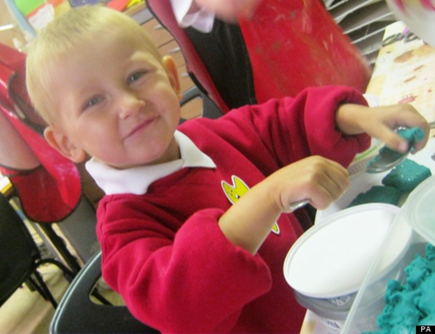
‘Of particular note was that without English as his first language and because of his lack of confidence, Daniel’s voice was not heard throughout this case…overall there is no record of any conversation held with him by any professional about his home life, his experiences outside of school, his wishes and feelings and of his relationships with his siblings, mother and her male partners. In this way despite Daniel being the focus of concern for all of the practitioners, in reality he was rarely the focus of their interventions.’

You can read an overview report of the SCR at https://lgiu.org/wp-content/uploads/2013/10/Daniel-Pelka-Serious-Case-Review-Coventry-LSCB.pdf

Voice of the adult at risk
The Human Rights (Jersey) Law 2000 enshrines in law the rights in the European Convention on Human Rights – eg the right to liberty, the right to respect for private and family life, freedom of thought and expression, the right to marry and found a family and the prohibition of discrimination. Human Rights should underpin all our work with people we are supporting.
Under the principles of Making Safeguarding Personal, there should be “no decision about me, without me” so it is important to involve the adult at risk throughout, enhancing their choice and control and listening to their voice. Adults should have access to advocacy services if needed to enable and empower them to express their views and opinions.
You can find out more about Making Safeguarding Personal at https://safeguarding.je/making-safeguarding-personal/
Watch the Research in Practice film ‘Skills and techniques for practice’ (Film 3 at www.researchinpractice.org.uk/adults/content-pages/training-and-development-programmes/online-learning-packages-tailored-support/skills-and-techniques-which-support-good-recording/ - 16m 25s long)

SCIE 11 top tips for Recording (www.scie.org.uk/social-work/recording)
Person-centred
Accurate
Real
Timely
No jargon
Evidence-based
Reading the previous record
Succinct
Holistic
IT compliant
Professional

The Research in Practice, Practice Tool for Good Recording (2017) highlights a number of characteristics, or hallmarks, consistent with good recording practice and professionally written records.

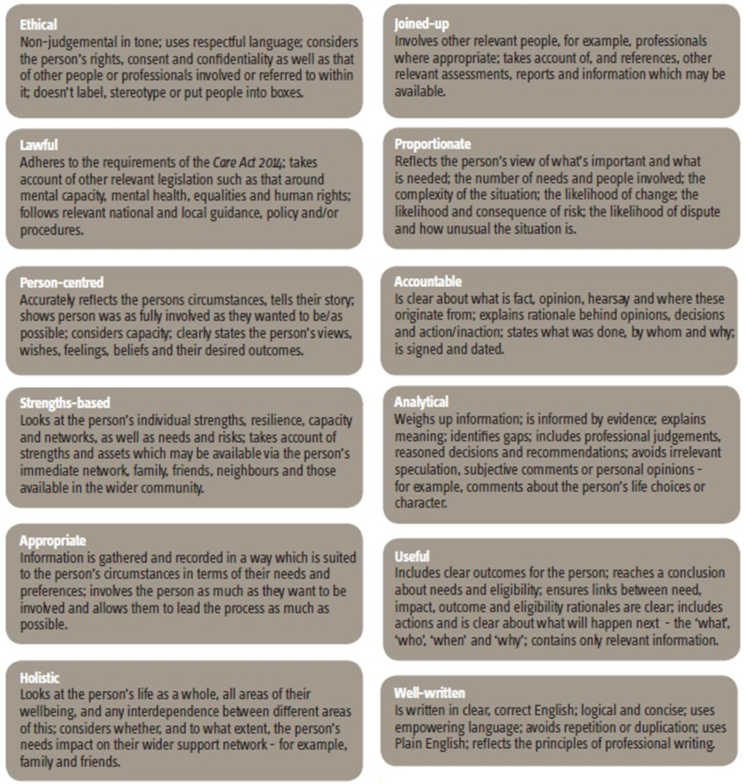

www.researchinpractice.org.uk/adults/publications/2017/june/good-recording-practice-tool-2017/

Helpful Approaches for Recording

- Tell a story of purpose
- Do not label
- Explain judgements
- Think about Power
- Make it understandable

Be clear about:
- Legal requirements
- What is your opinion and why?
- Other peoples’ opinions
- Owning and defending your judgement
- Final decisions
- Making sense and being understood

Recording, Analysis and Decision Making
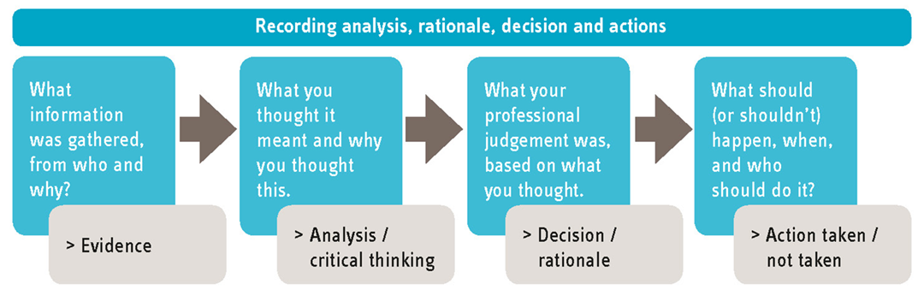

Good recording becomes especially critical in complex cases, where there are high levels of need, risk and/or harm, eg where safeguarding concerns have been raised or where mental capacity or best interest decisions have been made. SCRs often highlight inadequacies in recording as contributory factors to the failures to protect. For example the report relating to the death of Victoria Climbié stresses the keeping of proper notes and the accurate recording of concerns as being a fundamental aspect of basic professional competence. (Laming, 2003)

A good rule of thumb is that the higher the risk, the more in-depth the recording needs to be.

Watch the Research in Practice film ‘Strengths-based recording – achieving balance’ (Film 4 at www.researchinpractice.org.uk/adults/content-pages/training-and-development-programmes/online-learning-packages-tailored-support/skills-and-techniques-which-support-good-recording/ - 16m 54s long)
*Note: If you are a health and social care practitioner, you may also wish to watch Film 2 in the set of films which relates to practice standards for Social Work England, HCPC and CQC.
Strengths-based Recording
Blood and Guthrie’s (2018) seven principles for supporting older people using strengths-based and attachment-informed approaches. Adapted by Gerry Nosowska for consideration in good recording.

Principle | Recording Considerations
1. Collaboration and self-determination | Show the person’s own voice, they are the experts in their lives, we are collaborating with them to identify the outcomes required
2. Relationships are what matters most | Reflect the trust and understanding of who they are and show the holistic approach in partnership working
3. Everyone has strengths and something to contribute | Capture these, while balancing any concerns or worries you or they have, with regards to what is reasonable
4. Stay curious about the individual | Taking a future focus and looking at outcomes. Recording where a person has come from, where they are now, and also where they are going. Being positive about hopes and desires and how that might be achieved
5. Hope
6. Positive risk-taking | Show what sort of risks may need to be considered to achieve their goals and how they might be enabled
7. Build resilience | Language that we use needs to help this by being positive and affirming.

Key principles of effective recording
- All relevant information must be recorded
- Records must be legible, signed and dated and typed
- Records must be contemporaneous and kept up to date
- Records must be written in plain language and prejudice must be avoided
- Records must be accurate and adequate
- Records must clearly distinguish between statements of fact and opinion
- Records must include the voice of the child or adult at risk
- Managers must oversee, monitor and review all records
- Records should be kept securely
- Manual records moved to a new location must be monitored
- Show professional analysis, thinking, rationale for all decisions
- Show management involvement, sign off of all key decision points
- Show referral by line manager to senior management as needed

Records should be constructed on the basis of anti-discriminatory and non-judgemental approaches which clearly identify fact from opinion.
Records may be shared at and/or needed for:
- Case conferences
- Strategy meetings
- Planning/discussion meetings
- Court proceedings
- Supervision meetings
- Information sharing at all levels

Enablers and barriers to good recording
Think about the organisational and personal factors that facilitate or inhibit good recording. We will discuss this further in the seminar.
Organisational barriers | Organisational enablers
Personal barriers | Personal enablers

Language matters
Language is a powerful tool for communication but sometimes the way that it is used creates stigma and barriers for understanding.
We frequently use terms which have a very different meaning in the ‘outside’ world, for example:
- Assessment = test
- Case = baggage
- Frontline = where fighting happens
“Professionals need to understand that not everyone speaks the same language as them, and for children it can feel complex and overwhelming, and sometimes even embarrassing, as there is a lot of stigma attached to some of the terms used by professionals.”
(Ashleigh, care experienced young person)

TACT have produced guidance that aims to change the language of the care system. The guidance is available at www.tactcare.org.uk/content/uploads/2019/03/TACT-Language-that-cares-2019_online.pdf

Consider how these terms might create stigma and barriers for understanding and what you might use instead:
Challenging behaviour
Attention seeking behaviour
Difficult to place
Refusal to engage with services

Appropriate terminology is essential when discussing children and young people who have been exploited or are at risk of exploitation. Language implying that the child or young person is complicit in any way, or responsible for the crimes that have happened or may happen to them, must be avoided.
You can also listen to ‘Reflections on accessing care records and supporting good recording’ at www.researchinpractice.org.uk/children/content-pages/podcasts/reflections-on-accessing-care-records-and-supporting-good-recording/

Victim-blaming language may reinforce messages from perpetrators around shame and guilt. This in turn may prevent the child or young person from disclosing their abuse through fear of being blamed by professionals. When victim-blaming language is used amongst professionals, there is a risk of normalising and minimising the child or young person’s experience, resulting in a lack of appropriate response.
The following table outlines some terms that should not be used and includes a list of appropriate alternative phrases. More examples and further guidance is available at https://tce.researchinpractice.org.uk/appropriate-language-child-sexual-and-or-criminal-exploitation-guidance-for-professionals/

Inappropriate Term | Suggested alternatives
Putting themselves at risk This implies that the child is responsible for the risks presented by the perpetrator and that they are able to make free and informed choices | - The child may have been groomed  - The child is at an increased vulnerability of being abused and/or exploited  - A perpetrator may exploit the child’s vulnerability  - The child is not in a protective environment  - The situation could reduce the child’s safety  - The location is dangerous to children
Promiscuous  This implies consensual sexual activity has taken place. Promiscuous is a judgemental team which stereotypes and labels people. It isn’t appropriate in any context when discussion children and young people | - Child is vulnerable to being sexually exploited  - The child is being sexually exploited
Drug running  This implies that the child or young person is responsible for the exploitation and has the capacity to make a free and informed choice. It does recognise the abusive or exploitative context | - Child criminal exploitation  - The child is being criminally exploited  - The child is being trafficked for purpose of criminal exploitation
He/ She is choosing this lifestyle  This implies that the child or young or person is responsible for the exploitation and has the capacity to make a free and informed choice | - The child is being criminally exploited  - The child is being sexually exploited

Preparing for the Conversation Checklist
Common sources of information that would help you prepare for the initial conversation might include:
- The person
- Their informal network e.g. family, friends or neighbours
- Electronic or paper care records, for example referral / start of assessment any previous assessments for that person
- Colleagues who have had previous contact with person or family
- Other professionals or support agencies working with the person

In addition to gathering information from the above sources you should also consider gathering information on:
- Research literature or other evidence relating to specific conditions or illnesses (if known), consultant or GP report, information from family etc.
- Any aspects of culture or religion that might be of significance – should you take your shoes off? https://expatsincebirth.com/2013/11/24/take-off-your-shoes-please
- Community resources / support available in the area local to the person including recreational, cultural and religious amenities

When analysing the information, you should be:
- Thinking about what might be going on for the person and what this might mean for them and their informal network
- Creating multiple hypothesis rather than accepting the first explanation that presents – avoiding making assumptions
- Evaluating the information in terms of reliability, robustness, replicability and relevance Identifying what might be fact, what might be observation and what might be opinion – and how you might substantiate this
- Considering what further information you might need to know and where you would get this from

When planning the conversation, you should use the information you have gathered and analysed to consider:
- How to ensure the person is as involved in the conversation as they want to be and/or can be, eg do they require support such as advocacy
- Has the person asked for anyone else to be present – who needs to be part of conversation and who doesn’t?
- Any communication needs – is an interpreter required, do you need any documents in other formats or languages?
- Any cultural / religious considerations
- Any known risks, to you or the person, and how to mitigate these
- What the person might expect from the assessment process

- The structure of the conversation including:
  - its length
  - time of day
  - the preferred method of assessment
  - the setting or environment in which the assessment will take place, for example at home, in hospital, etc.

After planning the conversation, you should reflect on the plan. Try:
- Thinking “How would it feel for me if......?”
- Rehearsing the conversation. How will you:
  - introduce yourself?
  - find out how they want to be addressed?
  - open the conversation?
  - explain the purpose or the visit - What is your role?
  - manage expectations by being clear about what you can and can’t offer? What can I do / not do?
  - keep it on track whilst allowing the person to fully express their views
  - keep a focus on their strengths and assets
  - close the conversation and summaries the discussion and actions agreed?
- Reflecting on how to establish and/or build the relationship between you and the person
- THINK - Do I know everything I need to know before I go?
Watch the Research in Practice film ‘Strengths-based practice’ (13m 36s long) https://www.researchinpractice.org.uk/adults/content-pages/videos/strengths-based-practice-film/

How do you ensure the language you are using with people is clear and accessible?

When planning for a conversation, how do you ensure it is in the right time and place for the person, as much as possible?

When having conversations about safety, how do you frame this to ensure the person’s goals and wishes are at the centre?

What strategies do you have to get to know a person?

Fact/opinion
Records must clearly distinguish between fact, professional opinion and assumption. If you state an opinion or assumption, you must explain your reasoning, for example ‘The flat is unsuitable for bringing up a young child because it is in a state of disrepair and is cluttered and hazardous with unsafe appliances with exposed wires.’ If you make assumptions, they should be open and reasonable.
Read the statements below and decide whether they are fact or opinion:
There are inadequate play and stimulation opportunities | Fact / Opinion
The child said that his bruises came from hitting his head on the door | Fact / Opinion
This is the first incident of child abuse to the child | Fact / Opinion
The flat is unsuitable for bringing up a young child | Fact / Opinion
Mrs Green is good at keeping her house tidy | Fact / Opinion
Experienced professionals are better at dealing with child protection issues | Fact / Opinion
Children who were abused usually become abusers | Fact / Opinion
Lucas said his dad hit him | Fact / Opinion
I saw Jamie playing with his toys when I visited last | Fact / Opinion
Mrs Green does not display adequate parenting skills | Fact / Opinion

Fact/assumption
Assumptions or hypotheses are statements about the unknown which are based on what is known. If you make assumptions or hypotheses, they should be open and reasonable.
Consider the following paragraph:
Jones, a social worker in Jersey, was scheduled for a meeting in Smith’s office to discuss a large care case at 10:00 hrs. On the way to that office the social worker slipped on a freshly waxed floor and, as a result, received a badly bruised leg. By the time Smith was notified of the accident, Jones was on the way to hospital for x-rays. Smith called the hospital to enquire, but no one there seemed to know anything about Jones. It is possible that Smith called the wrong hospital

Having read the above paragraph, please classify each of the following statements as fact or assumption by ticking the correct box alongside each statement

 |  | Fact | Assumption
1 | Mr Jones is a Social Worker
2 | Jones was supposed to meet with Smith
3 | The accident occurred in Jersey
4 | Jones was taken to hospital for x-rays
5 | No one at the hospital knew anything about Jones
6 | Smith called the wrong hospital

Data Protection (Jersey) Law 2018
Under this law there are 6 Data Protection Principles which set enforceable standards for the collection and use of personal data. Information must be:
- Used lawfully, fairly and transparently
- Used for specified, explicit and legitimate purposes
- Used in a way that is adequate, relevant and limited to only what is necessary
- Accurate and, where necessary, kept up to date
- Kept for no longer than is necessary
- Kept securely
To process ‘Personal Data’ at least one condition from schedule 2 must be met (normally ‘consent’ or ‘vital interests’)
To process ‘Sensitive Data’ (racial or ethnic origin, sexual life, offences, political opinions, religious beliefs, Physical or mental health) - schedules (2 and 3) must be satisfied. ‘Explicit consent’ required or ‘vital interests.’
The Jersey Office of the Information Commissioner has more information - https://jerseyoic.org/
You can read the law at www.jerseylaw.je/laws/current/Pages/15.240.aspx
Fears about information sharing cannot be allowed to stand in the way of the need to safeguard children, young people and adults at risk. Every practitioner must take responsibility for sharing the information they hold if they have concerns about a child or adult at risk. No practitioner should assume that someone else will pass on information which may be critical to keeping a child safe.

The most important consideration is whether sharing information is likely to safeguard and protect the child or adult at risk.

Storing information
All records must be stored in accordance with your organisation’s own policies and with regard to the Data Protection (Jersey) Law 2018. Each agency should ensure there is a protocol in place detailing the length of time for which records are held. Guidance on children’s records is available from the NSPCC at https://learning.nspcc.org.uk/research-resources/briefings/child-protection-records-retention-storage-guidance
Records should be:
- stored securely (whether physical or electronic)
- separate for each individual
- kept only for as long as necessary
- only accessible to relevant staff and volunteers
- shared when required in accordance with safeguarding principles

Seven golden rules for information-sharing
- Remember that the General Data Protection Regulation (GDPR) is not a barrier to sharing information but provides a framework to ensure that personal information about living persons is shared appropriately.
- Be open and honest with the person (and/or their family where appropriate) from the outset about why, what, how and with whom information will, or could be, shared, and seek their agreement, unless it is unsafe or inappropriate to do so.
- Seek advice if you are in any doubt, without disclosing the identity of the person where possible.
- Share with consent where appropriate and, where possible, respect the wishes of those who do not consent to share confidential information. You may still share information without consent if, in your judgement, that lack of consent can be overridden in the public interest. You will need to base your judgement on the facts of the case.
- Consider safety and wellbeing: base your information-sharing decisions on considerations of the safety and wellbeing of the person and others who may be affected by their actions.
- Necessary, proportionate, relevant, accurate, timely and secure: ensure that the information you share is necessary for the purpose for which you are sharing it, is shared only with those people who need to have it, is accurate and up to date, is shared in a timely fashion, and is shared securely.
- Keep a record of your decision and the reasons for it – whether it is to share information or not. If you decide to share, then record what you have shared, with whom and for what purpose
From SCIE Data Protection - Overview for Social Care

Next Steps
You have now finished the independent learning ahead of the in-person seminar.
In the seminar, we will reflect on your learning from this module and in particular we will:
- Discuss why effective recording is so important and the barriers and enablers to good recording
- Share reflections on the use and impact of language
Important!
Please bring this workbook to the seminar with you. We will be referring to it throughout the session.

Further Learning
The SPB website (www.safeguarding.je) has a series of 7 Minute Briefings on a range of topics which you can use with your teams to prompt discussion and reflection on practice and systems. You can find 7 Minute Briefings under the ‘Training’ tab on the website – including an explanation of what they are.
The Research in Practice website is an excellent source of further material.
The SPB has a range of courses which will help you to further your knowledge. Please check our website for further details.

Acronyms
ABE | Achieving Best Evidence
ADRT | Advance Decisions to Refuse Treatment
APVA | Adolescent to Parent Violence and Abuse
ASCIT | Autism and Social Communication Inclusion Team
AWDO | Adult Workforce Designated Officer
CAMHS | Child and Adolescent Mental Health Service
CCE | Child Criminal Exploitation
CDC | Child Development and Therapy Centre
CEOP | Child Exploitation and Online Protection Agency
CEYS | Childcare and Early Years Service
ChiSVA | Children and Young People’s Sexual Violence Advisor
CIN | Child In Need
CLA | Children who are Looked After (formerly known as LAC Looked After Child)
CMHT | Community Mental Health Team
CP | Child Protection
CPC | Child Protection Conference
CQC | Care Quality Commission
CSDL | Capacity and Self-Determination Law
CSE | Child Sexual Exploitation
CYPES | Children Young People Education and Skills
DA(DV) | Domestic Abuse (Domestic Violence)
DBS | Disclosure and Barring Service
DSL | Designated Safeguarding Lead
ECHR | European Convention on Human Rights
EP | Educational Psychologist
EWO | Education Welfare Officer
EYAT | Early Years Advisory Team
EYFS | Early Years Foundation Stage
EYIT | Early Years Inclusion Team
FGM | Female Genital Mutilation
FII | Fabricated or Induced Illness
FLO | Family Liaison Officer
FNHC | Family Nursing and Home Care
GDPR | General Data Protection Regulation
GSF | Gold Standards Framework
HBV | Honour Based Violence
HSB | Harmful Sexual Behaviour
ICA | Independent Capacity Advocate
ICPC | Independent Child Protection Conference
IDVA | Independent Domestic Violence Advisor
IPVA | Inter Personal Violence and Abuse in Young People’s Relationships
ISS | Independent Safeguarding and Standards
ISVA | Independent Sexual Violence Advisor
JCAF | Jersey Common Assessment Framework
JCCT | Jersey Child Care Trust
JCF | Jersey’s Children First
JDO | Jersey Designated Officer
JFCAS | Jersey Family Court Advisory Service
JPACS | Jersey Probation and After-Care Service
JMAPPA | Jersey Multi Agency Public Protection Arrangements
LADO | Local Area Designed Officer (see JDO)
LPA | Lasting Power of Attorney
MAF | Managing Allegations Framework
MARAC | Multi Agency Risk Assessment Conference
MARRAM | Multi Agency Risk Review Action Meeting
MASH | Multi Agency Safeguarding Hub
MSP | Making Safeguarding Personal
NAI | Non Accidental Injury
PBS | Positive Behaviour Support
PPU | Public Protection Unit
PR | Parental Responsibility
RCPC | Review Child Protection Conference
RRRT | Rapid Response and Reablement Team
SALT | Speech and Language Therapy/Therapist
SARC | Sexual Assault Referral Centre
SCR | Serious Case Review
SEMHIT | Social, Emotional and Mental Health Inclusion Team
SEN | Special Educational Needs
SENCO | Special Educational Needs Coordinator
SEND | Special Educational Needs and Disabilities
SNRM | Self-Neglect Risk Management Meeting
SOJP | States of Jersey Police
SOLO | Sexual Offences Liaison Officer
SPB | Safeguarding Partnership Board
SPOC | Single Point of Contact
SPOR | Single Point of Referral
SRoL | Significant Restriction on Liberty
SUDI | Sudden Unexplained Death in Infancy
SUI | Serious or Untoward Incident
TAC | Team Around the Child
TAF | Team Around the Family
YES | Youth Enquiry Service

For information on services in Jersey, please see:
Children & Families Hub www.gov.je/caring/childrenandfamilieshub/Pages/ChildrenAndFamiliesHubHomepage.aspx
Jersey Online Directory www.jod.je
Children with Disabilities Directory www.gov.je/Health/Children/ChildDevelopment/Pages/Centre.aspx
Special Educational Needs pages on gov.je www.gov.je/Education/Schools/Sen/Pages/WhatSupportAvailable.aspx
NOTES

