Delegate Workbook
Designated Safeguarding Lead
Professional Differences
and
Managing Allegations

About this course
These materials are part of a learning package that includes self-directed learning via this workbook and an in-person seminar. Please ensure that you have set aside at least 4 hours to complete the work before attending the in-person seminar. The seminar will build on your knowledge and understanding and will ask you to reflect on the content of the materials.
You should set up an account with Research in Practice (RIP) if you don’t have one already (see below for instructions on how to set up your account). RIP is a free resource provided by the Safeguarding Partnership Board and contains a wealth of information including videos, briefings, webinars etc which will help you in your work.
All you need is a quiet place to work through the content and/or watch any videos, either alone or in a group. It might be useful, as you read or listen, to jot down thoughts that occur to you about the work you do and any questions or new ideas that come to mind.
Important!
You will need to bring your workbook to the seminar as we will be referring to it on the day.

Setting up your account with Research in Practice
Research in Practice (RIP) supports evidence-informed practice with children and families, young people and adults. RIP brings together academic research, practice expertise and the experiences of people accessing services to develop a range of resources and learning opportunities.
As a partner of the Safeguarding Partnership Board, your organisation is able to access RIP’s resources free of charge. To do this, you will need to set up a RIP account:
Go to www.researchinpractice.org.uk and select ‘create account’ at the top.
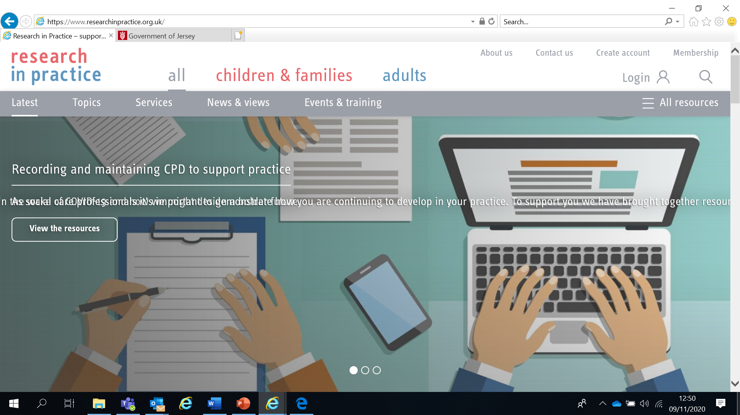

Use your work email and select ‘States of Jersey’ as your organisation from the drop-down list
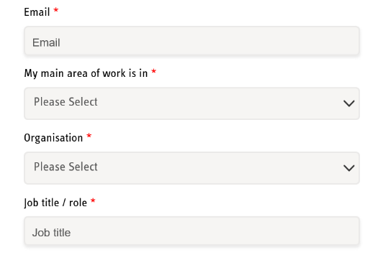
NOTE: You cannot set up an account with RIP if your work email uses Gmail, Hotmail or other generic accounts. Please contact us if this applies to you.
Once you have logged in with your new account, the resources are free to download:
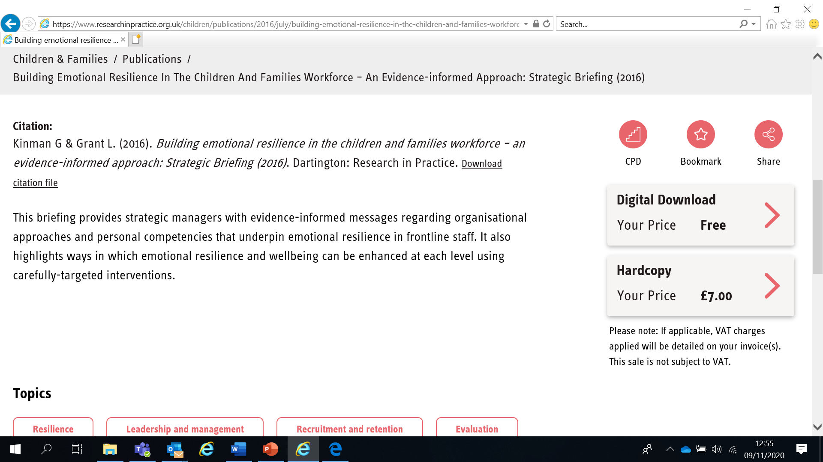

If you have any problems setting up an account, please contact safeguardingtraining@gov.je

Learning Objectives
In this module you will:
- Explain how professional challenge contributes to effective safeguarding
- Explain the concept of ‘professional curiosity’
- Identify factors that may inhibit or facilitate professional differences
- Identify how the SPB’s Resolving Professional Differences/Escalation Policy can be used to resolve professional differences in relation to the safeguarding needs of children and adults at risk
- Identify the importance of addressing low level concerns
- Explain the steps to take when an allegation of abuse is made against a member of staff using the Managing Allegations Framework (Child Workforce) and Multi-Agency Managing Allegations Framework for Adults

Links to Professional Practice
SPB: Child Procedures Manual, Adult Procedures Manual, Resolving Professional Differences/Escalation Policy, Continuum of Needs, Adults Thresholds Guidance, Managing Allegations Framework, Managing Allegations Framework for Adults
Intercollegiate Competency Framework: Level 4 and above
PQS:KSS - Developing confident and capable social workers | Assuring good social work practice and development | Promoting and supporting critical analysis and decision making | Relationship-based practice supervision | The role of social workers | Safeguarding | Effective assessment and outcome based support planning | Direct work with individuals and families
CQC - Safe | Responsive | Well led
PCF - Professionalism | Rights, justice and economic wellbeing | Knowledge | Critical reflection and analysis | Intervention and skills
RCOT - Identify needs | Develop intervention | Keep records | Demonstrate quality | Qualified | Support development

Top Tips
Do the readings – we've selected reading material that we know will enhance your knowledge and skills
Do the exercises – the more you put into this course, the more you will get out of it. The exercises will give you the opportunity to reflect on what you've read. You'll get a chance to discuss ideas and ask questions in the seminar

Emotional Alert!
We acknowledge that this is a sensitive subject – look after yourself and others.
This content:
- can trigger memories of experiences which were in some way abusive
- can highlight areas of difficulty for individual people who are aware of others or their own personal experiences
- can have an emotional impact on those working to protect children, families and adults
- contact us directly after listening if you want to talk or seek support from your manager if you are upset by any of the materials

Professional differences
Multi-agency working to safeguard children and adults at risk is often complex and means that, from time to time, staff from different professional backgrounds may hold a different professional opinion. It is important that this is fully understood as a different perspective has the potential to cause conflict.
Partnership working depends on resolving conflict as soon as possible. Professional differences of opinion can block effective partnership working and can lead to poorer outcomes for children and adults at risk. Effective partnership working depends on understanding differences of opinion and working towards resolving professional disagreements as soon as possible.
Human Rights and the FREDA principles
A human rights based approach underpins our conversations and interactions with children, young people, adults at risk and their families. It can also be helpful when trying to resolve professional differences to refer back to the shared core values in a human rights approach which are sometimes called the FREDA principles:
Fairness
Respect
Equality
Dignity
Autonomy

Professional challenge and curiosity
Nurturing professional challenge and curiosity are a fundamental aspect of working together to keep children, young people and adults safe.
Professional curiosity is the capacity and skill to explore and understand what is happening rather than making assumptions or accepting things at face value – sometimes described as ‘respectful uncertainty’.
Professional challenge is a professional responsibility. All organisations should promote a culture which encourages constructive challenge within and between organisations and acknowledge the important role that challenge can play in safeguarding.
Professional challenge in Serious Case Reviews (SCRs)
A 2016 NSPCC and SCIE (www.scie.org.uk) review of 38 Serious Case Reviews in the UK identified practice issues relating to professional challenge including:
- professionals feeling unable to challenge the decisions of another agency
- professionals feeling unsure about trusting their own judgement
- escalation procedures not being used
- a lack of confidence in escalating concerns
Working Together 2018 requires organisations to challenge appropriately and hold one another to account effectively. Effective working together depends on a culture of open and honest relationships between agencies; where different professional perspectives are welcomed and given serious consideration by professionals who want the best outcomes for children, families and adults at risk.
Professional curiosity in SCRs
A lack of professional curiosity has been cited in SCRs in Jersey and in the UK.
Questions to ask yourself to enhance professional curiosity:
- Would I live here and if not, why not?
- Would I be happy with this standard of care of a member of my family?
- What am I contributing to this challenge / problem / difficulty? How can I be of service?
- Whose voice needs to be in the conversation? Extend your invitation to everyone.
- How well do I know this family? What other ‘stories’ are there about this family that I am not privilege to?
- Do I need to change my mind? Are there gaps in my understanding?
- What is the purpose of my intervention and what is my desired impact?
- Am I curious about the exceptions to the problems?
- Change the frame of the conversation, change the response.
- How can I use relationships to create change?

We all have resources within us, tap into your expertise.

Engaging Resistant, Challenging and Complex Families
Working with families where there are safeguarding concerns can be difficult – but it is made especially demanding when families are resistant, challenging and complex. In such cases, it is important to look at the reasons why families may not engage with services because we know that successful early intervention underpinned by positive engagement is key to improving outcomes.

Many families in need of support have experienced discrimination, oppression & disadvantage which shape their interactions with professionals. Intervention by agencies can reinforce their experiences & is often viewed as further oppression which leads to further resistance & fear. Such fears may also inhibit families from discussing concerns with professionals & accessing support. The complexities of adults’ problems can come to eclipse children’s immediate needs. Use professional curiosity and a trauma-informed approach to reflect on why families may be resistant. The past affects the present – understand the story. A range of initiatives and approaches are required with flexibility of approach rather than strict adherence to any particular practice model.

Problems with service design and delivery can make services inaccessible or unattractive to engage with. Professionals’ behaviour is also a key factor, so a strengths and relationship-based approach is important.

Good supervision is key when working with resistant and complex families.
Read the SPB’s 7 Minute Briefings on:
- Professional Curiosity
- Engaging Resistant, Challenging and Complex Families
7 Minute Briefings are in the Resources section of the website. They are a useful resource that can be shared within your organisations and teams as a helpful way to support learning in your organisation.

Disguised Compliance
Disguised compliance involves parents and carers appearing to cooperate with professionals in order to allay concerns and stop professional engagement. There is a continuum of behaviours on a sliding scale with full cooperation on one end of the scale and effective resistance on the other. It’s human nature to show your best side to professionals but at its worst, superficial cooperation may be to hide deliberate abuse and professionals can sometimes delay or avoid interventions due to disguised compliance.
Published case reviews both locally and nationally highlight the importance of practitioners being able to recognise disguised compliance, establishing the facts and gathering evidence about what is actually happening in a child or adult at risk’s life.
Key issues:
- Parent/carer behaviour towards professionals (minimising, denying, diverting attention, manipulation, saying the right things and engaging ‘just enough’)
- Engagement with professionals (missing or cancelling appointments, promising to reschedule but not attending)
- Optimism (practitioner over-optimism about progress/ability to change/promises to engage, rationalizing behaviour as ‘parent/carer choice’ rather than non-compliance, acceptance of information without professional curiosity/further investigation)
- Lack of action (in some case reviews, disguised compliance was suspected or discussed but no actions were put in place to tackle it)
Practitioners need to remain open to the possibility of disguised compliance:
- Display professional curiosity when working with families – don’t accept information at face value without investigating further. Aim to triangulate and cross-reference information they have received to confirm or refute the facts that have been presented
- Establish the facts and gather evidence about what is actually happening or has been achieved
- Focus on the child/adult at risk’s needs, voice & lived experience rather than parent/carer actions
- Avoid being encouraged to focus too extensively on the needs and presentation of parents/carers, whether aggressive, argumentative or apparently compliant
- Think carefully about the engagement of parents/carers and its impact on your view of risk
- Focus on change in the family dynamic and the impact this will have on the life and wellbeing of the child/adult at risk. This is a more reliable measure than the agreement of parents/carers in the professional’s plan
- There is some evidence that an empathetic approach by professionals may result in an increased level of trust and a more open family response leading to greater disclosure. Practitioners need to build close partnership-style relationships with families whilst being constantly aware of the child/adult at risk’s needs and the degree to which they are met
- Make unannounced visits as well as pre-arranged ones
- There is no magic way of spotting disguised compliance other than the discrepancy between the parent/carer’s account and observations of the needs and accounts of children/adults at risk. The latter must always take precedent.

What is a Serious Case Review?
SCRs are commissioned by the Safeguarding Partnership Board for cases where abuse or neglect of a child or adult at risk is known or suspected and where either a child/adult at risk has died or a child has been seriously harmed and there is cause for concern about the way in which organisations and their staff have worked together to safeguard the child/adult at risk
SCRs are not about apportioning blame and are not part of any disciplinary process relating to an individual. They are about reviewing whether there are lessons to be learned about multi-agency working and if procedures are effective. They are designed to improve local practice and inter-agency working to reduce the risk of future harm to children and adults at risk. In the UK they are often made public (and anonymised) but in Jersey full SCRs are rarely published due to concerns around confidentiality. The SPB publishes ‘Learning Reports’ instead that highlight the learning from the SCR.
The process for determining whether to commission an SCR has changed recently. The first stage is now to hold a ‘Rapid Review’ where information is gathered over a short period and a panel, with an independent chair, decides if all the learning has already been identified or whether the case needs to progress to an SCR for a deeper dive into events that surround the incident.
The decision to progress to an SCR rests with the SPB’s Independent Chair.
Jersey’s SCRs are archived after a period of time. Current SCRs and Learning Reports are at Reports | Jersey Safeguarding Partnership Board
Think about any professional differences you have had or seen and answer the questions in the boxes below. Be ready to discuss this further in the seminar.

What do professionals disagree on?

Why might professionals disagree?

Factors that may inhibit / facilitate professional differences
Difference/challenge can have a negative connotation and can be perceived as conflict with ‘winners’ and ‘losers’. However, effective difference/challenge is about exploring, questioning, seeking to understand the position of the other and opening discussion to arrive at a well thought out decision as to the best way forward.

Three aspects have been identified that can inhibit or facilitate professional differences:

- Personal inhibitors/facilitators
- Professionals Inhibitors/facilitators
- Organisational Inhibitors/facilitators

Factors that may inhibit professional differences
Personal inhibitors: There are two factors to consider - those instigating and those receiving the challenge. Lacking confidence, fear of being wrong and professional seniority all affect challenge. Fear of being met with aggressions, defensive behaviour, seeing the challenge as a personal attack or criticism can also impact the challenge. Fear of damaging the relationship. Being passionate about and committed to their work that they cannot listen to another view or have any objectivity or ability to stand back and reflect.

Professional inhibitors: Fear of damaging relationships with other services and professionals, especially when they would need to collaborate in the future. Lack of understanding of roles and remits of others. Some colleagues take a narrow view of focussing on their task without any consideration for work of the interagency network. Reputational inhibitors. Being new to a case, where the perception is ‘others know better’.

Organisational Inhibitors: Organisational hierarchy, lack of process and structures can affect the ability to challenge. Agencies having different thresholds, lack of resources and over-focus on the process of safeguarding rather the needs of the child can also reduce the opportunity for challenge. Overuse of emails can hamper in-depth exploration and examination of complex issues or lead to misunderstanding.

Factors that may facilitate professional differences
Personal facilitators: If professionals feel respected, their role is valued and they will be listened to, they are more likely to challenge. Good working relationships can foster effective challenge.

Professional facilitators: Professionals need to have professional curiosity, sound knowledge and experience that is set within a professional culture that provides for reflection and case discussion, so that they can talk to one another and learn from each other about professional practice.

Organisational facilitators: Good communication between agencies, clear processes of knowing who to contact. It is important that there is ongoing opportunity for professional discussions, face to face meetings, networking, and time to think and plan together. Inter-agency training was cited as an important arena in which to promote good professional relationships and increased understanding of each other’s roles, remits and ways of working. Good regular supervision is also key to make sense of complex situations.

Differences of opinion, concerns and issues can arise for practitioners in multi-agency working as well as within a single agency.

Differences are most likely to arise in relation to:
- Criteria for referrals
- Outcomes of assessments
- Roles and responsibilities of workers
- Service provision
- Timeliness of interventions
- Information sharing and communication
Read sections 1 and 2 of the SPB’s Resolving Professional Differences/Escalation Policy from the Resources page (Policies section) on the website at Policies | Jersey Safeguarding Partnership Board
Reflect on a time when your professional opinion differed from a colleague. Did any of the factors listed in section 2 of the policy affect professional judgement? How did you overcome the differences of opinion?

You can record your thoughts below:

Things to remember when you have a difference of opinion:
- Having different professional perspectives within safeguarding practice is a sign of healthy and well-functioning inter-agency partnerships
- Professional differences and disagreements can help us find better ways to improve outcomes for children, adults and families
- All professionals are responsible for their own actions in relation to case work
- Differences and disagreements should be resolved as simply and quickly as possible in a constructive manner
- All practitioners should respect the views of others whatever the level of experience – challenging more senior or experienced practitioners can be hard
- Expect to be challenged; working together effectively depends on an open approach and honest relationships between agencies
- Professional differences are reduced by clarity about roles and responsibilities and the ability to discuss and share problems in networking forums
- The SPB’s Resolving Professional Differences/Escalation Policy should be used to resolve professional disagreements (more on this later)
Nurturing professional curiosity and challenge are a fundamental aspect of working together to keep children, young people and adults safe.
What Helps Professional Curiosity & Challenge
- Use of structured professional judgement: the SPB’s Continuum of Needs and Adults Thresholds Guidance documents can aid professional judgement
- Effective safeguarding supervision. You can learn more about supervision on the other DSL module or see our 7 Minute Briefing on supervision at 7 Minute Briefings | Jersey Safeguarding Partnership Board
The SPB’s Continuum of Needs (for children) and Adults Thresholds Guidance documents can help your decision-making and support multi agency dialogue. These are guidance documents only – the focus is on using professional skills to promote good safeguarding practice.

CONTINUUM OF NEEDS (for children)
Team around the child
Child/young person and family at the centre throughout
Universal needs | Early intervention | Child in need of support | Child in need of protection
All children have a right to a range of services – professionals will assess families to make sure their general needs are met | Requiring a single agency or coordinated multi agency response to support the child and family with additional needs | Requiring an intensive, coordinated multi agency response to support the child and family with considerable or complex needs | Requiring a specialist response where the child is suffering or at risk of suffering significant harm/impairment or serious risks to their development

STEP UP / STEP DOWN

All children have access to universal services/settings such as nurseries, schools, health visiting and youth services. These services are well placed to recognise and respond when extra support may be needed. Children will always have access to universal services whatever their needs may be.
There are times when extra help and support may be needed, perhaps because the child’s needs become increasingly more complex or because of parental or family circumstances. Children who have emerging or complex needs may need some more targeted support from a range of services.

Children’s Scenarios
Thresholds Activity
Choose whether to answer the questions on the Continuum of Needs for children or the Adults Thresholds Guidance (or both) depending on which sector you work in. We will discuss your answers in the seminar.
Using the Continuum of Need, decide whether you think each child sits at Universal Services, Early Intervention, Child in Need of Support or Child in Need of Protection.

Scenario | Level of need
Rory (age 13), has been missing school regularly and has started to make threats of suicide and his parents are unable to control him.

Chloe (age 12) lives with her parents who have frequent visits from the police when neighbours complain about shouting and the sound of breaking glass.

Matilda (age 4) is giggling as she was showing her genitals to her friend Bobby aged 4 in the home corner at school.

Bobby (10 months old), has not been brought for his health checks. When you see him, he is underweight and not appropriately dressed for the time of year. He has good eye contact with his mum and smiles when he sees her.

Pearl (age 11) has missed a lot of school because she takes her younger siblings to school and then has to go home to look after her mother, who has had a stroke.

Steven (age 7) has parents who are going through an acrimonious divorce and is finding it difficult to concentrate at school.

Adult’s Scenarios
Using the Adults Thresholds Guidance, decide whether you think each concern needs to be reported as a safeguarding concern or not.

Scenario | Reportable or not
Anne has MS and has just moved in with her son so that he can give her support. She has a small bruise on her arm caused by her son not using the correct technique when he helped get up from her chair. Anne is not distressed by this incident.

Sam lives in supported housing. One of the staff there always speaks to him rudely and in a loud voice which frightens Sam.

Robert goes to the day centre every Wednesday with his support worker. His support worker has run out of credit this week and asks Robert if he can use his phone. The worker spends 10 minutes on the phone outside resolving a personal issue.

Rosie lives in a care home and last Sunday evening she wasn’t given help to eat her evening meal. As a result, she only ate half of it.

Two residents of a care home have begun a sexual relationship with each other. One does not have capacity to consent to this.

Cathy, a wheelchair user who has a learning disability, is the victim of a hate crime because of her disability.

Escalation and Resolution
Any escalation of concern should be carried out in the spirit of achieving better outcomes for children, young people, adults and their families. Possible resolutions before the Escalation Pathway are to take the case to supervision or calling a multi-disciplinary meeting. In Adult Services a referral can be made to the Community Adult Support Panel
Where professional curiosity or challenge has not resolved professional differences, then the issue can be escalated using the Escalation Pathway unless the situation is so serious that it requires urgent action (eg via the Police)

Read the rest of the SPB’s Resolving Professional Differences/Escalation Policy and ensure you are familiar with it. The Policy is at Policies | Jersey Safeguarding Partnership Board

Four Stages of Escalation

The SPB retains records of any unresolved concerns that reach Stage 4.

Final Points to Consider:
- The ‘rule of optimism’ - not thinking about what the worst case scenario could be
- Accumulating Risk - seeing the whole picture
- Normalisation - accepting significant risks in someone’s life as ‘normal’ for them
- Professional Deference - thinking someone ‘knows best’ just because of their job title
- Confirmation Bias - looking for evidence that confirms your preconceptions
- ‘Knowing but not Knowing’ - sensing something is wrong, but not finding out what
- Confidence in Managing Tension - safeguarding issues are complex and difficult
- Dealing with Uncertainty - not everything can be ‘proven’, but action may still be needed
- Disguised Compliance - abusers may give an ‘appearance’ of compliance and innocence
- Professional Challenge - having different perspectives is healthy & should be encouraged
- Cultural Competence – being aware of, valuing and having respect for different cultural practices whilst not colluding with oppressive practices that can be disguised as cultural issues

Managing Allegations
Any allegation of abuse made against a person who works with children and young people or adults at risk must be dealt with quickly, fairly and consistently, in a way that provides effective protection for the alleged victim and supports the person who is the subject of the allegation. This includes those who work in a voluntary capacity
The SPB has policies for managing allegations of abuse against staff on its website under Policies and Guidance. The appropriate policy will depend on whether your organisation works with children/young people or adults at risk - or both

Positions of trust – children
Positions of trust in relation to children are defined under the Sexual Offences (Jersey) Law 2018 and include adults:
- regularly involved in caring for, teaching, training, supervising or being in sole charge of any children in premises such as a children’s home, school, nursing home, or any institution in which a child is detained (eg a teacher in charge of pupils in one school is in a position of trust for all pupils in all schools in Jersey)
- regularly involved in caring for, teaching, training, supervising, or being in sole charge of a child on an individual basis
- with regular unsupervised contact with a child due to the provision of public services required to safeguard the child
- engaged, on a professional or voluntary basis and not as a family member, either solely or with others, in coaching, motivating, guiding or training a child for a sport, hobby, career or competitive event

Positions of trust – adults
Positions of trust in relation to adults are defined in the Multi-agency Framework for Managing Allegations in respect of People working with Adults in a Position of Trust
- A Person in a Position of Trust is anyone who carries out work, be that paid or unpaid, on behalf of an agency which has access to children or adults with care and support needs or has access to privileged information about children or adults with care and support needs as part of their work

Multi agency policies
Read the Managing Allegations document that applies to your setting (children or adults) at Policies | Jersey Safeguarding Partnership Board
If you work with both children and adults, you should be familiar with both policies.

Your organisation should have a specific policy on managing allegations which links to your safeguarding policy.
Your organisation should have clear procedures on managing allegations based on SPB policies.
Find your organisation’s policy and procedures. Who is the person in your organisation that would deal with an allegation of abuse against staff? Are you clear on the process? Do all staff know about it?

Threshold for referrals

All concerns about staff behaviour should be managed appropriately. We will look at low level concerns about staff later.
The Managing Allegations Frameworks (MAF) must be used for all allegations that a staff member has:
- behaved in a way that has harmed, or may have harmed, a child or an adult at risk
- possibly committed a criminal offence against, or related to, a child or adult at risk
- behaved in a way that indicates they may pose a risk of harm to children or adults at risk
- behaved or may have behaved in a way that indicates they may not be suitable to work with children or adults at risk

The Frameworks provide further information on thresholds.

Remember that this applies:
- to all sectors (statutory, private and 3rd sector) and all staff. We will use the term ‘staff’ throughout this workbook but it includes paid staff, volunteers and students on placement
- whether the allegations are current or historical (including where the alleged perpetrator has recently left your organisation)
- inside and outside of work – in all circumstances where a person’s behaviour towards children or adults at risk may impact on their suitability to work or volunteer in your organisation

Read each of the 4 scenarios which follow. Some involve adult settings and some involve child settings. Write what you would do in each scenario.
Scenario 1:
About a fortnight ago, 7-year old child Ayesha arrived at your dance school with a bruise on her thigh which she was unwilling to talk about so you contacted the Children and Families Hub. The resulting enquiry produced no clear outcome, as the bruise was thought to be consistent with the explanation that her parents gave.
This morning, Ayesha’s parents have called you to report that she arrived home last night with a mark on her face. When mum asked what had happened, Ayesha became upset, saying that she had been hit by Mrs Smith, a member of your staff.
What actions would you take? What other things might you consider?

Scenario 2:
Tania has been a volunteer driver for your adult disability charity for six months and is a popular and reliable volunteer. The charity took references, completed a DBS check and she has recently completed safeguarding training.
Last week, another volunteer told you that Tania had been arrested for grooming a 15 year old boy.

What actions would you take? What other things might you consider?

Scenario 3:
Sam (15), a member of your youth group, has recently suffered a family bereavement and has been supported by one of your volunteers. The volunteer is an experienced and respected colleague who you have known for over 10 years.
Sam’s parent rings you to complain that the volunteer has messaged Sam via WhatsApp to check how he’s feeling.

What actions would you take? What other things might you consider?

Scenario 4:
Stuart was a care assistant in your nursing home but left employment yesterday. He only worked with you for a month before leaving to get a job as teaching assistant.
Patricia (93) has dementia and has just told you that she is glad Stuart left as he was ‘always rough’ with her. When you ask her what she means by ‘always rough’ she says that he hurt her when getting her out of bed and shows you a scratch on her arm.

What actions would you take? What other things might you consider?

We will discuss your answers in the seminar.
Areas of staff vulnerability
Some areas of work increase the vulnerability of staff. These include:
- Physical contact
- Control and physical intervention
- Communications with children and adults at risk, including online
- Intimate/personal care
- One to one situations
- Relationships
- Home visiting/lone working

Policies that support safe practice
A safer organisation has policies that support and protect staff as well as children and adults at risk. Policies that support safe practice include:
- Safer recruitment
- Behaviour management
- Codes of conduct
- Anti-bullying
- Equality and diversity
- Online safety
- Complaints
- Disciplinary

Do you have policies that support safe practice in your organisation, as detailed above? How are they shared with all staff and volunteers? Do you review them periodically?
Low Level Concerns About Staff
Concerns that do not meet allegation thresholds or are not otherwise serious enough to consider a referral to JDO/AWDO should still be managed. These concerns may be very small, sometimes no more than a ‘nagging doubt’.
An adult may not follow an organisation’s Code of Conduct or their conduct outside of work may cause unease about their suitability to work with children or adults at risk.
Research shows that some offenders are situational (where organisational factors increase the likelihood of offending). Some of these organisational offenders show patterns of rule breaking more generally.
Read the below example of a low-level concern about an adult and how it is managed.
- Mrs Simpson, a charity volunteer, accompanies a group of children on an outing. Mrs Simpson is seen on the edge of the group talking to a child who is on his own for a long time. She sits with the same child for lunch, and again later in the day when waiting for the parents to collect him. Another volunteer speaks to the DSL, as it did not sit comfortably with them, and the DSL makes a record of the information shared as a low-level concern
- DSL speaks to Mrs Simpson who explains the child in question was “having a bad day,” and she felt he needed some extra support and, new to volunteering, had not come across a situation like this before. She is horrified to hear that someone was concerned about her behaviour
- DSL considers this to constitute a low-level concern and, as such, does not make a referral (given it is not considered to meet the threshold of an allegation). DSL also arranges further training for Mrs Simpson and all the other volunteers
- DSL retains a copy of the relevant paperwork (including the record of the initial conversation with the volunteer, and with Mrs Simpson, and of the subsequent action taken) in a central low-level concerns file

Identifying Low Level Concerns
How do you identify and deal with concerning behaviour early, in order to minimise the risk of abuse and ensure staff are clear about professional boundaries and act within them in accordance with the organisation’s values?

A low-level concerns policy template is available to download as part of our Safer Organisations Toolkit. You can access the Toolkit in the Guidance section of the Resources on our website.

Next Steps
You have now finished the independent learning ahead of the in-person seminar.
In the seminar, we will reflect on your learning from this module and in particular we will:
- Ask you to consider a time when your professional opinion differed from a colleague and how you overcame the differences of opinion
- Gain your thoughts on the scenarios in your workbook and your use of the Continuum of Needs/Adults Thresholds Guidance documents
- Reflect on how your organisation manages low level concerns
- Consider a case study

Important!
Please bring this workbook to the seminar with you. We will be referring to it throughout the session.

Further Learning
The SPB website has a series of 7 Minute Briefings on a range of topics which you can use with your teams to prompt discussion and reflection on practice and systems. You can find 7 Minute Briefings under the Resources page on the website – including an explanation of what they are.
The Research in Practice website is an excellent source of further material.
The SPB has a range of courses which will help you to further your knowledge. Please check our website for further details.

Acronyms
ABE | Achieving Best Evidence
ADRT | Advance Decisions to Refuse Treatment
APVA | Adolescent to Parent Violence and Abuse
ASCIT | Autism and Social Communication Inclusion Team
CAMHS | Child and Adolescent Mental Health Service
CCE | Child Criminal Exploitation
CDC | Child Development and Therapy Centre
CEOP | Child Exploitation and Online Protection agency
CEYS | Childcare and Early Years Service
ChiSVA | Children and Young People’s Sexual Violence Advisor
CIN | Child In Need
CLA | Children who are Looked After (formerly known as LAC Looked After Child)
CMHT | Community Mental Health Team
CP | Child Protection
CPC | Child Protection Conference
CQC | Care Quality Commission
CSDL | Capacity and Self-Determination Law
CSE | Child Sexual Exploitation
CYPES | Children Young People Education and Skills
DA(DV) | Domestic Abuse (Domestic Violence)
DBS | Disclosure and Barring Service
DSL | Designated Safeguarding Lead
ECHR | European Convention on Human Rights
EP | Educational Psychologist
EWO | Education Welfare Officer
EYAT | Early Years Advisory Team
EYFS | Early Years Foundation Stage
EYIT | Early Years Inclusion Team
FGM | Female Genital Mutilation
FII | Fabricated or Induced Illness
FLO | Family Liaison Officer
FNHC | Family Nursing and Home Care
GDPR | General Data Protection Regulation
GSF | Gold Standards Framework
HBV | Honour Based Violence
HSB | Harmful Sexual Behaviour
ICA | Independent Capacity Advocate
ICPC | Independent Child Protection Conference
IDVA | Independent Domestic Violence Advisor
IPVA | Inter Personal Violence and Abuse in Young People’s Relationships
ISS | Independent Safeguarding and Standards
ISVA | Independent Sexual Violence Advisor
JCAF | Jersey Common Assessment Framework
JCCT | Jersey Child Care Trust
JCF | Jersey’s Children First
JDO | Jersey Designated Officer
JFCAS | Jersey Family Court Advisory Service
JPACS | Jersey Probation and After-Care Service
JMAPPA | Jersey Multi Agency Public Protection Arrangements
LADO | Local Area Designed Officer (see JDO)
LPA | Lasting Power of Attorney
MAF | Managing Allegations Framework
MARAC | Multi Agency Risk Assessment Conference
MARRAM | Multi Agency Risk Review Action Meeting
MASH | Multi Agency Safeguarding Hub
MSP | Making Safeguarding Personal
NAI | Non Accidental Injury
PBS | Positive Behaviour Support
PPU | Public Protection Unit
PR | Parental Responsibility
RCPC | Review Child Protection Conference
RRRT | Rapid Response and Reablement Team
SALT | Speech and Language Therapy/Therapist
SARC | Sexual Assault Referral Centre
SCR | Serious Case Review
SEMHIT | Social, Emotional and Mental Health Inclusion Team
SEN | Special Educational Needs
SENCO | Special Educational Needs Coordinator
SEND | Special Educational Needs and Disability
SNRM | Self-Neglect Risk Management Meeting
SOJP | States of Jersey Police
SOLO | Sexual Offences Liaison Officer
SPB | Safeguarding Partnership Board
SPOC | Single Point of Contact
SPOR | Single Point of Referral
SRoL | Significant Restriction on Liberty
SUDI | Sudden Unexplained Death in Infancy
SUI | Serious or Untoward Incident
TAC | Team Around the Child
TAF | Team Around the Family
YES | Youth Enquiry Service

For information on services in Jersey, please see:
Children & Families Hub www.gov.je/caring/childrenandfamilieshub/Pages/ChildrenAndFamiliesHubHomepage.aspx
Jersey Online Directory www.jod.je
Children with Disabilities Directory www.gov.je/Health/Children/ChildDevelopment/Pages/Centre.aspx
Special Educational Needs pages on gov.je www.gov.je/Education/Schools/Sen/Pages/WhatSupportAvailable.aspx

NOTES

