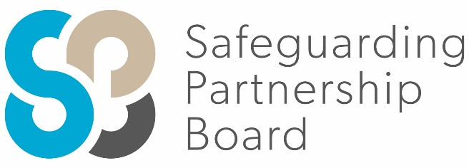

Delegate Workbook
When Children Tell: Responding to Child Disclosures

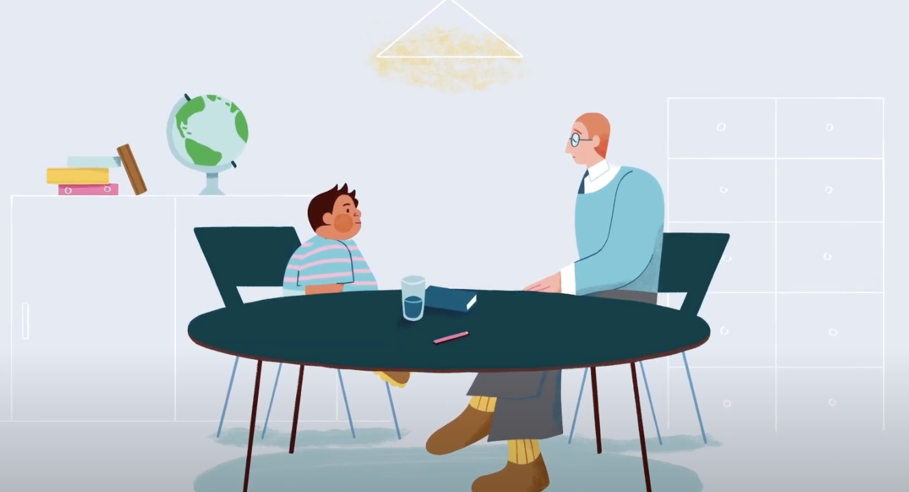

About this course
These materials are part of a learning package that includes self-directed learning via this workbook and an in-person seminar. Please ensure that you have set aside at least 3 hours to complete the work before attending the in-person seminar. The seminar will build on your knowledge and understanding and will ask you to reflect on the content of the materials.
You should set up an account with Research in Practice (RIP) if you don’t have one already (see below for instructions on how to set up your account). RIP is a free resource provided by the Safeguarding Partnership Board and contains a wealth of information including videos, briefings, webinars etc which will help you in your work.
All you need is a quiet place to work through the content and/or watch any videos, either alone or in a group. It might be useful, as you read or listen, to jot down thoughts that occur to you about the work you do and any questions or new ideas that come to mind.
Important!
You will need to bring your workbook to the seminar as we will be referring to it on the day.

Setting up your account with Research in Practice
Research in Practice (RIP) supports evidence-informed practice with children and families, young people and adults. RIP brings together academic research, practice expertise and the experiences of people accessing services to develop a range of resources and learning opportunities.
As a partner of the Safeguarding Partnership Board, your organisation is able to access RIP’s resources free of charge. To do this, you will need to set up a RIP account:
Go to www.researchinpractice.org.uk and select ‘create account’ at the top.
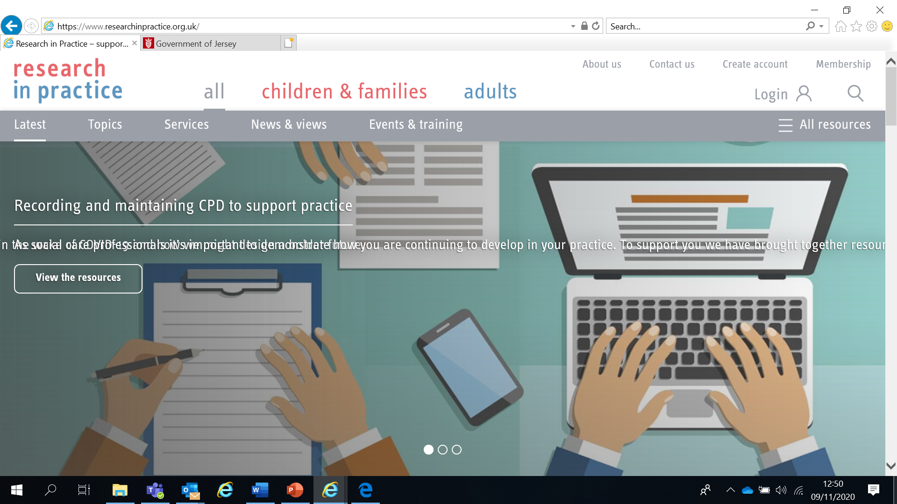

Use your work email and select ‘States of Jersey’ as your organisation from the drop-down list
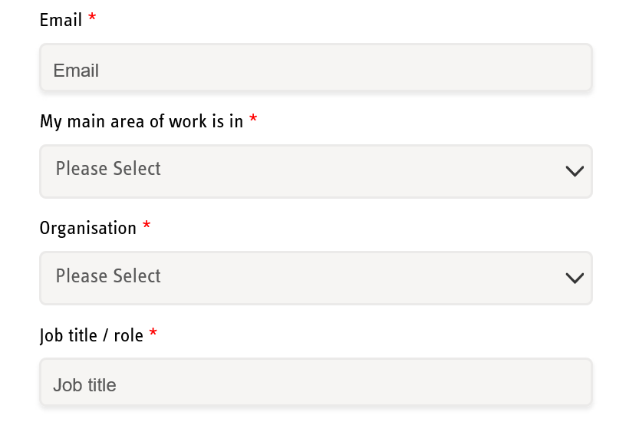

NOTE: You cannot set up an account with RIP if your work email uses Gmail, Hotmail or other generic accounts. Please contact us if this applies to you.

Once you have logged in with your new account, the resources are free to download:
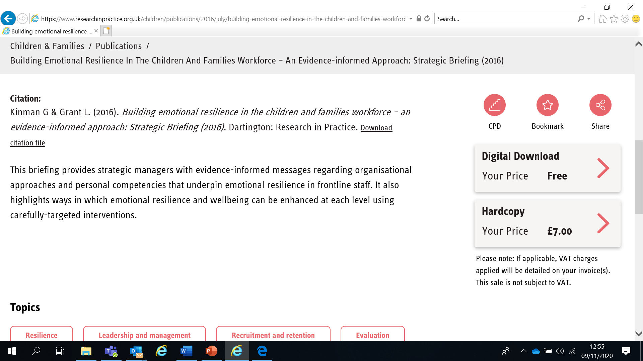

If you have any problems setting up an account, please contact safeguardingtraining@gov.je

Learning Objectives
In this module you will:
- Describe what a disclosure is and the forms disclosure may take
- Identify barriers and enablers to disclosure of abuse by children and young people
- Respond appropriately to a disclosure or allegation of abuse
- Describe the particular disclosure challenges of disabled children

Links to Professional Practice
SPB: Child Procedures Manual, Child Workforce Competency Framework
Intercollegiate Competency Framework: Level 2 and above

Top Tips
Do the readings – we've selected reading material that we know will enhance your knowledge and skills
Do the exercises – the more you put into this course, the more you will get out of it. The exercises will give you the opportunity to reflect on what you've read. You'll get a chance to discuss ideas and ask questions in the seminar

Emotional Alert!
We acknowledge that this is a sensitive subject – look after yourself and others.
This content:
- can trigger memories of experiences which were in some way abusive
- can highlight areas of difficulty for individual people who are aware of others or their own personal experiences
- can have an emotional impact on those working to protect children, families and adults
- seek support from your manager if you are upset by any of the materials

What is disclosure?
Disclosure is the process by which children and young people start to share their experiences of abuse with others. This can happen over a long period of time – it is a journey, not one act or action.
Children and young people may disclose abuse in a variety of ways including:
Directly: making specific verbal statements about what’s happened to them
Indirectly: making ambiguous verbal statements which suggests something is wrong
Behaviourally: displaying behaviour that signals something is wrong (this may or may not be deliberate)
Non-verbally: writing letters, drawing pictures or trying to communicate in other ways

Categories of abuse
There are 4 categories of abuse for children:
PHYSICAL ABUSE: may involve hitting, shaking, throwing, scalding, drowning, suffocating or otherwise causing physical harm to a child. Physical harm may also be caused when a parent or carer fabricates the symptoms or deliberately induces, illness in a child.
EMOTIONAL ABUSE: the persistent emotional ill treatment of a child such as to cause severe and persistent adverse effects on the child’s emotional development. It may involve conveying to a child that they are worthless and unloved, inadequate, or valued only insofar as they meet the needs of another person. It may feature age or developmentally inappropriate expectations being impose on children. These may include interactions that are beyond the child’s developmental capability, as well as overprotection and limitation of exploration and learning, or preventing the child from participating in normal social interaction. It may involve seeing or hearing the ill-treatment of another, including domestic violence or serious bullying causing children frequently to feel frightened or in danger, or the exploitation or corruption of children. Some level of emotional abuse in involved in all types of maltreatment of a child, though it may occur alone.
SEXUAL ABUSE: involves forcing or enticing a child or young person to take part in sexual activities, including prostitution whether or not the child is aware of what is happening. The activities may involve physical contact, include penetrative (e.g. rape, buggery or oral sex) or non-penetrative acts. They may include non-contact activities such as involving children in looking at, or in the production of sexual online images, watching sexual activities, or encouraging children to behave in sexually inappropriate ways.
NEGLECT: the persistent failure to meet a child’s basic physical and/or psychological needs, likely to result in the serious impairment of the child’s health or development. Neglect may occur during pregnancy as a result of maternal substance misuse. It may also include neglect of, or unresponsiveness to, a child’s basic emotional needs.
Once a child is born, neglect may involve a parent or carer failing to:
- Provide adequate food, clothing and shelter (including exclusion from home or abandonment)
- Protection a child prom physical harm or danger
- Ensure adequate supervision (including the use of inadequate caregivers)
- Ensure access to appropriate medical care or treatment

Physical Abuse
PHYSICAL INDICATORS | BEHAVIOURAL INDICATORS
Unexplained  - Bruises, welts, lacerations, abrasions  Location  - Face, lips, gums, mouth, eyes.  - Torso, back, buttocks, back of legs  - Neck, back of arms, wrists  - External genitalia  Shape  - Clustered, forming regular patterns, teeth marks, handprints  - Same as article used to inflict injury e.g. belt, buckle, flex, stick  Unexplained burns  - Small circular burns, particularly on the soles of the feet, palms of hand, back of buttocks  - Immersion burns, clear line of demarcation  - Rope burn on arms, legs, neck or torso  - Patterned burns indication a hot object e.g. electric fire or iron  Unexplained fractures/dislocations  - Skull, facial bones, spine  - Spiral fractures  - Dislocations, particularly shoulders or hips  - Multiple fractures in various stages of healing  Children under age 2 years: fractures and dislocations usually result from blows, throws, or other forceful action or severe shaking | - Running away  - Wary of adults  - Speaking in monosyllables  - Does not turn to parent to support  - Child believes she/he is bad and deserves punishment  - Constantly trying to please parent  - Role reversal, child tries to care for parent  - Behaviour extremes, aggressive or withdrawn  - Afraid to go home  - Reluctant to undress in school  - Inappropriately dressed to hide marks  - Indiscriminately seeks affection  - Inappropriate or precocious maturity  - Exposure to domestic violence  - Fear of physical contact  - Speaks of being severely punished

Sexual Abuse
PHYSICAL INDICATORS | BEHAVIOURAL INDICATORS
- Difficulty walking or sitting  - Pain, swelling, itching in genital area  - Bruises, bleeding, lacerations of the external genitalia, vaginal or anal areas  - Love bites or bite marks  - Pain during urination  - Pregnancy  - Vaginal/penile discharge  - Sexually transmitted infection  - Recurrent urinary/vaginal infections  - Constant sore throats of unknown origin  - Genital warts  - Allergic skin reaction (to semen)  - Torn, blood stained clothing  - Eating disorders  - Bruises, scratches especially to breasts, buttocks, lower abdomen, thighs  - Recurrent abdominal pain/headaches | Reactions similar to those following any other severe stress including:  - Regressive behaviour in younger children e.g. bed wetting  - Fears, nightmares, phobias e.g. of the dark or particular places  - Running away  - Drug/alcohol abuse  - Mood swings/personality changes  - Depression, anger aggression  - Deterioration in performance at school  - Suicidal thoughts  - Self-mutilation  Reactions directly related to sexual abuse including:  - Sexualised drawings  - Age – inappropriate sexual play  - Sophisticated or unusual sexual knowledge or behaviour  - Overtly seductive behaviour or aversion to intimacy  - Withdrawal from peers  - Prostitution  - Extreme mistrust  - States he/she is being sexually assaulted  - May feel it is his/her fault  - Confusion about sexual identity  - Anger with non-protective carer  - Assumes inappropriate parental role  - Sexually abusive behaviour to other children  - Hints about a secret they cannot tell
Emotional Abuse
PHYSICAL INDICATORS | BEHAVIOURAL INDICATORS
- Language delay  - Failure to thrive (no organic cause)  - Sleep disorders  - Psychosomatic complaints e.g. headache, nausea, abdominal pains  - Involuntary twitching of muscles especially on the face  - Speech disorders | - General development delay  - Hyperactive/disruptive behaviours  - Behaviour extremes e.g. withdrawn/aggressive/demanding  - Over – adaptive behaviour e.g. too well mannered  - Inhibited play  - Unusually fearful of consequences of actions, often leading to lying  - Threatening or attempted suicide  - Scapegoat of the family  - Compulsively clean and neat  - Anorexic/bulimic  - Limited attention span  - Learning difficulties  - Low self esteem  - Poor peer relationships

Neglect
PHYSICAL INDICATORS | BEHAVIOURAL INDICATORS
- Underweight, poor growth pattern, constant hunger  - Obese with a history of eating an unhealthy diet  - Poor physical hygiene, severe nappy rash, skin rashes, dirty, thin hair, cradle cap, thickened nails, body odour  - Unattended needs e.g. for glasses, dental care, untreated injuries  - Fatigue, listlessness, lethargy  - Recurrent and persistent minor infections  - Frequent attendance at A & E Department  - Failure to thrive with no organic cause  - Alcohol/drug/substance abuse | - Pale & listless, unkempt  - Begging or stealing food  - Arriving at school very early, leaving school late  - Truanting  - Inappropriate clothing for the weather  - Squinting, dental problems  - Caring for siblings, carrying parental responsibilities  - Socially challenging behaviour  - Self-harm  - Lack of supervision

Remember:
- Both physical and behavioural signs are important
- There may be reasons other than child abuse which could explain a child’s symptoms
- Always consider the age, stage of development and your knowledge of that child as an individual
- Attitudes of parents and carers are crucial, think about how they behave towards the child.
- Consider the whole context of a child’s life; Are they being bullied? What is happening at home? Domestic violence, alcohol or drug abuse, parental mental illness, bereavement, or family crisis?
- Children with disabilities are especially vulnerable and signs in them may be difficult to detect
- Different cultural, class or individual attitudes about child rearing must not cloud our judgement about whether a child is being abused and the decisions we take.

Noticing signs and signals of abuse or self-harm
“Failure to notice signs and signals, or misinterpretation of these signs, was most commonly attributed to teachers and other education staff. Young people believed that because they saw these professionals on a daily basis, more could have been done to recognise and intervene. Signs were often missed, although some young people did acknowledge that they were very good at hiding bruises and injuries from self-harm, which may explain why teachers did not notice. Other young people had made no attempts to hide these sorts of injuries and often said that teachers misinterpreted these signs and labelled the children or young people as merely ‘troublesome’.”
‘No-one noticed, no-one heard’ (NSPCC 2013, p50) https://learning.nspcc.org.uk/media/1052/no-one-noticed-no-one-heard-report.pdf
Consider the behavioural indicators on pages 6-9. Think about how professionals might misinterpret these behavioural indicators and record your thoughts below. We will discuss your answers in the seminar.

Barriers and enablers to disclosure
Read the Executive Summary (pages 6-7) and Sections 3.2 and 3.3 (pages 24-35) of ‘No-one noticed, no-one heard’ (NSPCC 2013) https://learning.nspcc.org.uk/media/1052/no-one-noticed-no-one-heard-report.pdf
Read the SPB’s 7 Minute Briefing ‘What Helps Children Tell – Child Sexual Abuse’ on p14 of your workbook or via the Resources page of the website at Resources | Jersey Safeguarding Partnership Board
Consider the questions in Box 7 of the Briefing and record your thoughts below. We will discuss this further in the seminar.

How do you recognise distress in a child?

Are you professionally curious as to the cause of distress?

How do you initiate conversations about well-being?

How do you ensure children know what abuse is and that it is not acceptable?

How do you let children know they can talk to you, and you can be trusted?

Do you know what to do if a child discloses?

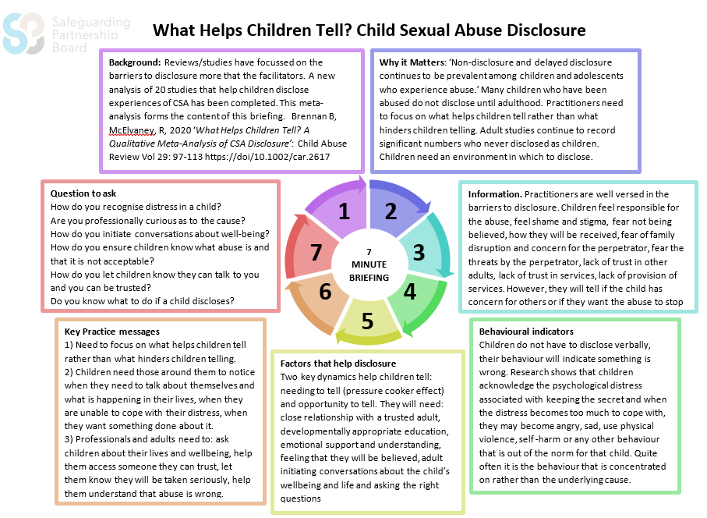
Resources | Jersey Safeguarding Partnership Board
Key dynamics in disclosure
There are two key dynamics in disclosure: needing to tell and opportunity to tell. Common to both, is being asked.
Needing to tell | Opportunity to tell
- Unable to cope with emotional distress  - Wanting something to be done about it  - Being asked | - Access to someone you can trust  - Expecting to be believed  - Being asked
Read the NSPCC’s ‘Let children know your listening’ https://learning.nspcc.org.uk/media/1664/let-children-know-listening-briefing-english.pdf and answer the questions below

How do you demonstrate you are listening to a child who is disclosing?

How do you reassure a child and show empathy?

How do you put a child in charge of the conversation?
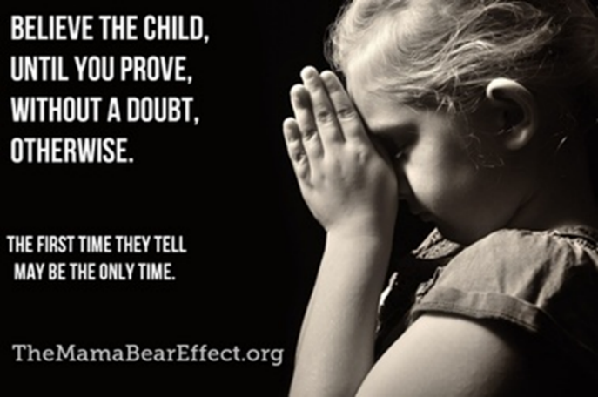
Watch the video ‘The Sh*t Kids Say’ (1m 33s) at www.youtube.com/watch?v=dYnLzSUQc6U
[NOTE: This video clip can evoke strong emotional responses]

Pathway to disclosure
Children and young people often disclose to people that they trust and who they have built a relationship with. There can be stages in disclosure (although not always in the order listed below or even all 3 stages being present):
Indirect acknowledgement of trauma (eg via music, lyric writing, drawing, etc)
Testing of safety/boundaries – “Can I trust you?” Rejecting people to see if they’ll still be there (including not attending appointments where they are of an age/ability to do so independently). “Can you bear what I have to tell you?”
Direct acknowledgement of trauma

Dealing with a disclosure
- Don’t panic - remain calm, reassure the child that they have done the right thing and you believe them
- Listen and don’t make assumptions
- Illicit enough information to decide if this is a safeguarding issue. DO NOT investigate
- Never ask leading questions - use open-ended questions, using the TEDi toolkit:
Tell: “Tell me more about that / Tell me what happened?”
Explain: “Explain what you mean by that?”
Describe: “If I had been there, describe what would I have seen?”
and finally, “Is there anything else you want to tell me?”
- Make no promises
- Be supportive, not judgmental
- Do not leave the child or young person alone
- Tell the Designated Safeguarding Lead immediately
- Record your conversation as soon as possible using the child words - not your own interpretation of events
- Never record disclosures on devices or take photos of the child

Why do we ask ‘Is there anything else?’

Sometimes children make partial disclosures of abuse, giving some details about what they’ve experienced but not the whole picture. They may use a partial disclosure to test your reaction – are you a ‘safe’ person to tell?

They may also withhold some information because they:
- are afraid they will get in trouble with or upset their family
- want to deflect blame in case of family difficulties as a result of the disclosure
- feel ashamed and/or guilty
- need to protect themselves from having to relive traumatic events
- have been threatened or coerced that they must keep the information secret
Safeguarding d/Deaf and disabled children and young people
Children and young people with disabilities are three times more likely to be abused or neglected than other children & young people. Children who are at particular risk include those with learning difficulties/disabilities, speech & language difficulties, health-related conditions and deaf children.

The information below is from the NSPCC Learning website
https://learning.nspcc.org.uk/safeguarding-child-protection/deaf-and-disabled-children

Professionals sometimes have difficulty identifying safeguarding concerns when working with d/Deaf and disabled children. It’s vital that everyone who works with d/Deaf and disabled children understands how to protect them against people who would take advantage of their increased vulnerability.

The NSPCC use the term ‘disabled children’ to refer to children and young people with a range of very different conditions and identities, some of whom may not identify as being disabled. This includes children who:

- are d/Deaf
- are on the autistic spectrum
- have a condition such as attention deficit hyperactivity disorder (ADHD)
- have a learning disability
- have a physical disability such as cerebral palsy
- have visual impairment
- have a long-term illness.

Children and young people may use different language to describe themselves and their needs. You should ask what terms they would prefer and use these when talking to them.
Children and young people who have disabilities are at an increased risk of being abused compared with their non-disabled peers and are also less likely to receive the protection and support they need when they have been abused.

Who is at most risk of abuse?

Disabled children at greatest risk of abuse are those with behaviour or conduct disorders. Other high-risk groups include:

- children with learning difficulties/disabilities
- children with speech and language difficulties
- children with health-related conditions
- d/Deaf children

Why are disabled children at greater risk of abuse?

There are several factors that contribute to disabled children and young people being at a greater risk of abuse including:

- misunderstanding the signs of abuse (professionals may mistake the indicators of abuse for signs of a child’s disability)
- lack of access to personal safety programmes and relationships & sex education
- increased isolation
- dependency on others
- inadequate support

But children and young people with speech, language and communication needs (including those who are d/Deaf, or have a learning disability or physical disability) face extra barriers when it comes to sharing their worries and concerns.

- Adults may have difficulty understanding a child’s speech so they may not realise when a child is trying to tell them about abuse.
- Adults may not have the knowledge and skills to communicate non-verbally with a child, which can make it harder for children to share their thoughts and feelings.
- Communicating solely with parents or carers may pose a risk if the child is being abused by their parent or carer.
- It can be difficult to teach messages about what abuse is or how to keep safe to children with communication needs. Without this knowledge children may not recognise that they are being abused or won’t know how to describe what’s happening to them.

Listening to the child

- Make sure the child’s voice is heard. Where there are safeguarding concerns, speak to children alone and don’t use parents as interpreters.
- If a child’s disability means verbal communication is difficult or impossible, make every attempt to communicate by other means.
- Consider how a child may communicate through their actions. Consider whether distressed or disruptive behaviour is due to the child’s disability or if the child is upset for another reason.
- Tailor tools and resources to the child’s needs. Check that the child has understood what you’ve told them and is able to apply it – don’t make assumptions about what they have understood.

Communication

Every child and family is different and has their own complexities and needs.
As part of assessing a family’s needs it’s essential to establish a d/Deaf or disabled child’s preferred method of communication. They may use:

- British Sign Language (BSL)
- Makaton
- Widgit
- Picture Exchange Communication System (PECS)
- some signs with speech
- speech, lip reading and gestures.

Establish how the child communicates with their family and others. Find out if there are any trusted adults that the child or young person communicates directly with. This could be:
- another member of the family
- a teacher
- a youth club leader.

There is no ‘ideal’ way to facilitate communication between safeguarding professionals and d/Deaf and disabled children and young people.

- Consider whether a child protection assessment or discussion is better with or without a third party. Would the child rather communicate directly with a trusted individual or have a third party in the room?
- Reflect on your own language limitations and don’t assume you can communicate “well enough”. Even when a child can use spoken language this may not be the method of communication they’re most comfortable with.
- Find out about parents’ preferred communication method. Parents need to be given every opportunity to communicate in their own language.
- Always prioritise the child’s strengths, requirements and needs, regardless of whether you’re working with an interpreter or not.

Empowering children with special educational needs and disabilities (SEND)

Social attitudes and assumptions about disability can have an impact on children’s self-confidence. Getting to know a child or young person with SEND and finding the best way to communicate with them is a positive way of building a child’s self-esteem. This can show the child that there is someone they can trust and communicate with and help them feel confident about letting someone know if they experience something that makes them feel uncomfortable.

Help empower children with SEND by:

- providing them with communication support and opportunities to express themselves
- helping them to build a supportive relationship with a trusted person
- consulting them on their views and wishes about their life and care in order to meet their needs
- providing accessible education on topics such as keeping safe, sex and relationships and online safety
- providing information in accessible formats
- providing opportunities for peer support and social activities
- giving them opportunities to express themselves creatively through activities like art and music
- giving them access to advocacy services.

More information on communicating with children & young people with speech, language & communication needs and/or developmental delay, is available at
www.researchinpractice.org.uk/media/2680/rip_communicating_with_cyp_with_speech_language_and_communication_needs_and_or_developmental_delay_july16.pdf
Reflection
The CSA Centre’s report ‘Key messages from research on identifying and responding to disclosures of child sexual abuse’ (www.csacentre.org.uk/resources/key-messages/disclosures-csa/) notes that:
“Children want to be noticed by friendly, approachable and caring professionals, with whom they have built a trusted relationship. They want to be asked how they are doing and what is going on, so they have an opportunity to have an open dialogue.”
Reflect on the questions below:

How would the children and young people you work with describe you?

Do you regularly ask children about their daily lives and invite them to share their experiences of things outside of your setting? How do you encourage open dialogue with them?

How do you give children the time they need?

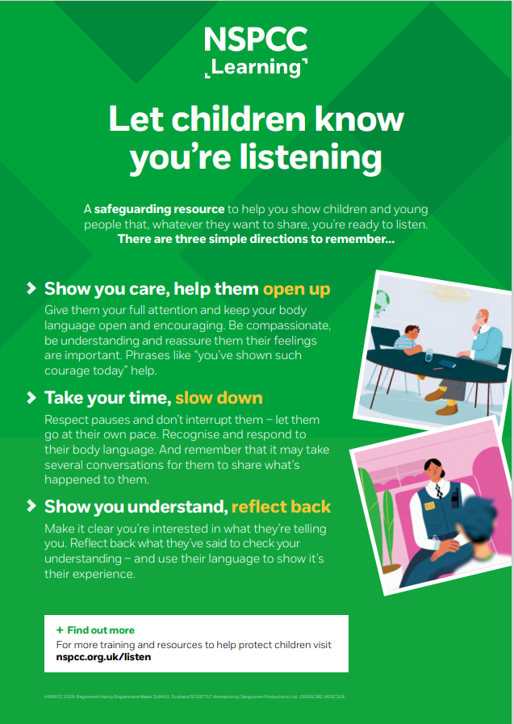
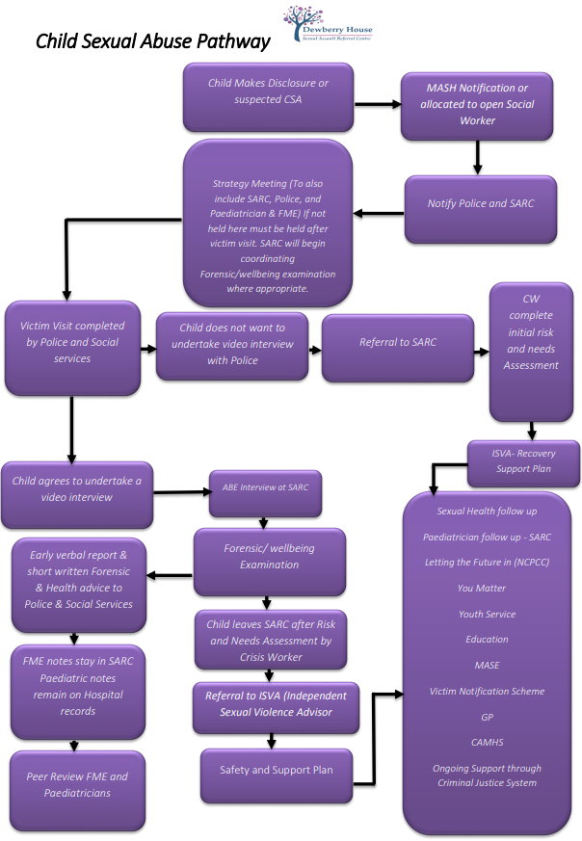
Guidance | Jersey Safeguarding Partnership Board
Next Steps
You have now finished the independent learning ahead of the in-person seminar.
In the seminar, we will reflect on your learning from this module and in particular we will:
- Discuss why behavioural indicators of abuse might be misinterpreted by professionals
- Consider the particular disclosure challenges for children with disabilities
- Use the Centre of Expertise for Child Sexual Abuse’s Signs and Indicators Template to consider a short case study
- Learn about ABE interviews from the States of Jersey Police
Important!
Please bring this workbook to the seminar with you. We will be referring to it throughout the session.

Further Learning/links
The SPB website has a series of 7 Minute Briefings on a range of topics which you can use with your teams to prompt discussion and reflection on practice and systems. You can find 7 Minute Briefings under the Resources page on the website – including an explanation of what they are.
The Research in Practice website is an excellent source of further material.
The SPB has a range of courses which will help you to further your knowledge. Please check our website for further details.

Open the Can of Worms. Written by Tracey Farrell, a mental… | by Blue Knot Foundation | Medium

Emotional Alert!
We acknowledge that this is a sensitive subject – look after yourself and others and seek support if you need it.

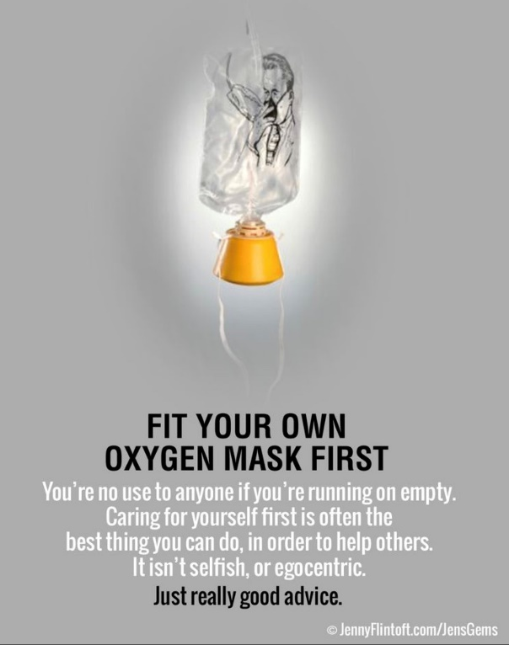

Acronyms
ABE | Achieving Best Evidence
ADRT | Advance Decisions to Refuse Treatment
APVA | Adolescent to Parent Violence and Abuse
ASCIT | Autism and Social Communication Inclusion Team
AWDO | Adult Workforce Designated Officer
CAMHS | Child and Adolescent Mental Health Service
CCE | Child Criminal Exploitation
CDC | Child Development and Therapy Centre
CEOP | Child Exploitation and Online Protection Agency
CEYS | Childcare and Early Years Service
ChiSVA | Children and Young People’s Sexual Violence Advisor
CIN | Child In Need
CLA | Children who are Looked After (formerly known as LAC Looked After Children)
CMHT | Community Mental Health Team
CP | Child Protection
CPC | Child Protection Conference
CQC | Care Quality Commission
CSDL | Capacity and Self-Determination Law
CSE | Child Sexual Exploitation
CYPES | Children Young People Education and Skills
DA(DV) | Domestic Abuse (Domestic Violence)
DBS | Disclosure and Barring Service
DSL | Designated Safeguarding Lead
ECHR | European Convention on Human Rights
EP | Educational Psychologist
EWO | Education Welfare Officer
EYAT | Early Years Advisory Team
EYFS | Early Years Foundation Stage
EYIT | Early Years Inclusion Team
FGM | Female Genital Mutilation
FII | Fabricated or Induced Illness
FLO | Family Liaison Officer
FNHC | Family Nursing and Home Care
GDPR | General Data Protection Regulation
GSF | Gold Standards Framework
HBV | Honour Based Violence
HSB | Harmful Sexual Behaviour
ICA | Independent Capacity Advocate
ICPC | Independent Child Protection Conference
IDVA | Independent Domestic Violence Advisor
IPVA | Inter Personal Violence and Abuse in Young People’s Relationships
ISS | Independent Safeguarding and Standards
ISVA | Independent Sexual Violence Advisor
JCAF | Jersey Common Assessment Framework
JCCT | Jersey Child Care Trust
JCF | Jersey’s Children First
JDO | Jersey Designated Officer
JFCAS | Jersey Family Court Advisory Service
JPACS | Jersey Probation and After-Care Service
JMAPPA | Jersey Multi Agency Public Protection Arrangements
LADO | Local Area Designed Officer (see JDO)
LPA | Lasting Power of Attorney
MAF | Managing Allegations Framework
MARAC | Multi Agency Risk Assessment Conference
MARRAM | Multi Agency Risk Review Action Meeting
MASH | Multi Agency Safeguarding Hub
MSP | Making Safeguarding Personal
NAI | Non Accidental Injury
PBS | Positive Behaviour Support
PPU | Public Protection Unit
PR | Parental Responsibility
RCPC | Review Child Protection Conference
RRRT | Rapid Response and Reablement Team
SALT | Speech and Language Therapy/Therapist
SARC | Sexual Assault Referral Centre
SCR | Serious Case Review
SEMHIT | Social, Emotional and Mental Health Inclusion Team
SEN | Special Educational Needs
SENCO | Special Educational Needs Coordinator
SEND | Special Education Needs and Disability
SNRM | Self-Neglect Risk Management Meeting
SOJP | States of Jersey Police
SOLO | Sexual Offences Liaison Officer
SPB | Safeguarding Partnership Board
SPOC | Single Point of Contact
SPOR | Single Point of Referral
SRoL | Significant Restriction on Liberty
SUDI | Sudden Unexplained Death in Infancy
SUI | Serious or Untoward Incident
TAC | Team Around the Child
TAF | Team Around the Family
YES | Youth Enquiry Service

For information on services in Jersey, please see:
Children & Families Hub www.gov.je/caring/childrenandfamilieshub/Pages/ChildrenAndFamiliesHubHomepage.aspx
Jersey Online Directory www.jod.je
Children with Disabilities Directory www.gov.je/Health/Children/ChildDevelopment/Pages/Centre.aspx
Special Educational Needs pages on gov.je www.gov.je/Education/Schools/Sen/Pages/WhatSupportAvailable.aspx

NOTES

