

Delegate Workbook

Working Together



**About this course**

These materials are part of a learning package that includes self-directed learning via this workbook and an in-person seminar. Please ensure that you have set aside at least 2 hours to complete the work **before** attending the in-person seminar. The seminar will build on your knowledge and understanding and will ask you to reflect on the content of the materials.

You should set up an account with Research in Practice (RIP) if you don’t have one already (see below for instructions on how to set up your account). RIP is a free resource provided by the Safeguarding Partnership Board and contains a wealth of information including videos, briefings, webinars etc which will help you in your work.

All you need is a quiet place to work through the content and/or watch any videos, either alone or in a group. It might be useful, as you read or listen, to jot down thoughts that occur to you about the work you do and any questions or new ideas that come to mind.

**Important!**

**You will need to bring your workbook to the seminar as we will be referring to it on the day.**

**Setting up your account with Research in Practice**

Research in Practice (RIP) supports evidence-informed practice with children and families, young people and adults. RIP brings together academic research, practice expertise and the experiences of people accessing services to develop a range of resources and learning opportunities.

As a partner of the Safeguarding Partnership Board, your organisation is able to access RIP’s resources free of charge. To do this, you will need to set up a RIP account:

Go to [www.researchinpractice.org.uk](http://www.researchinpractice.org.uk) and select ‘create account’ at the top.

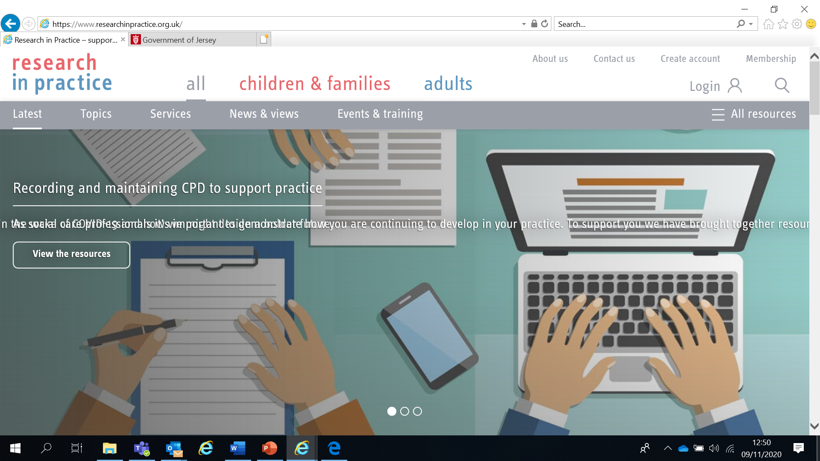

Use your work email and select **‘States of Jersey’** as your organisation from the drop-down list

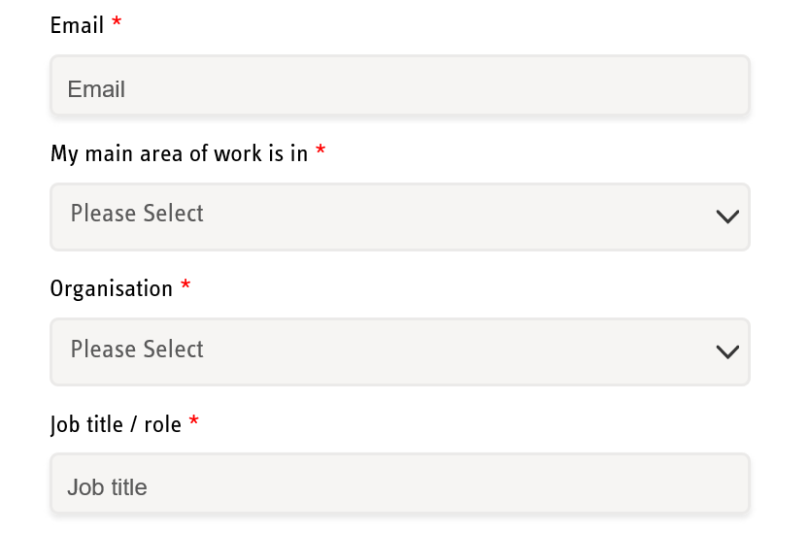

**NOTE: You cannot set up an account with RIP if your work email uses Gmail, Hotmail or other generic accounts. Please contact us if this applies to you.**

Once you have logged in with your new account, the resources are free to download:

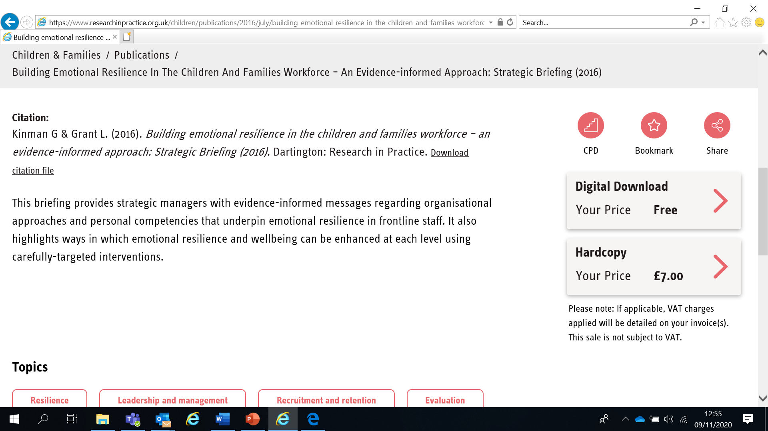

If you have any problems setting up an account, please contact safeguardingtraining@gov.je

**Learning Objectives**

In this module you will:

* Recognise that safeguarding requires working together effectively and sharing information appropriately
* Identify different organisations involved in safeguarding in Jersey and their roles and responsibilities
* Be able to locate the multi-agency policies and procedures which describe how we work together to safeguard children and young people
* Be able to identify a range of organisations in Jersey that support children, young people and their families
* Be able to identify the policy to use to resolve professional differences in relation to the safeguarding needs of children and young people

**Links to Professional Practice**

**SPB:** Child Procedures Manual, Child Workforce Competency Framework

**Intercollegiate Competency Framework:** Level 1 and above

**Top Tips**

**Do the readings** – we've selected reading material that we know will enhance your knowledge and skills

**Do the exercises** – the more you put into this course, the more you will get out of it.  The exercises will give you the opportunity to reflect on what you've read.  You'll get a chance to discuss ideas and ask questions in the seminar

**Emotional Alert!**

We acknowledge that this is a sensitive subject – look after yourself and others.

This content:

* can trigger memories of experiences which were in some way abusive
* can highlight areas of difficulty for individual people who are aware of others or their own personal experiences
* can have an emotional impact on those working to protect children, families and adults
* seek support from your manager if you are upset by any of the materials

**Working Together**

Everyone who comes into contact with children and families has a role to play in safeguarding and promoting the welfare of children. No single practitioner can have a full picture of a child’s needs and circumstances and, if children and families are to receive the right help at the right time, everyone who comes into contact with them has a role to play in identifying concerns, sharing information and taking prompt action

‘*Working Together to Safeguard Children: A guide to inter-agency working to safeguard and promote the welfare of children*’ is the UK government’s statutory guidance for all organisations and agencies who work with, or carry out work related to, children. We follow it in Jersey although it is not statutory yet - the new Children’s Law will enshrine *Working Together* principles in law in Jersey.

**Access a web-enabled version of *Working Together* at** [www.workingtogetheronline.co.uk](http://www.workingtogetheronline.co.uk/) **or download a copy at** [Working Together to Safeguard Children 2018 (publishing.service.gov.uk)](https://assets.publishing.service.gov.uk/government/uploads/system/uploads/attachment_data/file/942454/Working_together_to_safeguard_children_inter_agency_guidance.pdf)

**Safeguarding**

* Protecting children from maltreatment
* Preventing impairment of children’s health or development
* Ensuring that children are growing up in circumstances consistent with the provision of safe and effective care
* Taking action to enable all children to have the best outcomes

***Source: HM Government (2018) Working together to Safeguard Children***

**Child protection**

* Child protection is a part of safeguarding and promoting welfare. It refers to the activity that is undertaken to protect specific children who are suffering, or are likely to suffer, significant harm.
* Effective child protection is essential as part of wider work to safeguard and promote the welfare of children. However, all agencies and individuals should aim to proactively safeguard and promote the welfare of children so that the need for action to protect children from harm is reduced

**The Safeguarding Partnership Board (SPB)**

The Safeguarding Partnership Board’s role is to coordinate work locally which will safeguard children and adults and to monitor and challenge the effectiveness of Jersey’s safeguarding arrangements. It is a non-statutory body with the following key functions:

* Agree and publish multi-agency policies and procedures
* Provide multi-agency training
* Conduct Serious Case Reviews and Rapid Reviews

Membership of the Board consists of representatives from Health and Community Services, Police, Probation, Family Nursing and Home Care, Prison, Honorary Police, Jersey Employment Trust, Customer and Local Services, Adult and Children’s Social Care, Mental Health, NSPCC, Youth Service, CYPES, Primary Care (GPs), Law Officers Department and others.

The Board is supported by a Business Team based at 16 Britannia Place comprising a Board Manager, Policy Officer, Learning & Development Officers, Executive Assistant and Training Administrator.

**SPB Multi Agency Procedures**

The SPB Procedures are online and are for anyone who works with or cares for children who may be at risk of harm. This includes paid or unpaid colleagues, family members and members of the public. The procedures are based on Jersey law and *Working Together* and set out the process of a multi-agency agreement for safeguarding and protecting children and young people

**Read the Introduction section of the Procedures at** <https://jerseyscb.proceduresonline.com/chapters/p_introduction.html>

**Take a moment to bookmark the procedures so that you can access them easily** <https://jerseyscb.proceduresonline.com/index.htm>

**Key Organisations**

An awareness and appreciation of the role of your own and other organisations is essential for effective collaboration. The following organisations are some of those you should be familiar with:

**Safeguarding Partnership Board**

**Adult Social Care Service**

**Alcohol and Drugs Service**

**Ambulance Service**

**Andium Homes**

**Children’s Social Care Service**

**Child & Adolescent Mental Health Service (CAMHS)**

**Education**

**Family Nursing and Home Care**

**GPs**

**Health Care Professionals**

**Jersey Family Court Advisory Service**

**Youth Service**

**Police**

**Prison Service**

**Jersey Probation & After Care Service**

**Registered Childcare Providers**

**Voluntary & Private Sector Organisations**

**Faith Organisations**

***NB This list is not exhaustive***



**Read the Roles and Responsibilities of Agencies and Associated Groups section of the Procedures at** <https://jerseyscb.proceduresonline.com/chapters/p_agency_role.html>

**We will explore the role of agencies further in the seminar.**

Multi-agency working is key to effective safeguarding and child protection. Children and families will access a range of services throughout a child’s life. It’s vital that practitioners work together to gain a full overview of a child’s situation and have a coordinated approach to support.

Serious Case Reviews (SCRs) emphasise the importance of information sharing and collaboration between agencies so that professionals can fully understand any risks a child may be exposed to and take appropriate action to keep them safe.

**What is a Serious Case Review?**

Serious Case Reviews (SCRs) are commissioned by the Safeguarding Partnership Board for cases where abuse or neglect of a child or adult at risk is known or suspected and where either a child/adult at risk has died or a child has been seriously harmed and there is cause for concern about the way in which organisations and their staff have worked together to safeguard the child/adult at risk

SCRs are not about apportioning blame and are not part of any disciplinary process relating to an individual. They are about reviewing whether there are lessons to be learned about multi-agency working and if procedures are effective. They are designed to improve local practice and inter-agency working to reduce the risk of future harm to children and adults at risk.

In the UK they are often made public (and anonymised) but in Jersey full SCRs are rarely published due to concerns around confidentiality. The SPB publishes ‘Learning Reports’ instead that highlight the learning from the SCR.

The process for determining whether to commission an SCR changed in Jersey in 2020 in line with updated guidance in *Working Together*. The first stage is usually to hold a ‘Rapid Review’ where information is quickly gathered and a panel decides the next steps, which could be to progress the case to an SCR, or consider other reviews, meetings or audits.

The decision to progress to an SCR rests with the SPB’s Independent Chair.

Jersey’s SCRs are archived after a period of time. Current SCRs and Learning Reports, as well as the criteria for SCRs and referral forms, are available via the Reports page of our website at [Serious Case Reviews | Jersey Safeguarding Partnership Board](https://safeguarding.je/document-category/serious-case-reviews/)

**Professional challenge**

Working Together 2018 requires organisations to challenge appropriately and hold one another to account effectively. Effective working together depends on a culture of open and honest relationships between agencies; where different professional perspectives are welcomed and given serious consideration by professionals who want the best outcomes for children, families and adults at risk.

**The SPB’s** [Resolving Professional Differences/Escalation Policy](https://safeguarding.je/document-category/policies/) **should be used to escalate unresolved disputes where professional curiosity or challenge has not resolved any professional conflict.**

**Information Sharing and Communication**

SCRs in Jersey and the UK (including Coventry Safeguarding Children Board’s SCR into the death of Daniel Pelka in 2012) often identify **information sharing and communication** as one of the key issues.

Everyone who works with children has a responsibility to share any information that has a bearing on a child’s welfare as early as possible. Practitioners working in adult services should also share any information that has an impact on the wellbeing of a child – eg information about parents’ capacity to provide safe and loving care.

Effective communication includes:

* Being clear about what you are sharing and why
* Following up with written documentation
* Using clear language and describing risk and vulnerability in detail
* Acknowledging information that has been shared with you

Recording is the process of setting down information about something which has taken place so that it is available for future reference, eg information about a person, place, conversation, physical action, decision or thought process. In a safeguarding context, information is collected to evidence need, deliver outcomes and make decisions

**Safeguarding recording has a direct impact on children’s lives.** If not recorded, or not recorded well, the information is effectively rendered useless and unable to fulfil its purpose. If it isn’t recorded somewhere, it didn’t happen!

The Data Protection (Jersey) Law 2018 lists six Data Protection Principles which set enforceable standards for the collection and use of personal data. Information on these is available at <https://jerseyoic.org/media/iwcf3hr2/joic-09a-the-data-protection-principles_3.pdf>

To process ‘Personal Data’ (such as name, age, address) at least one condition from schedule 2 must be met - normally ‘consent’ or ‘vital interests’. Vital interests means the processing is necessary to protect someone’s life. To process ‘Sensitive Data’ (race, ethnicity, sexual life, offences, political opinions, religious beliefs, health) - schedules 2 and 3 must be satisfied. ‘Explicit consent’ required or ‘vital interests’.

The EU General Data Protection Regulation (GDPR) came into effect 25 May 2018 and aims to harmonise data protection laws across Europe. The Data Protection (Jersey) Law 2018 provides the same standard of protection for personal data as the GDPR and both place duties on organisations and individuals to process personal information fairly and lawfully and to keep the information they hold safe and secure.

You should follow your organisation’s policy on information sharing but remember that **fears about sharing information cannot be allowed to stand in the way of the need to protect children. Where there is any doubt regarding the sharing of information, seek advice from your Safeguarding Lead or your organisation’s Data Controller.**

The SPB training module ‘Effective Recording’ has more information on this topic



**The SPB’s Information Sharing Protocol offers in depth information to inform and guide professionals in their decision-making process when considering the sharing of personal information.**

**It is available at** [Policies | Jersey Safeguarding Partnership Board](https://safeguarding.je/document-category/policies/)

**The seven golden rules to sharing information**

1. Remember that the General Data Protection Regulation (GDPR), Data Protection Law (Jersey) 2018 and human rights law are not barriers to justified information sharing but provide a framework to ensure that personal information about living individuals is shared appropriately.

2. Be open and honest with the individual (and/or their family where appropriate) from the outset about why, what, how and with whom information will, or could be shared, and seek their agreement, unless it is unsafe or inappropriate to do so.

3. Seek advice from other practitioners, or your information governance lead, if you are in any doubt about sharing the information concerned, without disclosing the identity of the individual where possible.

4. Where possible, share information with consent, and where possible, respect the wishes of those who do not consent to having their information shared. Under the GDPR and Data Protection Law (Jersey) 2018 you may share information without consent if, in your judgement, there is a lawful basis to do so, such as where safety may be at risk. You will need to base your judgement on the facts of the case. When you are sharing or requesting personal information from someone, be clear of the basis upon which you are doing so. Where you do not have consent, be mindful that an individual might not expect information to be shared.

5. Consider safety and well-being: base your information sharing decisions on considerations of the safety and well-being of the individual and others who may be affected by their actions.

6. Necessary, proportionate, relevant, adequate, accurate, timely and secure: ensure that the information you share is necessary for the purpose for which you are sharing it, is shared only with those individuals who need to have it, is accurate and up-to-date, is shared in a timely fashion, and is shared securely.

7. Keep a record of your decision and the reasons for it – whether it is to share information or not. If you decide to share, then record what you have shared, with whom and for what purpose.

Source: Information Sharing: Guidance for Practitioners and Mangers (DCSF, 2008)





**Read the case study below and identify any barriers to sharing information and any missed opportunities for reporting/information sharing with other agencies. We will discuss this further in the seminar.**

A little boy called Johnny is born in Abidjan. At the age of 7 he is taken by his aunt to live with her in France. He uses a false passport to travel and is then given the name Peter.

Due to not being able to get any benefits in France, the aunt and child move to London in April. They have no home and very little money. Peter can speak no English. The aunt gets a job and the pair move into a hostel during the early weeks. The aunt tells everyone Peter is her son and claims benefits for him.

In June the aunt meets a man on the bus. They begin to talk and explain the pair’s situation. He is very kind and offers the pair a more permanent roof over their head. By July, Peter and his aunt move into the man’s home. The man becomes Peter’s aunt’s new boyfriend.

Within 2 weeks of moving into their new home, Peter needs to go to hospital due to wounds. His aunt explains this is due to Peter having scabies and scratching himself. The doctors alert Child Protection as a precaution and a social worker and police officer are assigned the case.

Two weeks later Peter is back in hospital with scalding to his head and face. The doctors immediately think the wounds have been inflicted upon the child. The aunt is questioned. She tells the CP officers, that she did in fact pour the water over Peter to stop him scratching. This is an Abidjan local tradition to kill the bug that causes scabies and always works. The officers assigned the case decide to cancel a home visit due to Peter having scabies and still being in hospital.

The child is discharged with the aunt after 2 weeks. Her story is found to be culturally acceptable, although the doctor does explain that this is not an acceptable form of healing scabies and explains about medication. The aunt is very grateful to the doctor for his information and thanks him for his help.

Peter very rarely goes to school and his aunt is given official warnings from education welfare regarding this. At home Peter is made to sleep in the bath; he is very skinny and has a very unkempt appearance.

Six months after the move into the aunt’s new boyfriend’s house, Peter’s attendance is no better. He is twice as skinny and the aunt goes to the police to tell them her boyfriend has sexually assaulted Peter. The very next day this allegation is retracted.

The police officer is asked to investigate, however as the aunt does not respond to letters sent regarding this, no further investigation is made.

One month later Peter is rushed to hospital suffering from a combination of malnutrition and hypothermia. Doctors transfer him to an intensive care ward where he later dies.

|  |  |
| --- | --- |
| **Services available in Jersey** | |
| ASCIT | Autism and Social Communication Inclusion Team. Supports schools in their understanding and management of pupils presenting with Autism Spectrum Condition (ASC) or related social communication difficulties. |
| Autism Jersey | Support, social events for children including a sibling support group, holiday play scheme, adult social club |
| Baby Steps | Support new parents with emotional transition to parenthood and building strong relationships with their babies |
| Barnardo’s Plan B | Support, drop-in sessions at Thomas House, mentoring service, decider skills programme in secondary schools |
| Brighter Futures | Supports parents, carers, children and young people with a range of personal development & educational programmes, advice and help |
| Brook | Provides free and confidential sexual health advice to young people under 25 |
| CAMHS | Child and Adolescent Mental Health Service – mental health assessment and therapeutic service for children and young people up to 18 |
| Child Development Centre | Offers assessment, treatment, diagnostic & family support service to U18s with complex developmental and/or health needs |
| Early Bird Programme | Programme for parents/carers of pre-school children who have or have been referred for diagnosis of an autism spectrum disorder |
| Eden House | Government of Jersey short break home for U18s on the autism spectrum and / or who have associated developmental complex needs |
| Educational Psychology | Work with schools, young people & others to reduce barriers to inclusion and improve understanding of special needs |
| Education Welfare Service | Works with children, families, schools and a range of other services to address concerns about attendance, punctuality and welfare |
| EYAT | Early Years Advisory Team – provide support for early years settings |
| EYIT | Early Years Inclusion Team – provide support for pre-school settings |
| Family First | Supports families of children with illnesses who require off-island treatment |
| Farm School | After school and holiday sessions on the farm. Also offers a smaller group session for children aged 6+ with additional needs |
| FNHC | Family Nursing and Home Care. Provides nursing and home care in the community from pre-birth to end of life |
| Frame Football | Football for children and young people with mobility and additional learning needs |
| Inclusion Project | Part of Jersey Youth Service. Youth clubs for young people aged 11-25 with various special needs and disabilities |
| Jersey Child Care Trust | Provides information and services to families, policy makers, childcare providers and other professionals |
| Jersey’s Children First | Standard practice model enabling agencies to work together to ensure children and families access the right help at the right time |
| Jersey Sport | Offer a range of after-school and holiday sessions for children of all abilities. ‘Sportability’ sessions for those with additional needs |
| JSAD | Jersey Sports Association for the Disabled – sport for those of all ages with a disability |
| Mavericks Performing Arts | Performing arts group for children and adults with disabilities, special needs and / or any additional needs |
| MECSH | Maternal Early Childhood Sustained Home-Visiting. Programme supporting child development and parent education |
| Mind Jersey | Mental health charity. Offers a range of services for adults, children and young people |

|  |  |
| --- | --- |
| **Services available in Jersey** | |
| Motion Studio | Term time and holiday courses on animation and digital art. Staff are SPELL (autism) trained |
| My Time for Young Carers | Activity and support sessions for U18s – including holiday programmes |
| NSPCC Letting the Future In | Therapeutic service for children age 4-17 who have made a disclosure of sexual abuse |
| Oakwell | Government of Jersey short break home for U18s with a range of additional needs including life limiting conditions |
| Parentscope | Free, regular drop—in session where parents and carers of children aged 3-16 can access a range of qualified professionals |
| Portage | Home-based educational support for pre-school children with special educational needs |
| Positive Behaviour Support | Supports professionals, carers and families to understand and respond effectively to behaviour that challenges |
| Riding for the Disabled | Weekly riding sessions for disabled children and adults |
| SALT | Speech and Language Therapy. |
| SEMHIT | Social Emotional & Mental Health Inclusion Team. Works with schools to provide advice and support on managing challenging behaviour |
| Short Breaks | For children and young people with disabilities. |
| Silkworms | Support programme for children aged 7-12 affected by a loved one’s chemical dependency |
| The Bridge | Multi agency community facilities offering an accessible one-stop shop for families and young people |
| Triple P/Stepping Stones | Positive Parenting Programme for parents and carers of U18s. Stepping Stones is for parents and carers of children with special needs |
| Youth Arts | Offer gig and performance opportunities plus a range of courses, events and weekly workshops on music, dance, drama and visual arts |
| Youth Service | Provide a range of personal and social development opportunities for young people aged 12-18 |
|  |  |
|  |  |
|  |  |
|  |  |
|  |  |
|  |  |
|  |  |
|  |  |

The above list is not exhaustive. For more information on the above services, or other services in Jersey, please see the Children & Families Hub (www.gov.je/caring/childrenandfamilieshub/Pages/ChildrenAndFamiliesHubHomepage.aspx), Jersey Online Directory ([www.jod.je](http://www.jod.je)), Children with Disabilities Directory (www.gov.je/Health/Children/ChildDevelopment/Pages/Centre.aspx) or Special Educational Needs pages on gov.je ([www.gov.je/Education/Schools/Sen/Pages/WhatSupportAvailable.aspx](http://www.gov.je/Education/Schools/Sen/Pages/WhatSupportAvailable.aspx))

**Next Steps**

You have now finished the independent learning ahead of the in-person seminar.

In the seminar, we will reflect on your learning from this module and in particular we will:

* **Discuss a range of organisations and their roles and responsibilities in safeguarding**
* **Consider the case study of Johnny/Peter**
* **Consider another case study to identify good practice**

**Important!**

**Please bring this workbook to the seminar with you. We will be referring to it throughout the session.**

**Further Learning**

The [**SPB website**](https://safeguarding.je/) has a series of 7 Minute Briefings on a range of topics which you can use with your teams to prompt discussion and reflection on practice and systems. You can find 7 Minute Briefings under the [**Resources**](https://safeguarding.je/resources/) page on the website – including an explanation of what they are.

The Research in Practice website is an excellent source of further material.

The SPB has a range of courses which will help you to further your knowledge. Please check our website for further details.

**Acronyms**

|  |  |
| --- | --- |
| ABE | Achieving Best Evidence |
| ADRT | Advance Decisions to Refuse Treatment |
| APVA | Adolescent to Parent Violence and Abuse |
| ASCIT | Autism and Social Communication Inclusion Team |
| AWDO | Adult Workforce Designated Officer |
| CAMHS | Child and Adolescent Mental Health Service |
| CCE | Child Criminal Exploitation |
| CDC | Child Development and Therapy Centre |
| CEOP | [Child Exploitation and Online Protection Agency](https://jerseyscb.proceduresonline.com/local_keywords/ceop.html) |
| CEYS | Childcare and Early Years Service |
| ChiSVA | Children and Young People’s Sexual Violence Advisor |
| CIN | Child In Need |
| CLA | Children who are Looked After (formerly known as LAC Looked After Children) |
| CMHT | Community Mental Health Team |
| CP | Child Protection |
| CPC | [Child Protection Conference](https://jerseyscb.proceduresonline.com/local_keywords/cpc.html) |
| CQC | Care Quality Commission |
| CSDL | Capacity and Self-Determination Law |
| CSE | Child Sexual Exploitation |
| CYPES | Children Young People Education and Skills |
| DA(DV) | Domestic Abuse (Domestic Violence) |
| DBS | Disclosure and Barring Service |
| DSL | Designated Safeguarding Lead |
| ECHR | [European Convention on Human Rights](https://jerseyscb.proceduresonline.com/local_keywords/echr.html) |
| EP | Educational Psychologist |
| EWO | Education Welfare Officer |
| EYAT | Early Years Advisory Team |
| EYFS | Early Years Foundation Stage |
| EYIT | Early Years Inclusion Team |
| FGM | Female Genital Mutilation |
| FII | Fabricated or Induced Illness |
| FLO | Family Liaison Officer |
| FNHC | Family Nursing and Home Care |
| GDPR | General Data Protection Regulation |
| GSF | Gold Standards Framework |
| HBV | Honour Based Violence |
| HSB | Harmful Sexual Behaviour |
| ICA | Independent Capacity Advocate |
| ICPC | Independent Child Protection Conference |
| IDVA | Independent Domestic Violence Advisor |
| IPVA | Inter Personal Violence and Abuse in Young People’s Relationships |
| ISS | Independent Safeguarding and Standards |
| ISVA | Independent Sexual Violence Advisor |
| JCAF | Jersey Common Assessment Framework |
| JCCT | [Jersey Child Care Trust](https://jerseyscb.proceduresonline.com/local_keywords/jcct.html) |
| JCF | Jersey’s Children First |
| JDO | Jersey Designated Officer |
| JFCAS | [Jersey Family Court Advisory Service](https://jerseyscb.proceduresonline.com/local_keywords/jfcas.html) |
| JPACS | [Jersey Probation and After-Care Service](https://jerseyscb.proceduresonline.com/local_keywords/jpacs.html) |
| JMAPPA | Jersey Multi Agency Public Protection Arrangements |
| LADO | Local Area Designed Officer (see JDO) |
| LPA | Lasting Power of Attorney |
| MAF | Managing Allegations Framework |
| MARAC | [Multi Agency Risk Assessment Conference](https://jerseyscb.proceduresonline.com/local_keywords/marac.html) |
| MARRAM | [Multi Agency Risk Review Action Meeting](https://jerseyscb.proceduresonline.com/local_keywords/marams.html) |
| MASH | Multi Agency Safeguarding Hub |
| MSP | Making Safeguarding Personal |
| NAI | Non Accidental Injury |
| PBS | Positive Behaviour Support |
| PPU | Public Protection Unit |
| PR | Parental Responsibility |
| RCPC | Review Child Protection Conference |
| RRRT | Rapid Response and Reablement Team |
| SALT | Speech and Language Therapy/Therapist |
| SARC | Sexual Assault Referral Centre |
| SCR | [Serious Case Review](https://jerseyscb.proceduresonline.com/local_keywords/scr.html) |
| SEMHIT | Social, Emotional and Mental Health Inclusion Team |
| SEN | [Special Educational Needs](https://jerseyscb.proceduresonline.com/local_keywords/sen.html) |
| SENCO | Special Educational Needs Coordinator |
| SEND | Special Education Needs and Disability |
| SNRM | [Self-Neglect Risk Management Meeting](https://jerseyscb.proceduresonline.com/local_keywords/snrm.html) |
| SOJP | States of Jersey Police |
| SOLO | Sexual Offences Liaison Officer |
| SPB | [Safeguarding Partnership Board](https://jerseyscb.proceduresonline.com/local_keywords/spb.html) |
| SPOC | Single Point of Contact |
| SPOR | Single Point of Referral |
| SRoL | Significant Restriction on Liberty |
| SUDI | Sudden Unexplained Death in Infancy |
| SUI | Serious or Untoward Incident |
| TAC | Team Around the Child |
| TAF | Team Around the Family |
| YES | [Youth Enquiry Service](https://jerseyscb.proceduresonline.com/local_keywords/yes.html) |

**For information on services in Jersey, please see:**

**Children & Families Hub** [www.gov.je/caring/childrenandfamilieshub/Pages/ChildrenAndFamiliesHubHomepage.aspx](http://www.gov.je/caring/childrenandfamilieshub/Pages/ChildrenAndFamiliesHubHomepage.aspx)

**Jersey Online Directory** [www.jod.je](http://www.jod.je)

**Children with Disabilities Directory** [www.gov.je/Health/Children/ChildDevelopment/Pages/Centre.aspx](http://www.gov.je/Health/Children/ChildDevelopment/Pages/Centre.aspx)

**Special Educational Needs pages on gov.je** [www.gov.je/Education/Schools/Sen/Pages/WhatSupportAvailable.aspx](http://www.gov.je/Education/Schools/Sen/Pages/WhatSupportAvailable.aspx)

NOTES