IN PARTNERSHIP WITH
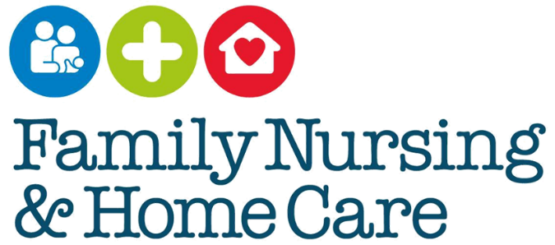

Multi-Agency Pre-Birth Protocol for Unborn Babies

Date approved July 2020

DOCUMENT PROFILE
Document Registration | TBC
Document Type | Policy
Title | Multi-Agency Pre-Birth Protocol for Unborn Babies
Authors | Jenny Querns - Safeguarding Lead for Adults and Children - Family Nursing and Home Care (FNHC) Patricia Marius -Named Nurse Interim Designate Lead  Catherine Houlder – Team Lead Midwife  Giselle Camm – Midwife  Sarah Samson – Midwife  Greg McDonald – Senior Practitioner Multi-Agency Safeguarding Hub  Dr Kate Wilson – Safeguarding Lead GP Children  Dr Penny Le Bas – Safeguarding Lead GP Adults  Pauline Huelin – Paediatric Liaison Health Visitor  Carly Lucas – Manager of the Independent Domestic Violence Advisory Service  Laura Hunter – Manager of Drug and Alcohol Services  Tim Malpas – Designate Lead Paediatrician
Publication date | May 2020
Target audience | Health and Community Services (HCS),  Community Young People and Education Skills (CYPES),  GP’s, Consultants, Midwives, Health Visitors, Nurses, Social Workers, aligned professionals who work with pregnant women.
Circulation list | HCS Intranet
Description | This is a multi-agency working protocol for unborn babies. With the agreed communication and care pathway between GP’s, Midwives, Health Visitors, Children’s Social Care and aligned supportive services to safeguard the health and well-being of unborn babies. The protocol is relevant to all professionals who work with pregnant woman, following the protocol enables pregnant woman access to the right help at the right time to protect the health of their unborn baby.  We work to empower families to identify their own needs and support them to find solutions. GP’s, Midwives and Health Visitors have particular responsibilities, however all practitioners who become aware of vulnerability and risk, need to act to protect unborn babies.  Safeguarding is everyone’s responsibility.
Linked policies | SPB Jersey Multi-Agency Child Protection Procedures 2015,  FNHC Safeguarding Adults and Children 2019,  SPB Jersey Adults Safeguarding Policy 2019,  SPB Jersey Delivering Effective Support for Children and Families understanding the Continuum of Children’s Needs 2019.
Approval forum | HCS, FNHC Governance, SPB
Review date | 1 year from publication due to rapid changes in HCS
Contact details | Jenny Querns Safeguarding Lead for Adults and Children j.querns@fnhc.org.je

CONTENTS LIST:

1. Introduction Page 4 - 5

2. Policy / Guideline purpose Page 5 - 6
2.1 Rationale page 5
2.2 Scope page 6
2.3 Principle page 6

3. Corporate Procedures Pages 7 - 17
3.1 Procedure page 7
3.2 Consent and Information Sharing page 8
3.3 Indicators presenting emerging need page 9 - 10
3.4 Indicators presenting the need for pre-birth assessment page 10
3.5 Purpose of a pre-birth assessment page 11
3.6 Working with prospective fathers/significant others page 11
3.7 Mental Health page 12
3.8 Young Parents page 12
3.9 Domestic abuse page 12
3.10 Alcohol page 13
3.11 Substance use page 14
3.12 Smoking page 14
3.13 Concealed pregnancy and Surrogacy page 15
3.14 The Post Natal Period page 15
3.15 Transfer to Health Visiting Service page 16
3.16 Escalation and Resolution Process page 17

4. Development and consultation process Page 17 - 18
4.1 Consultation Schedule page 17 - 18

5. Reference documents Page 18

6. Bibliography Page 20

7. Glossary of terms Page 21

8. Implementation plan Page 22

9. Appendices (to be used as stand-alone documents to guide practice)
Appendix 1 Multi-Agency Pre-Birth Referral Pathway
Universal Service
Early Help
Risk if significant harm
Appendix 2 Joint Health Needs Assessment
Appendix 3 Domestic Abuse Guidance for Professionals

- INTRODUCTION

  - The multi-agency protocol for pre-birth assessment sets out the requirements of partnership agencies, establishes how organisations should work together and details commitments and safeguarding standards as set out in the Safeguarding Partnership Board (SPB) Memorandum of Understanding, (2019) MOU

Recognising pregnant women and their partners, (if applicable) want the best for their unborn baby. The majority will meet the health and well-being needs of their unborn baby with a Universal service of care. It recognises that some may require a Right Help Right Time programme of Early Help. That some may be at risk of significant harm and require pre-birth assessment through children’s social work, where following assessment they may require a Child in Need or Child Protection plan of care (Appendix 1). Continuum-of-Need

  - The Children and Families Hub provides a single point of contact for children, young people and families who require additional support to ensure they are safeguarded and protected. The contact details for the Children and Families Hub is 01534 519000, email childrenandfamilieshub@gov.je.

The Children and Families Hub electronic referral form (which replaces MASH Enquiry Form and Early Help Referral Forms) can be accessed at:-

https://www.gov.je/caring/helpsupportchildrenfamilies/pages/childrenandfamilieshub.aspx

  - The Jersey’s Children First Practice Framework supports the work of the child and families hub. Jersey Children First in Practice

  - When thinking about how to support families, practitioners need to consider the unique protective and risk factors in the context families are living (SPB 2019). It is important to capture the lived experience and the voice of the unborn baby. Using structured professional judgement (enhanced professional judgement supported by the use of evidence-based tools for assessment), (Pfister HR and Bohm G 2008, Munro 1999).

  - The antenatal period and a child’s first year of life are extremely important, as this is where the foundations of physical, emotional, social development and attachment are lain, (Bowlby 1969). The way a baby develops in utero is affected by the toxic substances it may be exposed to such as alcohol, substances and stress have lifelong negative impacts on the child, www.beginbeforebirth.org

  - Practitioners should follow a “Think Family”, child centred approach, (SCIE 2012). The pre-proceedings process begins during pregnancy and provides a framework for working with parents in the antenatal period, when there are concerns that a baby may be at risk of significant harm, (DfE 2014)

  - Children have a right to life, survival and development (Article 6, ECHR, 2000). (Subject to Termination of Pregnancy (Jersey) Law 1997). The best interests of the child take priority once the child is born, (Article 3, ECHR 2000). The “paramountcy principle” recognises the best interests of the child within their families, with their parents playing a full part in their lives, unless compulsory intervention in family life is necessary (Working Together 2018 p9).

  - When a woman presents for antenatal care her midwife will begin a Joint Health Needs Assessment (Appendix 2). This is a shared piece of work with the client’s GP and health visitor. The midwifery service works in partnership to support the pregnant woman until the case transfers to the health visiting service post birth.

  - This assessment determines the care and the tiered response the client will require to meet her unborn child’s needs. Midwives may initiate the communication between professionals, however, developing and maintaining communication pathways is the responsibility of all professionals and not solely reliant on the midwife.

  - Working Together to Safeguard Children (2018) states “Everyone who works with children has a responsibility to keep them safe, no single practitioner can have a full picture of a child’s needs and circumstances and if children and families receive the right help at the right time, everyone who comes into contact with them has a role to play” (p11).

  - Evidence shows children under the age of one are eight times more likely to die than any other age group of child, the risk is greatest in the first three months after birth (Cuthbert et al 2011). Serious case reviews recognise that there have been failings and a timely pre-birth assessment to detect and address problems early would have made the difference to the outcome for that child, (DfE 2014).

  - Unlike many safeguarding situations, the antenatal period gives a window of opportunity for practitioners and families to work together to form relationships and decide the on-going support they may require. This can be a unique time with a family, where they can focus, on the need of their unborn baby and make positive change, (SPB 2019).

- POLICY / GUIDELINE PURPOSE

  - Rationale

    - To provide a referral pathway with standardised antenatal communication and joint health needs assessment, (Appendix 2)
    - To maintain high quality holistic care to pregnant women and their unborn baby.
    - Ensure relevant and proportionate information sharing between professionals with the pregnant woman and prospective father/significant other carer’s with consent, (unless to gain consent raises the risk to the unborn baby or pregnant woman).
    - Provide a plan of support that is seamless from the antenatal to the post-natal period.
    - Enable health and social care professionals to form individual planned care with each family; using evidence based assessment with shared information.
    - Promote ongoing collaboration, assessment and care plan review by all professionals involved with the family
    - Increase practitioner awareness of high quality intervention programmes available in Jersey, which offer support in the antenatal period and beyond, how to access and make referral.

  - Scope

    - The multi-agency protocol is relevant to:-
- Midwives,
- Heath Visitors,
- GPs,
- Children’s Social Workers,
- School Nurses,
- Paediatric Nurses,
- Registered General Nurses
- Paediatricians,
- Obstetricians

    - There is a wider network of professionals, who should have awareness of this protocol. Aligned professionals may identify concerns for the health and well-being of an unborn baby or pregnant woman:-

- Police
- Probation
- Independent Domestic/Sexual Violence Advisers
- Sexual Assault Referral Centre (SARC)
- Brook
- Drug and Alcohol services
- Adult Mental Health Services
- Youth Services
- Community and Local Services (this list is not exhaustive)

  - Principles

    - To safeguard unborn babies through timely multi-agency communication between healthcare professionals, children’s social work and aligned professionals.
    - Outline the responsibility of all professionals to take action when they recognise risk to an unborn baby, and their requirement to follow the right help at the right time programme.
    - Enabling, timely children’s social work pre-birth assessment and a plan of care to optimise the outcomes for unborn babies at risk of significant harm.

- CORPORATE PROCEDURE

  - Procedure

    - A woman’s first point of contact is often the GP. It is the responsibility of the GP to share relevant and proportionate information with the Midwife on making their clients referral for antenatal care, (ideally by 12 weeks gestation), (Appendix 1).

    - The initial point of contact with the Midwife is at the booking appointment. Where the midwife will begin the Joint Health Needs Assessment, (Appendix 2). (The information obtained is dependent on the information provided by the pregnant woman and family unless other professionals have shared information prior to this point.)

    - The Midwife is responsible for making a referral to the Health Visitor, it is the responsibility of the Health Visitor to access the Joint Health Needs Assessment and add to this joint working document.

    - The Joint Health Needs Assessment is shared with the health visitor by 28 weeks gestation, where the Health Visitor will add to the assessment through antenatal assessment. There will be continued communication between the Midwife, Health Visitor, and GP until Midwifery discharge post-delivery.

    - On receipt of the referral, it is the responsibility of the Health visitor to review the records pertaining to the family and at the earliest opportunity share any relevant health or social history pertaining to the pregnant woman/family with the Paediatric Liaison Health Visitor, the Midwife and GP.

    - This must include any information, which may affect the welfare of the pregnant woman and unborn baby and the safety of professionals.

    - The Joint health needs assessment provides a core of information, identifies emerging need, communication between services, and should detail action taken around referral to the Child and Family Hub.

    - As well as detailing referral to universal services, e.g. Universal Baby Steps, and targeted services such as Maternal Early Childhood Sustained Home Visiting (MECSH), and Parenting in Mind, (PIM) NSPCC.

    - Where a pregnant woman sees only her GP or a Consultant Obstetrician (Private Arranged Care) then it is the responsibility of the GP and consultant obstetrician to identified health and social need. They must make referral to the Children and Family Hub and liaise with midwifery, to follow referral criteria for extra support where there is identify need.

    - Cases with emerging need must be raised to the Antenatal Multi-Disciplinary Monthly Meeting (Antenatal MDT) where a Lead Midwife, the Paediatric Health Visitor Liaison Nurse, MESCH Champion, Children’s Social Worker, Adult Mental Health, Independent domestic violence/sexual abuse and Drug and Alcohol advisors meet to discuss cases with emergent need.

    - Referrals to the Antenatal MDT can be made my midwives, health visitors, GP’s, Safeguarding Health and/or Safeguarding Lead Nurse for Adults and Children FNHC.

    - At Antenatal MDT the Lead Midwife, Paediatric Liaison Health Visitor and aligned professionals will assess need, plan ongoing actions, analyse outcome of actions to date. They will liaise with the team around the child and take further steps to ensure the needs of the unborn baby are met in a timely fashion and that cases do not drift without appropriate action being taken prior to the child’s birth.

    - All professionals involved with the family have a responsibility for ongoing communication and collaborative working with support for practice decisions taken as required from the Lead Midwife, the Named/Lead Nurse for Safeguarding and/or the Designated Lead Nurse as required.

  - Consent and Information Sharing

    - Practitioners must gain consent to share information (this needs to be clearly documented). Recording the decision-making and reason for sharing information, documenting what you have shared, with whom and for what purpose, (Working Together, 2018, Data Protection (Jersey) Law 2018). Jersey Law

    - In gaining consent, practitioners must be open and honest with families and respect the wishes of those who do not consent to share confidential information unless to do so would place the unborn baby, child or person at risk of significant harm.

    - Information can be shared without consent if a practitioner has a reason to believe that the sharing of information will enhance the safeguarding of an unborn baby or child in a timely manner (HM Government 2018).

    - The Data Protection (Jersey) Law 2018 contains “safeguarding children and individuals at risk” as a processing condition that allows sharing of information without consent:-

- where it is not possible to gain consent;
- it cannot be reasonably expected that a practitioner gain consent;
- to gain consent would place a child or individual at risk
- If consent is refused and there is actual or potential risk of significant harm referral to the child and family hub must be forwarded, documenting the reason for referral without consent.
- If the mother of the unborn baby is a child herself, consent for referral to the child and family hub may be sought from the pregnant child or from her parents. The pregnant child will require a referral to the child and family hub in her own right and the unborn baby will need a separate referral to the child and family hub at 12 weeks gestation.

  - Indicators which may present emerging need:-

- smoking in pregnancy with a wish for support to stop
- low level concerns around alcohol or recreational substance use prior to falling pregnant
- feeling anxious for no good reason
- feeling worried about finances
- inadequate housing
- lacking of support or feeling isolated
- experiencing physical health needs, that are managed but may require support when they have their baby
- experiencing emotional or mental health, which is managed but may require support when they have their baby
- suffering from unresolved loss or grief
- a single parent and/or the only adult in the home when they give birth
- described adversity in their childhood (ACE’s) which plays on their mind (McCrory et al, 2015)
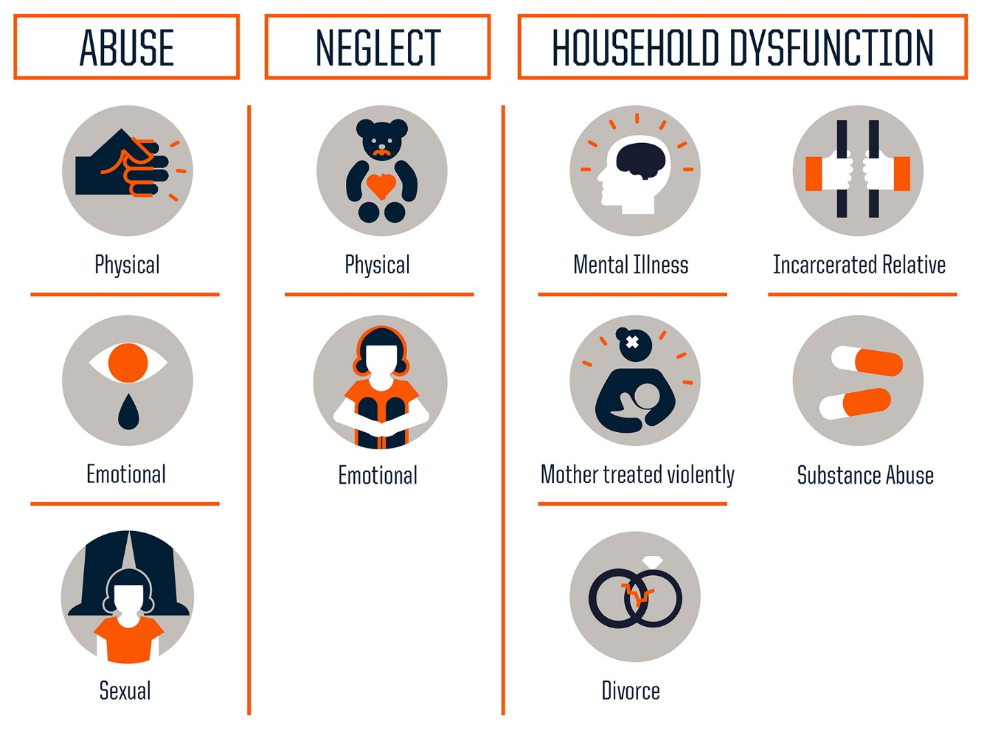

- A single agency health response can help with the offer of referral for evidenced based support for smoking cessation, support with lower level anxiety and mental healthfrom Pregnancy in Mind (PIM),, universal Baby Steps and MECSH.
- Alternatively, referral with consent can be made for extra support through the childrenandfamilieshub@gov.je where the family can be supported through an early help programme. (Appendix 1 Flow Chart Amber Pathway). Whilst in parallel referring forevidenced based support.

  - Indicators which may present need for pre-birth assessment, where the pregnant woman (including risk indicators with regards to the father or significant other person who will help the pregnant woman care for the baby when born):-

- under the age of 16 (or 18 without visible means of support)
- a looked after child or leaving care themselves, (both pregnant woman and prospective father/or significant other to be taken into account)
- clients whose previous child have died in suspicious circumstances, suffered significant harm or were removed from their care
- clients with children on the child protection register, or have had previous involvement with children’s services
- clients who have children who are looked after with other people or other family members
- late booking in this pregnancy (after 15 – 20 weeks) or have concealed the pregnancy
- living in an unsuitable physical environment to bring a baby home to or present as homeless
- clients who present with behaviours during assessment which give rise to professional concern
- experiencing emotional or mental health, a physical disability or learning disability that will have an impact on their capacity to care for their baby
- presenting with or disclose indicators of domestic abuse
- presenting with indicators of alcohol/substance misuse which will have an impact on their capacity to care for their baby
- clients who have a relative or associate who may represent a risk to children by having previously harmed a child, (this would include a history of significant criminal activity; sexual offences against adults or children, violent crime)
- disclosing the experience of female genital mutilation, forced marriage, risk of honour based violence, (DOH 2016 and HM Gov 2019)
- DOH-Female-Genital-Mutilation-Risk-and-Safeguarding-2016
- Mutli-agency-practice-guidelines-Handling-cases-of-Forced-Marriage
- presenting with a wish or intent to relinquish the baby for adoption after birth
- presenting with indicators they are at risk of child sexual exploitation, Child-Sexual-Exploitation there are concerns around sexual abuse within the family or the mother identifies as a sex worker CSA-Pathway
- Have a history of suspected of Fabricated or Induced Illness (FII)
- This is not an exhaustive list and a pregnant woman who presents with any other significantly worrying concern or a practitioner who identifies as having professional judgment that an unborn baby may be at risk of significant harm must act on their assessment of need.
- In these cases a referral with consent (or without if this would raise the risk to the unborn baby or the pregnant woman) must be forwarded to the childrenandfamilieshub@gov.je with request for pre-birth assessment. (Appendix 1 Flow Chart Red Pathway).
- Whilst in parallel referring for l for evidenced based support with smoking cessation, alcohol and drug services, adult mental health, Pregnancy in Mind (PIM), NSPCC, Baby Steps and MECSH.

  - The purpose of the pre-birth assessment is to identify:-

- The current risk to the unborn baby and work in partnership with the pregnant woman, father/significant other to reduce risk for the child when born
- To analyse the prospective parents capacity to change and respond to the needs of their child/children, taking into account current and historical concerns which will impact on safe parenting
- Identify the support prospective parents may need to achieve sustained change.
- Use the antental period as a window of time to reduce the risk to the unborn baby and child when born by accessing evidence based supportive programmes. Smoking Cessation (HCS); Drug and Alcohol Support services (HCS); Universal antenatal Baby Steps (FNHC); Pregnancy in Mind (NSPCC):MECSH) (FNHC); psychological and psychiatric support for parents through talking therapies/adult mental health/advocacy services, (this list is not exhaustive).

  - Working with Partners/Fathers and those identified as being prospective significant carers for the unborn child

- Partners/Fathers and people identified as prospective significant carers play an important role during pregnancy and after. It is important to record full names (dates of births, telephone numbers) of partners and/or those adults identified as being a significant carer for the unborn baby.
- Consent to share information should be sought from the pregnant woman’s partner however consideration should be given to whether asking consent from a mothers partner may put her at increased risk. If so consent should not be sought and proportionate information shared via children and families hub enquiry.
- Partners should be involved in the joint health needs assessment and asked directly about their life style choices such as drug and alcohol use, and offered referral to evidence based support based on their need.
- Information about partners who are not the biological parent should be gathered to ensure risk factors can be identified, (Brandon et al, 2017 cited in Research in Practice 2017).
- Involving fathers (partners/significant carers) in a positive way is important in ensuring a comprehensive assessment and this should include where they are not living together.
- Pregnant woman who ‘gate-keep’ (withhold) a father’s/partner’s identity gives rise to risk. Practitioners should ask at every meeting and challenge for the sake of the unborn baby (Research in Practise 2017).
- Aligned professionals who become aware of concerning relevant health or social history pertaining to the pregnant woman, their partner or any significant family member should make a children and families hub enquiry or adult safeguarding referral if the adult is at risk of significant harm.

  - Mental Health

- Pregnant women with a history of mental health problems will be offered an integrated care plan in the antenatal and postnatal period, (Nice Guidance 2014 updated 2020).
- They require care and treatment for their mental health, which takes into account the impact that pregnancy, may have on their mental health and the impact medication and stress may have on the unborn baby (Bergman et al 2007).
- Tools, which support practice decisions, are the Whooley Questions, Edinburgh Post Natal Depression Score and General Anxiety Disorder Scores 2 and 9, practitioners will follow single agency process and should use professional judgement around which tool and when to make assessment and referral to supportive mental health services.
- Practitioners will seek to obtain a psychiatric assessment where necessary and follow NICE Guidance and local mental health referral pathway.
www.nice.org.uk/guidance/Recommendations

Pathways/antenatal-and-postnatal-mental-health/identifying-and-assessing-mental-health-problems-in-pregnancy-and-the-postnatal-period

  - Young parents

- Teenagers who become parents may experience more educational, health, social and economic difficulties; consequently, their children may be exposed to greater social deprivation and disadvantage.
- Teenage mothers in leaving care services experience similar difficulties to those faced by all young mothers. However, they are less likely to have consistent, positive support from their families.
- Pre Birth Assessment should be considered if the pregnant women’s partner is leaving the care system. This should be irrespective of whether the mother herself is or was looked after child, (PHE 2016).
LGA_Framework_for_supporting_teenage_mothers_&_young_fathers

  - Domestic Abuse

- Professionals should take a supportive pro-active approach to screening for domestic abuse. If you don’t ask your client is unlikely to share, www.safelives.org.uk.
- It is not safe to ask a woman in front of her partner about domestic abuse, time must be made to ask her on her own.
- Indicators, which may raise suspicion around domestic abuse are highly significant and should be acted upon, and these can bedelayed pregnancy care, concealed pregnancy, history of miscarriage, premature labour, frequent urine infection, vaginal bleeding, bruising, increased anxiety, depression.
- Follow the Domestic Abuse Pathway (Appendix 3), recognise, respond, refer and record.
- On disclosure or on professional judgment refer to https://www.jdas.je/. With concurrent referral detailing concerns to the childrenandfamilieshub@gov.je
- Practitioners should be prepared and ask crucial questions on more than one occasion, as people who are living with domestic abuse may take time to disclose.
- If there is a known social history of domestic abuse pertaining to the expectant mothers partner/wider family, which may pose a risk of harm, refer to https://www.jdas.je/ and childrenandfamilieshub@gov.je detailing concerns.
- It is important to note that high-risk domestic abuse can be referred to both agencies without consent, if consent can’t be made or would raise the risks to the pregnant woman or the unborn child.
- Practitioners may wish to assess risk using CAADA DASH risk indicator checklist although referral to the independent domestic violence advisory service is not dependent on this risk having been assessed Safelives.org.uk DASH

  - Alcohol

- Department of Health advice is to avoid alcohol completely in pregnancy; as there is no conclusive evidence to indicate a safe exposure in pregnancy, (DOH 2016).
- The risks are present to the unborn baby once placental flow commences and the foetus is connected to the mother. Alcohol damages cells necessary for growth and disrupts connections in the brain and brain damage is irreversible. Foetal Alcohol Syndrome (FAS) is caused by alcohol consumption and effects include:

- Pre and post-natal growth retardation
- Adverse effects on the central nervous system (learning difficulties/behavioural problems)
- Facial abnormalities in FAS

- Foetal Alcohol Spectrum Disorder (FASD) reported at lower levels as it is not easy to determine. This is an umbrella term for several diagnoses related to in utero exposure to alcohol at any time during pregnancy. Babies with this type of brain damage may not have classic features are affected and often undiagnosed or misdiagnosed e.g. Attention Deficit Hyperactivity Disorder (ADHD) or Autism as they get older.
- It is important to give pregnant women this information, if a woman denies using alcohol, it is still important to inform them that if they do drink in their pregnancy then they may cause irreversible brain damage to their child.
- This is a hard hitting message but one that is supported by woman who have gone on to have children born with FAS/FASD who state they wish someone had told them when they were pregnant not to drink alcohol, (Dr Susan Turnbull, Public Health Seminar Jersey 2019).
- Practitioners may wish to help a pregnant women assess their alcohol use using a recognised Audit Tool. Drugabuse.gov
- If a pregnant woman is concerned about their alcohol use, or are alcohol dependant, it is dangerous for them to stop drinking without specialist support.
- Refer to the Alcohol Pathway team for support https://www.gov.je/Health/AlcoholDrugs
- With concurrent referral to childrenandfamilieshub@gov.je with consent (or without consent if to do so would raise the risks to the unborn baby or the pregnant woman).

  - Substance Use

- Babies are not born addicted, but can suffer distressing withdrawal symptoms. Drugs can have harmful effects on the embryo or foetus at any stage during pregnancy, (Racine et al, 2009).
- Most drug-using women are of child-bearing age. Substance misuse is often associated with poverty and other social problems, therefore pregnant drug using women may be in poor general health, they often smoke and drink alcohol and are may live in domestically abusive relationships.
- Substance misuse during pregnancy increases the risk of:-

- having a premature or low weight baby,
- the baby suffering symptoms of withdrawal from drugs used by mother during pregnancy,
- the death of the baby before or shortly after birth,
- Sudden Infant Death Syndrome,
- Physical and neurological damage to the baby before birth, particularly if violence accompanies parental use of drugs or alcohol.

- It is possible exposure at any stage could have a lasting effect on a child’s learning and behaviour.
- Drugs taken shortly before term can have an adverse effect on labour or the neonate after delivery. Not all damaging effects of intrauterine exposure to drugs or alcohol are obvious at birth as some become evident later in life.
- Refer substance using clients for support to the Drug and Alcohol Team https://www.gov.je/OpiateHelp
- With concurrent referral to childrenandfamilieshub@gov.je with consent (or without consent if to do so would raise the risks to the unborn baby or the pregnant woman, or if you are unable to gain consent)

  - Smoking

- Helping pregnant women who smoke to quit involves communicating in a sensitive, client-centred manner, particularly as some pregnant women find it difficult to say that they smoke. Such an approach is important to reduce the likelihood that some of them may miss the opportunity to get help, (Nice Guidelines 2020)
www.nice.org.uk/guidance/effective-interventions
- Some women find it difficult to say that they smoke because the pressure not to smoke during pregnancy is so intense. This, in turn, makes it difficult to ensure they are offered appropriate support.
- Midwives (at first maternity booking and subsequent appointments) will assess the woman's exposure to tobacco smoke through discussion and use of a CO test. Provide information (for example, a leaflet) about the risks to the unborn child of smoking when pregnant and the hazards of exposure to second hand smoke for both mother and baby. Information should be available in a variety of formats.
- Explain about the health benefits of stopping for the woman and her baby. Advise her to stop – not just cut down.
- It is normal practice to refer all women and their partners or significant others for help to quit to smoking cessation services
- At antenatal contact the health visitor will offer further health promotion with Lullaby Trust Smoking and Safe Sleep https://www.lullabytrust.org.uk/safer-sleep-advice/smoking/
- In certain circumstances (professionals may need to use professional judgement), clients may require referral for support if the unborn baby or child would be is at risk of significant harm due to smoking in the home.

  - Problems with Concealed Pregnancy and Surrogacy

    - Findings from Serious Case Reviews tell us that a lack of antenatal engagement can increase risk to unborn babies. Women choose not to engage with maternity services and conceal their pregnancies for a range of reasons. It is vital to give careful when assessing the given reason for concealment, (Murphy S and Lalor J 2015).
    - This may include but is not limited to having previous children removed from care, fearing this baby will be removed, underage sexual activity, domestic abuse, modern slavery, mental health, chaotic lifestyle, substance misuse or learning difficulties.
    - The surrogacy laws in Jersey are different from the UK and couples considering surrogacy should seek legal advice from a lawyer who specialises in Jersey law, (Gov.je). Professionals should follow UK best practice, (DHSC 2019). The intended parents should be offered universal Baby Steps, targeted Pregnancy In Mind, and the Maternal Extended Health Visiting Service if required.
    - A professional may become aware of a surrogacy arrangement and if there are concerns around the suitability of the intended parents, or the safety of the surrogate mother then the unborn baby may be at risk. In these circumstances, all staff have a responsibility to safeguard the unborn child.
    - Refer the pregnant woman who presents with these concerns with their consent or without if this may raise the risks to them or their unborn baby for support to the childrenandfamilieshub@gov.je

  - Post Natal Period

    - The estimated date of delivery is not always the day that the baby will be born, (term babies are born between 37 to 42 weeks gestation).If the family have an allocated children’s social worker, they must ensure that child protection or child in need plans are shared with the family and the professional network by 37 weeks gestation. The midwife will inform the allocated social worker or the on call duty social work team (depending on the day and time of the birth) as soon as possible following the birth.
    - Discharge home from hospital should not be delayed due to outstanding actions from children’s social care and for example, home assessments and viability assessments should be completed prior to 37 weeks to the estimated date of delivery.
    - In cases where children’s social care are considering initiating care proceedings, it is expected that court statements and all other relevant documentation will be prepared by 36 weeks gestation (where feasible) to prevent delay in discharge. All children subject to a child protection plan and/or legal proceedings require a discharge-planning meeting prior to the babies discharge from hospital. With a review child protection case conference a month post birth. If additional safeguarding concerns arise then, a multi-agency strategy meeting may also be called.
    - The allocated children’s social worker, will communicate with the team around the child and invite them to a discharge-planning meeting. The allocated children’s social worker will ideally chair the discharge-planning meeting or will identify another suitably qualified children’s social worker who is versed with the case to chair the meeting.
    - Discharge summaries from the hospital should include the outcome of the discharge-planning meeting to notify the GP if they cannot attend the discharge-planning meeting.
    - Children who are on the child protection register, regardless of ward setting, will not be discharged on a Friday, weekend or on a public holiday without discharge planning and an identified plan of care in place to maintain the child’s safety.
    - The midwife must complete pages 3 and 4 of the Personal Child Health Record (Red Book) in the early postnatal period.
    - A plan of care will be agreed based upon the joint health needs assessment between the discharging midwife and the clients named health visitor.
    - All pre-birth cases stepped down from a Child in Need Plan (Appendix 1 Magenta Flow Chart) or a Child Protection Plan (Appendix 1 Red Flow Chart) to Early Help (Appendix 1 Amber Flow Chart) will include a multi-agency step down process, the children’s social worker will call a step down meeting with key involved professionals. The pregnant woman and family will consent to the step down and there will be a documented plan of care with the identified lead agency and key worker for the unborn baby or child when born. Cases that step down to a universal service (Appendix 1 Green Flow Chart) will be cared for under single agency universal pathways.
    - Discharge letters, will be generated from hospital (by TrakCare) and sent to the health visitor via the child health department. Discharge letters from the Community Midwifes will be sent to the health visitor as soon as possible after discharge using the recognised central email address at FNHC.

  - Transfer of Care to the Health Visiting Service

    - The midwife will share any additional health or wellbeing concerns regarding the mother, baby or family with the health visitor on or before the tenth day following delivery and this must be documented by the health visitor in the client’s EMIS record.
    - The health visiting team will contact the mother to arrange a new birth visit. All new mothers will have the First Birth Visit by 14 days postnatal unless there are health or social needs which otherwise indicate. If this is the case a plan of care will be arranged between the medical director for the child and/or mother, the midwife and the health visitor and the plan of care will be clearly documented in the clients’ records of care.
    - Liaison will be made by the Paediatric Liaison Health Visitor to the Team Lead Health Visitor/Allocated Health Visitor and if proportionate to the Safeguarding Lead for Family Nursing and Home Care via hospital liaison if the child remains in hospital care. These actions follow Family Nursing & Home Care health visiting standard operating procedures and the ‘Healthy Child Programme’ (DoH 2009).
    - Where there is negotiated care, all new mothers will have their New Birth Visit, by 28 days post-delivery and this will be documented in the Personal Child Health Record (red book) and on EMIS.
    - In some cases, the midwife may continue to visit for longer (up to 28 days) depending on need of the family, in partnership with the health visitor.

  - Escalation Process/Conflict Resolution

    - If a practitioner remains concerned about a safeguarding matter, and the matter is not resolved, the practitioner should liaise with their line manager, their safeguarding Lead or the Safeguarding Health Named Nurse and/or Designated Lead for the island.
    - Safeguarding Health can be contacted by emailing safeguardinghealth@gov.je
    - Safeguarding Lead Nurse for Adults and Children FNHC by emailing j.querns@fnhc.org.je
    - Practitioners will use the SPB escalation and resolution process or any proceeding document to this to resolve differences of opinion that may have an impact on the safety of an unborn baby, child or pregnant woman
ESCALATION-POLICY-AND-RESOLUTION-PATHWAY-with-timescales-revised

4. DEVELOPMENT AND CONSULTATION PROCESS

A record of who is involved in the development of this document. This may include HCS committees, service users and other agencies.

4.1 Consultation Schedule

Name and Title of Individual | Date Consulted
Michelle Cumming Operational Lead for Child and Family services - FNHC  Giselle CAMM – Staff Grade Midwife  Victoria Cavill – Policy and Performance Officer SPB  Joanne Driver – MASH Lead Nurse and Interim Named Nurse  Pauline Huelin Paediatric Liaison Health Visitor  Patricia Marius – Named Nurse and Interim Designated Safeguarding Lead  Greg McDonald – MASH Manager  Jenny Querns Safeguarding Lead Nurse for FNHC  Sarah Samson - Lead for Maternity Services  Jan Auffret – Acting Lead Midwife  Racheal Stewart Early Help Co-ordinator | 05/11/2019
Peter Green Designate Doctor | 13/12/2019
Patricia Marius, Giselle Camm, Sarah Samson, Catherine Houlder, Jenny Querns, Greg MacDonald – monthly consultation meeting | 24/01/2020, 24/02/2020,
Carly Lucas, Manager of Independent Domestic Violence and Sexual Advisory Services  Lorna Hunter Manager Drug and Alcohol Services | 08/03/2020
COVID 19 Safeguarding Meeting. Discussion around ratification of document whilst COVID 19 restrictions are in place | 14/04/2020
Sharon Summers-Ma - Head of Midwifery and Associate Chief Nurse | 14/04/2020
Michelle Cumming Operational Lead for Child and Family Services | 14/04/2020
Kate Wilson – Safeguarding Lead GP children  Gwynne Raynes – Manager of Independent Services | 14/04/2020

Name of Committee/Group | Date of Committee / Group meeting
COVID 19 Safeguarding Group | 14/04/2020
Safeguarding Partnership Board | Date TBC

5. REFERENCE DOCUMENTS

Bergman K, Sarkar P, O’Connor TG, Modi N, Glover V (2007) – Maternal Stress During Pregnancy Predicts Cognitive Ability and Fearfulness in Infancy (Journal of American Academy of Child and Adolescent Psychiatry.

Bowlby J (1969) – Attachment and Loss Vol 1, Attachment: New York

Capacity and Self Determination (Jersey) Law 2016

Children’s (Jersey) Law 2002

Cuthbert C and Stanley K 2011 - All babies count: A new approach to prevention and protection for vulnerable babies
Article in Public Policy Research 18(4) · December 2011, DOI: 10.1111/j.1744-540X.2012.00672.x

Data Protection Jersey (Law) 2018

Department of Health (2009) Healthy Child Programme; Pregnancy and the first year of life.

Department of Health (2016) - UK Chief Medical Officers’ Alcohol Guidelines Review
Summary of the proposed new guidelines

Department of Health and Social Care (2019) - Care in Surrogacy Guidance for the care of surrogates and intended parents in surrogate births in England and Wales

Department for Education (2014) - Court orders and pre-proceedings For local authorities

Human Rights (Jersey) Law 2000

HM Government (2018) Working Together to Safeguard Children: A guide to interagency working to safeguard and promote the welfare of children London: The Stationary Office

Jersey’s Children First Practice Framework 2020.

https://www.gov.je/Caring/JerseysChildrenFirst/Pages/JerseysChildrenFirstInPractice.aspx

https://www.gov.je/Caring/JerseysChildrenFirst/Pages/index.aspx

Jersey Health and Social Services (June 2008). The Williamson Report: An Inquiry in to Child Protection in Jersey

Jersey Safeguarding Partnership Board Child Protection Procedures (2015)
http://jerseyscb.proceduresonline.com/

Jersey Safeguarding Partnership Board – Continuum of Need
https://safeguarding.je/wp-content/uploads/2020/01/Continuum-of-Need-Final-2020.pdfif2020

Jersey Safeguarding Partnership Board – Memorandum of Understanding 2019 (MOU)
https://safeguarding.je/wp-content/uploads/2019/09/2019-SPB-MOU-v13-FINAL-with-amendment.pdf

Jersey Safeguarding Partnership Board – Escalation and Resolution Process – 2017 – https://safeguarding.je/wp-content/uploads/2017/06/2017-01-12-Final-ESCALATION-POLICY-AND-RESOLUTION-PATHWAY-with-timescales-revised.pdf

Lullaby Trust 2020 - https://www.lullabytrust.org.uk/safer-sleep-advice/smoking/

Mental Health (Jersey) Law 2016

Murphy Tighe S and Lalor J (2015) Concealed pregnancy: A concept analysis - Journal of Advanced Nursing 72(1) DOI: 10.1111/jan.12769

McCrory et al 2015 - The Lasting Legacy of Childhood Adversity for Disease Risk in Later Life – Health Psychology © 2014 American Psychological Association 2015, Vol. 34, No. 7, 687–696 0278-6133/15/$12.00 http://dx.doi.org/10.1037/hea0000147

National Society for the Prevention of Cruelty to Children 2020 – Risk Assessment Pre-Birth: A Practice Model (to be published).

National Institute for Excellence in Practice (2020) Antenatal and postnatal mental health: clinical management and service guidance Clinical guideline [CG192] Published date: 17 December 2014. Last updated: 11 February 2020

https://www.nice.org.uk/guidance/cg192/chapter/1-Recommendations

https://pathways.nice.org.uk/pathways/antenatal-and-postnatal-mental-health/identifying-and-assessing-mental-health-problems-in-pregnancy-and-the-postnatal-period

Ofsted’s evaluation of SCR’s from April 2007 – March 2011

Ofsted (2011) Ages of Concern: learning from serious case reviews (SCR’s).

Public Health England – A framework for supporting teenage mothers and young fathers Public Health England Wellington House133-155 Waterloo Road London SE1 8UG
www.gov.uk/phe
http://dera.ioe.ac.uk/26423/1/PHE_LGA_Framework_for_supporting_teenage_mothers_and_young_fathers.pdf

Racine, N., Motz, M., Leslie, M., & Pepler, D. (2009). Breaking the cycle pregnancy outreach program: reaching out to improve the health and well-being for pregnant substance-involved mothers. Journal of the Motherhood Initiative for Research and Community Involvement, 11(1).

Research in Practice (2017) - Working effectively with men in families – including fathers in children’s social care

Research in Practice 2017 - Working Effectively with men in families – practice pointers for children’s social care

file:///C:/Users/quernsj/AppData/Local/Microsoft/Windows/INetCache/Content.Outlook/Y9AHIBB4/rip_frontline_tool_working_with_men_web%20(002).pdf

SCIE Accredited Guide 30 Published: July 2009 (updated December 2011) - Think child, think parent, think family: a guide to parental mental health and child welfare -

Termination of Pregnancy (Jersey) Law 1997

The University of New South Wales Research Centre for Primary Health Care and Equity (2011) MECSH Maternal Early Childhood Sustained Home – visiting

West Sussex Local Safeguarding Children Board. Child Protection good practice guide. Concealed pregnancy and Birth 2007
file:///C:/Users/quernsj/AppData/Local/Microsoft/Windows/INetCache/Content.Outlook/Y9AHIBB4/rip_frontline_briefing_working_with_men_web.pdf

6. BIBLIOGRAPHY

Department of Health (2016) – Female Genital Mutilation Risk
https://safeguarding.je/wp-content/uploads/2019/04/DOH-Female-Genital-Mutilation-Risk-and-Safeguarding-2016.pdf

HM – Government (2019) - Multi-Agency Practice Guidelines Handling Cases of Forced Marriage

https://safeguarding.je/wp-content/uploads/2019/04/HM-Gov-Mutli-agency-practice-guidelines-Handling-cases-of-Forced-Marriage.pdf

Jersey Domestic Abuse Services - www.jdas.je

National Society for the Prevention of Cruelty to Children – Pregnancy in Mind - https://learning.nspcc.org.uk/services-children-families/pregnancy-in-mind

Nice Guidance – When to suspect Child Maltreatment https://www.nice.org.uk/guidance/cg89

Nursing and Midwifery Council http://www.nmc.org.uk/standards/safeguarding/england/

General Medical Council - http://www.rcpch.ac.uk/sites/default/files/asset_library/Health%20Services/ChildProtCompL.pdf

Information about the Jersey’s Children First

Information about Jersey’s Safeguarding Partnership Board inter agency child protection procedures

Multi agency guidance in relation to Child Sexual Exploitation

Safelives - www.safelives.org.uk

Social Care Institute for Excellence (SCIE)

Tools to Help Practice Decisions

Alcohol – AUDIT Tool

Anxiety – General Anxiety Disorder Score 2 and 9

Depression - Edinburgh Post Natal Depression Score

Domestic Abuse - CAADA DASH Risk Indicator Checklist – (Safelives)

7. GLOSSARY OF TERMS / KEYWORDS AND PHRASES

Adverse Childhood Experiences – ACE’s
Child Sexual Exploitation – CSE
European Commission for Human Rights - ECHR
Female Genital Mutilation - FGM
General Practitioner - GP
Health Visitor – HV
Independent Domestic Violence and Sexual Abuse Advisor – IDV/SA
Midwife - MW
Maternal Early Childhood Sustained Home Visiting - MECSH
Memorandum of Understanding - MOU
Parenting in Mind- PIM
Safeguarding Partnership Board – SPB
Sexual Assault Referral Centre – SARC

8. IMPLEMENTATION PLAN

Name and Title of Individual | Date Consulted
Michelle Cumming Operational Lead for child and family services FNHC 443625  Giselle CAMM – Staff Grade Midwife  Victoria Cavill – Policy and Performance Officer SPB -  Joanne Driver – MASH Lead Nurse and Interim Named Nurse  Pauline Huelin Paediatric Liaison Health Visitor 449216  Patricia Marius – Named Nurse and Interim Designated Safeguarding Lead  Greg McDonald – MASH Manager  Jenny Querns Safeguarding Lead Nurse for FNHC - 443747  Sarah Samson - Lead for Maternity Services -  Racheal Stewart Early Help Co-ordinator (now left organisation) | 05/11/2019
Peter Green Designate Doctor | 13/12/2019
Patricia Marius, Giselle Camm, Sarah Samson, Catherine Houlder, Jenny Querns, Greg MacDonald – monthly consultation meeting | 24/01/2020, 24/02/2020,
Carly Lucas, Manager of Independent Domestic Violence and Sexual Advisory Services  Lorna Hunter Manager Drug and Alcohol Services | 08/03/2020
COVID 19 Safeguarding Meeting. Discussion around ratification of document whilst COVID 19 restrictions are in place | 14/04/2020

A summary of how this document will be implemented.

Action | Responsible Officer | Timeframe
Disseminate to Safeguarding Designated Nurse and Doctors, Safeguarding Named Paediatrician and GP’s, Team Lead Midwives and Health Visitors, and senior children’s social work practitioners | Designated Lead Nurse, Named Nurse, MASH Enquiry Manager and Safeguarding Lead for FNHC | At ratification of document
Safeguarding Leads, Team Leads and senior practitioners to roll out to front line staff | Safeguarding Leads, Team Leaders and Senior Practitioners | Within 1 month of ratification
Safeguarding Lead for FNHC to share at Strategic level with SPB |  | Within 1 month of ratification
Training to be offered via SPB, Safeguarding Health and FNHC Safeguarding |  | Within 3 months of ratification (COVID 19 allowing)

Appendix 1 Multi-Agency Pre-Birth Assessment Protocol
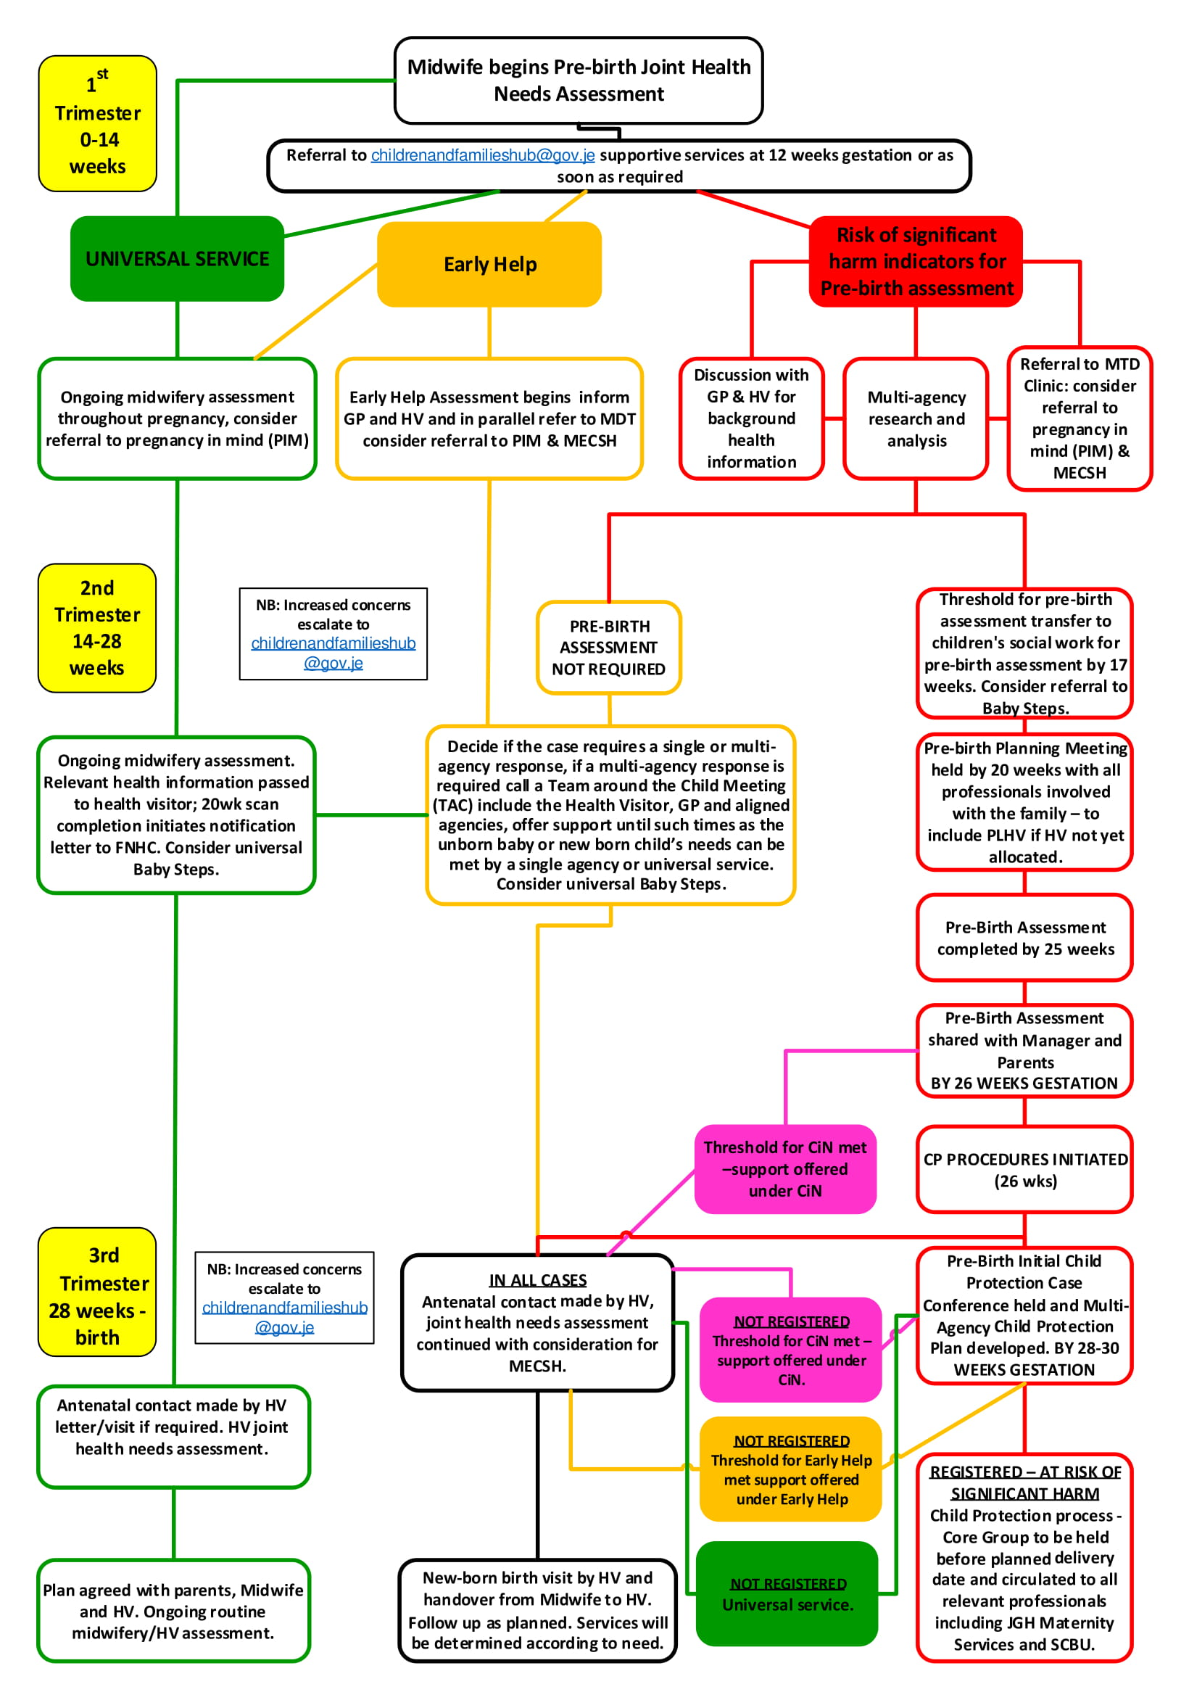

1st Trimester 0 – 14 Weeks

The joint health needs assessment commences at booking with the midwife. The midwife remains responsible for on-going health and social needs assessment throughout the pregnancy. Pregnant women who require no additional support beyond a universal service can be referred with consent universal antenatal Baby Steps and targeted pregnancy in mind (PIM) if required.

2nd Trimester – 14 – 28 Weeks

20 Week Scan completion will initiate a notification letter to be sent to Family Nursing & Home Care.

By 28 Weeks the Joint Health Needs Assessment commenced at booking will be shared with the health visitor by 28 Weeks gestation. The health visitor will add to the joint health needs assessment started by the midwife.

3rd Trimester – 28 weeks – Birth

28 weeks to Term the health visitor will make antenatal contact by letter (at 28 weeks) with the offer of a universal antenatal home visit inviting face to face contact and home visit in the antenatal period. The full contact details for the client’s health visiting team will be included in this letter.

With record of the locality, health visiting team and named health visitor shared with GP and obstetrician.

The health visitor and midwife continue to make joint health needs assessment and offer a universal service provision following the healthy child programme if no emergent need for extra support.

(Consideration to step up to Early Help and/or Safeguarding will be made if need emerges at any time from antenatal booking to post birth.)

Tier 2 Early Help

Steps identified for a universal service delivery are followed. In addition to this, if the pregnant woman or the unborn baby presents with emerging needs, then consideration is given to commencing Early Help. With consent, proportionate information being shared with all relevant professionals where Early Help Assessment and support will commence.

1st Trimester 0 – 14 Weeks and 2nd Trimester – 14 – 28 Weeks

Practitioners working with the pregnant women are best placed to support the emerging need. An Early Help assessment can be started by following the Right Help Right Time Programme. Referral should be made to the Children and Family Hub at childandfamilyhub@gov.je

On starting an Early Assessment, practitioners should use the five recommended questions:-
1. What is preventing this unborn babies or families wellbeing?
2. Have I asked if the family what they are concerned, have I discussed my concerns with the family and do I have all the information I need to help this child and their family?
3. What can I do now to help?
4. What can my agency, service or setting do to help this child?
5. What additional help, if any, may be needed from others

All the children in the family should be considered as part of the assessment. Some families may have needs, which are best met by a single agency response from Health, Midwife, GP, Health Visitor and Adult Mental Health. Others may require multi-agency support Identification of a lead worker who may be already working with the child and family to support a co-ordinated Team around the Child and Family response.

Referral to the multi-disciplinary antenatal monthly Multi-Disciplinary Team Meeting will be made in parallel to the decision to start an early help plan of care in pregnancy.

A supportive package of care will be offered involving with the expectant mother and the unborn babies father or significant carers. This is achieved by arranging a team around the child (TAC) Meeting and forming a manageable plan. The plan should consider timely intervention and the effectiveness of the plan must be evaluated.

Meetings should continue until the expectant mother and the team around her feel content that the needs of the unborn baby can be met under a universal service provision.

Should safeguarding concerns arise then consideration will be made with consent from the family (if to do so would not increase risk) and re- referral to the Child and Family Hub detailing the increased level of concern and request for a pre-birth assessment.

Discussion at the multi-disciplinary antenatal monthly meeting will continue to ensure that the case does not drift and the needs of the unborn baby are met in a timely manner. Where cases will be considered for referral for supportive evidence based service interventions dependant on emerging need.

Referral to antenatal services such as the universal Baby Steps Programme (FNHC), and the targeted emotional wellbeing antenatal service Pregnancy in Mind (PIM) NSPCC will be considered.

Liaison between the families identified key worker and the family GP and aligned professionals should result as an effective response to support needs and is key to the ongoing support and care of the family.

3rd Trimester – 28 weeks – Birth

At 28 Weeks

The health visitor contact letter (as per universal service provision) will be sent to the client. In addition to this the offer of an antenatal home visit will be made by telephone contact with the offer of an antenatal home visit to assess if the criteria for the Maternal Early Childhood Sustained Home Visiting (MECSH) Programme has been met (University of South Wales 2011). If the family’s meet the criteria for MECSH, the pregnant woman will be offered antenatal contact visits between 28 weeks gestation and due date.

Tier 3 Child in Need and Tier 4 Child in Need of protection

This criterion is for unborn babies or families where their needs met threshold for statutory and/or specialist timely intervention to keep them safe. If time allows the midwife, should seek additional information from the GP and health visitor, (unless to do so would place the unborn baby or pregnant woman at risk of further harm).

Professional curiosity is necessary to ensure the safety of the unborn baby in particular if the presentation of the client is incongruent to the information provided. For example signs of domestic abuse or alcohol/drug use which may be denied. Professionals in their interaction with their clients should respond to such opportunities to enquire deeper and not always take things at face value, seeking advice if necessary on how to take action in situations that are more challenging.

The midwife should consult with their named professionals in the health safeguarding team, and complete referral to the Child and Family Hub.

The midwife will receive feedback on the outcome of the enquiry to the referrer who must in turn share with practitioners involved with the client.

The case will be referred in parallel to the monthly antenatal multi-disciplinary meeting where it is the responsibility of the practitioners to ensure the unborn baby’s needs are met in a timely fashion and there is no drift on the case.

Where cases will be considered for referral for supportive evidence based service interventions dependant on emerging need.

1st Trimester 0 – 14 Weeks.

Referral to the childandfamilyhub@gov.je should happen at 12 weeks gestation or thereafter, with the specific request for a pre-birth assessment detailing the reason for referral in line with indicators for pre-birth assessment.

The Child and Family Hub will triage the referral, undertake research and refer to the most appropriate service to meet the unborn baby’s need, (Children’s social work, Early Help, Universal Services).

Where a case meets threshold for pre-birth assessment the case will transfer to children’s social work.

A referral to the antenatal multi-disciplinary team meeting must happen in parallel to this referral.

Consideration for referral to universal antenatal services for example Baby Steps and targeted services such as Pregnancy in Mind (NSPCC) is also a considered requirement.

The midwife will liaise with the health visitor to discuss whether a joint home visit should occur in the antenatal period. The discussion and outcome must be documented by the midwife on TrakCare and by the health visitor on EMIS.

Referral to the health visiting service is a requirement, detailing emergent need, which may meet the criteria for referral to MECSH.

All professionals involved with the family have a responsibility for ongoing communication and collaborative working; to facilitate four weekly Antenatal Multi-Disciplinary Team Meetings held with Midwifery, Paediatric Liaison Health Visitor, Children’s Services, Adult Mental Health Services and Drug and Alcohol Services, the GP should be invited to attend these meeting and the outcome communicated between all professionals.

2nd Trimester – 14 – 28 Weeks

20 weeks gestation

Children social work will arrange a Multi-Agency Pre-Birth Planning Meeting. All professionals involved with the family, (to include the Safeguarding Lead for Adults/Children for Family Nursing and Home Care if the HV is not allocated at this point). This should be held in the second trimester to allow enough time for a pre-birth Initial Child Protection Case Conference to be called early in the 3rd trimester.

25 weeks gestation

The pre-birth assessment will be completed and will be shared with the parents and the children’s social worker’s Team Manager where the case is allocated. The outcome will be agreed. The pre-birth assessment must include an interim safety plan for example 72 hours post birth stay, pre-discharge meeting and alternative care arrangements.

26 weeks gestation decision making plan

Child Protection Procedures (CP) - If following pre-birth assessment the unborn child is considered at risk of significant harm. Independent Safeguarding Services (ISS) will be notified of the need for an Initial Child Protection Conference (ICPC) and the pre-birth assessment will form the ICPC report.

Child in Need (CIN) Plan (CIN Plan) - If following pre-birth assessment the unborn child meets threshold for a child in need plan; the family will be offered support and CIN meetings will commence to meet the needs of the unborn baby and the family.

Early Help or Universal Service - If following pre-birth assessment the unborn child’s case is not considered to meet threshold for children’s social work support, the case can be considered for Early Help, or sign posted to universal service support.

There will be ongoing assessment which is a live process and will continue throughout pregnancy, professionals should re-refer to the childandfamilyhub@gov.je. If new safeguarding concerns emerge detailing new concerns and reasons for re-referral.

The use of the Escalation and Resolution Process will be used if there are professional differences of opinion. Discussing cases at the monthly Antenatal MDT to ensure all professionals have shared proportionate information.

3rd Trimester – 28 weeks – Birth

28 weeks to 30 weeks Gestation

A pre-birth ICPC will be held:-

Child in Need of Protection – if at the initial child protection case conference the unborn child meets the threshold for risk of significant harm, their name will placed on the child protection register under a category of being at risk of either physical, emotional, sexual abuse or neglect.

A multi-disciplinary child protection plan will be developed, which will include all professionals involved with the unborn baby and their parent(s)/family(s). The details of significant adults in the baby’s life, (biological father, new partner, friends, and extended family) and the support they provide or the risk they pose will be assessed as part of the child protection plan. The date for child protection core groups will be circulated to all relevant professionals and held before the planned delivery date. All professionals involved with the family have a responsibility for ongoing communication and collaborative working.

Child in Need Plan - If at the initial child protection case conference the threshold for significant harm is not met, the unborn child’s needs may be considered under a child in need plan. A child in need meeting will be called post conference, and prior to the birth of the baby inviting all relevant professionals.

Early Help or Universal Services If at ICPC the threshold is not met for social work intervention there may be suggestion to the parents that, with their consent, an Early Help Plan may meet their needs. In these cases, if emerging needs increase then a re-referral to the childandfamilyhub@gov.je may be required detailing new concerns and reasons for re-referral.

32 Weeks Gestation

Child in Need of Protection - A pre-birth meeting will be initiated at 32 weeks held by the Safeguarding Midwife, with parents, midwifery, paediatricians, paediatric liaison health visitor, and health visitor, appropriate services e.g. drug and alcohol service, SCBU.

This will be arranged by midwifery services.

The midwife and health visitor should consider arranging a joint home visit and the outcome of the visit documented on Trakcare by the Midwife and EMIS by the Health Visitor.

The midwife will keep the pregnant woman’s GP informed of the plan of care.

One month post delivery

Review child protection case conference

Legal Planning Meetings

Appendix 2

Joint Pre-Birth Health Needs Assessment

A joint pre-birth health assessment is carried out between your GP, your midwife and your health visitor with every pregnant woman.

- It helps your GP, midwife and health visitor understand the support you may need to prepare for the birth of your baby.
- It is important you and your unborn baby receive the right help at the right time.
- From this assessment, is the offer of the service to meet your unborn baby’s needs
- This may be a universal service, a referral for Early Help to the Right Help Right Time Programme or a service that protects you and your unborn baby from risk of significant harm.

Your midwife and health visitor value confidentiality, and will keep your information safe following Data Protection (Jersey) Law 2019.

However, if you share information that raises risks to either you or your unborn baby this information will be shared. Information is shared with your consent unless to gain consent raises further risk to you or your unborn baby.

It is important to let your midwife/health visitor know if you or your partner have any problems with communication? For example if you require an interpreter or have literacy problems, or need to use sign language.

Basic Details  Mother of unborn and Estimated Date of Delivery  DOB  Address  Contact Number  Do you live with the father to be  Yes/No  Ethnicity  Relationship Status  Gender  Occupation of parents to be:-  Names and DOB of other children  Addresses of children if different to above  Significant others who will offer support | Father’s name and DOB:-  Contact Number  Ethnicity  Relationship status  Gender  Partner’s name and DOB if different to father of unborn:-  Address of partner if different:-

GP

Obstetric History

Medical history (expectant mother)

Medical history of partner (if appropriate)

Current pregnancy:-  - Is this pregnancy a planned pregnancy  - Are you a late booker (after 15 – 20 weeks)  - Are you having regular antenatal care  - Do you feel happy about being pregnant  - Is your partner and/or baby’s father happy about the pregnancy  - Are you smoking  - Are you drinking alcohol/or using substances  - Is anyone in your family smoking/drinking alcohol or using substances?  Are you worried about:-  - Money, employment, finances  - Poor Housing/unstable/overcrowded housing  - A Lack of support or feeling you are isolated  - Do you have a history or current physical ill health  - Do you have a history or current Mental ill health  - Do you have unresolved loss or grief  - Have you or your partner ever used recreational substances  - You may have had adversity in your childhood  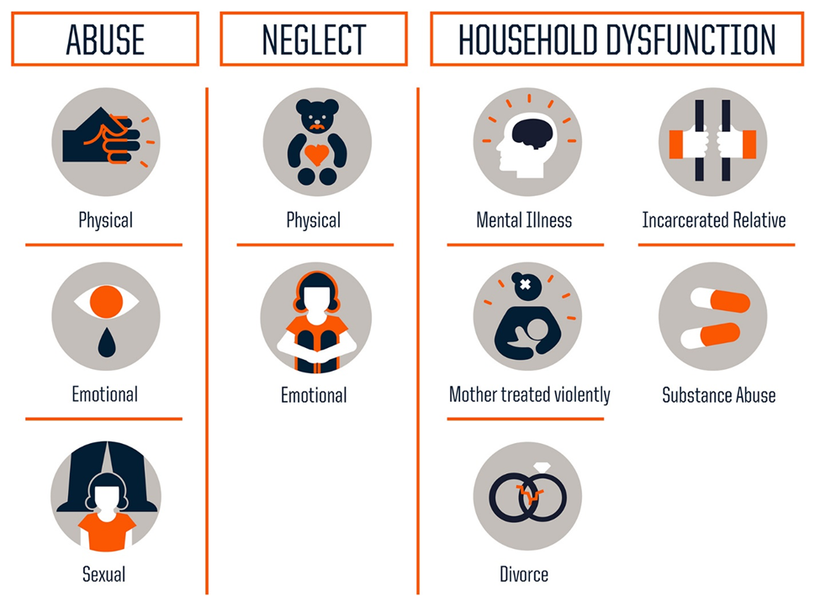  Would you or your partner like support with:-  • Reducing or stopping Smoking  • Reducing or stopping Alcohol/Substance use  Would you or your partner like support with your:-  • Emotional Health  • Physical Health  • Relationships  • Deal with worries from your adverse experiences in childhood  Somethings may be a risk to your baby and your midwife/health visitor would like to understand these better:-  - Have you had current or historical support from the children’s services with your other children  - Do you have current mental health that means you will need support to care for your baby  - Do you have a learning disability that means you will need support to care for your baby  - Do you have a physical disability that means you will need support to care for your baby  - Do you live with relationships that worry or scare you  - Are a looked after child or are you leaving care  - Do either your or your partner use alcohol or substances as a means of coping or on a daily basis  - Do you have contact with a person who may represent as a risk to children, this would be someone who had previously harmed a child, (this would include issues such as a violent history; significant criminal history; sexual offences against adults or children)  - Have either you or your partner had children removed from your care  - Have you had previous child in need or child protection plans with your other children  - Do you intend to relinquish the baby for adoption after birth  - Are you or have you been at risk of child sexual exploitation  - Have you experience Female Genital Mutilation (FGM). | Please answer – Yes/No/  NA

Health Pre-Birth Assessment Practitioner Guidance

Use the practice guidance to expand on the questionnaire that you have given to your client to complete

1. CURRENT PREGNANCY

- Was this pregnancy/baby planned or unplanned?
- Was this a Concealed pregnancy/late booker/undiagnosed pregnancy? (15-20 weeks)
- Have you had regular ante natal care? If not, why?
- How do you feel about being pregnant? Are you happy/sad/shocked? Are you developing a relationship with your baby?
- How does your partner and/or baby’s father feel about the pregnancy? Is he supportive?
- How do your other children feel about the pregnancy? (if relevant)

Additional Professionals notes:

Is there anything regarding “current pregnancy” that seems likely to have a significant negative impact on the child? :

PREPARATION FOR PARENTHOOD

PLANNING FOR THE FUTURE
- What are your goals for the future? What would you like to see happening?

- Have you prepared/thought about a Birth plan?

- Have you attended any parent education classes or feel that you need to?

- What equipment do you have ready for the baby?

- What are the sleeping arrangements for baby once he/she is born?

Additional Professionals notes:

Is there anything regarding “preparation for parenthood” that seems likely to have a significant negative impact on the child?

2. ABILITIES

- Do you have any physical needs/problems? If yes, what are they?

- Do you have any emotional needs/problems? If yes, what are they?

- Do you have any learning needs/problems? If yes, what are they?

Additional Professionals notes:

Is there anything regarding “abilities” that seems likely to have a significant negative impact on the child? :

4. SOCIAL HISTORY

- Do you feel socially isolated? Do you go out much?

- What was your own experience of being parented as a child/adolescent? Were they positive or negative experiences?

- What would you do differently now that you are a mother/father yourself?

- Are you in Employment?

- Have you any significant Debt that may have an influence on you financially?

- Is the current housing adequate or appropriate/are you homeless?

- Have you been in trouble with the police? Have you or your partner any criminal records? Are there any Court Orders currently in place?

Additional Professionals notes:

Is there anything regarding parental “social history” that seems likely to have a significant negative impact on the child? :

5. BEHAVIOUR (only ask this with the pregnant woman when she is on her own

- Have you been a victim/perpetrator of domestic abuse with either your current or previous partner?

- Have you or your partner ever been abusive to others? If so, who?

- Have you or your partner ever been abusive to any child? If so, who?

Additional Professionals notes:

Is there anything regarding parental “behaviour” that seems likely to have a significant negative impact on the child? :

SUBSTANCE MISUSE
- Have you ever misused substances (prescribed or unprescribed)? If so, did you receive support/any services?

- Have you ever misused alcohol? If so, did you receive any support/services?

- Do you feel that your life is currently stable or chaotic?

Additional Professionals notes:

Is there anything regarding “substance misuse” that seems likely to have a significant negative impact on the child? :

6. HOME CONDITIONS ( please refer to any home conditions assessments/ questionnaire for your area if relevant)

- Is your home environment chaotic?

- Are there any current health risks here? Is it unsanitary / dangerous?

- Are there any issues in regards to over- crowding? How many people/children live at the home address?

Additional Professionals notes:

Is there anything regarding “home conditions” that seems likely to have a significant negative impact on the child? :

- MENTAL HEALTH (NICE Guidance)

- Have you or your partner ever suffered from mental illness? Did you receive any treatment

- Have you ever self-harmed – currently or in the past?

- Are you or your partner currently on any medication and/or involvement with any other mental health services?

If mental health is likely to be a significant issue has there been contact with the Mental Health Team/GP? If so, who?

Additional Professionals notes:

Is there anything regarding “mental health” that seems likely to have a significant negative impact on the child? :

8. LEARNING DIFFICULTY/DISABILITY
- Do you or your partner have any learning needs? If so, what kind?

- Can you read and/or write?

If learning difficulty/disability is likely to be a significant issue has there been contact with the Learning Disability Service/Advocacy Service/POVA team? If so, who?

Additional Professionals notes:

Is there anything regarding “learning difficulty/disability” that seems likely to have a significant negative impact on the child? :

10. SUPPORT
- Do you have any support from extended family (locally and out of area)? If so, who?

- Do you have any support from friends? If so, who?

- Do you have any support from any other professionals? If so, who?

- Is the support likely to be available within a realistic timescale?

- Is it likely to enable change? Is it practical support/emotional?

- Will it effectively address any immediate concerns?

Additional Professionals notes:

Is there anything regarding “support” that seems likely to have a significant negative impact on the child? :

11. HISTORY OF BEING RESPONSIBLE FOR CHILDREN

- Have you ever cared/looked after your younger siblings?

- Have you ever cared/looked after your partner’s children or any other children?

- Have you or your partner’s children ever been known to Social Services? If so, in what capacity? What is different about your life now? How have circumstances changed?

Additional Professionals notes:

Is there anything regarding “history of being responsible for children” that seems likely to have a significant negative impact on the child? :

12. ABUSE
Do you consider yourself to have suffered abuse as a child? If so, did you receive any support/counselling?

Additional Professionals notes:

Is there anything regarding “abuse” that seems likely to have a significant negative impact on the child? :

13. ENGAGEMENT WITH PROFESSIONALS
- Do you currently have any involvement with professionals/services? If so, who?

- Would you engage or continue to engage with services as to access support now if needed? If so, who?

- Have you had any previous involvement with other professionals/services? If so, who?

Additional Professionals notes:

Is there anything regarding “attitude to professional involvement” that seems likely to have a significant negative impact on the child? :

14. ABILITY AND WILLINGNESS TO ADDRESS ISSUES IDENTIFIED IN THIS ASSESSMENT

- Violent behaviour? YES NO NA
- Drug misuse? YES NO NA
- Alcohol misuse? YES NO NA
- Mental health problems? YES NO NA
- Reluctance to work with professionals? YES NO NA
- Limited skills, knowledge/understanding YES NO NA
- Criminality? YES NO NA
- Poor family relationships? YES NO NA
- Issues from childhood? YES NO NA
- Poor personal care? YES NO NA
- Chaotic lifestyle? YES NO NA
Additional Professionals notes: it is important to note where your client is at in relation to change

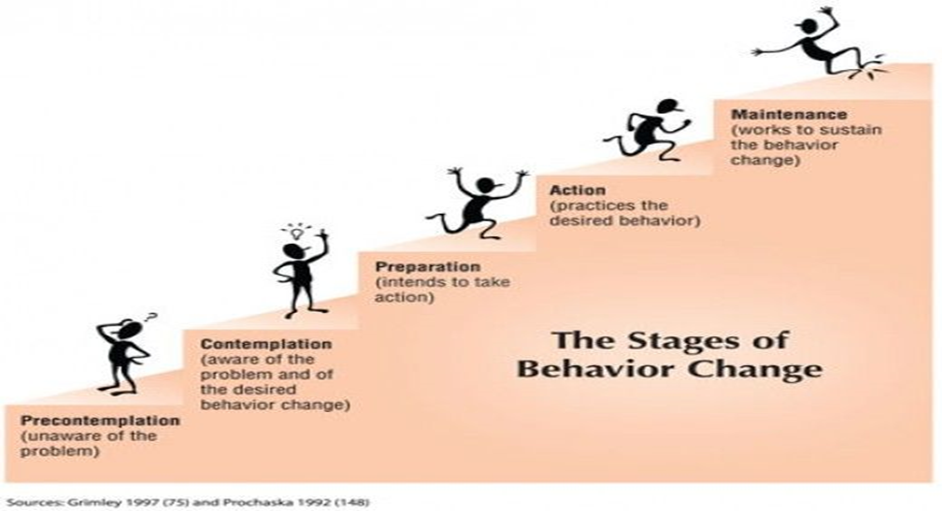

14. What are the strengths?

15. What issues have the potential to adversely affect the child?

16. PLANNING FOR THE FUTURE
- What are your goals for the future? What would you like to see happening?

- Is this realistic and appropriate?

Additional Professionals notes:

CONCLUSION OF HEALTH PRE BIRTH ASSESSMENT

CONCERNS/RISKS IDENTIFIED: | ACTIONS TAKEN: | COMPLETED BY  (AND DATE):

Appendix 3

Domestic Abuse – Guidance for Professionals

Domestic abuse is defined as ‘Any incident or pattern of incidents of controlling, coercive or threatening behaviour, violence or abuse between those aged 16 or over who are or who have been intimate partners or family members regardless of gender, sexuality or ethnicity.

This can encompass but is not limited to the following types of abuse:

- Psychological
- Physical
- Sexual
- Financial
- Emotional

Controlling behaviour is a range of acts designed to make a person subordinate and/or dependent by isolating them from sources of support, exploiting their resources and resources for personal gain, depriving them of the means needed for independence, resistance or escape and regulating their everyday behaviour.

Coercive behaviour is an act or a pattern of acts of assault, threats, humiliation and intimidation or other abuse that is used to harm, punish, or frighten their victim.

Domestic abuse can occur in all sections of society irrespective of gender, race, culture, nationality, religion, sexuality, disability, age, class or educational level.

Recognise, Respond, Record, Refer

- Recognise

Asking the question

It is now recognised good practice for many services to ask people about domestic abuse routinely or where other vulnerabilities indicate it would be appropriate. We know that from talking to victims and survivors that it is hard for someone to disclose that they are experiencing domestic abuse.

People need to feel that the person asking:
- Is genuinely interested
- Will be non-judgemental
- And will know how to respond if the answer is yes

Many people will not use the label domestic abuse from their experiences or they may not be familiar with the term (especially if they use another language), or they may think it only applies to physical violence. It is therefore important to think about how to ask about domestic abuse and be familiar with behaviours before you do so.

- Respond

Framing the question

Where possible and appropriate, start with framing the question by explaining why you are asking.

For example: ‘Given the current situation and the fact that everyone is spending more time in their home together. We are just checking with all our clients the impact that, is having so that we can ensure we are able to provide the best support.’

Explaining why you are asking is helpful, especially when you are talking to people who may be mistrustful and query the motives behind your questions.

Example introduction:
Due to the Covid-19 situation, as part of the conversations we are having with all of our clients at the moment, we are asking questions about other issues besides ……….. (reason for service involvement). We feel it is really important to help you with any problems or issues that you may be experiencing. We understand that sometimes in order to help with one problem other problems must also be addressed and at times like this, which none of us have ever experienced before, we want to ensure that you feel safe in your home environment and that if you do require any help that we are able to arrange that for you.

Example questions:
- Is everything alright at home? How are you feeling?
- Are you getting support from your partner/family members at home?
- Everyone has rows at times, have you seen an increase in rows/arguments? What happens when these occur?
- Do arguments or comments made ever result in you feeling put down or bad about yourself?
- Has anyone ever been violent towards you? Who?
- Do you ever feel frightened or have you ever felt frightened?
- Does your partner and/or family members like to know what you are doing? Who you are speaking to?
- Does your partner control your access to finances or ability to do what you would like to do?
- You mentioned that your partner and/or family member uses alcohol/drugs/gambles – how do they react when doing this?
- Does your partner pressure you to have sex or perform sexual acts?

Validating
- Be sensitive, respectful and listen carefully to what you are being told.
- Seek to empower victims, not to take over or make decisions for them. Ask them what they want you to do.
- Remain non-judgemental – never imply that the victim is to blame for the abuse.
- Validate the victim’s experience; tell them you are glad they told you.
- Make your role clear, explain boundaries and the limits of confidentiality, the extent and limits of your powers and legal duties.
- Give key messages, e.g. you are not alone, you do not deserve to be treated like this, there is support and help available for you.
- Provide information on the help which is available, to enable the client to make an informed and safe choice to protect themselves and their children.

Address immediate safety issues
- Ensure the immediate safety of the victim and anyone else in the family
- Do not take any action that could place you or your colleagues at risk of violence.
- Seek emergency assistance if needed.

- Record

Consider safety and confidentiality when recording in notes. Records may be used in future criminal/civil court proceedings and may also be used as part of MARAC (Multi-Agency Risk Assessment Conference) information.

Be particularly careful if anything is recorded in hand held notes or records that the perpetrator may have access to.

Ensure that you document any disclosures as per your agencies policies.

- Refer
A large number of victims of domestic abuse never tell anyone what they are experiencing, however if someone discloses domestic abuse to a professional (or even a friend or colleague) encouraging or making a referral to the relevant support services should be done.
Ensure that you action any safeguarding (children and/or adult) procedures as per your agencies policies.
Remember consent of the victim does not need to be obtained in High risk cases where you believe that the victim is at significant risk of harm.

Domestic Abuse Referral Pathway
Domestic abuse is “Any incident or pattern of incidents of controlling, coercive or threatening behaviour, violence or abuse between those aged 16 or over who are or who have been intimate partners or family members regardless of gender, sexuality or ethnicity. This can encompass but is not limited to, the following types of abuse: psychological, physical, sexual, financial and emotional”. This also includes honour based violence (HBV), forced marriage and female genital mutilation (FGM)
Recognise: Be familiar with the signs of domestic abuse and ask all client on contact about their home situation.
Respond: Ask Crucial Questions - Frame the question, validate and address immediate safety concerns.
Example questions:
- Is everything alright at home? How are you feeling?
- Are you getting support from your partner/family members at home?
- Everyone has rows at times, have you seen an increase in rows/arguments? What happens when these occur?
- Do arguments or comments made ever result in you feeling put down or bad about yourself?
- Has anyone ever been violent towards you? Who?
- Do you ever feel frightened or have you ever felt frightened?
- Does your partner and/or family members like to know what you are doing? Who you are speaking to?
- Do they control your access to finances or ability to do what you would like to do?
- Does or has your partner and/or family member ever prevented you from accessing medical support or assistance for care needs?
- You mentioned that your partner and/or family member uses alcohol/drugs/gambles – how do they react when doing this?
- Does your partner pressure you to have sex or perform sexual acts?

If there is any immediate danger call 999.

Disclosure
No disclosure
Refer to Jersey Domestic Abuse Support for a risk assessment, further advice and support.
Tel: 880505 jdas@gov.je www.jdas.je
Refer: Discuss referral to specialist support service and highlight confidential nature of support.

Contact: Children and Families Hub Tel: 519000
Is the victim pregnant and/or do they have children?
Record: Document that you have asked the question and details of your conversation accurately.
If you have concerns that either a child, young person or adult with care or support needs may be at risk of harm or neglect you must follow your agencies safeguarding policies and procedures.

Contact: SPOR
SPOR@gov.health.je
Tel: 444440

Is your victim an adult with care and support needs?

If there is no disclosure but you suspect otherwise, does your role give you the opportunity to periodically ‘ask the crucial questions’ again?

Record: Document that you have asked the question and details of your conversation accurately including your decision making. Does your role give you the opportunity to periodically “ask the crucial questions again”?

If a client does not consent to referral but you believe the person is at significant risk of harm you should call Jersey Domestic Abuse Support and discuss the situation to obtain advice on the appropriate measures to take.

Common behaviours associated with domestic abuse

Emotional abuse

You can experience abuse and violence without being physically hurt. Emotional abuse does not leave physical scars but it can have a big impact on a person’s mental health and well-being. Someone experiencing emotional abuse can feel anxious, depressed and even suicidal.

Perpetrators of emotional abuse use it to take away a person’s independence, confidence and self-esteem. This helps the perpetrator maintain power and control in the relationship. Physically abusive relationships often include aspects of emotional abuse.

The signs of emotional abuse can be difficult to identify, especially because it is non-physical. Emotional abuse includes:

- Blaming a partner for the problems in a relationship
- Constantly comparing them to others to undermine their self-esteem and self-worth
- Usually being in a bad mood
- Intentionally embarrassing them in public
- Name calling
- Yelling, insulting or swearing at them
- Telling them what to wear
- Preventing them from seeing family and friends
- Threatening suicide
- Making them feel guilty when they refuse sex
- Online humiliation and intimidation
Someone experiencing emotional abuse can start to believe what the perpetrator says about them. They may also blame themselves for the abuse. The constant criticism lowers their self-esteem and confidence making it very difficult to leave the relationship.

Controlling/coercive behaviour Be alert to the dangers of controlling behaviour during Covid-19 when victims of domestic abuse are increasingly isolated.

Coercive control seeks to make a person dependent by isolating them from support, exploiting them, depriving them of their independence and regulating their everyday activity through fear and intimidation.

It creates invisible chains and a sense of fear that pervades all elements of a victim’s life.
Indicators of coercive control are where a partner attempts to isolate you from your family and friends, may monitor your time and take control over aspects of your everyday life, such as where you go, who you see, what you can wear and when you can sleep. They may also deprive you of your basic needs such as food or access to medical care.

Abusive partners will also often repeatedly put you down, making you feel worthless and use manipulative language to sow seeds of doubt that makes you question your own memory, perception and sanity.

Financial/economic abuse

Financial abuse can be subtle, with a perpetrator gradually taking control over bank accounts and financial transactions. Financial abuse can also be obvious, violent and threatening. For example someone may forbid their partner from working or spending their wages.

Financial abuse can leave people without means for basic essentials or access to their own bank account. It can also result in huge debts being built up against their names.
Economic abuse broadens this definition and takes into consideration resources such as food, clothing and transport.

Financial abuse includes:
Someone taking complete control of finances and money, restricting access to bank accounts, providing an inadequate allowance and monitoring what their partner spends money on, forbidding a partner to work, taking a partners pay and not allowing them access to it, preventing them from getting to work by taking their keys or car, identity theft to secure credit, using their credit cards without permission and refusing to work or contribute to household expenses.

Sexual abuse

Sexual abuse is any form of forced or unwanted sexual activity. The perpetrator of sexual abuse may use physical force, make threats or take advantage of a person unable to give consent.

Sexual abuse mainly happens between people who know each other and can occur in the context of domestic abuse. Sexual coercion is particularly common and involves continuing to pressure the victim to have sex after he or she has said no.
Sexual abuse impacts on a person’s physical and emotional health. It can lead to long-term mental health issues, including anxiety and post-traumatic stress disorder.
Sexual abuse includes:
- Rape
- Deliberately causing pain during sex
- Assaulting the genitals
- Forced sex without protection against pregnancy or STI’s
- Forcing someone to perform sexual acts
- Using sexually degrading insults
- Unwanted touching
- Unwanted exposure to pornography
- Sexual jokes
- Withholding sex as a punishment
- Using sex to coerce compliance

Physical abuse

Physical abuse happens when a person uses physical force against another person. Physical abuse can start slowly and inconspicuously, for example with throwing an object or a slap and can often get more intense or worse over time.

A person may experience many different types of physical abuse. Physical abuse includes:

- Hitting, slapping, punching, kicking, hair pulling, biting, pushing.
- Rough handling
- Scalding and burning
- Physical punishments
- Inappropriate use of restraints
- Making someone purposely uncomfortable
- Misuse of medication
- Sleep and food deprivation
- Forced feeding
- Abuse of children or pets
- Destroying property or pets
- Driving dangerously
- Using weapons
- Locking someone out of their house or in their house.

Harassment/Stalking

Harassment and stalking happen when a person is persistently pursued against their will. The perpetrator does this to control, intimidate and create fear.

Stalking and harassment limit a person’s freedom and makes them feel that they have lost control of their lives. Some people who have been stalked have been forced to change their lives completely by moving house and changing jobs. Anyone can be a victim of stalking/harassment.

To control, intimidate and create fear in a person a perpetrator may:
- Make repeated phone calls
- Send numerous text messages
- Loiter outside or near a person’s home or work
- Leave messages on social networking sites, such as Facebook.
- Leave notes on a person’s car
- Leave flowers at a person’s home
- Follow or continually stare at the person that they are stalking
- Monitor a person’s use of technology, including phone, email and other communications.

Online or digital abuse

- Monitoring of social media profiles or emails
- Abuse over social media such as Facebook or Twitter
- Sharing intimate photos/videos without consent
- Spyware or GPS locators

For your information only – Not part of template

Document format: Electronic | Microsoft Word (Will be converted to PDF by before uploading to document library on Intranet)
Front cover | As per template
Body text – font | Arial 12
Headings | Arial 12 and coloured russet as per template
Tables and charts | Arial (size as appropriate)
Use of bold | Headings only
Alignment | Left hand justified
Line spacing | Body text – single
Paragraph spacing | One line between paragraphs  Two lines between main sections
Underlining | None
Logo | Title page only
Margins | 2.54cm left / right / top / bottom
Headers / footers | Arial 8
Policy title and policy number | To be included in the header
Page numbering | To be included in the footer (page x of y, centre aligned)
Printing | Portrait / single sided
Referencing style | Harvard

