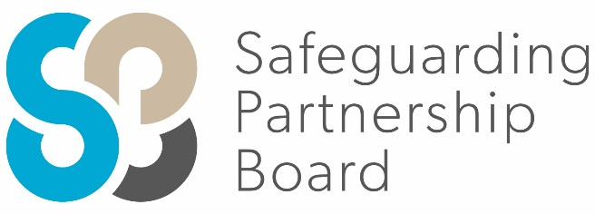

Delegate Workbook

Understanding Child Neglect

About this course
These materials are part of a learning package that includes self-directed learning via this workbook and an in-person seminar. Please ensure that you have set aside at least 3 hours to complete the work before attending the in-person seminar. The seminar will build on your knowledge and understanding and will ask you to reflect on the content of the materials. In order to get the most out of this workbook and maximise the opportunity for reflection, we suggest that you break your study time into manageable sections.
You should set up an account with Research in Practice (RIP) if you don’t have one already (see below for instructions on how to set up your account). RIP is a free resource provided by the Safeguarding Partnership Board and contains a wealth of information including videos, briefings, webinars etc which will help you in your work.
All you need is a quiet place to work through the content and/or watch any videos, either alone or in a group. It might be useful, as you read or listen, to jot down thoughts that occur to you about the work you do and any questions or new ideas that come to mind.
Important!
You will need to bring your workbook to the seminar as we will be referring to it on the day.

Setting up your account with Research in Practice
Research in Practice (RIP) supports evidence-informed practice with children and families, young people and adults. RIP brings together academic research, practice expertise and the experiences of people accessing services to develop a range of resources and learning opportunities.
As a partner of the Safeguarding Partnership Board, your organisation is able to access RIP’s resources free of charge. To do this, you will need to set up a RIP account:
Go to www.researchinpractice.org.uk and select ‘create account’ at the top.
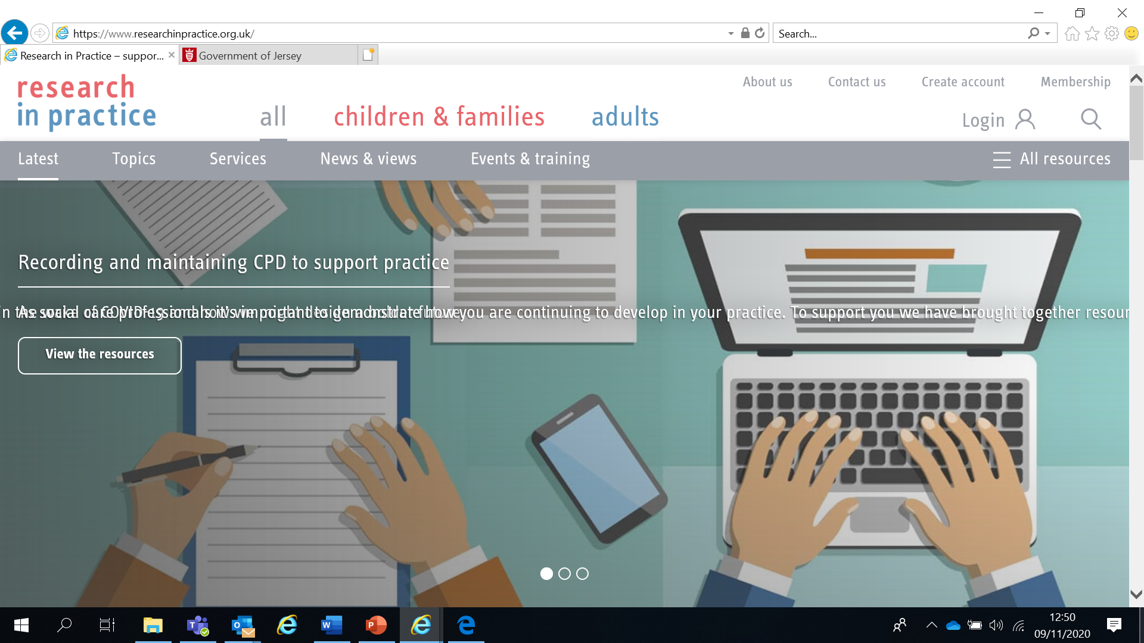

Use your work email and select ‘States of Jersey’ as your organisation from the drop-down list
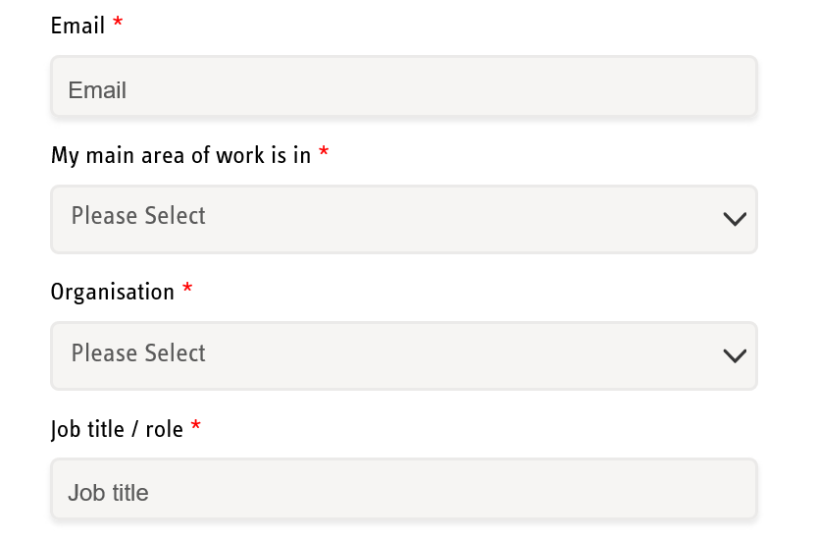

NOTE: You cannot set up an account with RIP if your work email uses Gmail, Hotmail or other generic accounts. Please contact us if this applies to you.

Once you have logged in with your new account, the resources are free to download:
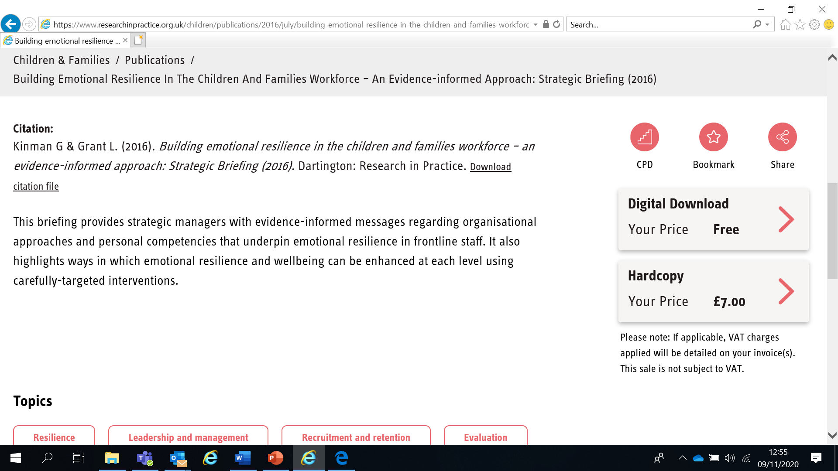

If you have any problems setting up an account, please contact safeguardingtraining@gov.je

Learning Objectives
In this module you will:
- Name the six different forms of child neglect
- Recognise the signs and indicators of child neglect and where these are identified on the SPB’s Continuum of Need
- Demonstrate an awareness of the impact of child neglect
- Recognise the risk factors for child neglect
- Name the tool used in Jersey to assess child neglect

Links to Professional Practice
SPB: Child Procedures Manual, Child Workforce Competency Framework, Child Neglect Strategy
Intercollegiate Competency Framework: Level 1 and above
PQS KSS: Analysis, decision-making, planning and review; Child and family assessment; Relationships and effect direct work; Shaping and influencing the practice system; Confident analysis and decision-making; Purposeful and effective social work; Support effective decision-making
CQC: Responsive, Effective, Caring
PCF: Critical reflection and analysis; Rights, justice and economic wellbeing; Diversity and equality; Values & ethics

Top Tips
Do the readings – we've selected reading material that we know will enhance your knowledge and skills
Do the exercises – the more you put into this course, the more you will get out of it. The exercises will give you the opportunity to reflect on what you've read. You'll get a chance to discuss ideas and ask questions in the seminar

Emotional Alert!
We acknowledge that this is a sensitive subject – look after yourself and others.
This content:
- can trigger memories of experiences which were in some way abusive
- can highlight areas of difficulty for individual people who are aware of others or their own personal experiences
- can have an emotional impact on those working to protect children, families and adults
- seek support from your manager if you are upset by any of the materials

What is Neglect?
Neglect is the persistent failure to meet a child’s basic physical, emotional and/or psychological needs, likely to result in the serious impairment of the child’s health or development. Neglect may occur during pregnancy as a result of maternal substance abuse. Once the child is born, neglect may involve the parents or carers failing to:
- Provide adequate food, clothing & shelter (including exclusion from home or abandonment)
- Protect the child from physical and emotional harm or danger
- Ensure adequate supervision (including the use of inadequate care-givers)
- Ensure access to appropriate medical care or treatment
- Ensure child receives a suitable education
It may also include neglect of, or unresponsiveness to, a child’s basic emotional needs.
(Working Together)

The Profile of Neglect
Child neglect is the most common reason for a child to be subject to a child protection plan. Neglect features in 60% of serious case reviews. Domestic abuse, mental ill health and/or substance misuse are common in households where children are neglected. Neglect commonly occurs alongside other forms of abuse.
Neglect is one of the Adverse Childhood Experiences or ACEs.
Watch the video on ACEs at https://player.vimeo.com/video/189290361 (5m 43s)

Neglect is a key priority of the Safeguarding Partnership Board and aligns with the Jersey’s Children’s First Practice Framework. The SPB’s Multi-Agency Child Neglect Strategy aims to improve outcomes for children, young people and families in Jersey and gives guidance to all professionals in seeing, monitoring and assessing child neglect.
The SPB’s Multi-Agency Child Neglect Strategy is available at Strategies | Jersey Safeguarding Partnership Board and includes a Neglect Toolbox (pages 18-21) with:
- Indicators
- Chronology Guide
- Assessment Resources
- Safer Sleeping Risk Assessment Tools
- Training materials

Forms of Neglect

Physical neglect: child may have inadequate or inappropriate (eg for the weather conditions) clothing, poor levels of hygiene, lack of clean living conditions, abandonment or exclusion from home
Medical neglect: child’s health needs are not met, or they are not provided with appropriate treatment needed as a result of illness or accidents
Nutritional neglect: child is given insufficient calories to meet their physical/developmental needs, or they are given food of insufficient nutritional value, e.g. high fat or high sugar food in place of balanced meals; childhood obesity can be a sign of neglect
Emotional neglect: parent/carer does not respond to the child’s basic emotional needs, including failing to interact or provide affection
Lack of supervision and guidance: child may be exposed to hazards, parents or caregivers may be inattentive to avoidable dangers or may leave the child with inappropriate carers. Lack of supervision can include not providing appropriate boundaries for young people
Educational neglect: child does not receive appropriate learning experiences; they may be under-stimulated and/ or experience a lack of interest in their achievements. This may include not sending their child to school regularly, and/or failing to respond to special educational needs

Child neglect and its relationship to other forms of harm
Neglect may heighten vulnerability to other forms of harm including CSE, intra-familial sexual abuse and HSB (https://www.researchinpractice.org.uk/children/publications/2016/november/child-neglect-and-its-relationship-to-other-forms-of-harm-responding-effectively-to-children-s-needs-evidence-scopes/)
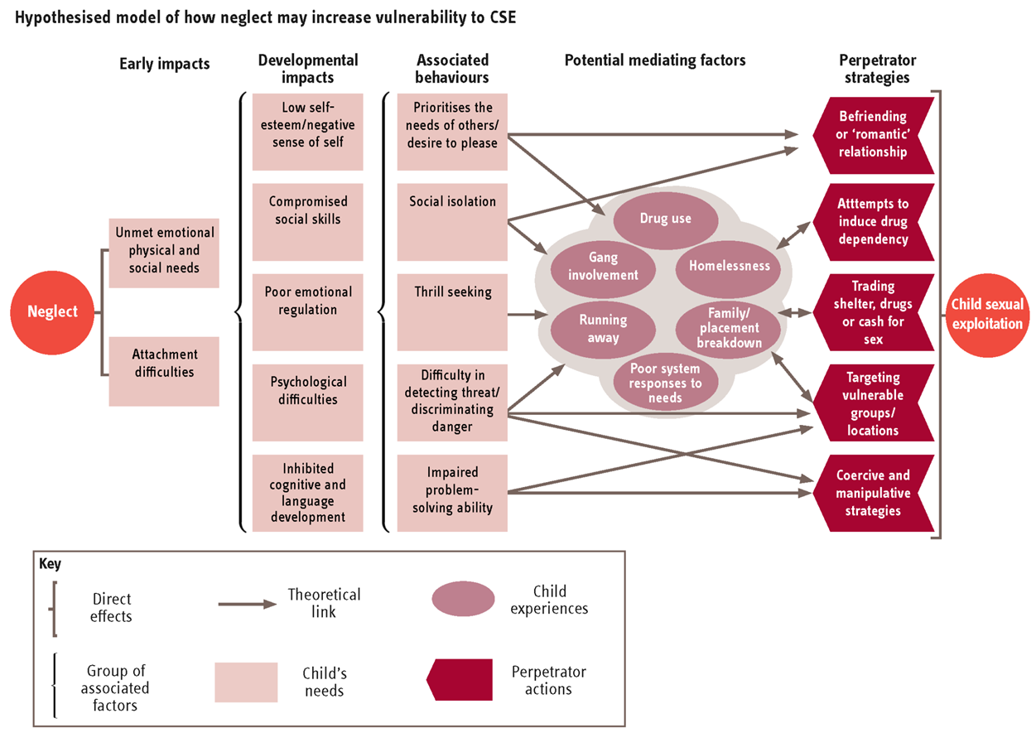

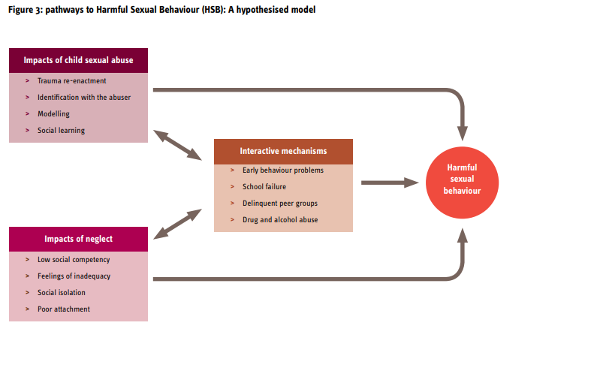
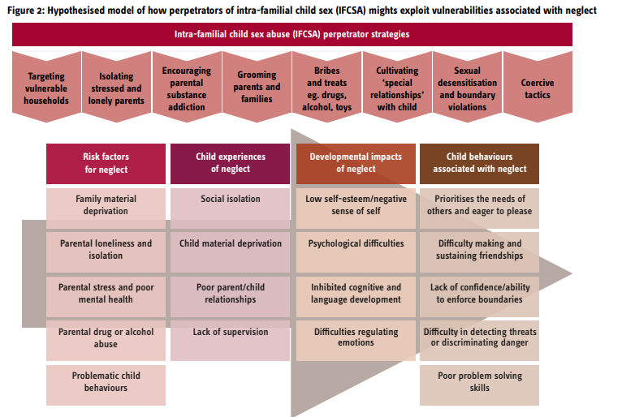
How does your professional experience compare to the national picture on neglect?

How do you or your team analyse the range of issues under the umbrella term ‘neglect’?

What are some of your experiences of working with children at different stages of development and life circumstances? What are the similarities? What are the differences?

Watch the NSPCC ‘We’re Here’ video child neglect - Google Search
Reflect on the following questions and write your thoughts below.

Continuum of Need and Neglect
It is important that all professionals have an understanding of the local picture of neglect, with a common language and understanding of neglect thresholds with the use of the Continuum of Need. The focus should be on promoting early identification and support in line with the Jersey’s Children First practice framework.
Using the SPB’s Continuum of Need, complete the table below by finding THREE indicators at each level.
Continuum of Needs

Level of Need | Indicators of Neglect
Early Help
Child in Need of Support
Child in Need of Protection
The SPB’s Resolving Professional Differences/Escalation Policy should be used to escalate unresolved disputes where professional curiosity or challenge has not resolved any professional conflict

Watch the Research in Practice film ‘Poverty-aware practice’ (19m 41s) https://www.researchinpractice.org.uk/children/content-pages/training-and-development-programmes/online-learning-packages-tailored-support/neglect-and-poverty-aware-practice/
Reflect on the following questions and write your thoughts below.

How do you use chronologies – in particular, thinking about the evidence from Serious Case Reviews – to evidence the cumulative harm of chronic unmet need?

How do you share ideas and resources for talking and listening to children? What creative approaches have you developed?

What is the best support you’ve been given in supervision to support you to deal with the emotional intensity of child protection work?

Risk factors for neglect

Child risk factors  Disability  Behavioural problems  Chronic ill health  ACEs | Parental risk factors  Poor mental health  Substance use  Domestic violence and abuse  Previous ACEs | Wider risk factors  Poverty / affluence  Unemployment  Poor social support  Learning difficulties  Lack of experience of positive parenting in childhood  Emotionally unavailable/detached parents

The impact of poverty
Poverty is defined in different ways. Whichever definition is used, it is important to remember that:
- Resources and opportunities are shaped by the way the economy and society are structured, and by political decisions about the distribution of resources
- What constitutes ‘enough’ money is socially defined. Not having enough can result in exclusion and feelings of being ‘outside’ of social norms
- A lack of resources within the household will often be compounded by a lack of resources in the local community
Read pp4-6 of the Research in Practice briefing ‘Neglect in a context of poverty and austerity’ (https://www.researchinpractice.org.uk/media/2344/frontlinebriefing-neglectmay19_web-2.pdf)

Neglect by affluence
Whilst poverty is a recognised risk factor of neglect, not all the risk factors are exclusive to children and young people living in poor households. Professionals must remain alert to neglect by affluence. Research suggests limited attention has been paid to neglect of children in affluent families because they are considered to be ‘low risk’. Children from affluent families may suffer maltreatment in less visible ways - they might not be materially neglected, dirty or malnourished, but may be emotionally neglected.

- Adverse family circumstances in cases of neglect
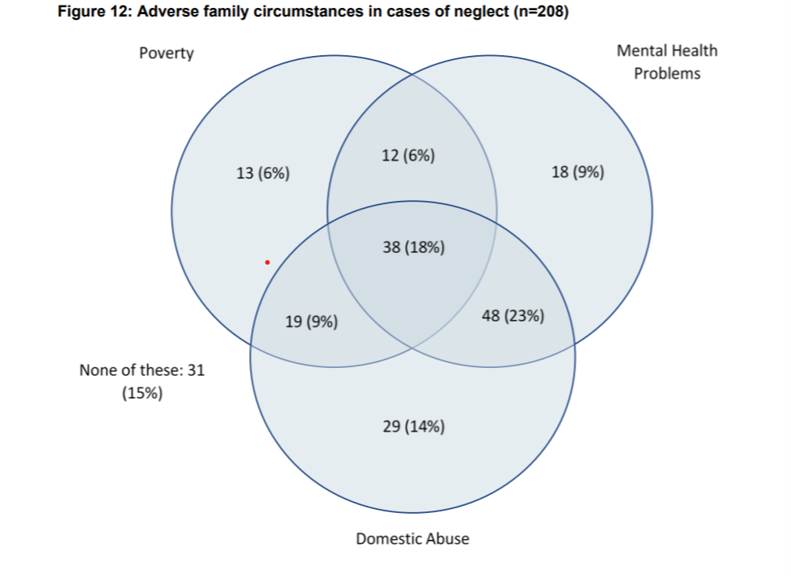

Triennial analysis of serious case reviews 2014-17 | Research in Practice

- Danya Glaser’s FRAMEA care pathway, organised around four tiers of concern (see also Schrader-McMillan and Glaser 2014)
- 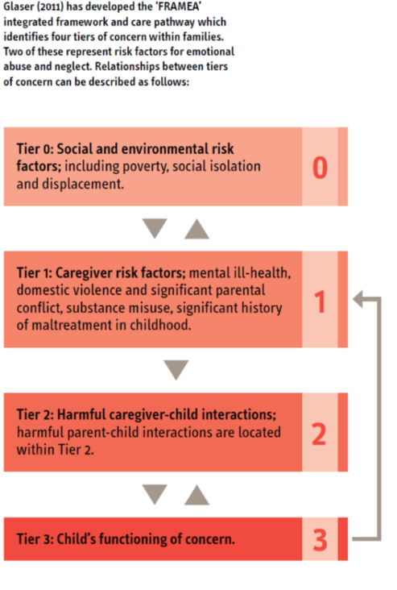

Watch the Research in Practice film ‘A child’s experience of neglect’ (20m 50s) https://www.researchinpractice.org.uk/children/content-pages/training-and-development-programmes/online-learning-packages-tailored-support/neglect-and-poverty-aware-practice/
Reflect on the following questions and write your thoughts below.
How do both the direct and indirect experiences of poverty affect the families you work with? Can you think of examples from your own practice of each?

How might you as a team analyse the use of terms like ‘resistant’ or ‘failure to engage’ and the different factors underlying that term?

The Impact of Neglect Across the Life Course
Watch the video on The Science of Neglect (6 minutes)
https://developingchild.harvard.edu/resources/inbrief-the-science-of-neglect-video/

The impact of neglect is often cumulative – advancing gradually and imperceptibly. It can also have an instant impact, eg a young child left alone at home or crossing a busy road without supervision. The impacts below are indicative rather than definitive and illustrate how neglect can impact across the life course. It is not possible to predict when or which impacts may occur in any individual’s life.

Life Stage | Reported Impacts
Early impacts  (impacts most commonly associated with an early onset) | Alterations in the body’s stress response (the body’s stress response (the hypothalamic-pituitary adrenal system)  Insecure attachments  Delayed/declining cognitive development  Decreased language function  Low self-esteem  Low confidence  Negative self-representations  Withdrawal, difficulty in making friends  Acting out/aggression/impulsivity  Poor coping abilities  Poor problem-solving skills  Disorganised attachments  Low achievement in school
Medium and longer-term impacts  (impacts that are more likely to manifest over the medium to longer term – including, in some cases, emerging in later adolescence or adulthood) | Depression, anxiety  Dissociation  Poor affect/emotion regulation  ADHD symptoms  Running away  Anti-social behaviour  Violence and delinquency  More likely (than peers) to be arrested for violent offences  Substance misuse and addition  Social withdrawal, social isolation  Conflict and hostility in relationships  Poor educational achievement  Longer-term mental health problems, including PTSD and personality disorders  Suicide attempts  Physical health problems, such as increased risk of hypertension and chronic pain

Flood S and Holmes D (2016) ‘Child neglect and its relationship to other forms of harm – responding effectively to children’s needs’ Research in Practice, NSPCC & Action for Children. Available at: https://www.researchinpractice.org.uk/children/publications/2016/november/child-neglect-and-its-relationship-to-other-forms-of-harm-responding-effectively-to-children-s-needs-evidence-scopes/
Watch the video on Rethinking ‘Did Not Attend’ (2 minutes) and consider the impact of not being brought to medical appointments - www.youtube.com/watch?v=dAdNL6d4lpk

For information on the forms of neglect by age group, read pages 28-29 of the SPB’s Child Neglect Strategy at Strategies | Jersey Safeguarding Partnership Board

Aspects of child development that may raise concerns about neglect
Type of effect | Infants 0-2 | Early Childhood | The School Years
Development | Poor growth/intellectual capacity  Under stimulation  Nappy rash, infections hospital attendances  Failure to thrive | Short stature, dirty, unkempt  Delay in learning new skills  Learning slow and painful  Language delay | Severe educational deficits: learning disabilities, poor problem solving  Poor reading, writing and maths
Behaviour | Withdrawn, lethargic, depressed  Self-stimulating behaviour, eg rocking | Lacking social skills – either aggressive or withdrawn  Indiscriminate friendliness | Disruptive/overactive in class  Desperate for attention  Few friends  Overcompensation
Emotional | Absence of learned trust | Shame and self-doubt  Lack of confidence and expectation of failure  Poor self-concept | Encopresis/eneuresis  Guilt/self-blame  Self-harming  Disturbed eating patterns

Neglect can be difficult to assess neglect because:
- It can be subjective and prone to bias
- There is a high threshold for recognition
- It is difficult to capture and compare
- It can be complex and intergenerational

In Jersey we use a tool called the Graded Care Profile 2 (GCP2) to assess neglect. GCP2 is an objective, evidence-based assessment that identifies parental strengths as well as areas of concern. We will look at the GCP2 during the seminar and signpost you to further training on the tool if required.

Watch the Research in Practice film ‘Parental capacity to change and working effectively with parents (26m 02s) https://www.researchinpractice.org.uk/children/content-pages/training-and-development-programmes/online-learning-packages-tailored-support/neglect-and-poverty-aware-practice/
Reflect on the following questions and write your thoughts below.
Give some thought to your own relationship-based practice with parents. How do you establish trust? What helps? What hinders?

Consider the three spheres, ‘authority’, ‘empathy’ and ‘humility’. What support do you have to develop these aspects of your practice?
(Sidebotham et al, 2016)

Next Steps
You have now finished the independent learning ahead of the in-person seminar.
In the seminar, we will reflect on your learning from this module and in particular we will:
- Consider the factors specific to Jersey that impact on neglect
- Look at the GCP2 (Graded Care Profile 2) tool to assessing neglect
- Consider a case study

Important!
Please bring this workbook to the seminar with you. We will be referring to it throughout the session.

Further Learning
The SPB website has a series of 7 Minute Briefings on a range of topics which you can use with your teams to prompt discussion and reflection on practice and systems. You can find 7 Minute Briefings under the Resources page on the website – including an explanation of what they are.
The Research in Practice website is an excellent source of further material.
The SPB has a range of courses which will help you to further your knowledge. Please check our website for further details.

Acronyms
ABE | Achieving Best Evidence
ADRT | Advance Decisions to Refuse Treatment
APVA | Adolescent to Parent Violence and Abuse
ASCIT | Autism and Social Communication Inclusion Team
AWDO | Adult Workforce Designated Officer
CAMHS | Child and Adolescent Mental Health Service
CCE | Child Criminal Exploitation
CDC | Child Development and Therapy Centre
CEOP | Child Exploitation and Online Protection Agency
CEYS | Childcare and Early Years Service
ChiSVA | Children and Young People’s Sexual Violence Advisor
CIN | Child In Need
CLA | Children who are Looked After (formerly known as LAC Looked After Children)
CMHT | Community Mental Health Team
CP | Child Protection
CPC | Child Protection Conference
CQC | Care Quality Commission
CSDL | Capacity and Self-Determination Law
CSE | Child Sexual Exploitation
CYPES | Children Young People Education and Skills
DA(DV) | Domestic Abuse (Domestic Violence)
DBS | Disclosure and Barring Service
DSL | Designated Safeguarding Lead
ECHR | European Convention on Human Rights
EP | Educational Psychologist
EWO | Education Welfare Officer
EYAT | Early Years Advisory Team
EYFS | Early Years Foundation Stage
EYIT | Early Years Inclusion Team
FGM | Female Genital Mutilation
FII | Fabricated or Induced Illness
FLO | Family Liaison Officer
FNHC | Family Nursing and Home Care
GDPR | General Data Protection Regulation
GSF | Gold Standards Framework
HBV | Honour Based Violence
HSB | Harmful Sexual Behaviour
ICA | Independent Capacity Advocate
ICPC | Independent Child Protection Conference
IDVA | Independent Domestic Violence Advisor
IPVA | Inter Personal Violence and Abuse in Young People’s Relationships
ISS | Independent Safeguarding and Standards
ISVA | Independent Sexual Violence Advisor
JCAF | Jersey Common Assessment Framework
JCCT | Jersey Child Care Trust
JCF | Jersey’s Children First
JDO | Jersey Designated Officer
JFCAS | Jersey Family Court Advisory Service
JPACS | Jersey Probation and After-Care Service
JMAPPA | Jersey Multi Agency Public Protection Arrangements
LADO | Local Area Designed Officer (see JDO)
LPA | Lasting Power of Attorney
MAF | Managing Allegations Framework
MARAC | Multi Agency Risk Assessment Conference
MARRAM | Multi Agency Risk Review Action Meeting
MASH | Multi Agency Safeguarding Hub
MSP | Making Safeguarding Personal
NAI | Non Accidental Injury
PBS | Positive Behaviour Support
PPU | Public Protection Unit
PR | Parental Responsibility
RCPC | Review Child Protection Conference
RRRT | Rapid Response and Reablement Team
SALT | Speech and Language Therapy/Therapist
SARC | Sexual Assault Referral Centre
SCR | Serious Case Review
SEMHIT | Social, Emotional and Mental Health Inclusion Team
SEN | Special Educational Needs
SENCO | Special Educational Needs Coordinator
SEND | Special Education Needs and Disability
SNRM | Self-Neglect Risk Management Meeting
SOJP | States of Jersey Police
SOLO | Sexual Offences Liaison Officer
SPB | Safeguarding Partnership Board
SPOC | Single Point of Contact
SPOR | Single Point of Referral
SRoL | Significant Restriction on Liberty
SUDI | Sudden Unexplained Death in Infancy
SUI | Serious or Untoward Incident
TAC | Team Around the Child
TAF | Team Around the Family
YES | Youth Enquiry Service

For information on services in Jersey, please see:
Children & Families Hub www.gov.je/caring/childrenandfamilieshub/Pages/ChildrenAndFamiliesHubHomepage.aspx
Jersey Online Directory www.jod.je
Children with Disabilities Directory www.gov.je/Health/Children/ChildDevelopment/Pages/Centre.aspx
Special Educational Needs pages on gov.je www.gov.je/Education/Schools/Sen/Pages/WhatSupportAvailable.aspx

NOTES

