

Delegate Workbook

Child Protection Conferences



**About this course**

These materials are part of a learning package that includes self-directed learning via this workbook and an in-person seminar. Please ensure that you have set aside at least 2 hours to complete the work **before** attending the in-person seminar. The seminar will build on your knowledge and understanding and will ask you to reflect on the content of the materials.

You should set up an account with Research in Practice (RIP) if you don’t have one already (see below for instructions on how to set up your account). RIP is a free resource provided by the Safeguarding Partnership Board and contains a wealth of information including videos, briefings, webinars etc which will help you in your work.

All you need is a quiet place to work through the content and/or watch any videos, either alone or in a group. It might be useful, as you read or listen, to jot down thoughts that occur to you about the work you do and any questions or new ideas that come to mind.

**Important!**

**You will need to bring your workbook to the seminar as we will be referring to it on the day.**

**Setting up your account with Research in Practice**

Research in Practice (RIP) supports evidence-informed practice with children and families, young people and adults. RIP brings together academic research, practice expertise and the experiences of people accessing services to develop a range of resources and learning opportunities.

As a partner of the Safeguarding Partnership Board, your organisation is able to access RIP’s resources free of charge. To do this, you will need to set up a RIP account:

Go to [www.researchinpractice.org.uk](http://www.researchinpractice.org.uk) and select ‘create account’ at the top.

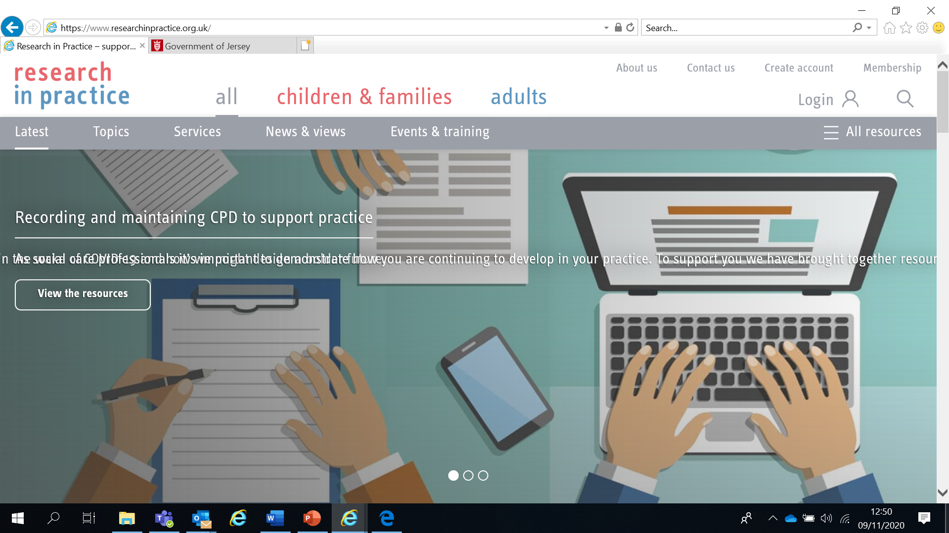

Use your work email and select **‘States of Jersey’** as your organisation from the drop-down list

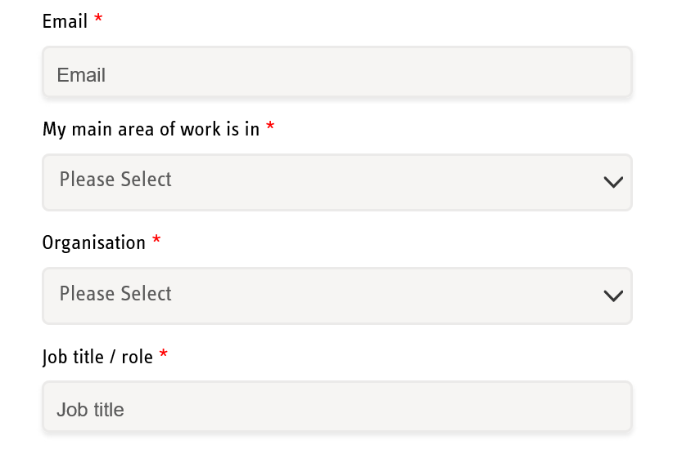

**NOTE: You cannot set up an account with RIP if your work email uses Gmail, Hotmail or other generic accounts. Please contact us if this applies to you.**

Once you have logged in with your new account, the resources are free to download:

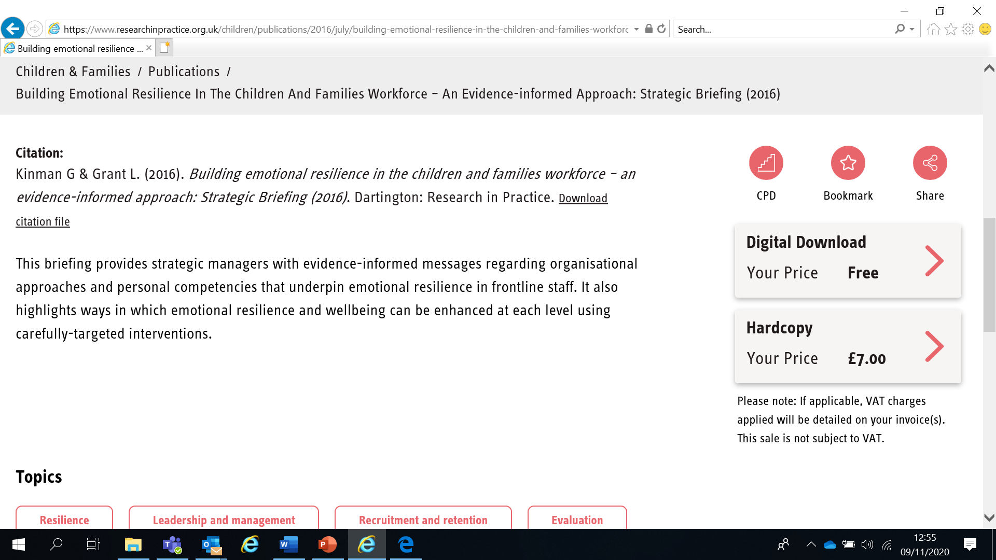

If you have any problems setting up an account, please contact safeguardingtraining@gov.je

**Learning Objectives**

In this module you will:

* Understand your role in relation to working together and the key principles in Children and Young People Jersey Law 2022 [Jersey Children and Young People (Jersey) Law 2022](https://www.jerseylaw.je/laws/enacted/Pages/L-14-2022.aspx) and the commensurate [Statutory Guidance](https://www.gov.je/Caring/Children/ChildrenWelfare/Pages/ChildrenAndYoungPeopleJerseyLaw2022StatutoryGuidance.aspx) in the document.
* Apply the Jersey Children First Model and the Continuum of Need
* Practitioners will understand Information Sharing in relation to this [Statutory Guidance](https://www.gov.je/Caring/Children/ChildrenWelfare/Pages/ChildrenAndYoungPeopleJerseyLaw2022StatutoryGuidance.aspx)
* Understand the structure and your role within a Strategy Discussion/Meeting, core group and a child protection conference
* Know how to write effective Child Protection Conference Reports
* Understand your role in a Child Protection Conference
* Feel confident in participation and decision making

**Your Professional Responsibilities**

You have specific responsibilities as a professional to:

* Follow [Jersey Children’s First](https://www.gov.je/Caring/JerseysChildrenFirst/pages/index.aspx) (JCF) and begin an Early Help Wellbeing Assessment for families who present with Wellbeing Needs.
* Refer children who present with Health and Development Needs to the [Child and Family HUB](https://www.gov.je/Caring/ChildrenAndFamiliesHub/pages/childrenandfamilieshubhomepage.aspx) for support.
* Refer children who present with Safeguarding Needs to the [Child and Family HUB](https://www.gov.je/Caring/ChildrenAndFamiliesHub/pages/childrenandfamilieshubhomepage.aspx) for support.
* Report concerns for the safety and welfare of a child to the Children and Families Hub (519000) or to police if urgent
* Work openly and honestly with children and their families and communicate in clearly understood ways
* Participate in Strategy Discussion/Meetings, child protection enquiries, child protection conferences and core group meetings when requested and required
* Complete updated reports for meetings and send well-briefed professionals if you are unable to attend

**Intercollegiate Competency Framework:** Level 3 and above

**Wellbeing Alert!**

We acknowledge that this is a sensitive subject – look after yourself and others.

This content:

* can trigger memories of experiences which were in some way abusive
* can highlight areas of difficulty for individual people who are aware of others or their own personal experiences
* can have an emotional impact on those working to protect children, families and adults
* seek support from your manager if you are upset by any of the materials

**Working Together to Safeguard Children**

[A shared vision for working together](https://www.gov.je/caring/children/childrenwelfare/pages/childrenandyoungpeoplejerseylaw2022statutoryguidance.aspx)

* All practitioners working with children and young people should be committed to, and united in, a shared vision: for every child to live a happy and healthy life in a supportive environment, surrounded by adults who actively promote their wellbeing and act to safeguard their welfare.
* To achieve this shared vision, you should be committed to playing your part in implementing and delivering effective multi-agency arrangements to promote the wellbeing and safeguard the welfare of children and young people.

[Children and Young People Jersey Law 2022 Statutory Guidance (gov.je)](https://www.gov.je/caring/children/childrenwelfare/pages/childrenandyoungpeoplejerseylaw2022statutoryguidance.aspx)

**The Legal Framework**

* Article 2 of the Children (Jersey) Law 2002 ([Children (Jersey) Law 2002 (jerseylaw.je)](https://www.jerseylaw.je/laws/current/Pages/12.200.aspx)) states that: “The child’s welfare shall be the court’s paramount consideration”
* The 1989 UN Convention on the Rights of the Child ([Convention on the Rights of the Child | OHCHR](https://www.ohchr.org/en/instruments-mechanisms/instruments/convention-rights-child)) states that every child has a right to a childhood, to be protected from harm, a right to education, to be treated fairly and for their views to be heard
* The Jersey SPB Multi-Agency Website Core Child Protection Procedures and Practice Guidance are free for all professionals where they can be accessed [here](https://jerseyscp.trixonline.co.uk/contents/contents). All agencies must have safeguarding procedures in place for professionals to meet their responsibility to identify and report risks and concerns of children to the Children and Families Hub ([www.gov.je/ChildrenAndFamiliesHub](http://www.gov.je/ChildrenAndFamiliesHub))

**Definition of Significant Harm**

Significant Harm is defined in the Children (Jersey) Law 2002, Article 24:

 Children witnessing **domestic abuse** is recognised as ‘harm’ after the UK Adoption and Children Act 2002 amended the definition in the Children Act 1989 to include 'impairment suffered from seeing or hearing the ill-treatment of another’. We follow this definition in Jersey.

The Children (Jersey) Law 2002 introduced the concept of “significant harm” as the threshold that justifies compulsory intervention in family life, in the best interests of children. This threshold gives statutory agencies such as Children’s Service and the Police a duty to make enquiries under Article 42 Enquiries, and to decide whether they should take action to safeguard or promote the welfare of a child who is suffering, or likely to suffer, significant harm.

*When a child becomes subject to a child protection plan, this will be based on them suffering or being likely to suffer significant harm under one of the four categories*

|  |  |  |  |
| --- | --- | --- | --- |
| **Physical Abuse** | **Emotional Abuse** | **Sexual abuse** | **Neglect** |

**DEFINITIONS OF ABUSE**

**PHYSICAL ABUSE**

Physical abuse may involve hitting, shaking, throwing, scalding, drowning, suffocating or otherwise causing physical harm to a child. Physical harm may also be caused when a parent or carer fabricates the symptoms or deliberately induces, illness in a child.

**EMOTIONAL ABUSE**

Emotional abuse is the persistent emotional ill treatment of a child such as to cause severe and persistent adverse effects on the child’s emotional development. It may involve conveying to a child that they are worthless and unloved, inadequate, or valued only insofar as they meet the needs of another person. It may feature age or developmentally inappropriate expectations being impose on children. These may include interactions that are beyond the child’s developmental capability, as well as overprotection and limitation of exploration and learning, or preventing the child from participating in normal social interaction. **It may involve seeing or hearing the ill-treatment of another, including domestic violence** or serious bullying causing children frequently to feel frightened or in danger, or the exploitation or corruption of children. Some level of emotional abuse in involved in all types of maltreatment of a child, though it may occur alone.

**SEXUAL ABUSE**

Sexual abuse involves forcing or enticing a child or young person to take part in sexual activities, including prostitution whether or not the child is aware of what is happening. The activities may involve physical contact, include penetrative (e.g. rape) or non-penetrative acts. They may include non-contact activities such as involving children in looking at, or in the production of sexual online images, watching sexual activities, or encouraging children to behave in sexually inappropriate ways.

**NEGLECT**

Neglect is the **persistent** failure to meet a child’s basic physical and/or psychological needs, likely to result in the serious impairment of the child’s health or development. Neglect may occur during pregnancy as a result of maternal substance misuse. It may also include neglect of, or unresponsiveness to, a child’s basic emotional needs.

* Once a child is born, neglect may involve a parent or carer failing to;
* Provide adequate food, clothing and shelter (including exclusion from home or abandonment)
* Protection a child prom physical harm or danger
* Ensure adequate supervision (including the use of inadequate care-givers)
* Ensure access to appropriate medical care or treatment

**Strategy Discussion/Meeting**

**Read the section on Strategy Meetings and Article 42 enquiry on the SPB Child Procedures at**

[Article 42 Child Protection Enquiries Under the Ministers...](https://jerseyscp.trixonline.co.uk/chapter/article-42-child-protection-enquiries-under-the-ministers-duty-to-investigate)

Whenever there is reasonable cause to suspect that a **child is suffering or is likely to suffer, significant harm,** Children’s Social Work will call a Strategy Discussion/Meeting, which will be chaired by a senior Children’s Social Care Manager.

Professionals participating in Strategy Discussion/Meetings must have all their agency's information relating to the child to be able to contribute it to the meeting and must be sufficiently senior to make decisions on behalf of their agencies.

Strategy Meeting/Discussions will be used to determine the need for Article 42 Enquiries Under the Ministers Duty to Investigate see [here](https://jerseyscp.trixonline.co.uk/contents/contents) for further information.

The Strategy Meeting/Discussion will decide if children’s social work should conduct single agency investigation or children’s social work, and police conduct a joint agency investigation.

The Meeting

* determines whether a child protection enquiry (‘Article 42’ as this is the part of the law it relates to) is needed and if so, how this will be coordinated
* decides what information will be shared with the family and by whom
* considers the needs of any other children

[Article 42 Enquiry and the Multi-Agency Assessment](https://jerseyscp.trixonline.co.uk/chapter/article-42-child-protection-enquiries-under-the-ministers-duty-to-investigate" \l "article-42-enquiry-and-the-multi-agency-assessment)

Children’s Social Work have statutory responsibility to lead on enquiries under Article 42 of the Children (Jersey) Law 2002, the [Children and Young People Law 2022](https://www.jerseylaw.je/laws/enacted/Pages/L-14-2022.aspx) and [commensurate Statutory Guidance](https://www.gov.je/Caring/Children/ChildrenWelfare/Pages/ChildrenAndYoungPeopleJerseyLaw2022StatutoryGuidance.aspx). A multi-agency assessment will be initiated when threshold for Article 42 Enquiry is met.

The Jersey Childrens First Framework provides the framework for gathering and analysing information for the enquiry and for following Core Procedures on [Assessment](https://jerseyscp.trixonline.co.uk/chapter/assessment), where conclusions and recommendations will then be made.

**Read the section on** [Jersey’s Children First in practice](https://www.gov.je/Caring/JerseysChildrenFirst/pages/jerseyschildrenfirstinpractice.aspx#anchor-0).

*Additional training available at:* [Guidance and training for Jersey's Children First](https://www.gov.je/Caring/JerseysChildrenFirst/pages/guidancepractitioners.aspx)

At the completion of Article 42 enquiry, Children's social care must evaluate and analyse all the information gathered to determine if the threshold for significant harm has been reached.

Notification, verbal or written, of the outcome of the enquiries, including an evaluation of the outcome for the child, should be given to all the agencies who have been significantly involved, the parents and children of sufficient age and appropriate level of understanding, in particular in advance of any initial child conference that is convened.

**The Continuum of Need**

Informed by the Children (Jersey) Law 2002 and Children and Young People (Jersey) Law 2022 Statutory Guidance, the Continuum Tool identifies four levels of vulnerability, risk and need to assist practitioners to identify the most appropriate service response for children and their families.

Problems should be identified as **early as possible** so that the child and family receive help and support in a timely way to prevent the problem becoming worse or entrenched. The Continuum of Need is a useful tool to help with this.

**Download and read the SPB’s Continuum of Need (Continuum of Need) on the Polices section of the website** [Continuum-of-Childrens-Needs-Guidance-2024-Final.pdf](https://safeguarding.je/wp-content/uploads/2022/10/Continuum-of-Childrens-Needs-Guidance-2024-Final.pdf)

|  |  |
| --- | --- |
| **Level of Need** | **Response** |
| **Universal Need** | Access to appropriate universal services e.g. access to antenatal care, GP, dentist, healthy child programme, nursery, pre-school, school and college settings |
| **Wellbeing need**  *Early Help* | If a wellbeing need is identified, an early help wellbeing assessment can be requested.  Children with emerging needs are best supported by those who already work with them, such as health visitors, youth services, early years settings, schools and colleges, community and voluntary sector services. These services can undertake an early help wellbeing assessment to determine what additional support may be needed, whether this is single or multi-agency.  Multi-agency support should be coordinated as needed with a team around the child and family in line with the Jersey’s Children First practice model.  When a child’s or family’s needs are so complex that they would benefit from a designated lead worker, a Family Partnership Worker from the Children and Families Hub teams may be allocated. |
| **Health or Development Need**  *Child in need* | If a health or development need is identified, a wellbeing assessment must be made.  At this higher level of need, a social worker, paediatrician or practitioner from Child and Adolescent Mental Health Services (CAMHS) is best placed to carry out a wellbeing assessment. |
| **Safeguarding Need**  *Child protection* | If a safeguarding need is identified, enquiries must be made by a social worker to determine whether and what action is required to safeguard the child’s welfare.  Specialist or statutory intervention includes the Children’s Service – including the Children’s Social Work Service and the Child and Adolescent Mental Health Service (CAMHS) Tier 4. |

All agencies have a responsibility to address the needs of children and young people in Jersey. Effective joint working ensures children’s needs can be met across the continuum.

**\*\*\* NOTE: The Continuum of Need document is not intended to replace the professional judgement of practitioners. If in doubt, advice should always be sought from a manager, Designated Safeguarding Lead or the Children and Families Hub \*\*\***

**REMEMBER – Never do nothing**

**The SPB’s** [Resolving Professional Differences/Escalation Policy](https://safeguarding.je/document-category/policies/) **should be used to escalate unresolved disputes where professional curiosity or challenge has not resolved any professional conflict**

**Child Protection Conferences**

The Standards and Quality Team are the organisation that provides independent oversight to child protection plans and reviews the care arrangements for children who are looked after by the Government of Jersey. They also investigate allegations of professional abuse.

An Initial Child Protection Case Conference (ICPC) will be held:

* where child protection enquiries (Article 42) show that a child has suffered or is likely to suffer significant harm
* where there are concerns regarding an unborn child
* where a child subject to a Child Protection Plan in another authority moves to Jersey

The Conference should take place within 15 working days of a Strategy Discussion or from being notified that a child on a CP plan has moved to Jersey.

**Download and read the SPB’s Child Protection procedures on Child protection Conferences**

[Child Protection Conferences](https://jerseyscp.trixonline.co.uk/chapter/child-protection-conferences)

The purpose of child protection conferences is to:

* Ensure the child’s welfare is safeguarded by considering any immediate and short-term risks as well as longer term risks for the child;
* Where there is immediate risk of significant harm, set actions without delay;
* Capture the voice of the child
* Bring together, in a multi-agency setting, information about the child's current wellbeing, health and developmental needs and determine the steps needed to promote their wellbeing, health and development within the context of their wider family and environment through analysis of the information received
* Ensure relevant and proportionate information is shared to enable a collective assessment of risk
* Understand parents/carer’s health needs and parental capacity, and determine the steps needed to support and enable them to better meet the needs of their child;
* Consider the evidence presented to the conference and taking into account the child's present situation and information about his or her family history, present and past family functioning, and decide whether the child has suffered, or is likely to suffer, significant harm.
* Consider under which category or risk they are at risk from
* Recommend what future action is required in order to safeguard and promote the welfare of the child, including the child becoming the subject of a child protection plan, determine what planned outcomes for the child and how best to achieve these.
* Appoint a lead social worker from Jersey children's social care
* Identify a core group of practitioners and family members to develop, implement and review the progress of the child protection plan
* Clarify the contingency plan if the agreed actions are not completed and/or circumstances change impacting on the child's safety and welfare.

**Involving Parents**

When Child Protection Conferences were established in the UK in 1974 following the [Maria Colwell inquiry](https://thetcj.org/child-care-history-policy/the-maria-colwell-reportchaired-by-tg-field-fisher), they were professional only forums. In 1988, following the [Cleveland inquiry](https://thetcj.org/child-care-history-policy/the-cleveland-reportby-judge-elizabeth-butler-sloss),parents/carers were invited to attend but were only passive observers.

Nowadays, parents/carers are active participants in child protection case conferences and are encouraged to contribute usually by attending unless it is likely to prejudice the welfare of the child.

**Read the section on ‘Involving Children and Family Members’ on the SPB Child Procedures** ([https://jerseyscb.proceduresonline.com/chapters/p_ch_protection_conf.html#invol_ch_fam](https://jerseyscb.proceduresonline.com/chapters/p_ch_protection_conf.html))

**Involving Children**

“Children and young people are a key source of information about their lives and the impact any problems are having on them in the specific culture and values of their family. It is therefore puzzling that the evidence shows that children are not being adequately included in child protection work.” ([Munroe Review 2011 Section 2.5](https://assets.publishing.service.gov.uk/government/uploads/system/uploads/attachment_data/file/175391/Munro-Review.pdf))

**Advocacy Services**

The main function of advocacy is to assist the child / young person to contribute effectively and make their views known. They may assist the child / young person to give their views. An advocacy worker can have a positive role to play as a child’s independent supporter and can help them prepare for a conference.

Advocacy Services in Jersey are provided by:

* Jersey Cares (for looked after children)
* Barnardo’s (for children in need and those in need of protection) [JSY Advocacy | Barnardo's](https://www.barnardos.org.uk/get-support/services/jsy-advocacy)

**Scenario Activity – Jayden**

**Read the information about Jayden below and then think about the questions on the table. You should use the SPB’s Continuum of Need to help you identify the level of risk for Jayden.**

**Health Visitor Information**

You have known Mum and Jayden since Jayden was born. You feel you have got to know Mum well and have developed a good relationship with her. Jayden is four years old.

Since you’ve known Mum you are aware that she speaks of feeling isolated so you have given her information on local community resources and groups she can attend. You have also made referrals for her to attend at parenting support groups. When you asked Mum how she was finding these support groups she said that she didn’t feel she needed them and as such hasn’t attended.

Jayden’s immunisations are up to date. There was delay in getting his immunisations done but mum always had a good reason why she had missed an appointment. She always had a good reason when she was not able to be at home for visits you arranged with her and if she missed a home visit, she would bring Jayden to the clinic. Looking at your records it is now apparent that you’ve not had a successful visit to the home since Jayden was quite a young baby. But mum has brought him to clinic, so you’ve not really viewed the lack of home visiting as an issue of concern.

Since you’ve known them, you’ve seen Jayden with a few bruises. Mum has always had an explanation which you felt was plausible. It’s only by putting your report together for conference that you’ve seen from looking at your own chronology that for a 4-year-old, Jayden seems to have had more injuries than most. And a lot of these injuries seem to be facial.

You’ve also accessed A & E records which show Jayden has attended the hospital on 3 occasions when Mum has reported he has fallen over and hurt himself. These injuries are in addition to the ones you have observed. Jayden doesn’t have any health conditions, but he has been referred to speech and language therapy as his speech appears delayed.

**Designated Teacher Information**

Jayden only started at your school this term, so you don’t feel that you know him well. Since he’s been with you, there have been no concerns regarding his attendance or punctuality. There have been a couple of lates but Mum has always apologised and had a reasonable explanation.

But it has been noted that Jayden never returns to school with his homework. When you ask him about this, he seems confused. You raised this with Mum but were concerned with her reaction as she appeared to get angry with Jayden, saying to him that she always does his homework with him and he has it when he comes into school so she doesn’t know what he is doing with it after she leaves him in the playground. You were a bit concerned about Jayden’s reaction to Mum when she appeared angry as although he didn’t say anything he seemed to ‘freeze’ and become quite watchful of mum’s actions. This occurred at the end of a school day and you observed mum to take Jayden quite roughly by his hand. You then saw mum walk off at quite a quick pace so that Jayden had difficulties keeping up with her and he had to keep running. Mum didn’t seem aware that she was walking too fast for Jayden to walk with her in comfort. This incident occurred a few days before Jayden came into school with the bruising on him.

Since Jayden has been cared for full time by Dad, he has been bringing his homework into school. Jayden has also appeared more talkative since being in Dad’s care and he says he likes having Dad around more.

**Housing**

You’ve known the family since shortly after they came to Jersey. There have been repeated complaints made by neighbours re fighting and shouting at mum’s accommodation. Some of the complaints have referred to hearing a child crying. Mum has been spoken to and has made counter allegations against her neighbours. She says that they are picking on her because she has come from the UK. The weekend before Jayden made his disclosure at school about Mum hurting him, another neighbour complaint had been received regarding hearing shouting followed by what sounded like a child crying.

You haven’t been inside the property for almost a year. When you last visited you were concerned that there was damage to doors where it looked like they had been hit – possibly by a fist? On the last occasion when you visited, you noted that whilst Mum’s bedroom appeared comfortable and warm, Jayden’s room was poorly furnished. There was no sheet on his bed and the bed was a mattress on the floor. His duvet appeared dirty and there was an unpleasant background smell. There was a lock toward the top of Jayden’s door on the outside. Mum said she had put it there to keep Jayden out of his room during the day as he has been smearing in there (hence the smell) and she had been advised to do this by the health visitor.

**GP**

The GP has known Jayden’s dad since he was a child and knows the rest of the family well. He has seen Jayden’s dad for anxiety and depression prior to him leaving Jersey some years ago but has not seen him since he returned to the island.

Jayden is registered with the same GP and he has seen him on twelve occasions in the last two years. Jayden appears to be a clumsy child who falls often as he presents with bruises and bumps, often to his head. He has on a few occasions warranted an attendance at A&E.

The GP has had concerns that when presenting, Jayden can look pale and grubby and is often silent in his mother’s presence. A very quiet child.

**Now answer the following questions about Jayden below:**

|  |  |
| --- | --- |
| What does your information tell you about Jayden’s life experience? |  |
| What risks or concerns can you identify for Jayden? |  |
| What things are working well for Jayden? |  |
| What would you do with this information? |  |
| Who else may have relevant information to share? |  |
| Where do you think the level of risk of harm currently is for Jayden? |  |
| What about future risk of harm to Jayden? |  |

**Professional Reports Guidance**

|  |
| --- |
| **Introduction** |
| Professionals and agencies who are invited to attend conference should make every effort to do so but if are unable to, they should provide, wherever possible, a well briefed agency representative to speak to the report. All professionals/agencies will be expected to submit a written report (using the standard agency/professional templates for Child Protection Conference).  As a minimum, at every conference there should be attendance by children's social care and at least two other professional groups or agencies, who have had direct contact with the child who is the subject of the conference. Attendees may also include those whose contribution relates to their professional expertise or responsibility for relevant services. In exceptional cases, where a child has not had relevant contact with three agencies (i.e. Children's Social Care and two others) this minimum quorum may be breached. This is at the discretion of the conference chairperson.  Those attending conferences should be there because they have a significant contribution to make, arising from professional expertise, knowledge of the child, their parents or carers, or both.  The decision at conference about whether a child has suffered significant harm or is likely to in the future and should be subject to a Child Protection Plan, is the responsibility of all agencies represented at conference. |
| **Completing the Guidance** |
| **When completing this report, it is important to:**   * Be child focused – what does this mean for the child’s experience? * Contain any information deemed relevant to assessing the risks to and welfare of a child * Present the information in a manner which can be understood by conference attendees and enable such information to be evaluated from a sound evidence base. * Take care in distinguishing between fact, observation, allegation and opinion. When information is provided from another source i.e., it is second or third hand, this should be made clear. * Avoid any repetition or duplication within your report, * Fill in the information that you know about and provide as much detail as possible to enable the conference to make an informed decision about what action is necessary to safeguard and promote the welfare of the child, and to make realistic and workable proposals for taking that action forward. * Exclude confidential/sensitive information from the written report. For example, in certain circumstances e.g., Police investigations this should not be included and should be discussed separately with the Child Protection Adviser as Chair of the Conference.   *You should advise the Chair in advance if there is information that should not be shared with certain members at conference.* |
| **Report Format:  When to send it and who to send it to** |
| Reports from professionals and agencies (excluding Jersey’s Children's Social Care) should be based on the SPB Child Protection Conference Report pro-forma.  Those professionals/agencies unable to attend the last Core Group prior to a Review Child Protection Conference will be expected to submit a written report.   Reports should be e-mailed using secure email to Standards & Quality team[S&QTeam@gov.je](mailto:S&QTeam@gov.je) |

## Multi-Agency Report for Child Protection Conference

|  |  |  |  |
| --- | --- | --- | --- |
| **Agency** |  | **Name** |  |
| **Job Title** |  | **Contact Details** |  |
| **Date of Conference** |  | **Will you be attending? Y/N (If not, who will be attending on your behalf)** |  |

|  |  |
| --- | --- |
| **Date report shared with parent(s):** |  |
| **Date report shared with the young person(s):** |  |
| **If not shared; please state, why not:** |  |

|  |  |  |  |
| --- | --- | --- | --- |
| **Family composition and details Include all those living in the family home** | | | |
| **Child's name** | **DOB** | **Gender M/F** | **Communication Needs** |
| **Siblings’ names** | **DOBs** | **Gender M/F** | **Communication Needs** |
| **Parents’/Carers’ names** | **Relationship to child** | **Parental responsibility?** | **Communication**  **Needs** |
| **Family address  (including postcode):** |  | | |
| **Phone number(s):** |  | | |

|  |  |  |  |
| --- | --- | --- | --- |
| **Details of any significant others not living in family home** | | | |
| **Name** | **DOB** | **Relationship** | **Previously known to Children’s Services (Y/N)** |
|  |  |  |  |

|  |
| --- |
| **WHAT ARE WE WORRIED ABOUT?**  Current Harm  Current Risks or Concerns and how does this IMPACT upon the child(ren). |
|  |

|  |
| --- |
| **WHAT’S WORKING WELL?**  (What is working well now & what has worked well in the past)  Existing Strengths and Protective Factors |
|  |

|  |
| --- |
| **COMPLICATING FACTORS**  (What makes the family’s life and parenting experience harder?) |
|  |

|  |
| --- |
| **VIEWS OF THE CHILD/REN – DIRECT WORK WITH THE CHILDREN**  (What has the child told you about their daily lived experience?) |
|  |

|  |
| --- |
| **OBSERVATIONS OF THE CHILD/REN** |
|  |

|  |
| --- |
| **VIEWS OF THE PARENTS/NETWORK/SIGNIFICANT OTHERS** |
|  |

|  |
| --- |
| **WHAT NEEDS TO HAPPEN & NEXT STEPS**  (How can we reduce the worries and risk of harm?)  Describe precisely what outcomes you need to see to be satisfied there is sufficient safety. |
|  |

|  |  |
| --- | --- |
| **VIEWS**  (Please give your view re CP Planning & Timescale for Change – Trajectory) | |
|  | |
| **Views around whether threshold has been met for a child protection plan?** |  |
| **What risk category do you consider the child(ren) are at risk of?** |  |
| **How can your service support?** |  |

**Report completed by**

|  |  |  |  |
| --- | --- | --- | --- |
| **Name** |  | **Designation** |  |
| **Signature** |  | **Date** |  |

**NB You can download the form at** [Forms | Jersey Safeguarding Partnership Board](https://safeguarding.je/document-category/forms/)

**Conference Process**

1. Chair reads multi-agency reports to prepare for meeting. Initial reports should be submitted to at least **2** working days before the conference. Review reports should be submitted at least **5** working days before
2. Chair, in conjunction with other professionals, considers if exclusion periods or safety issues need to be considered, and preparations made
3. Chair, in conjunction with the social worker and the family, considers if the child / young person is or should be invited and how they can participate effectively and appropriately
4. Chair meets with the family before to explain the process
5. Chair opens the meeting with introductions, ground rules, process, and issues around confidentiality
6. Chair asks professionals to share their information and what the likely impact is on the child being discussed
7. Chair seeks clarity and views from the parents, carers and child / young person on the information shared
8. Chair may exclude individuals from part or all of the meeting due to safety considerations or the sensitivity or confidentiality of the information being shared
9. Chair summarizes the information shared
10. Professionals make a recommendation to the Chair to inform his/her decision on whether a child should be subject of a child protection plan
11. An outline plan for the child is devised at the first core group and is aimed at reducing the risks of harm to the child and providing support

**Decisions of an Initial Child Protection Conference**

* Whether a child has and is likely to suffer significant harm from abuse or neglect and thus placed on a child protection plan. If not, whether a child in need plan should be established to promote the child’s welfare
* Deciding on the most suitable category for registration
* Developing an outline plan to safeguard and promote the child’s welfare
* Identifying the core group members responsible for implementing the child’s protection plan
* Setting timescales for the completion of necessary work, referrals and assessments

**Core Group Meetings**

* Consists of relevant family members, child/young person (as appropriate), and professionals involved with the children or have actions within the child protection plan
* Will meet within 10 working days of an initial conference and at least every 4 weeks thereafter
* Must review the progress of the child protection plan and relevant updates on the children’s safety and welfare
* Helps to inform relevant assessments
* Should take place at a location that is considered safe for those attending and maximizes the attendance of all
* Will be chaired by a social worker or their manager

**Child Protection Plans**

|  |  |  |  |  |  |
| --- | --- | --- | --- | --- | --- |
| **Child(ren)/YP** | **What do we want to happen?** | **How will this happen?** | **Who will help with this and make it happen?** | **How will we know it has happened?** | **Review -what progress has been made (scale)** |
|  |  |  |  |  |  |

The Child Protection Plan should set out what work needs to be done, why, when and by whom. The Plan should:

* When and in what situations the child will be seen by the child's Lead Social Worker, both alone and with other family members or caregivers present;
* Describe the identified developmental needs of the child, and what services are required;
* Include specific, achievable, child-focused outcomes intended to safeguard and promote the welfare of the child;
* Include realistic strategies and specific actions to achieve the planned outcomes;
* Include a Contingency Plan to be followed if circumstances change significantly and require prompt action.
* Clearly identify roles and responsibilities of professionals and family members, including the nature and frequency of contact by professionals with children and family members;
* Lay down points at which progress will be reviewed, and the means by which progress will be judged; and
* Set out clearly the roles and responsibilities of those professionals with routine contact with the child - e.g. health visitors, GP's and teachers - as well as those professionals providing specialist or targeted support to the child and family.

**Next Steps**

You have now finished the independent learning ahead of the in-person seminar.

In the seminar, we will reflect on your learning from this module and in particular we will:

* **Discuss a scenario and consider the information in relation to what it tells you about what life is like for the child concerned**
* **Complete a case conference report**
* **Convene a mock child protection conference where you will be given a specific role and scenario to present at the mock conference. You will be asked to decide the level of risk, based on the Continuum of Need and the information you will hear during the mock conference.**

**Important!**

**Please bring this workbook to the seminar with you. We will be referring to it throughout the session.**

**Tips for Professionals**

* Share information about concerns in the conference, not afterwards. If you need advice on whether to share something, ask the chair prior to the conference
* Share your reports and their contents with the parents or service user and submit them before deadline.
* Actively participate in the decision-making process and development of the child’s plan
* Do not get into heated exchanges with parents/family
* Do not present assumptions as factual statements
* If you cannot attend, send a well-informed colleague
* Avoid reading reports verbatim. Summarize salient facts
* Be mindful if an interpreter is present. Take frequent pauses when sharing information
* Be mindful of language barriers, cultural differences and interpretations, and cognitive delays or issues. Consider this when writing reports and discussing concerns with parents and their children

**Further Learning**

The Safeguarding Partnership has responsibility for promoting understanding of safeguarding and helping agencies to work together to Safeguard children and Adults at Risk, resources can be accessed [here](https://safeguarding.je/about/).

There is a series of 7 Minute Briefings on a range of topics which you can use with your teams to prompt discussion and reflection on practice and systems. You can find 7 Minute Briefings under the [Resources](https://safeguarding.je/resources/) page on the website – including an explanation of what they are.

The Research in Practice website is an excellent source of further material.

The SPB has a range of courses which will help you to further your knowledge. Please check our website for further details.

**“The big problem for society (and consequently for professionals) is establishing a realistic expectation of professionals ability to predict the future and manage risk of harm to children and young people….. It may be judged highly unlikely that the child will be re-abused but low probability events happen. This does not in itself indicate flaws in the professional reasoning. The ideal would be if risk management could eradicate risk, but this is not possible; it can only try to reduce the probability of harm.”**

Munroe Review, May 2011

**Acronyms**

|  |  |
| --- | --- |
| ABE | Achieving Best Evidence |
| APVA | Adolescent to Parent Violence and Abuse |
| ASCIT | Autism and Social Communication Inclusion Team |
| CAMHS | Child and Adolescent Mental Health Service |
| CCE | Child Criminal Exploitation |
| CDC | Child Development and Therapy Centre |
| CEOP | [Child Exploitation and Online Protection agency](https://jerseyscb.proceduresonline.com/local_keywords/ceop.html) |
| CEYS | Childcare and Early Years Service |
| ChiSVA | Children and Young People’s Sexual Violence Advisor |
| CIN | Child In Need |
| CLA | Children who are Looked After (formerly known as LAC Looked After Children) |
| CP | Child Protection |
| CPC | [Child Protection Conference](https://jerseyscb.proceduresonline.com/local_keywords/cpc.html) |
| CQC | Care Quality Commission |
| CSDL | Capacity and Self-Determination Law |
| CSE | Child Sexual Exploitation |
| CYPES | Children Young People Education and Skills |
| DA(DV) | Domestic Abuse (Domestic Violence) |
| DBS | Disclosure and Barring Service |
| DSL | Designated Safeguarding Lead |
| ECHR | [European Convention on Human Rights](https://jerseyscb.proceduresonline.com/local_keywords/echr.html) |
| EP | Educational Psychologist |
| EWO | Education Welfare Officer |
| EYAT | Early Years Advisory Team |
| EYFS | Early Years Foundation Stage |
| EYIT | Early Years Inclusion Team |
| FGM | Female Genital Mutilation |
| FII | Fabricated or Induced Illness |
| FLO | Family Liaison Officer |
| FNHC | Family Nursing and Home Care |
| GDPR | General Data Protection Regulation |
| HBV | Honour Based Violence |
| HSB | Harmful Sexual Behaviour |
| ICPC | Independent Child Protection Conference |
| IDVA | Independent Domestic Violence Advisor |
| IPVA | Interpersonal Violence and Abuse in Young People’s Relationships |
| ISVA | Independent Sexual Violence Advisor |
| JCAF | Jersey Common Assessment Framework |
| JCCT | [Jersey Child Care Trust](https://jerseyscb.proceduresonline.com/local_keywords/jcct.html) |
| JCF | Jersey’s Children First |
| JDO | Jersey Designated Officer |
| JFCAS | [Jersey Family Court Advisory Service](https://jerseyscb.proceduresonline.com/local_keywords/jfcas.html) |
| JPACS | [Jersey Probation and After-Care Service](https://jerseyscb.proceduresonline.com/local_keywords/jpacs.html) |
| JMAPPA | Jersey Multi Agency Public Protection Arrangements |
| LAC | Looked After Children |
| LADO | Local Area Designed Officer (see JDO) |
| MAF | Managing Allegations Framework |
| MASH | [Multi Agency Safeguarding Hub](https://jerseyscb.proceduresonline.com/local_keywords/mash.html) |
| MARAC | [Multi Agency Risk Assessment Conference](https://jerseyscb.proceduresonline.com/local_keywords/marac.html) |
| MARRAM | [Multi Agency Risk Review Action Meeting](https://jerseyscb.proceduresonline.com/local_keywords/marams.html) |
| NAI | Non Accidental Injury |
| NFA | No Further Action |
| PBS | Positive Behaviour Support |
| PPU | Public Protection Unit |
| PR | Parental Responsibility |
| QST | Quality and Standards Team (formerly ISS – Independent Safeguarding Standards) |
| RCPC | Review Child Protection Conference |
| SALT | Speech and Language Therapy/Therapist |
| SARC | Sexual Assault Referral Centre |
| SCR | [Serious Case Review](https://jerseyscb.proceduresonline.com/local_keywords/scr.html) |
| SEMHIT | Social, Emotional and Mental Health Inclusion Team |
| SEN | [Special Educational Needs](https://jerseyscb.proceduresonline.com/local_keywords/sen.html) |
| SENCO | Special Educational Needs Coordinator |
| SEND | Special Education Needs and Disability |
| SNRM | [Self-Neglect Risk Management Meeting](https://jerseyscb.proceduresonline.com/local_keywords/snrm.html) |
| SOJP | States of Jersey Police |
| SPB | [Safeguarding Partnership Board](https://jerseyscb.proceduresonline.com/local_keywords/spb.html) |
| TAC | Team Around the Child |
| TAF | Team Around the Family |
| YES | [Youth Enquiry Service](https://jerseyscb.proceduresonline.com/local_keywords/yes.html) |

|  |
| --- |
| Notes |